Quantitative Risk Assessment

Based on the results of the qualitative register and the improved version of the priority heatmap (shown in the Qualitative Risk Assessment), the following contribution completes the quantitative analysis of these risks through three steps, consistent with the assignment requirements: (1) standard quantitative risk analysis of probability distributions, expected loss, variance, and risk exposure based on Indicators & Warning analysis and Monte Carlo simulation, including sensitivity analysis and validation against the qualitative ranking; (2) machine learning-based risk prediction model with features matching the register Key Risk Indicators; and (3) situation assessment linking the business and non-business environment to the input of the model.

Standardized Quantitative Modeling: I&W and Monte Carlo Simulation
Three risks selected for full quantification – ADC market share erosion (R-MSE), critical ADC talent poaching (R-006), and the first mover advantage ADC combination therapy opportunity (R-010) – all (a) represent risks with such exposure in dollars that the decision-making process will be compromised by a point estimation, (b) feature observable leading, coincident, and lagging indicators collected from public information (ClinicalTrials.gov, Drugs@FDA, SEC EDGAR) and internal HR turnover statistics, and (c) have direct impact on the deal’s $10 billion 2030 revenue forecast.
The Indicators & Warning (I&W) technique, adapted from intelligence-analysis tradecraft (Grabo, 2004) and applied here to competitive business risk, converts each qualitative risk into measurable warning signs with defined amber and red escalation thresholds rather than a single static likelihood score. For R-MSE the indicators are the number of competitor ADC approvals and Phase 3 initiations per year, tracked against Seagen’s share trend, with a warning triggered if Seagen’s ADC share declines more than 5% in a year or three or more competitor ADCs enter Phase III in the same window. For R-006 the indicator is the monthly voluntary departure rate among a pre-identified list of critical Seagen personnel. For R-010 the indicators are the number of new ADC combination programs entering preclinical or Phase 1 development per quarter and the count of new external partnerships signed.
However, the impacts of each of the risks considered are themselves ranges, not point estimates: according to the DCF stress test performed by the team, a revenue gap of 10% compared to the projected revenue of $10 billion results in the reduction of the deal’s value by about $4.42 billion, while a revenue gap of 20% causes the reduction in value by $9.57 billion. This means that a simple expected value calculation will fail to capture the true level of uncertainty surrounding these risks. Therefore, a Monte Carlo simulation was chosen to convert probability and impact distributions into a full value distribution. As advised by PMI (1996) and applied in the case study reference material (Khadem et al., 2018), probabilities and impacts were assumed to be triangularly distributed, based on the minimum, most likely, and maximum values specified (the default approach when only expert-based estimates of three possible values are known but no data on frequency is available) (Vose, 2008). In each of 100,000 simulations both the probability and the impact value was generated, their multiplication yielding the expected value/loss. Table 2 reports the resulting statistics, including the standard deviation and coefficient of variation that quantify the dispersion of each exposure.
Risk | Type | Mean Prob. | Impact P50 ($B) | Exp. Loss/ Value ($B) | EL Std. Dev. ($B) | EL CV | P90 Scenario VaR ($B)
R-MSE — ADC market-share erosion | Threat | 53.3% | 4.86 | −2.66 | 1.06 | 0.40 | 6.67
R-006 — Critical ADC talent poaching | Threat | 55.0% | 0.65 | −0.37 | 0.13 | 0.35 | 0.87
R-010 — First-mover ADC combinations | Opportunity | 50.0% | 1.64 | +0.83 | 0.21 | 0.25 | 1.95
Table 2. Monte Carlo outputs (100,000 iterations per risk, seed 42). Standard deviation and coefficient of variation (CV = SD / |mean|) quantify dispersion of the expected loss/value. Variance equals SD² (R-MSE 1.12, R-006 0.016, R-010 0.043).
Expected loss, variance, and risk exposure. R-MSE carries by far the largest dollar exposure (expected loss −$2.66 billion, P90 scenario value-at-risk $6.67 billion) and also the widest absolute dispersion (standard deviation $1.06 billion; variance 1.12), confirming it as the dominant source of enterprise risk exposure. R-006 has the highest probability of materializing (55.0%) but the tightest dollar dispersion (SD $0.13 billion), meaning the talent-attrition risk is more likely than not to occur in some form yet its typical financial consequence is an order of magnitude smaller than losing ADC market share outright. R-010 offsets these threats with an expected upside of +$0.83 billion (SD $0.21 billion) and the lowest coefficient of variation of the three. Aggregating the two threats, the combined expected loss is $3.03 billion (SD $1.07 billion), partially offset by the R-010 upside for a net expected threat position of roughly −$2.20 billion.
Scenario-based exposure and loss exceedance. Reading the simulation through the scenario (Bernoulli) view gives management the exceedance probabilities that point estimates hide, in the same spirit as the reference case study’s finding of an “8% chance of exceeding the budget.” For the combined ADC threats, the simulation indicates a P90 scenario loss of approximately $7.07 billion, an 18.7% probability that combined threat losses exceed $6 billion in a given assessment, and roughly a 4.7% probability they exceed $8 billion — a quantified tail that justifies sizing contingency reserves against the upper, not the expected, end of the range.
Sensitivity analysis. Mirroring the sensitivity analysis in Khadem et al. (2018), which isolated the three risks driving most of a project’s cost and schedule exposure, a variance-driver decomposition was run on each modeled risk. For both threats the impact assumption, not the probability assumption, dominates outcome variance — impact explains roughly 80% of expected-loss variance for R-MSE and R-006, versus about 57% for the opportunity R-010. The practical implication is that tightening the impact estimate (the DCF stress bands) would reduce decision uncertainty more than refining the probability estimate, directing additional analytical effort where it is most valuable.
Validation against the qualitative assessment. Following the case study’s validation approach of cross-checking the probabilistic ranking against the qualitative ranking, the Monte Carlo expected-loss ordering by magnitude (R-MSE > R-010 > R-006) is consistent with the qualitative priority ordering: R-006 is Critical on the L × I scale because of its high likelihood, while R-MSE carries the largest financial consequence per occurrence. The two views agree on which risks dominate the profile and diverge only on the probability-versus-magnitude emphasis — which is precisely the additional insight quantitative modeling is meant to surface. Figures 2 through 5 present the simulation graphically.
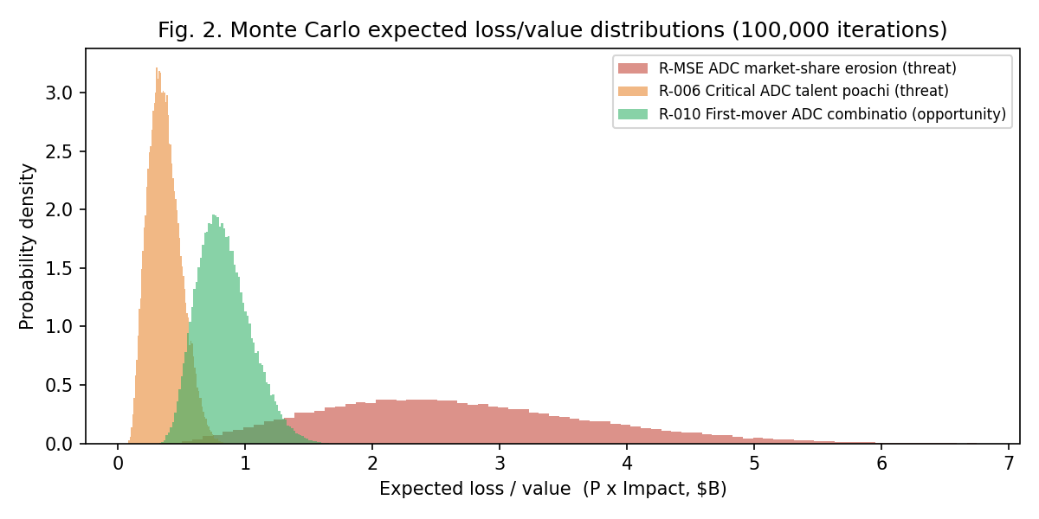
Figure 2. Monte Carlo expected loss/value distributions (100,000 iterations).
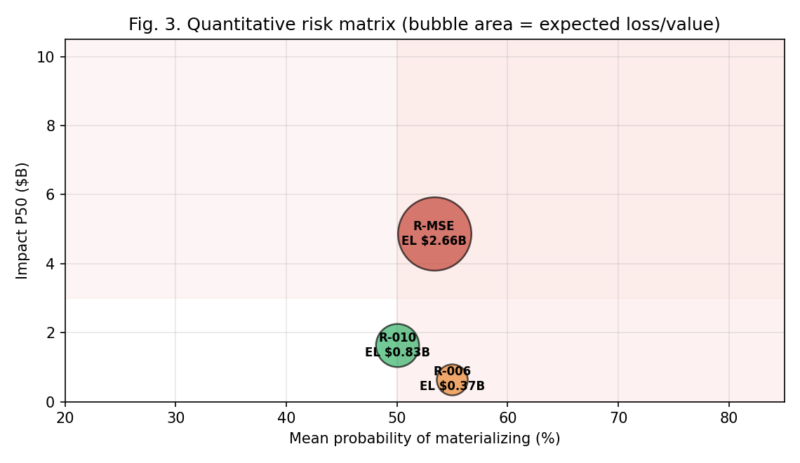
Figure 3. Quantitative risk matrix; bubble area is proportional to expected loss/value.
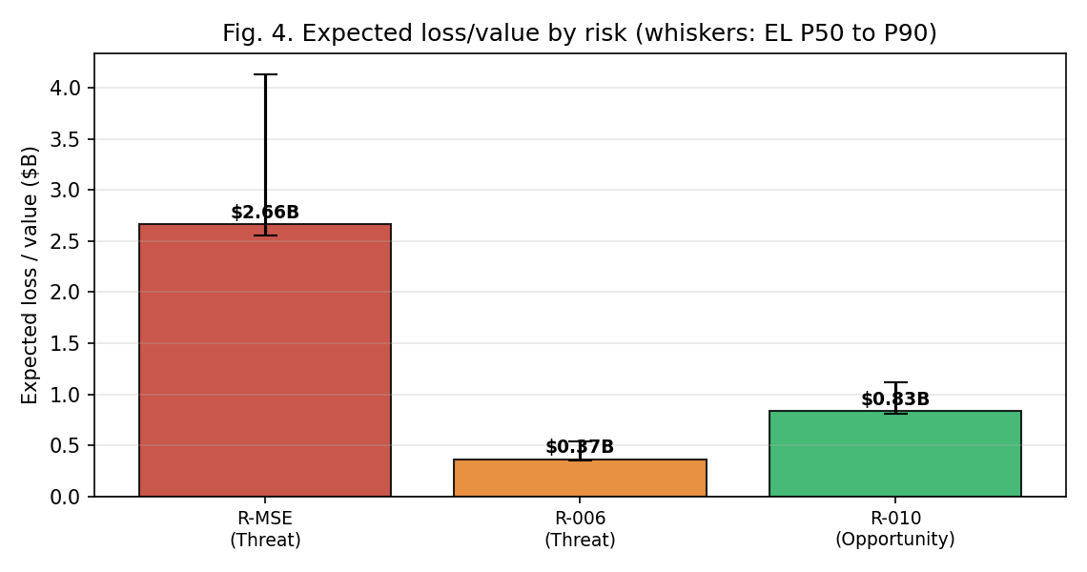
Figure 4. Expected loss/value by risk; whiskers span the P50–P90 range.
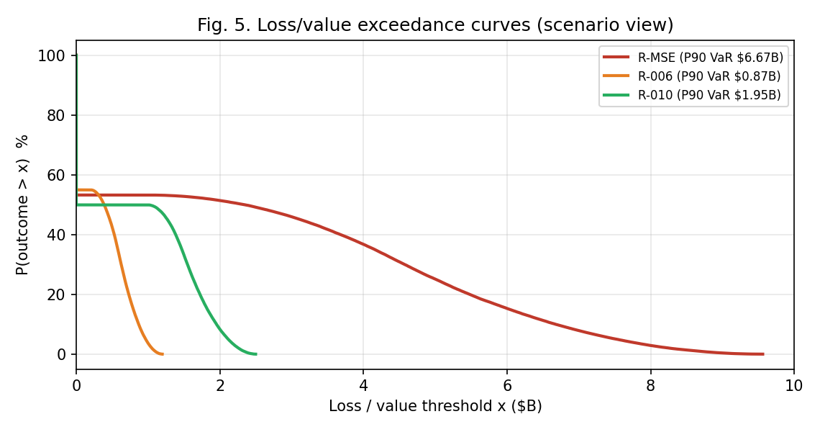
Figure 5. Loss/value exceedance curves; the P90 point is the scenario value-at-risk.

Machine Learning-Based Risk Prediction
For the assignment, there is a need for a supervised algorithm together with feature selection that is consistent with the Key Risk Indicators. In the case where real data are unavailable, there will be a need for the use of a synthetic or proxy data set. Due to the lack of labeled historical data on the outcomes of the integration between Pfizer and Seagen, a synthetic dataset of 600 "risk-quarters" was constructed to simulate the monitoring of the integration. It is important to note that each feature is linked to a Key Risk Indicator in the register (defined in Key Risk Indicators contribution; Table 4 of consolidated report) and not to some abstract probability and impact scores.
Data-generating process and assumptions. Each KRI was sampled from a documented, plausible distribution — for example, competitor ADC approvals as Poisson(2.4)/year, annualized attrition as Normal(6%, 2.6%), interest coverage as Normal(1.4×, 0.30), and revenue-versus-plan as Normal(90%, 10%) — with ranges chosen to reflect the operating conditions described elsewhere in this report. A latent warning score then accumulates points each time a KRI crosses the amber or red trigger defined for that indicator (with a protective offset when R-010 capture indicators are strong), and Gaussian noise is added so the labeling rule is not perfectly separable. The score maps to a three-class warning state (Green/Amber/Red) and to a binary Red-escalation flag. Because the labels are generated from the same thresholds management would apply operationally, the model learns the escalation logic of the register rather than an arbitrary rule, and the noise term ensures the validation metrics reflect genuine, non-trivial prediction.
Models, validation, and interpretation. A Random Forest (300 trees, balanced class weights) and a logistic-regression baseline were trained with a 75/25 stratified hold-out and 5-fold stratified cross-validation. On the decision-relevant binary task — predicting whether a quarter breaches the Red escalation threshold — the Random Forest achieved 0.85 ± 0.05 cross-validated accuracy and 0.93 ± 0.03 cross-validated ROC-AUC, with hold-out accuracy 0.81 and ROC-AUC 0.91 (Table 3). On the harder three-class task it achieved 0.68 cross-validated accuracy, with the Amber middle class the principal source of error — the expected behavior for an ordinal boundary class. Most importantly, the model’s feature-importance ranking (Figure 6) independently recovers the same five indicators the register flags as the highest-priority drivers: competitor approvals (17.5%), critical-scientist attrition (15.0%), share change (14.5%), revenue-versus-plan (14.5%), and interest coverage (12.1%). That the model, trained only to predict escalation, rediscovers the register’s priority drivers is a form of construct validation: the KRI set and the predictive signal point to the same risks.
Model / task | CV accuracy | CV ROC-AUC | Hold-out accuracy | Hold-out ROC-AUC
Random Forest — binary (Red-quarter) | 0.85 ± 0.05 | 0.93 ± 0.03 | 0.81 | 0.91
Logistic Regression — binary baseline | 0.79 | — | 0.79 | —
Random Forest — 3-class (G/A/R) | 0.68 | — | 0.65 (macro-F1 0.65) | —
Table 3. Supervised-model validation on the KRI-aligned synthetic dataset (600 risk-quarter observations; 5-fold stratified cross-validation and 75/25 hold-out).
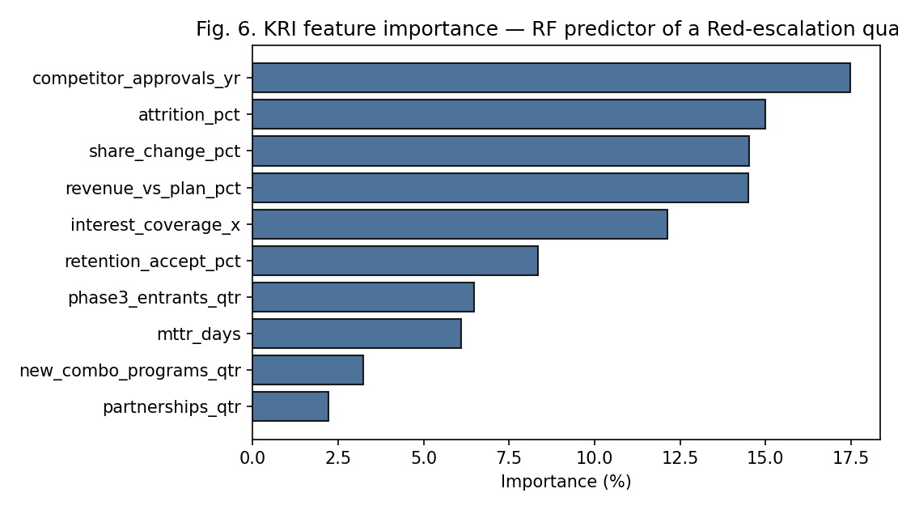
Figure 6. Random Forest feature importance — KRI predictors of a Red-escalation quarter.
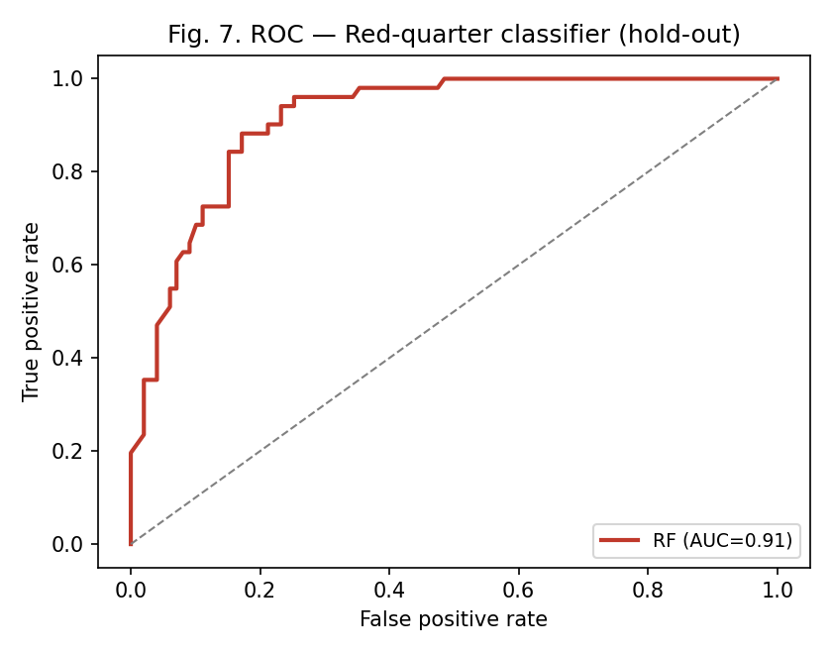
Figure 7. ROC curve for the binary Red-quarter classifier (hold-out set).
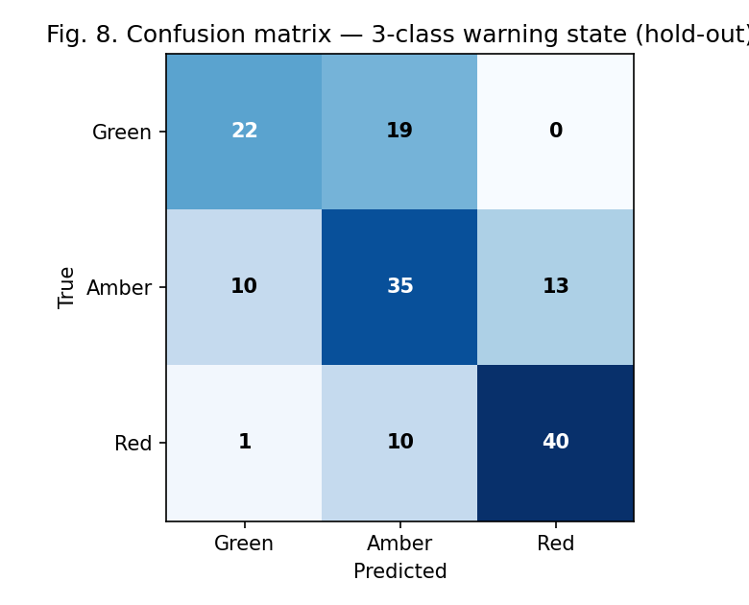
Figure 8. Confusion matrix for the three-class warning-state classifier (hold-out set).
Interpretation and limits. The model’s output — a predicted probability that the next quarter breaches the Red escalation threshold — can serve as a composite early-warning score feeding the KRI dashboard, informing the likelihood dimension of the register ahead of any single indicator breaching on its own. The synthetic basis validates the workflow (KRI feature selection, cross-validation, ROC and confusion-matrix interpretation), not Pfizer-specific probabilities; a production deployment would retrain on actual quarterly KRI history as it accumulates. As a methodological contrast, the earlier rule-based Random Forest trained on only the Likelihood and Impact columns of the sixteen-risk register is retained in the accompanying notebook; with only two numeric features and two populated classes it recovered the dominant Medium class but only one of two High risks — the small-sample, class-imbalance problem that motivated both expanding the register to twenty risks and moving to the KRI-feature synthetic dataset used here.

Integrated Situation Assessment
The risks and indicators above do not operate independently, and an integrated situation assessment requires connecting the business environment (market competition, financial conditions, supply chain) with the non-business environment (regulatory, geopolitical, technological change) to show how each informs the model inputs, influences the risk distributions, and shapes overall enterprise exposure.
On the business-environment side, the ADC market’s double-digit growth (a 9–14% CAGR across independent estimates) is simultaneously why the acquisition is strategically sound and why competitive pressure (R-MSE) is so severe — a market this attractive draws well-funded rivals (AbbVie, Merck, Bristol Myers Squibb, Gilead), all of which made nine- and ten-figure ADC investments in the same window Pfizer is integrating Seagen. This growth rate directly sets the R-MSE impact range used in the Monte Carlo model: share loss is assessed against an expanding market, which is why even the optimistic impact bound is non-trivial. Pfizer’s financial condition, having nearly doubled total debt, narrows its flexibility to respond: every dollar of debt service is a dollar unavailable for the combination-therapy R&D that the analysis shows is necessary to capture the R-010 opportunity within its limited window. This is the clearest example of risks compounding — pressure to hit the $1 billion synergy target can accelerate the very talent attrition (R-006) the deal’s scientific value depends on avoiding, the self-defeating feedback loop identified in earlier course work and reflected in the elevated 55% probability assigned to R-006.
On the non-business-environment side, the IRA’s regulatory trajectory is now substantially resolved as a matter of law following the Third Circuit’s 2025 dismissal of AstraZeneca’s challenge, which is why the $1–3 billion R-003 impact is treated in the model as a near-certainty within its stated timeline rather than a contingent risk — directly tightening the downside of the R-002 revenue distribution. Geopolitically, the concentration of ADC payload-conjugation capacity in a small number of contract manufacturers introduces a supply-chain dimension to R-007 that is easy to overlook in a purely financial read but bears directly on whether Seagen’s pipeline can scale fast enough to capture the R-010 opportunity. Technologically, the pace of ADC innovation — dozens of new clinical entrants per year and rapidly advancing linker and payload chemistry — means R-010’s first-mover window should be treated as a time-bound asset rather than a durable moat, which is why its probability input (50%) is deliberately not higher and why its KRI thresholds are set to demand sustained quarterly progress.

References
Committee of Sponsoring Organizations of the Treadway Commission. (2017). Enterprise risk management: Integrating with strategy and performance. AICPA.
Grabo, C. M. (2004). Anticipating surprise: Analysis for strategic warning. University Press of America.
Grand View Research. (2025). Antibody drug conjugates market size, share & trends analysis report. https://www.grandviewresearch.com/industry-analysis/antibody-drug-conjugates-market
Hubbard, D. W. (2020). How to measure anything: Finding the value of intangibles in business (3rd ed.). Wiley.
Khadem, M. M. R. K., Piya, S., & Shamsuzzoha, A. (2018). Quantitative risk management in gas injection project: A case study from Oman oil and gas industry. Journal of Industrial Engineering International, 14(3), 637–654. https://doi.org/10.1007/s40092-017-0237-3
Mordor Intelligence. (2026). Antibody-drug conjugates market size and share analysis — growth trends & forecasts (2026–2031). https://www.mordorintelligence.com/industry-reports/antibody-drug-conjugates-market
Munos, B. (2009). Lessons from 60 years of pharmaceutical innovation. Nature Reviews Drug Discovery, 8(12), 959–968.
Project Management Institute. (1996). A guide to the project management body of knowledge (PMBOK Guide). Project Management Institute.
Towards Healthcare. (2025). Antibody drug conjugate market sizing. https://www.towardshealthcare.com/insights/antibody-drug-conjugate-market-sizing
Vose, D. (2008). Risk analysis: A quantitative guide (3rd ed.). Wiley.

