Quantitative Risk Assessment Using the Indicators & Warning (I&W) Technique
Pfizer Inc. / Seagen Acquisition | Group 10 | Module 3
Our team first used qualitative analysis to assess and rank all sixteen registered risks. We then used quantitative analysis for most important risks. Low-priority registered risks can be managed quite well through qualitative monitoring. Thus, quantitative modeling is unnecessary. We applied a full quantitative analysis to three higher-priority competitive risks: ADC market-share erosion (threat, R-MSE), critical ADC talent poaching (threat, R-006), and first-mover opportunity in ADC combination therapy (threat, R-010). This summary explains the method we used, the steps we followed and the main results now included in the Risk Register.

Why the Indicators & Warning (I&W) technique
Competitive risk in the ADC market changes quickly especially during the 18–24 month integration period. Thus, it is insufficient to capture this risk in one single risk score. Here we used the Indicators & Warning (I & W) technique as it converts each qualitative risk into measurable warning signs with clear amber and red thresholds. It has three advantages over a static rating. First, the risk rate is a probability estimate based on observable signals rather than judgements alone. Second, the escalation will be more consistent as managers know exactly when a risk should be raised. Third, the same indicators can also be used as live KRIs for ongoing monitoring. For example, market-share erosion can be tracked by monitoring the number of competitor ADC approvals and Phase 3 starts against Seagen’s share trend. A warning will be triggered if Seagen’s share declined by more than 5% or the number of competitive ADC approvals is 3 or more each year.

Why Monte Carlo simulation, with a machine-learning extension
The impact of each risk is a range instead of a number. Our DCF stress testing displays a 10% revenue shortfall could reduce deal value by roughly $4.42 billion and a 20% shortfall could reduce the deal value by $9.57 billion. The inherent uncertainty will be ignored by a single expected number. Thus, we choose Monte Carlo simulation as it can transfer the probability and impact assumptions into a distribution of possible outcomes. This allowed us to estimate the P50, P90 and scenario value-at risk, which can directly support threshold-based decisions. The probability and impact were modeled using triangular distributions (minimum, most-likely, maximum). We ran 100,000 iterations for each risk. The probability estimate can be improved in the future with a supervised machine-learning model such as logistic regression or gradient boosting. These models could be trained on the past biopharma M&A integration outcomes. The same I&W indicators could be used as model inputs. The Monte Caro simulation would then transfer the impact uncertainty around the learned probability estimate into an outcome distribution. Since we did not have a labeled training dataset available, we treat the machine-learning layer only as a possible future improvement.

Steps taken to quantify probability and impact
- Chose three most important competitive risks from the qualitative Module 2 assessment, based on their relevance to competition and their overall risk scores.
- Defined I&W indicators for each risk with leading, coincident, and lagging signals drawn from public data (ClinicalTrials.gov, Drugs@FDA, SEC EDGAR) and internal attrition data.
- Set amber/red warning thresholds for each indicator so that the team would know when a risk should be escalated.
- Used current indicator readings to estimate a triangular probability distribution (minimum / most-likely / maximum) for each risk.
- Input each impact range to the team’s DCF model and register outcomes generated by the model (e.g., 10% miss ≈ $4.42B, 20% miss ≈ $9.57B) and expressed it as a triangular distribution.
- Ran a 100,000-iteration Monte Carlo simulation. In each run, the model multiple probability by impact to generate outcomes. The expected loss/value, P50, P90, and a Bernoulli-based scenario value-at-risk are calculated based on the outcomes.
- Added the high-level outputs to the Risk Register (new Quant I&W Assessment tab) and documented the model in the appended notebook and data file.

High-level results
ADC market-share erosion is the biggest risk exposure. Its expected loss is about $2.66 billion. Its P90 scenario value-at-risk is $6.67 billion. Talent poaching has a lower expected loss of around $0.37 billion but a higher probability at 55%. Thus, active retention efforts are still needed. The first-mover opportunity in ADC combination therapy offset some of these risks by adding around $0.83 billion in expected upside value.
Risk | Type | Mean Prob. | Impact P50 ($B) | Impact P90 ($B) | Exp. Loss/Value ($B) | Scenario VaR P90 ($B)
ADC market-share erosion | Threat | 53.3% | 4.86 | 7.48 | −2.66 | 6.67
Critical ADC talent poaching (R-006) | Threat | 55.0% | 0.65 | 0.95 | −0.37 | 0.87
First-mover ADC combinations (R-010) | Opportunity | 50.0% | 1.64 | 2.11 | +0.83 | +1.95
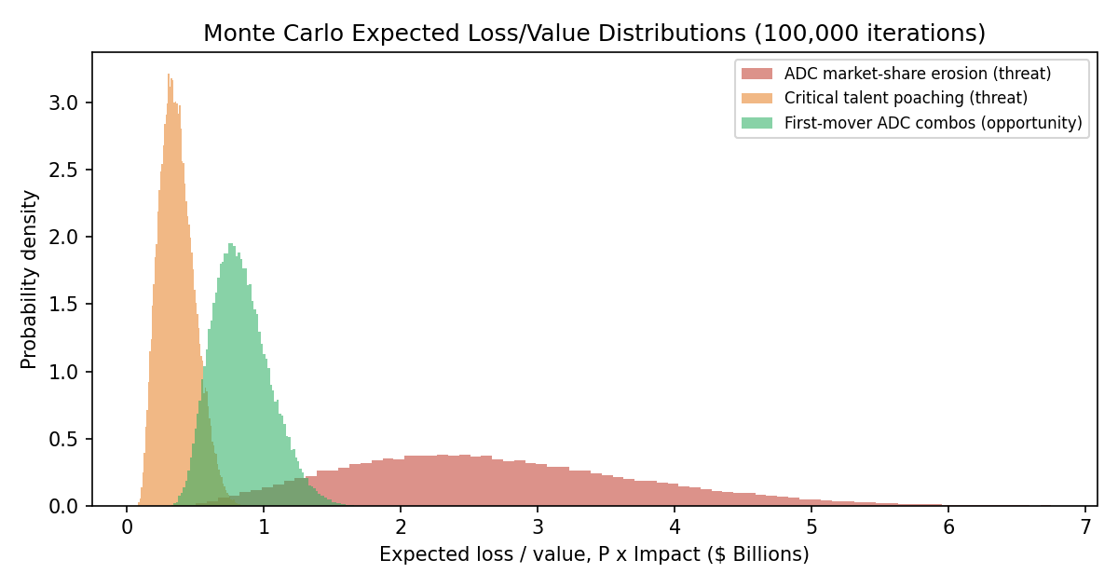
Figure 1. Monte Carlo expected loss/value distributions (100,000 iterations; full code in appended notebook).

References
Committee of Sponsoring Organizations of the Treadway Commission. (2017). Enterprise risk management: Integrating with strategy and performance. AICPA.
Fleisher, C. S., & Bensoussan, B. E. (2015). Business and competitive analysis: Effective application of new and classic methods (2nd ed.). Pearson FT Press.
Grabo, C. M. (2004). Anticipating surprise: Analysis for strategic warning. University Press of America.
Hubbard, D. W. (2020). How to measure anything: Finding the value of intangibles in business (3rd ed.). Wiley.
Munos, B. (2009). Lessons from 60 years of pharmaceutical innovation. Nature Reviews Drug Discovery, 8(12), 959–968.
Pfizer Inc. (2023). Pfizer completes acquisition of Seagen [Press release].
Vose, D. (2008). Risk analysis: A quantitative guide (3rd ed.). Wiley.

