**Supplementary Material**

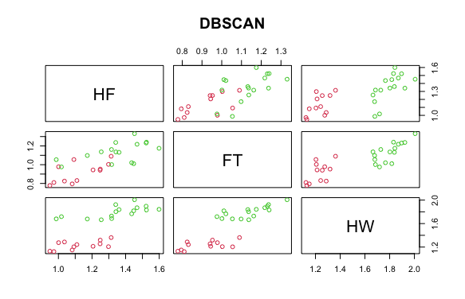

*Macrotermes gilvus*

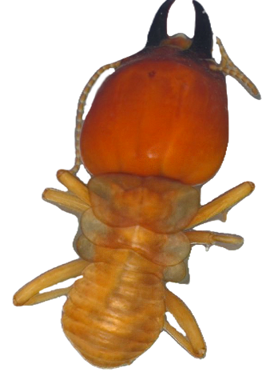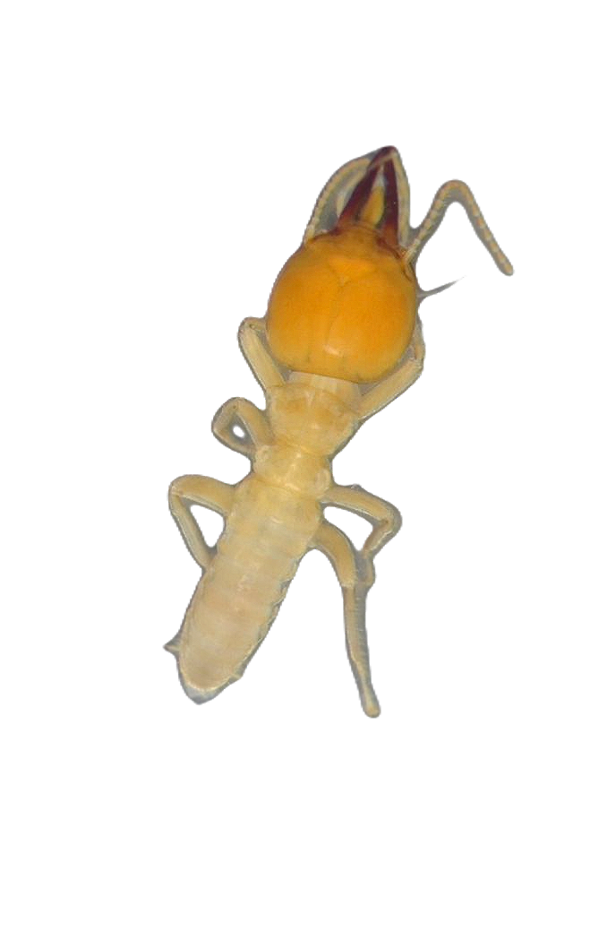

1mm

1mm

Supplementary Figure 1: A plot from DBscan showing how the morphometric traits of 1) hind femur (HF) 2) front tibia (FT) 3) head width (HW) are utilised to predict the number of morphs in a species. This shows two distinct clusters signifying *Macrotermes gilvus;* small soldiers (left of plots, red) and large soldiers (right of plots, green)