Student Name: Lewis Setter [Senior]

Date: 8/27/2018

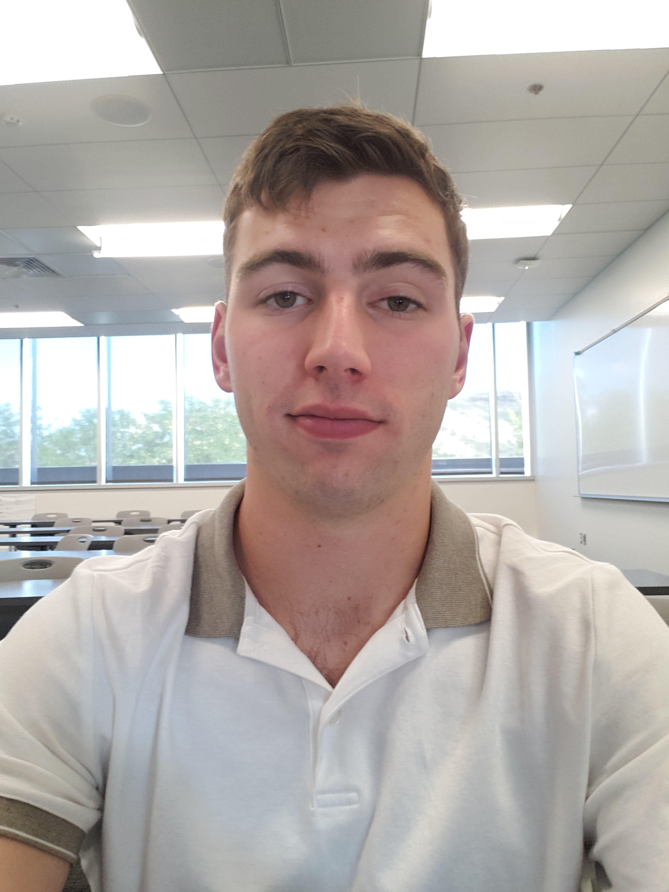

My name is Lewis. I am a senior in electrical engineering. I am starting on a combined non-thesis masters this year as well. My acedmic intrests include algorithms and wireless electronics.

One of the things I like to do outside of class is rugby. I started in highschool after quiting football and basketball and have played for the Mines club team each uear that I have been in school.

For the time being, my plans for when I leave school are to begin developing 5G applications. I want to consider positions of leadership as well.