Energy and Hygrothermal Performance of Cross Laminated Timber Single-Family Homes Subjected to Constant and Variable Electric Rates

Lewis Setter, Eric Smoorenburg, Sajith Wijesuriya, Paulo Tabares-Velasco*

Department of Mechanical Engineering

Colorado School of Mines, Golden, USA

# Abstract

Cross Laminated Timber (CLT) is a panelized mass timber product suitable for sustainable building construction that can reduce building energy use and cooling electricity peak demand. Previous studies have shown that CLT has a market in the US for tall commercial buildings. However, most of the current CLT literature has failed to consider application in residential construction. Residential building energy use is highly susceptible to weather. Thus, it has the potential to benefit from using CLT as the envelope material given its natural massiveness and enhanced air-tightness. Furthermore, the construction advantages of CLT make it a candidate for rapidly growing residential areas. This study numerically analyzes potential energy savings when CLT is implemented in a single-family home in different US climates. A typical new light frame stud construction home is compared against the same house implemented with a CLT construction. The effects of increased thermal mass and reduced infiltration are taken into account in order to determine the impact of CLT on energy consumption. This study also considers the use of variable thermostat setpoints to introduce precooling strategies with the objective of reducing cooling electricity energy cost when time-of-use electricity rates are available. In addition, this study examines temperature and humidity changes in CLT homes using WUFI software platform, a wall assembly simulator used to analyze thermal and moisture changes. The thermal changes throughout the wall assemblies indicate the insulation performance of CLT, as well as ensure that the CLT assembly is physically practical, meaning that there is no moisture or humidity accumulation that can lead to rot or mold.

# 1. Introduction

Mass timber construction has recently seen worldwide interest and increased use due to its multiple advantages over traditional construction. Its benefits include structural robustness and high level of pre-fabrication[1]. Another important facet of mass timber construction is that timber buildings have been shown to have low global warming potential (GWP) compared to mineral based buildings, with cross laminated timber (CLT) capable of obtaining the lowest GWP of timber structures [new 2]. CLT is a panelized timber product that has established itself as a viable and environmentally friendly building technology in Europe and is seeing increased use in the rest of the world [2, 3]. It has widespread applications in medium rise to high rise buildings and provides numerous benefits such as modular construction, dimensional stability that decrease the overall construction time, and has superior fire performance to other building construction systems [4, 5] [6]. These benefits have created an opportunity for CLT to be used in rapidly growing urban areas where ease of construction is must.

Unlike in Europe, CLT is not yet widely used in the United States despite current literature paving the way for the implementation of CLT. Most of the research being done with CLT is targeted at medium and high-rise buildings. Pei et al, for instance, found that the economically viable market in the US is between 8~20 stories [7]. Even though research on CLT in medium and low-rise building applications has increased in the US, research on the use of CLT in single-family homes buildings lacks attention. Previous studies have evaluated the overall construction cost of building a single-family home using CLT and have estimated the construction cost of CLT single-family homes to be about 20% higher than comparable stud frame homes [8]. However, such studies have failed to numerically analyze the impact of energy use and/or hygrothermal performance on the feasibility of CLT constructions.

The previous results regarding high-rise CLT buildings suggest that single-family homes could also make use from many of the benefits that CLT offers [9]. One of the benefits of working with CLT is reduced air leakage due to improved construction methods. CLT single-family homes could prove more energy efficient than light wood stud frames constructions by providing tighter control of airflow in and out of a building**.** High thermal mass gives rise to another set of benefits for CLT buildings. Given the susceptibility of single-family homes to weather, the additional thermal mass of CLT panels could aid in regulating the indoor climate. By storing sensible heat, CLT creates an opportunity to control a built environment with reduced heating and cooling energy [10]. Generally, homes in the U.S. have low thermal mass. Hence, they exhibit low storage potential [11, 12]. In a similar manner to how phase change materials operate [13], a combination of thermal mass characteristics and programmable thermostats which cool the house during off-peak can store cooling energy and reduce the cooling electricity requirement during peak use. Studies with phase change materials achieve energy cost savings up to 25% [14, 15] [16]. One caveat of this comparison is that since PCMs store thermal energy in the form of both the latent heat and sensible heat, the storage capacity of CLT is expected to be lower than PCMs since CLT is only able to store thermal energy in the form of sensible heat. Even so, the operating principles are similar enough to expectations of reasonable energy savings for CLT single-family homes.

Although CLT has the potential to reduce energy costs for a single-family home, CLT panels in a single-family home will be more susceptible to the environment than CLT panels in a mid-rise building. This makes the hygrothermal performance of these buildings unclear. When designing and constructing mass timber buildings, engineers and architects must consider the long term hygrothermal performance of CLT. Its performance structurally, thermally, and in terms of fire resistance are all closely related to moisture content and relative humidity. Previous research has found that CLT offers less air permeability and has a greater capacity for storing humidity in comparison to light-weight timber construction [17]. High relative humidity leads to the risk of mold growth on wood-based construction products, including CLT. In wooden constructions, the surface relative humidity levels must be lower than 70% to prevent mold growth and rot.[L] However, most lumber used in CLT panel assemblies is processed in accordance with ANSI/APA PRG 320, restricting relative humidity level below 65% at 68˚F. [was 22]

Along with the risk of mold growth is the risk of losing strength and stiffness of the panel. Previous work has shown that moisture content caused by a relative humidity above 65% can reduce the stiffness in CLT [18]. Thus, it is in the scope of this study to understand the wet and dry process and the long-term moisture content in the key components of the multilayer mass timber constructions within CLT single-family homes. This must take place across several climates in order to effectively assess the durability of these constructions. Additionally, it is necessary to determine whether the CLT homes in this study are feasible from a hygrothermal standpoint in both a constant setpoint and variable setpoint scenario.

The objective of this study is to investigate the roles of thermal mass and reduced infiltration in thermal performance CLT homes compared to typical wood stud frame constructions in three different climate zones in the United States. The contributions of this study are: (1) quantification of the benefits of thermal mass and reduced infiltration has on building energy use, (2) energy cost analysis for a combined strategy that includes precooling with a variable set-point schedule, CLT, and time-of-use residential electric plans and (3) hygrothermal analysis of CLT assembly when subjected to a constant and variable setpoints to determine the long term feasibility of CLT in a single-family home provided the conditions of the energy performance models.

# 2. Methodology

The study compares the performance of a CLT home compare to a wood stud frame home in Sacramento, Phoenix and Boston. It combines building energy and hygrothermal software:

* Building Energy Optimization (BEopt) version 2.5 to create models of single-family homes. BEopt performs annual building energy simulations using EnergyPlus as the simulation engine and can also perform parametric or optimization analyses using a sequential search optimization technique to find cost-effective energy packages [20] (Christensen, Anderson et al. 2006). EnergyPlus is a whole building energy simulation program, which uses an integrated, simultaneous solution approach to solve for different heat transfers processed in and out of the built environment
* WUFI Pro version 6.2 to perform hygrothermal simulation of the exterior walls, attic and second level floor. WUFI Pro is a 1D software that takes an assembly and runs an hourly hygrothermal analysis on it based on given initial conditions and changes in the temperature, humidity, and overall climate on both sides of the assembly. Review of data from WUFI helps to determine the thermal and hygrothermal integrity of many different types of assemblies in many different climates.

These two softwares and the overall methodology of the study are described below and in Figure 1.

1. Energy analysis with constant setpoint

This step compares energy use for a CLT home with a reference that represents a typical single-family home based on NREL House Simulation Protocols [19].This step also analyzes the role infiltration has on CLT constructions by simulating a CLT home with its infiltration raised to the same level as a typical home.

1. Energy analysis with variable setpoint

This step analyzes the ability of CLT homes to reduce energy cost when variable electricity rates are available. This occurs by introducing variable cooling setpoints into the homes in the simulations and comparing the results in the CLT and reference cases.

1. Long term hygrothermal analysis

The third step analyzes and assess the impact that precooling has on the hygrothermal performance of CLT over a three-year period under the conditions generated during the steps 1 and 2. This study looks into the humidity and temperature in the CLT wall, floor, and attic assemblies over a three-year period.

The data flow in this study is as follows:

1. BEopt generates models of the reference home, the low infiltration CLT home, and the high infiltration CLT home for both constant and variable cooling setpoint schedules.
2. EnergyPlus uses the models from BEopt along with TMY3 weather files as inputs and produces hourly energy data for a one-year period as an output.
3. A Python script uses the variable setpoint EnergyPlus simulation data to calculate annual energy use with time-of-use price schedules.
4. WUFI Pro uses the CLT construction assembly properties, the EnergyPlus predicted indoor air temperature and relative humidity, and WUFI/ASHRAE weather data inputs to produce hourly hygrothermal data for a three-year period as an output.
5. Final post-processing of hygrothermal data is done in MATLAB and Excel.

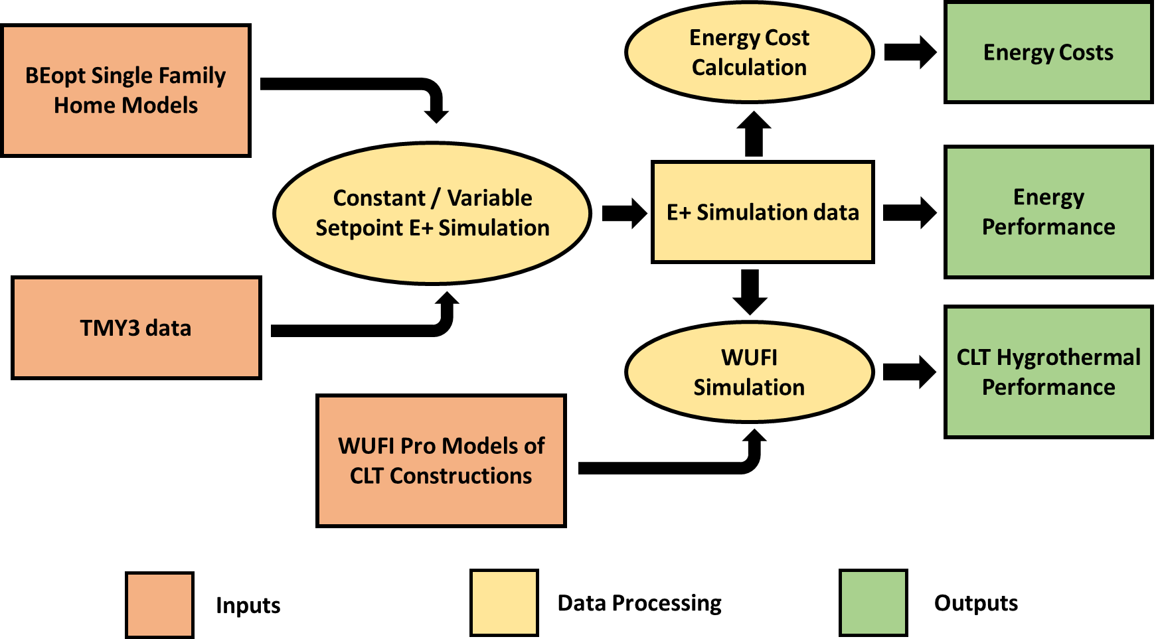

Figure 1: Data flow between software packages and final analysis

## 2.1. Building Description

All simulated homes are based on a reference building depicted in Figure 2 and defined by the NREL House Simulation Protocols that meet 2009 IECC code [21] The house has a conditioned area of 232 m2, a garage, slab-on-grade, and an unconditioned attic with the following characteristics:

* Cooling set-point of (76 °F)
* Heating set-point of (71 °F)
* Electric air conditioner rated at SEER 13
* Natural gas heater rated at 78% AFUE
* Natural ventilation allowed 7 days a week throughout the year

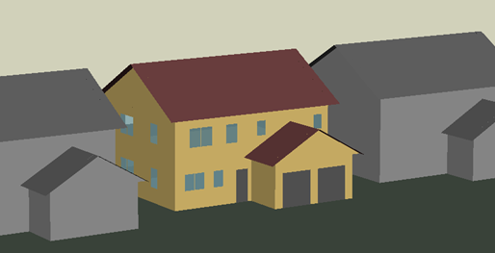

Figure 2: A rendering of the BEopt model of the single family home in question

Table 1 Table 1compares the envelope systems of each simulated CLT homes. CLT envelopes are modified versions of the reference home.

|  |  |  |  |
| --- | --- | --- | --- |
| Parameter | Reference Home | CLT Home with High Infiltration | CLT Home with Low Infiltration |
| Exterior wall structural material | 90x40 mm (2x4 in) studs, with fiberglass insulation | 105 mm (4⅛ in) 3 ply CLT | 105 mm (4⅛ in) 3 ply CLT |
| Second floor structural material | 240x40 mm (2x10 in) studs | 178 mm (7 in) 5 ply CLT | 178 mm (7 in) 5 ply CLT |
| Roof structural material | 240x40 mm (2x10 in) studs | 105 mm (4⅛ in) 3 ply CLT | 105 mm (4⅛ in) 3 ply CLT |
| Exterior sheating | OSB | XPS | XPS |
| Infiltration | 7 ACH50 | 7 ACH50 | 2 ACH50 |

Table 1: Comparison between the reference home and the CLT home [18].

Table 2 compares the thermal storage potential (kWh/K) of the reference CLT home. Reference homes only considers the drywall as potential thermal storage while CLT homes considers drywall and CLT panels. CLT can potentially provide 2.5-4 times more thermal storage than traditional wood-stud walls.

|  |  |  |  |  |
| --- | --- | --- | --- | --- |
|  |  | **Thermal Mass (kWh / K)** | | |
|  | **Surface Area (m2)** | **Reference Home** | **3Ply CLT Home** | **5Ply CLT Home** |
| Partition Walls | 232 | 1.1 | 7.2 | 12.2 |
| Interzonal Walls/Floors | 53 | 0.14 | 1.6 | 2.8 |
| Exterior Walls | 182 | 0.71 | 5.6 | 9.6 |
| Ceilings | 232 | 0.55 | 7.2 | 12.2 |
| Floors | 213 | 5.9 | 6.6 | 11.2 |
| Furniture | 93 | 3.1 | 2.9 | 4.9 |
| Total | ~ 1000 | ~ 12 | ~31 | ~53 |

Table 2: Summary of surface area and sensible thermal mass for various components in the living zone.

CLT thermal properties used in EnergyPlus are a thermal conductivity of 0.12 W/m K (0.83 Btu in/h ft2 F), a specific heat of 1590 J/kg C (0.38 Btu/lb-F), and a density of 560 kg/m3 (35 lb/ft3) [8].

*Hygrothermal simulations*

The hygrothermal analysis on the CLT homes focus on wall, attic, and second level floor, (the assemblies that contained CLT) having the same thickness in all three regions. All simulations started on January 1st.

Figure 3 shows the CLT wall assembly, from left (exterior) to right (interior): the exterior is made of composite wood panels, followed by an air gap, exterior polystyrene insulation, a weather resistive barrier (WRB), the 3-ply CLT panel and interior gypsum board.

Figure 4 shows the CLT floor assembly from left to right, which is equivalent to top to bottom, respectively: laminate flooring, underlay, an oriented strand board (OSB), the 5-ply CLT panel, and finally a gypsum board for the ceiling. The laminate flooring is the floor of the second level of the house and the gypsum board is the ceiling of the first level of the house.

Figure 5 shows the CLT attic assembly, from left to right, which is equivalent to top to bottom, respectively: with R5 cellulose insulation, 5-ply CLT panel, followed by a gypsum board for the bottom/ceiling. All hygrothermal properties come from the WUFI database.

The orientation of the analyzed wall assembly is based on the direction from which the rain comes from most often to test the surface enduring the most wind and rain in the respective regions. The analyzed wall orientations are as follows:

* Phoenix: East
* Sacramento: South-East
* Boston: North-East

In addition, the initial relative humidity of the wall assembly is set to 80%. A 1% water infiltration from rainfall exists just behind the WRB to see if it is still capable of drying throughout the years even if the WRB is breached. The interior climate data used in the WUFI hygrothermal analysis simulations are from the low infiltration BEopt model. It should be noted then that homes with good ventilation and properly finished surfaces are at less of a risk of high mold growth [new 22].

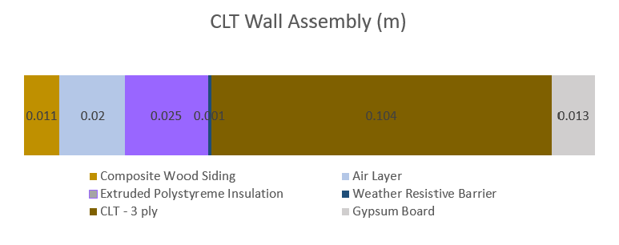

Figure 3: Cross Section of CLT Exterior Wall Assembly

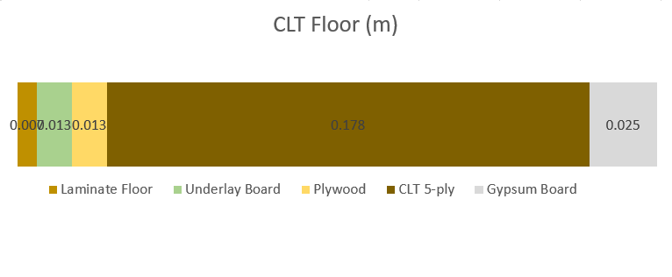

Figure 4: Cross Section of CLT Floor Assembly

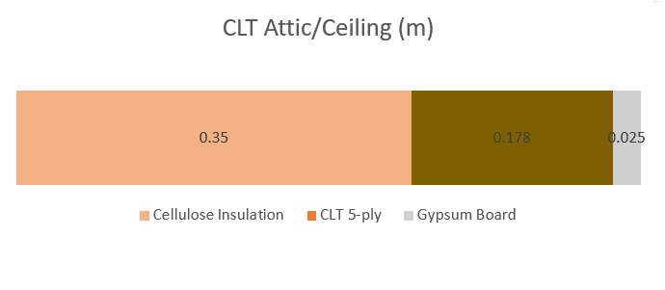

Figure 5: Cross Section of CLT Attic Assembly

*Electric rates*

For the constant setpoint analysis, Utility costs are calculated using a constant rate for both gas and electricity use. The study uses the average electricity and gas rates from each simulation location to calculate utility costs. Table 3 shows theses costs for each location [22]. The gas rates apply to home heating energy and water heating.

|  |  |  |
| --- | --- | --- |
| City | Electric Rate  $/kW-hr | Gas Rate  $/therm |
| Phoenix | 0.1218 | 1.6560 |
| Boston | 0.1981 | 1.4062 |
| Sacramento | 0.1702 | 1.1059 |

Table 3: Utility rates for every location for the constant setpoint simulations.

Table 4 provides information of the thermal mass of all the envelope components (There is no comparison between the different envelope materials though)

|  |  |  |  |  |
| --- | --- | --- | --- | --- |
|  |  | **Thermal Mass (kWh / K)** | | |
|  | **Surface Area (m2)** | **Reference Home** | **3Ply CLT Home** | **5Ply CLT Home** |
| Partition Walls | 232 | 1.1 | 7.2 | 12.21 |
| Interzonal Walls/Floors | 53 | 0.14 | 1.64 | 2.79 |
| Exterior Walls | 182 | 0.71 | 5.65 | 9.58 |
| Ceilings | 232 | 0.55 | 7.2 | 12.21 |
| Floors | 213 | 5.9 | 6.61 | 11.21 |
| Furniture | 93 | 3.1 | 2.89 | 4.90 |
| Total | ~ 1000 | ~ 12 | ~31 | ~53 |

Table 4: Summary of surface area and sensible thermal mass for various components in the living zone.

## 2.2. Pre-cooling Strategies

To calculate cost for the variable setpoint simulations, the study uses time of use (TOU) plans provided by electrical utilities in each city. Gas rates remain the same as in the constant setpoint simulation. Phoenix uses the E-21 Super Peak TOU price plan from the Salt River Project, Sacramento uses the Residential TOU Option 1 price plan from the Sacramento Municipal Utility District, and Boston uses NSTAR’s Boston Edison Co. Optional Residential TOU price plan. Table 5, Table 6, and Table 7 describe the price plans in detail.

|  |  |  |
| --- | --- | --- |
| Electric Rate  (USD/kWh) | Months | Period |
| 0.297 | May – Jun, Sep – Oct | 3 PM – 6 PM |
| 0.082 | May – Jun, Sep – Oct | 6 PM – 3 PM |
| 0.350 | Jul – Aug | 3 PM – 6 PM |
| 0.084 | Jul – Aug | 6 PM – 3 PM |
| 0.123 | Jan – Apr, Nov – Dec | 3 PM – 6 PM |
| 0.075 | Jan – Apr, Nov – Dec | 6 PM – 3 PM |

Table 5: Annualized TOU rate for Phoenix, E-21 Super Peak TOU Rate

|  |  |  |
| --- | --- | --- |
| Electric Rate  (USD/kWh) | Months | Period |
| 0.111 | Jan – May, Oct – Dec | 8 AM – 11 AM  7 PM – 10 PM |
| 0.103 | Jan – May, Oct – Dec | 11 AM – 7 PM  10 PM – 8 AM |
| 0.244 | Jun – Sep | 3 PM – 10 PM |
| 0.115 | Jun – Sep | 10 PM – 3 PM |

Table 6: Annualized TOU rate for Sacramento, Residential TOU Option 1

|  |  |  |
| --- | --- | --- |
| Electric Rate  (USD/kWh) | Months | Period |
| 0.133 | Jan – May, Oct – Dec | 10 PM – 9 AM |
| 0.236 | Jan – May, Oct – Dec | 9 AM – 10 PM |
| 0.134 | Jun – Sep | 5 PM – 8 AM |
| 0.312 | Jun – Sep | 8 AM – 5 PM |

Table 7: Annualized TOU rate for Boston, Boston Edison Co. Optional Residential TOU

Suitable pre-cooling techniques for similar building models have been previously studied for Phoenix, Arizona using PCMs as the Thermal Energy Storage (TES) technique [Brandt, 2015]. Hence, the precooling setpoints used in this study are the same as in the previous study. In Phoenix and Sacramento, the cooling setpoint is reduced to 19 °C (67 °F) for 5 hours leading up to peak pricing and then raised to 26 °C (78 °F) for the entirety of peak pricing before being lowered back to typical value of 24 °C (76 °F). In Boston, the cooling setpoint is raised from 24 °C (76 °F) to from 9:00AM to 4:00PM. Figure 6 shows the setpoints used in each location.

Figure 6: Summer cooling setpoint for Phoenix, Sacramento, and Boston with peak pricing in blue

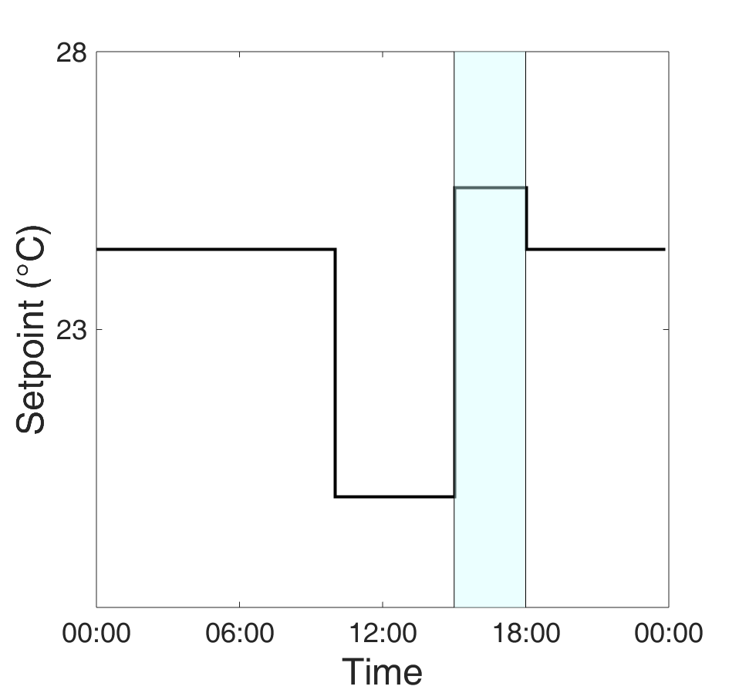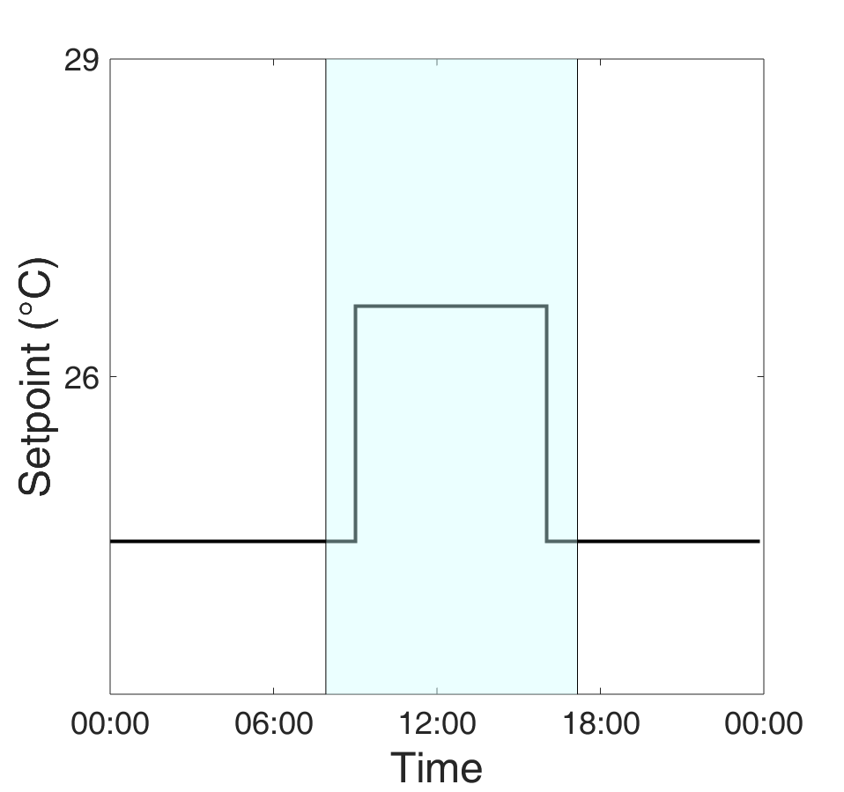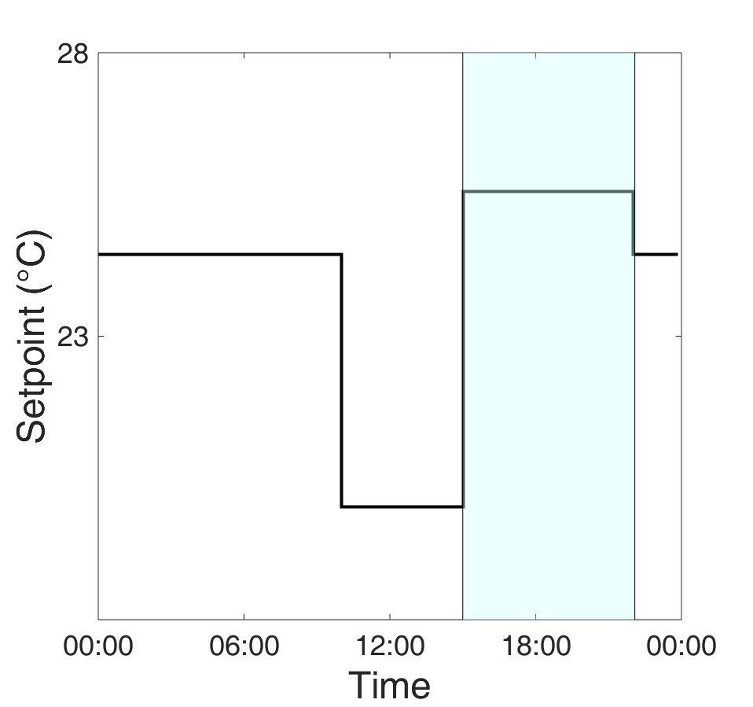

Phoenix

Sacramento

Boston

# 3. Results

## 3.1. Constant Setpoint Analysis

Table 7 displays the annual energy costs for the reference home and the CLT home with low infiltration (2 ACH50 infiltration) for each city. Table 8 also shows relative cost reduction alongside the annual costs of heating energy and cooling energy. CLT reduces energy related cost by up to 18%.

|  |  |  |  |
| --- | --- | --- | --- |
|  | Reference Home Energy Cost (USD) | CLT, 2 ACH50 Home Energy Cost (USD) | Cost Reduction |
| **Phoenix** |  |  |  |
| Total | $1,980 | $1,770 | 11% |
| Heating | $191 | $120 | 37% |
| Cooling | $610 | $510 | 15% |
| **Boston** |  |  |  |
| Total | $3,400 | $2,780 | 18% |
| Heating | $1,440 | $930 | 36% |
| Cooling | $70 | $55 | 20% |
| **Sacramento** |  |  |  |
| Total | $2,140 | $1,930 | 10% |
| Heating | $540 | $400 | 26% |
| Cooling | $96 | $67 | 30% |

Table 8: Annual total energy cost, heating energy cost, and cooling energy cost in all three analyzed cities.

The results of the constant setpoint analysis suggest that CLT constructions reduce the annual energy cost for heating and cooling in both hot, warm, and cold climates. Furthermore, energy cost reduction in cold climates greatly exceeds cost reduction in other climates. CLT reduces the annual heating cost in Boston by 36%, equating to a savings of about 500 USD in the cooling category alone. In Phoenix, the hottest climate, CLT reduces the annual cost of heating by 15%. However, this only amounts to a savings of 100 USD on heating energy.

Figure 7 the shows how the energy cost patterns from Table 8 can be attributed the different characteristics of the CLT single-family homes. It plots the sensible heating rate during the coldest day of year in each location and the sensible cooling rate during the hottest day of the year over their respective 24-hour periods in each city.

Figure 7: Sensible heating and cooling loads in Boston, Phoenix, Sacramento

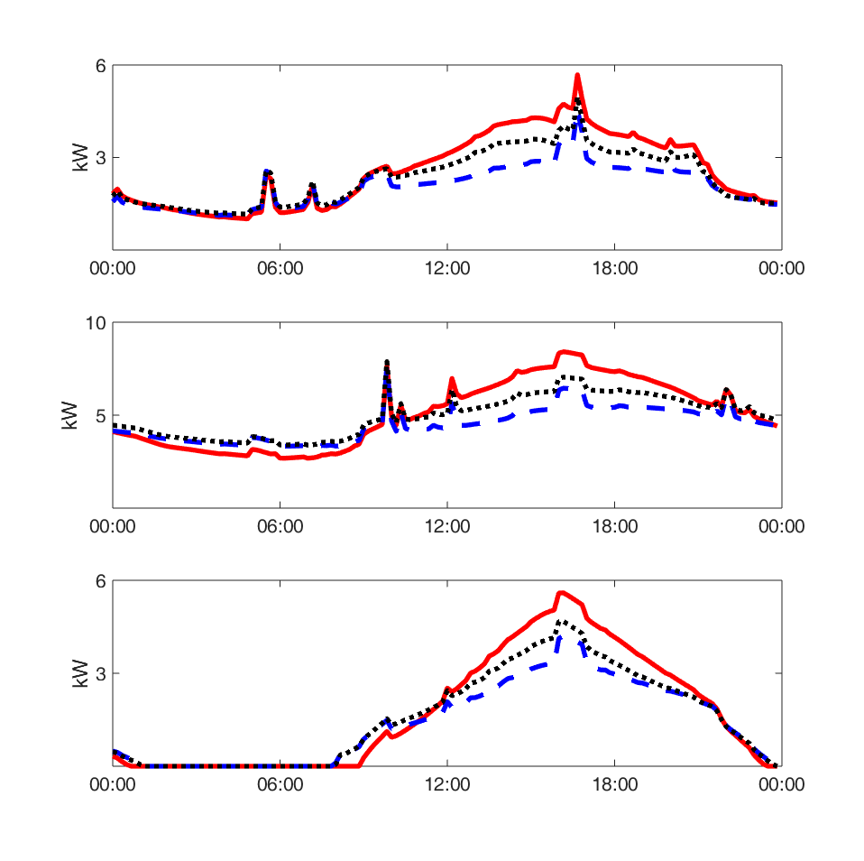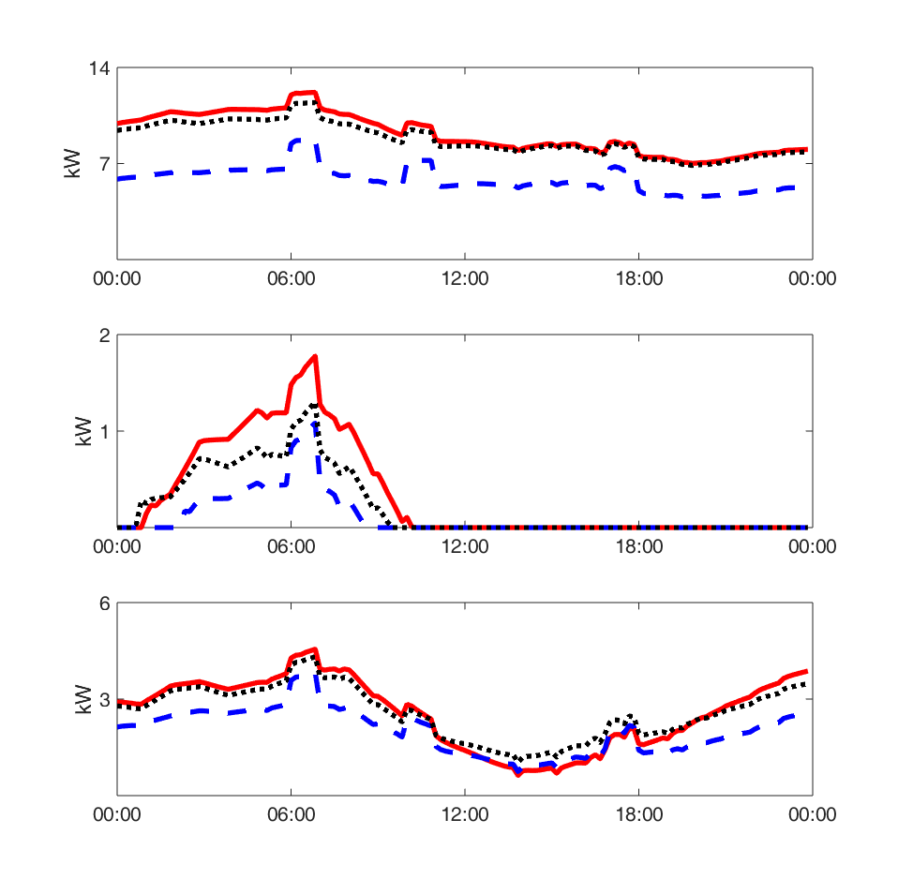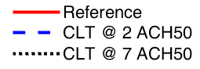

**Sensible Heating Load Over the Coldest Day in of the Year**

**Sensible Cooling Load Over the Hottest Day of the Year**

Phoenix

Phoenix

Boston

Boston

Sacramento

Sacramento

The sensible heating rate plots suggest that the improved heating performance of the CLT homes is almost entirely attributable to reduced infiltration. In Boston, the coldest city, the CLT home with a high infiltration reduces heating energy by only 4% compared to the reference home, as opposed to 36% for the low infiltration CLT home. Given the high cost of CLT constructions, this result suggests that air tightening retrofit solutions might achieve similar levels of heating energy reduction, and for a fraction of the cost. Another study, for instance, found that simple, inexpensive modifications to the envelope of a single-family home reduced the energy consumption of a single-family home by half of what the simulated CLT constructions manage [23].

The plots of sensible cooling rate show that in all 3 locations, the cooling rate of the CLT house with 7 ACH50 infiltration is about half way between the cooling rate of the reference house and that of the CLT house with 2 ACH50 infiltration during the day. However, during the night, the cooling rates of the 2 CLT models are very similar. This indicates that despite energy savings generated during the day, the added thermal mass of the CLT incurs an energy penalty because extra cooling is need at night to remove heat gained during the day from the CLT and meet the cooling setpoint. Surprisingly, however, peak cooling rate reduction is the nearly the same as annual cooling energy reduction, between 15% and 20%, despite the energy penalty. In fact, CLT reduces the cooling rate by 15% to 20% throughout the day. This suggests that energy penalty is negligible. Table 9 shows that the relationships in the heating rate and cooling rate plots are true in all three cities and lists clarifying information regarding the conditions of each city over the days appearing in the plots.

|  |  |  |  |  |  |  |
| --- | --- | --- | --- | --- | --- | --- |
| City | Reduction in Heating Energy over 24 Hours on Coldest Day | | Minimum Outdoor Temperature on Coldest Day | Reduction in Peak Electric Use Rate on Hottest Day | | Maximum Outdoor Temperature on Hottest Day |
| CLT @ 7 ACH50 | CLT @ 2 ACH50 | CLT @ 7 ACH50 | CLT @ 2 ACH50 |
| Boston | 4% | 36% | -13 °C | 10% | 17% | 37 °C |
| Sacramento | 0% | 22% | 4 °C | 12% | 19% | 40 °C |
| Phoenix | 33% | 67% | 11 °C | 10% | 16% | 43 °C |

Table 9: Reduction in Heating Energy on the coldest day of the year and reduction in peak electricity purchase rate during the hottest day of the year for all three cities.

## 3.2. Precooling Analysis

Table 10 shows the cost reduction between the reference homes and the CLT homes in Sacramento and in Boston are marginal. The variable setpoint reduced cost by 17% in Phoenix, reducing electricity costs from the reference case by 240 USD. The analysis of CLT with variable setpoint show that the use of CLT in single-family homes improves the effectiveness of precooling in both Sacramento and Phoenix and improves the effectiveness of setback in Boston.

Here explain table 9

|  |  |  |  |
| --- | --- | --- | --- |
|  | Sacramento | Phoenix | Boston |
| Reference | $ 1,010 | $ 1,310 | $1,270 |
| CLT | $ 970 | $ 1,080 | $1,210 |
| Electricity Cost Reduction | 4% | 17% | 5% |
| Peak Cooling Reduction | 45% | 33% | 31% |

Table 10: Annual electricity cost in all three cities using a variable cooling setpoint

Despite the low energy cost savings in Sacramento and Boston, CLT reduces the peak cooling energy by 30% or more in all three cities. Figure 8 shows indoor air temperature, the interior surface temperature of the exterior walls, and the purchased electricity rate during the hottest day of the year for each analyzed building and location

.

*Electricity Purchase Rate*

*Exterior Wall Temperature*

*Indoor Temperature*

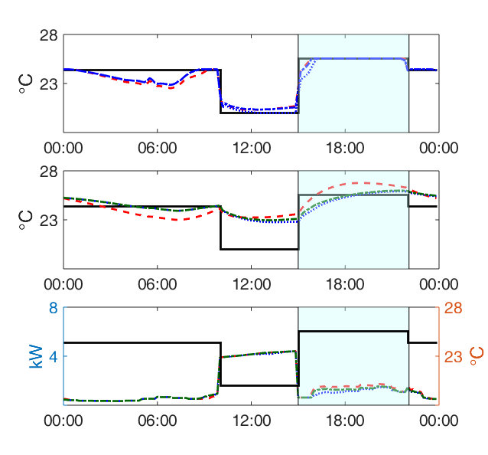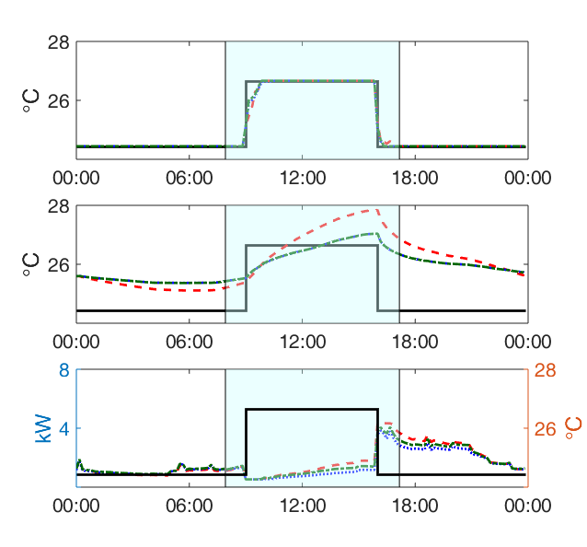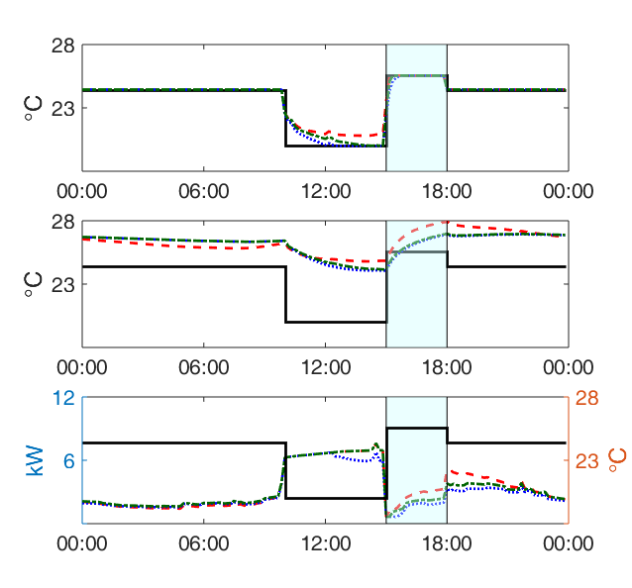

*Electricity Purchase Rate*

*Exterior Wall Temperature*

*Indoor Temperature*

*Electricity Purchase Rate*

*Exterior Wall Temperature*

*Indoor Temperature*

***Phoenix***

***Sacramento***

***Boston***

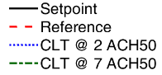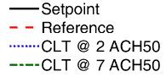

Figure 8: Indoor temperature, wall temperature, and purchased electricity in the three cities over a 24 hour period during the hottest day of the year

The variable setpoint simulations show that CLT homes cool down both faster and to a lower temperature than the reference homes, indicating the precooling potential of the CLT homes. This is due to the air tightness of the CLT constructions. The simulations further show that the CLT walls are less prone to temperature swings than the wood stud frame walls and can decrease in temperature for a longer period. Because these properties, the CLT homes reduce the purchased electricity rate during peak hours. In Phoenix, the warmest location, electricity costs during peak hours are 10% lower in the CLT home than in the reference home. Another benefit that the CLT homes experience is that there is a significantly smaller spike in the electricity demand at the end of the setback period.

## 3.3. Hygrothermal Simulation

Figure 9, Figure 10, and Figure 11 illustrate the relative humidity of the CLT panel in the wall over a three-year period for each region. The red line plots the relative humidity in the CLT panel closest to the interior of the house (interior side). The blue line graphs the relative humidity in the middle of the CLT panel (mid side). The green line graphs the relative humidity in the CLT panel closest to the exterior climate (exterior side). For all following graphs, the y-axis represents the relative humidity while the x-axis is the time in 6-month intervals, starting with January 1st. The relative humidity in the CLT panel in the wall for both base case (a) and the precooling (b) are displayed for each region.

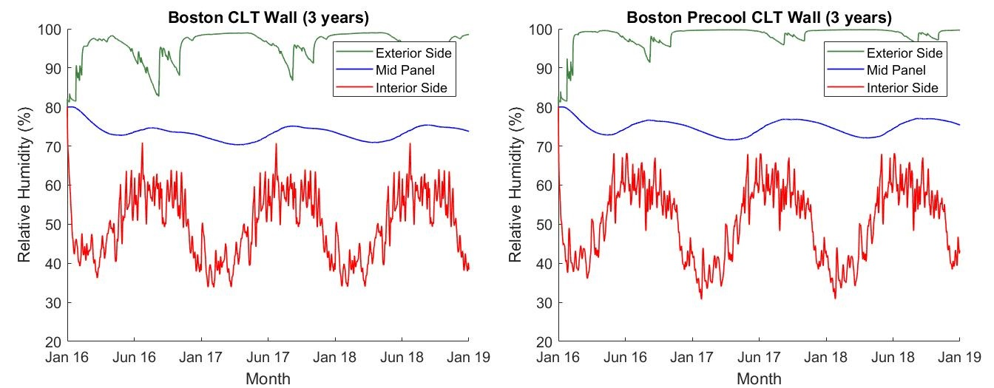 a) b)

Figure 9: CLT panel relative humidity of Boston for a) base case with constant setpoint and a) variable setpoint precooling the home

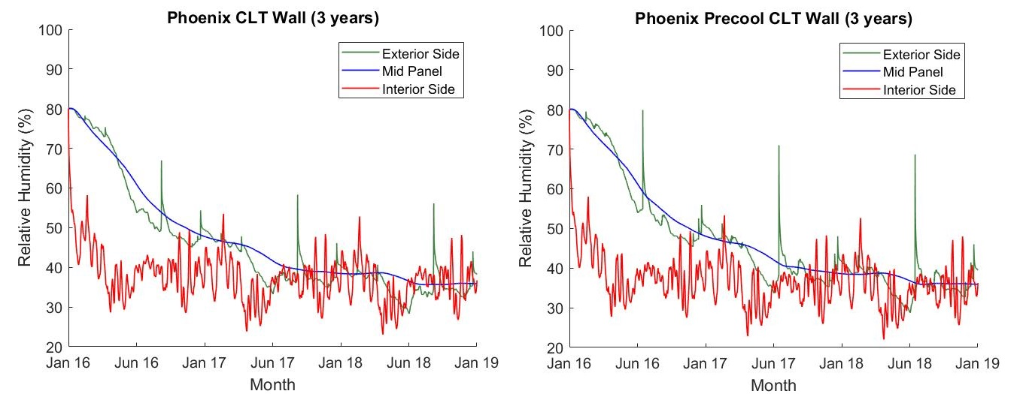

a) b)

Figure 10: CLT panel relative humidity of Phoenix for a) base case with constant setpoint and a) variable setpoint precooling the home

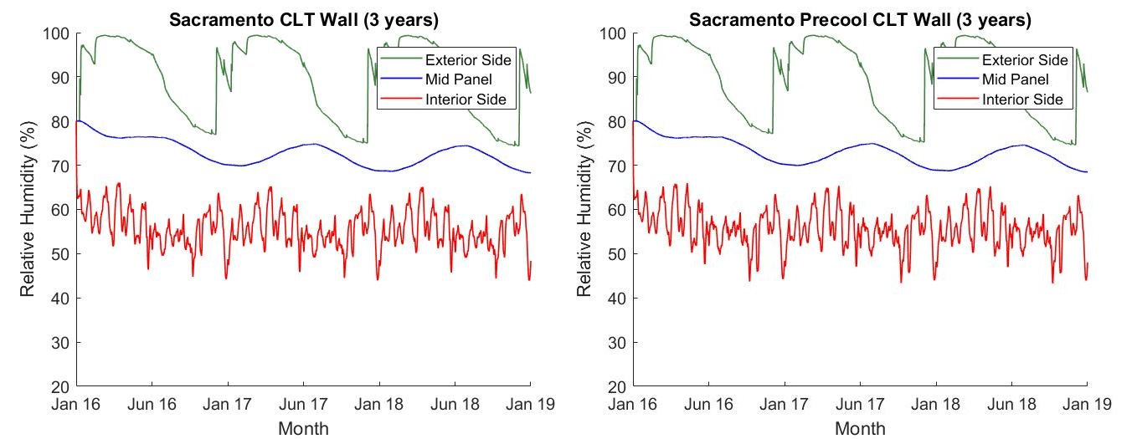

1. b)

Figure 11: CLT panel relative humidity of Sacramento for a) base case with constant setpoint and a) variable setpoint precooling the home

In Boston, displayed in Figure 9, the exterior side of the CLT panel quickly rises and stays around 100% due to rain penetrating the WRF. In both the base case and the precooling case, exterior side and mid panel have a relative humidity (RH) higher than 70%. This indicates that the majority of the CLT panel is at risk of developing rot and mold. The same can be said for Sacramento, as seen in Figure 10. Although the relative humidity for the exterior side of the panel reaches 100% for a brief period of time, it spends almost the entire year above 80% RH and about half of the year above 90% RH. Furthermore, the middle section of the panel does not see an extreme increase for either Sacramento or Boston. It fluctuates between 70% and 80% RH after the first half of the year. This indicates an increase for the risk of mold and rot. In Phoenix, Figure 11, there is a significant decrease in relative humidity for both the exterior and middle of the CLT panel. At the three years, the relative humidity of both the exterior side and middle of the panel are reduced to 35-40%. The spikes in relative humidity of the exterior side are caused by a large rain event in the weather. Due to Phoenix being in a dry region, the sudden increase in relative humidity brought on by rain quickly decreases back to its pre-rain levels.

In all cases, the interior side of the CLT panel follows the indoor relative humidity as expected. Additionally, the are no significant differences in the relative humidity on the interior side of the CLT panel between the variable and constant setpoints, indicating little change when precooling is used. The relative humidity in middle of the CLT panel is likely influenced by the relative humidity from the exterior side of the CLT panel due to the 1% rainwater infiltration on the exterior side of the CLT. With this breach, regions with more frequent rain saturate the exterior side of the CLT panel. This causes it to reach 100% relative humidity. This is the case for both Boston and Sacramento. The relative humidity of the CLT’s exterior side for these two regions never decrease below 70% as required. This is the case for houses with and without precooling. It is evident that the integrity of the CLT panels is largely dependent on the relative humidity on its exterior side toward the middle of the panel.

Figure 12, Figure 13, and Figure 14 illustrate the course of relative humidity in the CLT panels of the floor (a) and attic (b) in each region over a three year period. The green line graphs the middle of the CLT panel for both the attic and the floor. For the attic, the red line graphs the attic side of the CLT panel and the blue line graphs the ceiling side of the CLT panel, the ceiling of the 2nd story. For the floor, the red line graphs the floor side of the CLT panel, the 2nd level floor. The blue line graphs the 1st level ceiling side of the CLT panel, the ceiling of the 1st story. Graphs of the floor and attic under precooling were not included due to how similar they were to the constant setpoint base case, which is shown.

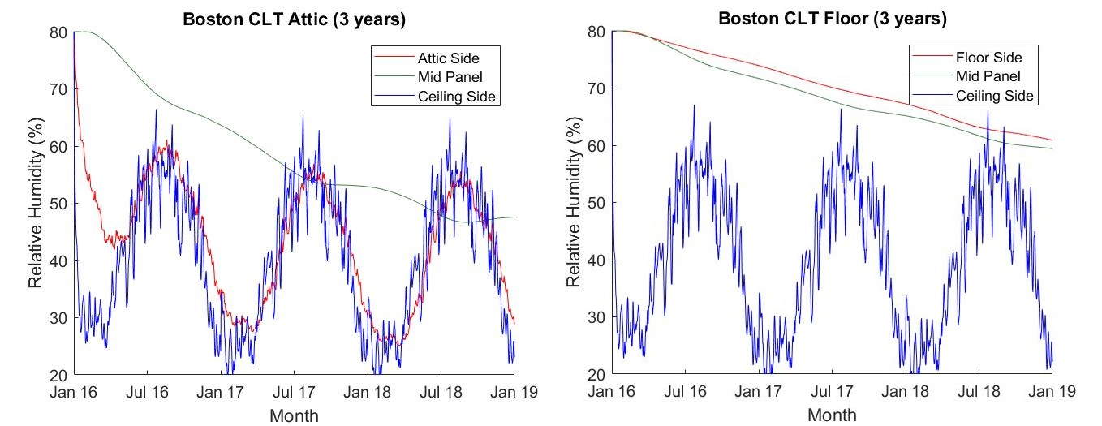

1. b)

Figure 12: Relative humidity of Boston attic CLT panel and floor CLT panel

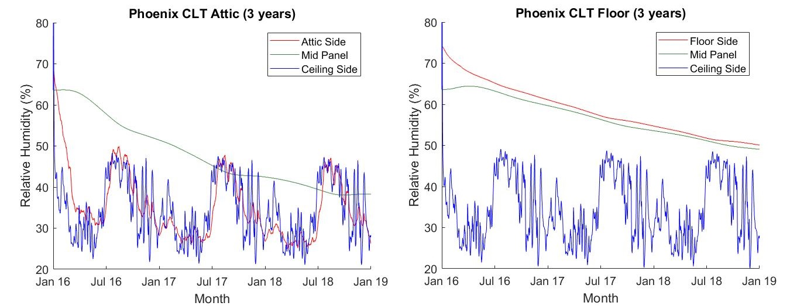

1. b)

Figure 13: Relative humidity of Phoenix attic CLT panel and floor CLT panel

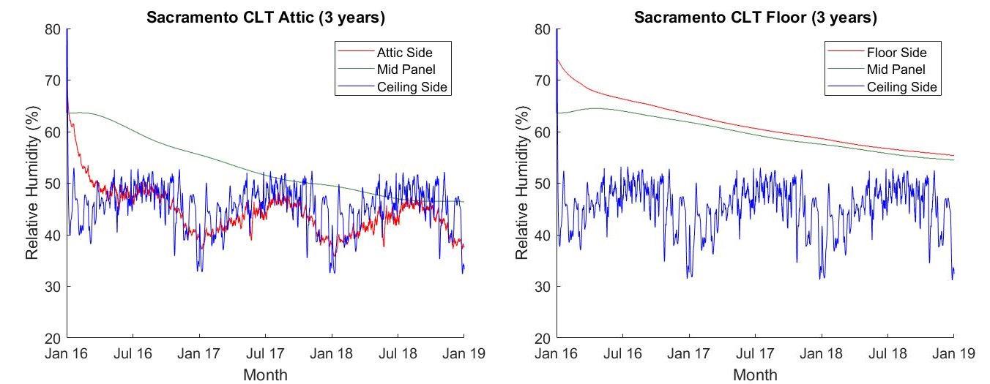

1. b)

Figure 14: Relative humidity of Sacramento attic CLT panel and floor CLT panel

It should be noted that the relative humidity at the ceiling side of the panel closely follows the interior relative humidity due to its proximity to the interior climate. This helps explain why the graph of the relative humidity of the ceiling side in the attic assembly is similar to its counterpart in the floor assembly. Regardless of climate, in the floor assembly, the floor side of the CLT panel has the highest humidity for the entirety of the simulation. Both the floor side and the middle of the CLT panel see continual reduction in relative humidity to 60% and below, but at a slow and gradual slope. This is likely due to the flooring, overlay, and OSB, which are creating a barrier that makes it harder for moisture to escape in that direction (via the floor). Finally, the CLT panel in the attic dries in an expected fashion. The rate at which the middle of the panel and the attic side of the panel is apparently dependent on the exterior climate. For example, the middle of CLT panel in Phoenix sees the greatest reduction in relative humidity while the one in Sacramento sees the least. For all climates, the mid panel RH for the attic reaches a lower RH than that of the mid panel of the floor assembly.

# 4. Conclusion

This study numerically analyzes both the annual energy performance and long term hygrothermal performance of CLT constructed single-family homes. By simulating these homes in BEopt, EnergyPlus, and WUFI, the CLT homes can be compared against standard wood frame constructions to determine the feasibility of CLT in the residential market. The conclusion of this study are as follows.

Preliminary results show that the use of CLT in the construction of single-family homes results in annual energy cost savings across all climates considered in this study, with higher savings in cold climates than in hot climates. For example, the CLT home in Boston, shows reduction in annual heating energy of 36%, and 600 USD, while the CLT home in Phoenix, shows a reduction in annual cooling energy of 17% resulting in a savings of only $100. Regardless, neither of these savings are sufficient to offset the 20% increase in construction cost of a CLT single-family home over a typical wood frame home at the current cost of CLT. However, the additional mass and increase airtightness warrants further simulations in areas of the US such as Colorado and Minnesota and with other strategies such as natural ventilation, night cooling and increase flow rate. Moreover, optimized CLT home designs should be considered by future studies to determine the most suitable environments for residential CLT buildings.

In cold climates, the analyzed homes show that reductions in heating costs are predominantly due to the infiltration decrease. In hot climates, cooling energy reduction is due to both the reduced infiltration of the CLT construction and the thermal characteristics of CLT. This occurs because the hot climates considered in this study experience low temperatures at night and cool the CLT. The cooled CLT then aids in keeping a CLT home at a comfortable temperature during the day. However, the thermal energy gained by the CLT during day needs to be removed at night by the cooling system to adequately control indoor climate. The increased nighttime cooling load helps explain why energy cost savings in hot climates are insignificant.

Precooling analysis preliminary demonstrated that CLT constructed single-family homes have the potential to benefit from precooling. The CLT homes achieved cooling energy cost savings 30-45% lower than the wood frame home in Phoenix and Sacramento, the reduction was 45%. Despite the large reduction in cooling energy during peak pricing, the CLT homes did not experience a significant reduction in annual electricity costs. The annual electricity cost of the CLT home in Phoenix was only 17% lower than the corresponding wood stud home. Even though CLT shows promise for benefiting from precooling, it is unlikely that even an optimized setpoint schedule would create enough energy cost savings to offset construction costs at the current cost of CLT.

The integrity of the CLT panels depend heavily on the state of the WRB and the climate that the CLT house is located in. The CLT fares well and quickly dries to safe levels, well below 70% relative humidity, when used to build a house in a climate that is dry and devoid of frequent rain, even if the WRB has been breached or if the CLT has been in some way been exposed water. When CLT is used in more humid climates and climates with more rainfall, then it is imperative that the WRB does not fail. Exposure to a water source can saturate half of the CLT panel, bringing its relative humidity levels to 100% and encourage the growth of mold and rot, placing the CLT’s structural integrity at risk. This study also discovered that the relative humidity in the interior of the house does not greatly affect the CLT panel, unless that relative humidity has a considerable range. A CLT house with a precooling system displayed no significant differences in terms of drying and relative humidity when compared to a CLT house without a precooling system.

The results of this study demonstrate that the potential of CLT as a viable construction material in the construction of single-family homes warrants further studies on a case-specific basis. This is especially important if the cost of CLT construction falls relative to the cost of other construction methods. Furthermore, this study reveals that CLT is a potential candidate for homes which can take advantage of time of use electric rates by implementing a variable setpoint schedule. The maximum possible savings the CLT homes can achieve in a precooling scenario is a point for future research.

# 5. References

1. Mallo, M.F.L. and O.A. Espinoza, *Outlook for cross-laminated timber in the United States.* BioResources, 2014. **9**(4): p. 7427-7443.

2. Harris, R., *Cross laminated timber.* Wood composites. Cambridge: Woodhead Publishing, 2015: p. 141-67.

3. Chen, Y., *Comparison of environmental performance of a five-storey building built with cross-laminated timber and concrete.* Sustainable Building Science Program, University of British Columbia-Department of Wood Science, Vancouver, BC, Canada, 2012.

4. Karacabeyli, E. and B. Douglas, *CLT: Handbook Cross-laminated Timber*. 2013: FPInnovations.

5. Ceccotti, A., *New technologies for construction of medium-rise buildings in seismic regions: the XLAM case.* Structural Engineering International, 2008. **18**(2): p. 156-165.

6. Buchanan, A.H., *Fire performance of timber construction.* Progress in structural engineering and materials, 2000. **2**(3): p. 278-289.

7. Pei, S., et al., *Progress on the development of seismic resilient Tall CLT Buildings in the Pacific Northwest.* 2014.

8. Burback, B., *Potential of cross laminated timber in single family residential construction*. 2016: Colorado School of Mines.

9. Štefko, J. and J. Bednár. *Wood Based Building Envelope Regarding Air Tightness*. in *Key Engineering Materials*. 2016. Trans Tech Publ.

10. Arababadi, R. and K. Parrish, *Modeling and Testing Multiple Precooling Strategies in Three Residential Building Types in the Phoenix Climate.* ASHRAE Transactions, 2016. **122**(2).

11. Dexter, M.E., *Energy conservation design guidelines: including mass and insulation in building walls.* ASHRAE Journal, 1980. **22**(3): p. 35-38.

12. Turner, W., I. Walker, and J. Roux, *Peak load reductions: electric load shifting with mechanical pre-cooling of residential buildings with low thermal mass.* Energy, 2015. **82**: p. 1057-1067.

13. Konstantinidou, C.A., W. Lang, and A.M. Papadopoulos, *Multiobjective optimization of a building envelope with the use of phase change materials (PCMs) in Mediterranean climates.* International Journal of Energy Research, 2018.

14. Kosny, J., N. Shukla, and A. Fallahi, *Cost analysis of simple PCM-enhanced building envelopes in southern US climates.* Report submitted to Building Technologies Program-Building America Project, US DOE, 2012.

15. Thiele, A.M., et al., *Annual energy analysis of concrete containing phase change materials for building envelopes.* Energy Conversion and Management, 2015. **103**: p. 374-386.

16. Cole, W.J., et al., *Reduced-order residential home modeling for model predictive control.* Energy and Buildings, 2014. **74**: p. 69-77.

17. Brandner, R., Flatscher, G., Ringhofer, A. et al. *Cross laminated timber (CLT): overview and development.* European Journal of Wood and Wood Products, 2016. **74**(3): p. 331-351.

18. Gülzow, A., Richter, K. & Steiger R., *Influence of wood moisture content on bending and shear stiffness of cross laminated timber panels*. European Journal of Wood and Wood Products, 2011. **69**(2): p. 193-197.

19. Hendron, R. and C. Engebrecht, *Building America house simulation protocols*. 2010, Office of Energy Efficiency and Renewable Energy (EERE), Washington, DC (United States).

20. Christensen, C., et al., *BEopt™ Software for Building Energy Optimization: Features and Capabilities.* National Renewable Energy Laboratory (NREL) Technical Report, 2006.

21. Wilson, E., et al., *2014 Building America House Simulation Protocols*. 2014, National Renewable Energy Laboratory (NREL), Golden, CO.

22. Association, A.T.E.W., *Standard for performance-rated cross laminated timber.* ANSI/APA PRG, 2012. **320**.

23. Nabinger, S. and A. Persily, *Impacts of airtightening retrofits on ventilation rates and energy consumption in a manufactured home.* Energy and Buildings, 2011. **43**(11): p. 3059-3067.

24. Standard, A., *Standard 62.1-2004,".* Ventilation for acceptable indoor air quality, 2004.