**Spatiotemporal variation in lifelong telomere dynamics in a long-term ecological study**

Lewis G. Spurgin1, Kat Bebbington1, Eleanor A. Fairfield1, Martijn Hammers2, Jan Komdeur2, Terry Burke3, Hannah, L. Dugdale2,4, and David S. Richardson1,5,.

1. School of Biological Sciences, University of East Anglia, Norwich Research Park, NR4 7TJ, United Kingdom
2. Groningen Institute for Evolutionary Life Sciences, University of Groningen, Groningen, The Netherlands
3. Department of Animal and Plant Sciences, University of Sheffield, Sheffield, UK
4. School of Biology, The Faculty of Biological Sciences, University of Leeds, Leeds LS2 9JT, UK
5. Nature Seychelles, Roche Caiman, Mahé, Republic of Seychelles

**Correspondence:** Lewis Spurgin: [l.spurgin@uea.ac.uk](mailto:l.spurgin@uea.ac.uk); David Richardson: [david.richardson@uea.ac.uk](mailto:david.richardson@uea.ac.uk)

**Running head:** Early-life telomeres

### Abstract

1. Understanding individual-level variation in response to the social and ecological environment is fundamental to understanding life-history evolution and population dynamics. Telomeres, the protective caps at the ends of chromosomes, shorten in response to oxidative stress, and telomere shortening is correlated with reduced survival. Investigating telomere dynamics may help us quantify individual variation in the costs of the social and ecological environment, and enhance our understanding of the dynamics of natural populations.
2. Here we study spatio-temporal variation in lifelong telomere dynamics in the Seychelles warbler (*Acrocephalus sechellensis*). We combine long-term life history and ecological data a large longitudinal telomere datasets, consisting of 1808 samples from 22 cohorts born between 1993 and 2014. We provide a detailed analysis of how telomere dynamics vary over individual lifespans and cohorts, and with spatio-temporal variation in the social and ecological environment.
3. We found that telomere length decreases with cross-sectional and longitudinal measures of age, and that telomere length decreases most rapidly early in life. However, both cross-sectional and longitudinal data suggested that against this overall pattern of shortening, bouts of telomere length increases occur in some individuals. Using a large number of repeated measurements we show statistically that these increases are unlikely to be explained solely by qPCR measurement error.
4. Telomere length decreased with age in almost all cohorts studied, but telomere length and the slope of the relation ship with age varied markedly among cohorts. Telomere length was positively associated with island-wide temporal insect abundance, suggesting that the costs associated with living in a harsher environment can be studied by investigating telomere dynamics. We also found evidence for sex-specific relationships between telomeres and tarsus length, potentially reflecting differential costs of growth.
5. Our long-term data show that in a natural population, telomere dynamics vary in a highly complex manner over individual lifespans, and across space and time. Variance in telomere dynamics among individuals is the product of wide array of genetic, parental and environmental factors. Explaining this variation more fully will require the integration of comprehensive long-term ecological and genetic data from multiple populations and species.

**Keywords:** Biomarkers; Intra- and inter-individual variation; Life-history; Telomere; Seychelles warbler; Senescence

**Data archival location:** This manuscript was written in R Markdown (<http://rmarkdown.rstudio.com/>). All data and scripts required to reproduce the manuscript, figures and analyses will be made available on GitHub.

### Introduction

A major aim of ecologists is to quantify and understand why individuals vary in their response to different environments. Identifying the costs imposed on populations is central to understanding variation in fitness (Lindström 1999), and thus for understanding population and community dynamics (Bolnick et al. 2011). However, fully quantifying individual-level variation in costs is impossible in wild systems, and thus effective biomarkers that reflect the physiological consequences of individual-level experiences are required.

Telomeres have been proposed to be a potential biomarker of such costs (Monaghan 2014). Telomeres are repetitive DNA sequences on the ends of linear chromosomes that protect against DNA damage. Telomeres generally shorten with age (Monaghan and Haussmann 2006), and there is evidence from a range of taxa that the greatest rate of telomere shortening occurs in early life (e.g. Frenck et al. 1998; Haussmann et al. 2003). Telomere shortening occurs in response to oxidative stress, which can be elevated due to environmental factors (Von Zglinicki 2002). There is evidence from both humans and wild animal populations that telomere shortening is influenced by the conditions experienced during both early life and adulthood (Price et al. 2013; Monaghan 2014; Nettle et al. 2015; Reichert et al. 2015). Importantly, the extent of telomere shortening is directly linked to senescence and survival. When telomeres become critically short cells senesce (Campisi 2003), and the accumulation of these cells can result in organismal senescence and death (Wong et al. 2003).

The association between senescence and telomere length has inspired a great deal of recent research into telomere evolutionary ecology, and relationships between telomere dynamics and survival have been documented in several wild organisms (reviewed in Horn et al. 2010; Haussmann and Marchetto 2010; Simons 2015). While there is as yet little direct evidence that the relationship between telomere dynamics and survival is causal (Simons 2015), there is mounting evidence that telomeres can act as biomarkers of cost in wild populations, providing a signature of the ecological stress that has been experienced and is otherwise difficult to detect (e.g. Schultner et al. 2014; Asghar et al. 2015). There is also some evidence that telomeres can increase, as well as decrease, in length (Simons et al. 2014; Bateson and Nettle 2016), which has important ramifications for our understanding of how telomeres reflect costs. However, increases in telomere length are often attributed to measurement error (Steenstrup et al. 2013; but see Bateson and Nettle 2016), and as such its ecological significance is unknown.

Although a considerable amount of effort has been put into studying telomere dynamics in natural populations, our understanding of the forces responsible for explaining variation in telomere length is still limited. Understanding how different factors shape telomere length variation is important, as before we can use telomeres as a measure of the costs experienced by individuals, we need to know how different developmental, genetic and ecological variables interact to affect telomeres. Telomere length and rates of shortening can vary according to parental characteristics (Njajour2007; Heidinger et al. 2016), among sexes (Barrett and Richardson 2011), and with a whole host of environmental conditions experienced at different life-history stages (Monaghan 2014). Recent evidence suggests that telomere dynamics are indeed highly variable over individual lifespans, and that even the relationship between telomeres and age can vary markedly among cohorts (Fairlie et al. 2016). To understand which factors best explain variation in telomere dynamics, more studies are required that incorporate telomere variation over entire lifespans with comprehensive, long-term ecological data.

The longitudinal study (since 1986) of the Seychelles warbler (*Acrocephalus sechellensis*) population on Cousin Island provides an excellent system for studying telomere dynamics and senescence patterns in the wild (reviewed in Hammers et al. 2015). Due to the isolated nature of the study population and intensive field monitoring, we have comprehensive ecological and survival data spanning many years (see Methods, below). Environmental conditions and population density on Cousin Island vary across space and time due to weather-induced changes in foliage cover and food availability (Van de Crommenacker et al. 2011). Variation in oxidative stress experienced by individuals is associated with territory quality (Van de Crommenacker et al. 2011). However, neither early-life nor adult survival appear to be associated with territory quality or local density (Brouwer et al. 2006; Hammers et al. 2013).

As well as territory quality variation, there is also variation in the social environment. Facultative cooperative breeding occurs in the Seychelles warbler (Komdeur 1994; Richardson et al. 2003b), and the presence of helpers (but not non-helpers) in the natal territory is associated with increased survival of offspring later in life (Brouwer et al. 2012). Lastly, we have an established protocol for assessing telomere length in this species (Barrett et al. 2012; Bebbington et al. 2016), and telomere length predicts survival independently of age, suggesting that individual variation in telomere length is ecologically relevant in this species (Barrett et al. 2013; Hammers et al. 2015; Bebbington et al. 2016). Thus, we have an excellent system in which to assess the costs of different social and environmental conditions experienced by individuals, and to assess how these costs vary over space and time.

In this study, we test how lifelong telomere dynamics are related to environmental variation across 22 Seychelles warbler cohorts. We first study how telomere length and rates of shortening are related to age, and how this relationship varies among cohorts, in order to gain an in-depth understanding of the temporal dynamics of telomere changes. We then examine, within individuals, how telomere length changes with age, and statistically test whether observed increases in telomere length are larger than expected based on measurement error. Finally, we test how a wide range of social and environmental variables are related to telomere length and shortening in order gain a fuller understanding of the forces driving telomere dynamics in natural populations.

### Methods

##### Study species and sampling

The Seychelles warbler is a small (~15 g), insectivorous passerine bird with a mean life expectancy of 5.5 years at fledging (Hammers et al. 2013). The population of *ca*. 320 birds on Cousin Island (04'20'S, 55'40'E) has been intensively studied since 1986 (Richardson et al. 2003a; Spurgin et al. 2014). This species' main breeding season runs from June-September, when the breeding females on each of the *ca*. 115 territories lay one or, rarely, two or three eggs (Komdeur et al. 1991). As a result of this low reproductive output, combined with higher mortality in first-year birds (39% in first-year birds versus 16% in adults; Brouwer et al. 2006), cohort sizes in the Seychelles warbler are typically small (< 50).

Individuals are usually ringed (with an individually numbered metal ring and unique combination of colour rings) in their first year of life, and so are of known age. We aged all birds using information on eye colour (Komdeur 1991) and previous captures (Richardson et al. 2003a). As Seychelles warblers are non-migratory endemics naturally confined to the island (Komdeur et al. 2004), a biannual census of birds on Cousin during each breeding season gives accurate measures of local density, social status (e.g. breedier, helper, non-helper) and individual survival (Crommenacker et al. 2011; Barrett et al. 2013). Full details of monitoring methods can be found in Brouwer *et al.* (2012).

Seychelles warblers are highly territorial and all territories were mapped during each main breeding season using detailed observational data of foraging and territorial defence behaviour, and surveyed for territory quality (Richardson et al. 2003a). Territory quality is calculated based on territory size, foliage cover and insect abundance (Komdeur 1992). Where territory quality estimates were not available for a specific year we used the average value for that territory across years (Hammers et al. 2013). Cousin is subject to intra- and inter-annual variation in rainfall and food availability, and such island-wide temporal variation may override the effects of individual territory quality. As an estimate of seasonal variation in food availability, we calculated an index of the number of insects across the entire island during each main breeding season (referred to hereafter as 'insect abundance'). This index is calculated as the mean number of insects found per unit leaf area over all surveys carried out on the island in a main breeding season.

Each time a bird is caught on Cousin body mass and tarsus length are measured (to the nearest 0.1g and 0.1mm, respectively). A blood sample (*ca* 25 $μ$ l) is taken from each bird captured via brachial venipuncture, and stored at room temperature in 1 ml of absolute ethanol in a 1.5 ml screw-cap microfuge tube.

##### Molecular methods

For each sample, genomic DNA was extracted from a ~2 mm2 flake of preserved blood using the DNeasy Blood and Tissue Kit (Qiagen), following the manufacturer's protocol, with the modification of overnight lysis at 37oC and a final DNA elution volume of 80 $μ$ l. Sex was determined using the PCR-based method outlined by Griffiths *et al.* (1998). Prior to telomere analysis, DNA concentration and purity were quantified using a NanoDrop 8000 Spectrophotometer (ThermoScientific), and the following thresholds were applied before samples were included for further analysis: i) DNA concentration must be at least 15 ng l-1 (based on a mean of three measurements), ii) the 260/280 absorbance ratio has to be between 1.8 and 2 for acceptable DNA purity and, iii) the 260/230 absorbance ratio must be higher than 1.8. DNA integrity was further validated by visualization with ethidium bromide after electrophoresis on a 1.2% agarose gel, and all samples with evidence of DNA degradation were re-extracted or excluded. All DNA extractions that passed the above criteria were diluted to 3.3 ng l-1 before telomere measurement. We measured relative telomere length (RTL) for all samples using a quantitative PCR (qPCR) assay of telomeres and a GAPDH control gene, following Bebbington *et al.* (2016).

For a subset of birds we had longitudinal data, with one or more additional samples taken at different ages (n = 1057 measurements from 402 birds). For these individuals we calculated the within-individual change in RTL by subtracting RTL at time point *t* from RTL at time point *t* + 1 (hereafter $Δ$ RTL, n = 655 measurements). Negative values of $Δ$ RTL reflect decreases in telomere length with age, while positive values increases.

##### Statistical analyses

We performed all statistical analyses using R version 3.2.2 (R Development Core Team 2011). RTL was square root transformed to improve linear model fits, and we assessed repeatability of RTL using the rptR package. We explored the cross-sectional relationship between RTL and age among cohorts using linear mixed models (LMMs) carried out in the lme4 package (Bates et al. 2014). Following a similar approach to Fairlie *et al.* (2016), we compared a selection of models fitting different relationships between RTL and age. We created models where the relationship between RTL and age was linear, quadratic, log-linear, and where age was fitted as a factor. For each age term, we fitted additional models including birth year (cohort) as a factor, and an interactions between cohort age. All fitted models are included in Table 1. For random effects we included individual ID, and catch year. Models were compared using AIC with correction for finite sample size (AICc).

Using the longitudinal data, we then tested how telomeres change with age in individuals, using LMMs of RTL as a response and $Δ$ age (a longitudinal measure based on within-subject centring; Pol and Wright 2009) as an explanatory variable. We calculated $Δ$ age using log and polynomial transformed age data, and carried out model selection as above, with the exception that we did not model $Δ$ age as a factor (due to a lack of discreet groupings), and mean age was also included in models to partition within-individual vs cross-sectional effects (Pol and Wright 2009).

We also used longitudinal data to determine individual-level consistency in RTL. We constructed a LMM with RTL at time *t* + 1 as the response variable, RTL at time *t* and age at time *t* as fixed effects, and individual ID and cohort as random effects. To obtain an estimate of explanatory power of the fixed effects, we calculated marginal R2 following Nakagawa & Schielzeth (2013).

When examining the distribution of longitudinal telomere changes we observed increases in telomere length with age, so we used repeat measurements to test whether these increases could be explained by measurement error. We calculated the change in RTL between pairs of repeat measurements within samples (hereafter $Δ$ RTL*sample*; N = 422 measurements from 293 samples) in exactly the same way as for across samples (hereafter $Δ$ RTL*individual*), using completely separate reactions run on separate plates. To test whether greater changes in RTL were observed among individuals compared to among repeat samples, we compared the variance in $Δ$ RTL*sample* and $Δ$ RTL*individual* using a Levene's test. Then, to separately test whether the extent of telomere increases and decreases within individuals was greater than expected by measurement error, we split $Δ$ RTL measurements into groups in which RTL decreased ($Δ$ RTL < 0) and increased $Δ$ RTL ($Δ$ RTL > 0), and tested whether $Δ$ RTL*inidividual* values were significantly different from $Δ$ RTL*sample* values, using Wilcoxon tests.

We then used LMMs to test how variation in environmental and social conditions influenced telomere length within cohorts. We created a full model with RTL as a response variable, alongside the following explanatory variables: log age (based on the RTL and age analysis; see results), tarsus length, body mass, sex, insect abundance, territory quality, island-wide population density (an annual measure estimated from the summer breeding census), territory group size, and the number of helping subordinate birds present in the territory. The random effects structure was informed by the analysis of telomere dynamics and age (see results): we included individual ID, cohort ID, and a random slope of log age among cohorts. We report model estimates and confidence intervals for all effects included in the full model. We also calculated marginal R2 and conditional R2 (incorporating fixed and random effects, respectively; Johnson 2014) to assess the explanatory power of these models. As a complementary approach, we also performed model averaging, using the MuMIn package in R (Bartoń 2012). Model selection was performed using the full model described above and a top model set defined, containing all models with AICc $≤$ 6 compared to the best supported model (Burnham et al. 2011). We report model-averaged coefficients, confidence intervals and 'relative importance', which reflects the relative weights of each predictor variable across the top model set.

For individuals with longitudinal data we repeated the above analyses of telomere dynamics, replacing telomere length with $Δ$ RTL*individual* as the response variable, and including the environmental/social explanatory variables from the first of the two sampling points. We excluded the cohort ID random effect from this analysis, as longitudinal telomere dynamics did not differ among cohorts; see results.

### Results

We measured telomere lengths using a total of 1808 unique samples from juvenile and adult Seychelles warblers from 22 cohorts born between 1993 and 2014. Efficiencies (mean $±$ s.d.) for our telomere and GAPDH reactions were (1.78 $±$ 0.05) and (1.92 $±$ 0.04) respectively. Inter-plate repeatability of RTL, based on 422 samples measured at least twice, was 0.68 (CI = 0.65, 0.70).

##### Telomere dynamics and age amnong cohorts

We first tested how RTL was related to age among cohorts using a model selection approach. The top model contained a loglinear relationship between RTL and age, as well as a log age x cohort interaction (Table 1A). The second-best model contained log age and cohort ID, with no interaction term, although this model was substantially poorer in terms of model fit ($Δ$ AICc > 10). All other models fitted the data much less well ($Δ$ AICc > 35; Table 1). The log-linear relationship between RTL and age could be seen clearly in the raw data; RTL decreased with age (estimate = -0.050, CIs = -0.064, -0.036), with the greatest decrease occurring in the first year of life (Fig. 1A). There was substantial variation in RTL among cohorts, with no obvious trend over time (Fig. 1B). There was a negative relationship between RTL and age in 21 of the 22 cohorts, but the slope of the relationship between log age and RTL varied substantially among cohorts (Fig.1C). In the one year in which RTL increased with age (2013), 17 of the 18 birds were fledglings or subadults, suggesting that the observed pattern was an artifact of the sampling in this season rather than a real relationship.

A within-individual analysis of RTL and age revealed that the top model explaining RTL contained $Δ$ log age, which reflects within-individual changes in log-transformed age (Table 1B). Models including cohort ID and cohort x age interactions were substantially poorer fits than models only containing age (Table 1B). RTL decreased with $Δ$ log age (estimate = -0.052, CIs = -0.085, -0.018), confirming that within-individual telomere shortening occurs across the Seychelles warbler dataset.

There was positive correlation between telomere measurements taken at different time points (Fig. 2A), but this was very weak (marginal R2 = 0.01), and not significant (estimate = 0.066, CIs = -0.006, 0.137). Although both cross-sectional and longitudinal data indicated a general trend of telomere shortening with age, we found that RTL within individuals increased in 44% of our 655 $Δ$ RTL*individual* measurements (Fig. 2A). To test whether increases in telomere length in our dataset could be explained by measurement error, we compared variance in telomere length among repeat measurements of samples to the variance observed among different samples of the same individual. We found significantly higher variance in telomere length over individual lifetimes compared to among sample replicates (Levene's test: F = 43.63; P < 0.001; Fig. 2B). Splitting the longitudinal data into instances of decreasing (i.e. $Δ$ RTL < 0) and increasing (i.e. $Δ$ RTL > 0) telomere length revealed that not only did we observe significantly greater decrease in RTL within individuals compared to within samples (Wilcoxon test: P < 0.001), but also a significantly greater increase (P < 0.001; Fig. 2B).

##### Telomere dynamics and the environment

In addition to age, RTL was associated with tarsus length, sex and insect abundance (Fig. 3A). Tarsus length was negatively related to RTL and males had longer telomeres than females (Fig. 3B), while insect abundance was positively related to RTL (Fig. 3C). The full model was weak in terms of explanatory power of fixed effects (marginal R2 = 0.07), although including the random effect terms increased this substantially (conditional R2 = 0.22). The model averaging approach yielded qualitatively identical results to the full LMM, with the same explanatory variables 'significant' in terms of being retained in top models, and having model-averaged confidence intervals not overlapping zero (Table S1; Fig. S1). One interesting finding from the model selection was that sex only appeared in top models where tarsus length was also present (Table S1). In accordance with this, when tarsus length was removed from the full model sex was no longer significant (estimate = 0.009, CIs = -0.012, 0.031), and a sex x tarsus interaction was significant when included (estimate = 0.020, CIs = 0.002, 0.039); RTL decreased with tarsus length in both sexes, but this decrease was stronger in females (Fig. 3B). No social or ecological environmental variables were significant predictors of $Δ$ RTL using the full model approach (Table S2). Using model selection, we found that the top model explaining $Δ$ RTL contained age and population density (Table S3). $Δ$ RTL was positively related to age, consistent with telomere shortening being highest in early life, and negatively related to population density; however, in both instances model averaged confidence intervals overlapped zero (Fig. S2).

### Discussion

Here we use a long-term, multi-cohort dataset to assess the relationships between spatio-temporal variation in the ecological environment and lifelong telomere dynamics in a contained population of Seychelles warblers. We found that telomere length decreases with age, and that this decrease is greatest in early life. Telomere length decreased with age in almost all of the 22 cohorts studied, but telomere length, and the rate of decrease of telomere length with age, varied substantially among cohorts. Despite an overall trend for telomere shortening in the Seychelles warbler, we found that telomere length increased within some individuals at particular life stages, and that the extent of these increases cannot be explained solely by qPCR measurement error. Finally, we found that telomeres are related to tarsus length in a sex-specific manner, and that telomere length is positively associated with temporal fluctuations in food availability.

Our study adds to the substantial body of literature from humans and wild animals showing that telomere length decreases with age, and that this decrease is most rapid in early life (e.g. Frenck et al. 1998; Haussmann et al. 2003; Heidinger et al. 2012). However, we also found that despite an overall trend for shortening, telomere length both increased and decreased, especially after the juvenile period. Importantly, these increases were observed in longitudinal as well as cross-sectional data, suggesting that selective disappearance of individuals with shorter telomeres does not explain this pattern entirely. Longitudinal increases in measured telomere length have been observed in humans and (reviewed in Steenstrup et al. 2013) wild animals (Kotrschal et al. 2007; Fairlie et al. 2016). The most commonly invoked explanation for increases in telomere length is measurement error, which can be a particular problem in qPCR-based telomere studies (Steenstrup et al. 2013; Nussey et al. 2014; Verhulst et al. 2015). However, recent modelling work suggests that longitudinal telomere dynamics in humans are indeed consistent with apparent lenghtening, and that dismissing apparent telomere lengthening as solely measurment error is "too strong" without additional data (Bateson and Nettle 2016). Here, we explicitly compare intra-individual variation among samples to variation among sample replicates, on a large scale. Our results suggest that qPCR measurement error alone cannot explain observed increases in RTL observed within individuals.

Increases in telomere length were not consistent over individual lifespans, but increases occured at specific, short periods, against a backdrop of overall telomere shortening. Consistent with a pattern of sporadic changes in telomere length with age, we found that within-individual telomere measurements were only weakly correlated. These findings are in contrast to other avian studies where birds were reared in laboratory (Heidinger et al. 2012) or nest-box (Boonekamp et al. 2014) conditions, in which within-individual telomere length measurements were highly consistent, and individual-level telomere shortening occurred throughout the juvenile period and into adulthood. However, the lifelong telomere dynamics found in Seychelles warblers are strikingly similar to those found in Soay sheep (Fairlie et al. 2016), and we anticipate that a similar pattern may be found in other wild populations.

The finding that increases in telomere length may be sporadic and overlaid onto an overall pattern of shortening is an important point when assessing the occurrence of telomere lengthening. Previously described approaches to distinguish telomere elongation from measurement error, based on assumptions about follow-up time between measurements (Steenstrup et al. 2013), or based on measuring variance among measurements (Simons et al. 2014), assume that telomere elongation within individuals is consistent over time. Such sporadic changes in telomere length over lifespans could occur due to changes in the composition of cell types within individual samples, or due to the actual elongation of telomeres. Determining the mechanism of these changes is essential for how we view telomeres as biomarkers of costs. For example, if telomeres can be lengthened in response to improvements in environmental conditions, this would suggest that they reflect short- to medium-term costs, rather than the cumulative costs that an individual has faced over its lifespan (Bateson 2016). New statistical and technical approaches are therefore now required to determine the mechanisms behind increases in telomere length within individuals, so that biologically informed hypotheses about the ecological causes and consequences of these increases can be generated and tested.

A few studies have shown that temporal variation in telomere dynamics occurs in natural populations, although these have been limited in the number of seasons (Mizutani et al. 2013; Watson et al. 2015; Fairlie et al. 2016). The long-term Seychelles warbler dataset has allowed us to show that temporal variation in telomere dynamics can occur over substantial time periods. Our data suggest that birth year is a highly important factor in shaping telomere dynamics, but also that age-related declines in telomere length vary among cohorts. This is consistent with telomere length being controlled by both genetic and environmental factors - something that is becoming apparent from quantitative genetic studies of telomere dynamics. Moreover, our findings suggest that the telomere dynamics of a population at a given point in time represent a snapshot of a temporally varying process. Research of telomere dynamics within and across multiple cohorts and populations will enable us to better understand how how and why population-level telomere dynamics vary over space and time.

We found that temporal variation in population-level food availability was positively related to telomere length. This is consistent with the strong cohort effects we found, and suggests that temporal variation in conditions may be a key driver of costs in the Seychelles warbler. Although the environmental conditions on Cousin Island are relatively benign in comparison to other island systems (e.g. Coulson et al. 2001), substantial annual variation in rainfall does occur, with associated changes in insect abundance, and it appears that this confers a cost to Seychelles warblers. We also found evidence for sex-specific telomere dynamics, with males having longer-telomeres than females, and that this sex-difference interacts with tarsus length. If the sex-dependent relationship between telomere and tarsus lengths was due to differential growth alone we would expect the opposite pattern to that observed, as male Seychelles warblers are larger than females (Fig. 3B). One possibility is that the environment imposes differential costs on males and females: a recent study in captive zebra finches found that manipulation of dietary nutrients had sex-dependent effects on telomere dynamics (Noguera et al. 2015). Also worth noting is that the effect of telomere length on survival in strongest in male Seychelles warblers (Barrett et al. 2013), although the nature of the relationship between sex, telomeres and survival is not yet clear (Barrett and Richardson 2011)

Although we found clear associations between the environment and telomere dynamics, we should bear in mind that our social and ecological variables explained a only a small proportion of the variance in RTL. A poor social and ecological environment is known to be detrimental to Seychelles warblers, both in terms of oxidative stress and survival (Van de Crommenacker et al. 2011; Brouwer et al. 2012), and it is therefore perhaps surprising that these variables do not explain more variance in RTL. While measurement error clearly accounts for some of this lack of explanatory power, it is also likely that early-life RTL in the Seychelles warbler is explained by a set of environmental and genetic variables not considered here (e.g. Bebbington et al. 2016). A key question to be addressed is the extent to which RTL, especially in early life, reflects inheritance and parental effects (Asghar et al. 2014; e.g. Becker et al. 2015; Heidinger et al. 2016). Long-term ecological study systems are uniquely suited to addressing such questions in natural systems (Clutton-Brock and Sheldon 2010). To gain a full understanding of telomere dynamics in natural systems, long-term studies combining ecological and genetic data will be required from a range of species.

### Acknowledgements

We thank Nature Seychelles for facilitating the long-term Seychelles warbler project. The Seychelles Bureau of Standards and Department of Environment gave permission for sampling and fieldwork. Emma Barrett laid the foundations for this study, generating the original telomere qPCR protocol. We thank everyone who has helped in the field, with lab work and with database management, and the Seychelles warbler research group for discussions. This work was funded by two Natural Environment Research Council (NERC) grants to DSR (NE/F02083X/1 and NE/K005502/1). LGS was also funded by a fellowship from the BBSRC, and HLD by a NERC fellowship (NE/I021748/1). MH was funded by a VENI fellowship from the Netherlands Organisation for Scientific Research (863.15.020).

### References

Asghar, M., S. Bensch, M. Tarka, B. Hansson, and D. Hasselquist. 2014. Maternal and genetic factors determine early life telomere length. Proceedings of the Royal Society B: Biological Sciences 282:20142263–20142263.

Asghar, M., D. Hasselquist, B. Hansson, P. Zehtindjiev, H. Westerdahl, and S. Bensch. 2015. Hidden costs of infection: Chronic malaria accelerates telomere degradation and senescence in wild birds. Science 347:436–438.

Barrett, E. L. B., and D. S. Richardson. 2011. Sex differences in telomeres and lifespan. Aging Cell 10:913–21.

Barrett, E. L. B., W. Boner, E. Mulder, P. Monaghan, S. Verhulst, and D. S. Richardson. 2012. Absolute standards as a useful addition to the avian quantitative PCR telomere assay. Journal of Avian Biology 43:571–576.

Barrett, E. L. B., T. Burke, M. Hammers, J. Komdeur, and D. S. Richardson. 2013. Telomere length and dynamics predict mortality in a wild longitudinal study. Molecular Ecology 22:249–259.

Bartoń, K. 2012. Package ‘MuMIn’. Model selection and model averaging base on information criteria. R package version 1.7.11.

Bates, D., M. Maechler, B. Bolker, and S. Walker. 2014. lme4: Linear mixed-effects models using Eigen and S4. R package version 1.1-7, http://CRAN.R-project.org/package=lme4. R package version, doi: [citeulike-article-id:7112638](http://dx.doi.org/citeulike-article-id:7112638).

Bateson, M. 2016. Cumulative stress in research animals: Telomere attrition as a biomarker in a welfare context? BioEssays 38:201–212.

Bateson, M., and D. Nettle. 2016. The telomere lengthening conundrum - it could be biology. Aging Cell, doi: [10.1111/acel.12555](http://dx.doi.org/10.1111/acel.12555).

Bebbington, K., L. G. Spurgin, E. A. Fairfield, H. L. Dugdale, J. Komdeur, T. Burke, and D. S. Richardson. 2016. Telomere length reveals cumulative individual and transgenerational inbreeding effects in a passerine bird. Molecular Ecology 25:2949–2960.

Becker, P. J. J., S. Reichert, S. Zahn, J. Hegelbach, S. Massemin, L. F. Keller, E. Postma, and F. Criscuolo. 2015. Mother-offspring and nest-mate resemblance but no heritability in early-life telomere length in white-throated dippers. Proceedings of the Royal Society B: Biological Sciences 282:20142924.

Bolnick, D. I., P. Amarasekare, M. S. Araújo, R. Bürger, J. M. Levine, M. Novak, V. H. Rudolf, S. J. Schreiber, M. C. Urban, and D. A. Vasseur. 2011. Why intraspecific trait variation matters in community ecology. Trends in Ecology & Evolution 26:183–192.

Boonekamp, J. J., G. A. Mulder, H. M. Salomons, C. Dijkstra, and S. Verhulst. 2014. Nestling telomere shortening, but not telomere length, reflects developmental stress and predicts survival in wild birds. Proceedings of the Royal Society B: Biological Sciences 281:20133287.

Brouwer, L., D. S. Richardson, C. Eikenaar, and J. Komdeur. 2006. The role of group size and environmental factors on survival in a cooperatively breeding tropical passerine. Journal of Animal Ecology 75:1321–1329.

Brouwer, L., D. Richardson, and J. Komdeur. 2012. Helpers at the nest improve late-life offspring performance: evidence from a long-term study and a cross-foster experiment. PLoS ONE 7:e33167.

Burnham, K., D. Anderson, and K. Huyvaert. 2011. AIC model selection and multimodel inference in behavioral ecology: some background, observations, and comparisons. Behavioral Ecology and Sociobiology 65:23–25.

Campisi, J. 2003. Cellular senescence and apoptosis: How cellular responses might influence aging phenotypes. Experimental Gerontology 38:5–11.

Clutton-Brock, T., and B. Sheldon. 2010. Individuals and populations: the role of long-term, individual-based studies of animals in ecology and evolutionary biology. Trends in ecology & evolution 25:562–573.

Coulson, T., E. A. Catchpole, S. D. Albon, B. J. Morgan, J. M. Pemberton, T. H. Clutton-Brock, M. J. Crawley, and B. T. Grenfell. 2001. Age, sex, density, winter weather, and population crashes in Soay sheep. Science 292:1528–1531.

Crommenacker, J. van de, J. Komdeur, and D. S. Richardson. 2011. Assessing the cost of helping: the roles of body condition and oxidative balance in the Seychelles warbler (Acrocephalus sechellensis).

Fairlie, J., R. Holland, J. G. Pilkington, J. M. Pemberton, L. Harrington, and D. H. Nussey. 2016. Lifelong leukocyte telomere dynamics and survival in a free-living mammal. Aging Cell 15:140–148.

Frenck, R. W., E. H. Blackburn, and K. M. Shannon. 1998. The rate of telomere sequence loss in human leukocytes varies with age. Proceedings of the National Academy of Sciences of the United States of America 95:5607–5610.

Griffiths, R., M. C. Double, K. Orr, and R. J. Dawson. 1998. A DNA test to sex most birds. Molecular Ecology 7:1071–5.

Hammers, M., S. A. Kingma, K. Bebbington, J. Van de Crommenacker, L. G. Spurgin, D. S. Richardson, T. Burke, H. L. Dugdale, and J. Komdeur. 2015. Senescence in the wild: Insights from a long-term study on Seychelles warblers. Experimental Gerontology, doi: [10.1016/j.exger.2015.08.019](http://dx.doi.org/10.1016/j.exger.2015.08.019).

Hammers, M., D. S. Richardson, T. Burke, and J. Komdeur. 2013. The impact of reproductive investment and early-life environmental conditions on senescence: support for the disposable soma hypothesis. Journal of Evolutionary Biology 26:1999–2007.

Haussmann, M. F., and N. M. Marchetto. 2010. Telomeres: Linking stress and survival, ecology and evolution. Current Zoology 56:714–727.

Haussmann, M. F., C. M. Vleck, and I. C. T. Nisbet. 2003. Calibrating the telomere clock in common terns, Sterna hirundo. Experimental Gerontology 38:787–789.

Heidinger, B. J., J. D. Blount, W. Boner, K. Griffiths, N. B. Metcalfe, and P. Monaghan. 2012. Telomere length in early life predicts lifespan. Proceedings of the National Academy of Sciences of the United States of America 109:1743–8.

Heidinger, B. J., K. A. Herborn, H. M. Granroth-Wilding, W. Boner, S. Burthe, M. Newell, S. Wanless, F. Daunt, and P. Monaghan. 2016. Parental age influences offspring telomere loss. Functional Ecology 30:1531–1538.

Horn, T., B. C. Robertson, and N. J. Gemmell. 2010. The use of telomere length in ecology and evolutionary biology. Heredity 105:497–506.

Johnson, P. C. 2014. Extension of Nakagawa & Schielzeth’s R(2)GLMM to random slopes models. Methods in Ecology and Evolution 5:944–946. Wiley-Blackwell.

Komdeur, J. 1991. Cooperative breeding in the Seychelles warbler. PhD Thesis, Cambridge University.

Komdeur, J. 1992. Importance of habitat saturation and territory quality for evolution of cooperative breeding in the Seychelles warbler. Nature 358:493–495.

Komdeur, J. 1994. The effect of kinship on helping in the cooperative breeding Seychelles warbler (Acrocephalus sechellensis).

Komdeur, J., I. D. Bullock, and M. R. W. Rands. 1991. Conserving the Seychelles Warbler Acrocephalus sechellensis by translocation: a transfer from Cousin Island to Aride Island.

Komdeur, J., T. Piersma, K. Kraaijeveld, F. Kraaijeveld-Smit, and D. S. Richardson. 2004. Why Seychelles warblers fail to recolonize nearby islands: unwilling or unable to fly there? Ibis 146:298–302.

Kotrschal, A., P. Ilmonen, and D. J. Penn. 2007. Stress impacts telomere dynamics. Biology Letters 3:128–130.

Lindström, J. 1999. Early development and fitness in birds and mammals. Trends in Ecology & Evolution 14:343–348.

Mizutani, Y., N. Tomita, Y. Niizuma, and K. Yoda. 2013. Environmental perturbations influence telomere dynamics in long-lived birds in their natural habitat. Biology Letters 9:20130511.

Monaghan, P. 2014. Organismal stress, telomeres and life histories. Journal of Experimental Biology 217:57–66.

Monaghan, P., and M. F. Haussmann. 2006. Do telomere dynamics link lifestyle and lifespan? Trends in Ecology and Evolution 21:47–53.

Nakagawa, S., and H. Schielzeth. 2013. A general and simple method for obtaining R2 from generalized linear mixed-effects models. Methods in Ecology and Evolution 4:133–142.

Nettle, D., P. Monaghan, R. Gillespie, B. Brilot, T. Bedford, and M. Bateson. 2015. An experimental demonstration that early-life competitive disadvantage accelerates telomere loss. Proceedings of the Royal Society B: Biological Sciences 282:20141610. The Royal Society.

Noguera, J. C., N. B. Metcalfe, W. Boner, and P. Monaghan. 2015. Sex-dependent effects of nutrition on telomere dynamics in zebra finches (Taeniopygia guttata). Biology Letters 11:20140938.

Nussey, D. H., D. M. Baird, E. L. B. Barrett, W. Boner, J. Fairlie, N. J. Gemmell, N. Hartmann, T. Horn, M. F. Haussmann, M. Olsson, C. Turbill, S. Verhulst, S. Zahn, and P. Monaghan. 2014. Measuring telomere length and telomere dynamics in evolutionary biology and ecology. Methods in Ecology and Evolution 5:299–310.

Pol, M. van de, and J. Wright. 2009. A simple method for distinguishing within-versus between-subject effects using mixed models. Animal Behaviour 77:753–758.

Price, L. H., H. T. Kao, D. E. Burgers, L. L. Carpenter, and A. R. Tyrka. 2013. Telomeres and early-life stress: An overview. Biological Psychiatry 73:15–23.

R Development Core Team. 2011. R: A Language and Environment for Statistical Computing. R Foundation for Statistical Computing; R Foundation for Statistical Computing.

Reichert, S., F. Criscuolo, and S. Zahn. 2015. Immediate and delayed effects of growth conditions on ageing parameters in nestling zebra finches. The Journal of Experimental Biology 218:491–499.

Richardson, D. S., T. Burke, and J. Komdeur. 2003a. Sex-specific associative learning cues and inclusive fitness benefits in the Seychelles warbler. Journal of Evolutionary Biology 16:854–861.

Richardson, D. S., J. Komdeur, and T. Burke. 2003b. Avian behaviour: Altruism and infidelity among warblers. Nature 422:580.

Schultner, J., B. Moe, O. Chastel, C. Bech, and A. S. Kitaysky. 2014. Migration and stress during reproduction govern telomere dynamics in a seabird. Biology Letters 10:20130889.

Simons, M. J. 2015. Questioning causal involvement of telomeres in aging. Ageing Research Reviews, doi: [10.1016/j.arr.2015.08.002](http://dx.doi.org/10.1016/j.arr.2015.08.002).

Simons, M. J. P., G. Stulp, and S. Nakagawa. 2014. A statistical approach to distinguish telomere elongation from error in longitudinal datasets. Biogerontology 15:99–103. Springer Netherlands.

Spurgin, L. G., D. J. Wright, M. van der Velde, N. J. Collar, J. Komdeur, T. Burke, and D. S. Richardson. 2014. Museum DNA reveals the demographic history of the endangered Seychelles warbler. Evolutionary Applications 7:1134–1143.

Steenstrup, T., J. V. B. Hjelmborg, J. D. Kark, K. Christensen, and A. Aviv. 2013. The telomere lengthening conundrum - Artifact or biology? Nucleic Acids Research 41:e131.

Van de Crommenacker, J., J. Komdeur, T. Burke, and D. S. Richardson. 2011. Spatio-temporal variation in territory quality and oxidative status: A natural experiment in the Seychelles warbler (Acrocephalus sechellensis). Journal of Animal Ecology 80:668–680.

Verhulst, S., E. Susser, P. R. Factor-Litvak, M. J. P. Simons, A. Benetos, T. Steenstrup, J. D. Kark, and A. Aviv. 2015. Commentary: The reliability of telomere length measurements. International journal of epidemiology 44:1683–6. Oxford University Press.

Von Zglinicki, T. 2002. Oxidative stress shortens telomeres. Trends in Biochemical Sciences 27:339–344.

Watson, H., M. Bolton, and P. Monaghan. 2015. Variation in early-life telomere dynamics in a long-lived bird: links to environmental conditions and survival. The Journal of Experimental Biology 218:668–674.

Wong, K. K., R. S. Maser, R. M. Bachoo, J. Menon, D. R. Carrasco, Y. Gu, F. W. Alt, and R. A. DePinho. 2003. Telomere dysfunction and Atm deficiency compromises organ homeostasis and accelerates ageing. Nature 421:643–648.

**Table 1** Telomere dynamics and age in Seychelles warbler cohorts. Linear mixed models were created with RTL as the response variable, and different measures of age, cohort ID, and cohort x age interactions as explanatory variables (see methods for details). Models are ranked by AICc, with best models at the top of the table.

|  |  |  |  |  |
| --- | --- | --- | --- | --- |
| Model | df | AICc | Delta AICc | Weight |
| A | - | - | - | - |
| Cohort + Age (log) + Age (log)*cohort | 48 | -1074.102 | 0 | 0.997 |
| Cohort + Age (log) | 27 | -1062.782 | 11.32 | 0.003 |
| Age (quadratic) + Cohort + Age (quadratic)*cohort | 48 | -1039.028 | 35.073 | 0 |
| Age (linear) + Cohort + Age (continuous)*cohort | 48 | -1036.929 | 37.173 | 0 |
| Age (linear) + Cohort + Age (factor) + Age (continuous)*cohort | 63 | -1035.722 | 38.379 | 0 |
| Age (linear) + Cohort | 27 | -1035.072 | 39.03 | 0 |
| Age (log) | 6 | -1034.942 | 39.16 | 0 |
| Age (linear) + Cohort + Age (factor) | 42 | -1032.966 | 41.135 | 0 |
| Cohort + Age (factor) | 41 | -1027.498 | 46.604 | 0 |
| Age (linear) + Age (factor) | 21 | -1009.351 | 64.751 | 0 |
| Age (quadratic) + Cohort | 27 | -1007.366 | 66.736 | 0 |
| Age (linear) | 6 | -1006.873 | 67.229 | 0 |
| Age (factor) | 20 | -1004.885 | 69.217 | 0 |
| Cohort | 26 | -1000.037 | 74.065 | 0 |
| Age (quadratic) | 6 | -996.559 | 77.543 | 0 |
| Null model | 5 | -989.909 | 84.193 | 0 |
| Age (linear) + Cohort + Age (factor) + Age (factor)*cohort | 189 | -936.877 | 137.225 | 0 |
| Age (linear) + Cohort + Age (factor) + Age (continuous)*cohort + Age (factor)*cohort | 208 | -931.359 | 142.743 | 0 |
| Cohort + Age (factor) + Age (factor)*cohort | 188 | -926.127 | 147.975 | 0 |
| B | - | - | - | - |
| Delta age (log) | 6 | -371.11 | 0 | 0.41 |
| Delta age (log) + MeanAge | 7 | -370.124 | 0.986 | 0.25 |
| Delta age (linear) + MeanAge | 7 | -368.331 | 2.779 | 0.102 |
| Cohort + Delta age (log) + MeanAge | 28 | -367.567 | 3.543 | 0.07 |
| Delta age (linear) | 6 | -366.596 | 4.513 | 0.043 |
| Cohort + Delta age (linear) + MeanAge | 28 | -366.467 | 4.643 | 0.04 |
| Delta age (quadratic) | 6 | -365.591 | 5.519 | 0.026 |
| MeanAge | 6 | -365.397 | 5.712 | 0.024 |
| Delta age (quadratic) + MeanAge | 7 | -364.439 | 6.67 | 0.015 |
| Null model | 5 | -364.379 | 6.731 | 0.014 |
| Cohort + MeanAge | 27 | -360.94 | 10.17 | 0.003 |
| Cohort + Delta age (quadratic) + MeanAge | 28 | -360.043 | 11.066 | 0.002 |
| Cohort + Delta age (log) | 27 | -359.688 | 11.422 | 0.001 |
| Cohort + Delta age (linear) + MeanAge + Delta age (continuous)*cohort | 48 | -354.619 | 16.491 | 0 |
| Cohort + Delta age (quadratic) | 27 | -354.605 | 16.505 | 0 |
| Cohort + Delta age (log) + MeanAge | 48 | -354.366 | 16.744 | 0 |
| Cohort + Delta age (linear) | 27 | -352.972 | 18.138 | 0 |
| Cohort | 26 | -350.968 | 20.142 | 0 |
| Cohort + Delta age (log) | 47 | -347.557 | 23.553 | 0 |
| Cohort + Delta age (linear) + Delta age (continuous)*cohort | 47 | -343.587 | 27.523 | 0 |
| Cohort + Delta age (quadratic) + MeanAge + Delta age (quadratic)*cohort | 48 | -336.136 | 34.974 | 0 |
| Cohort + Delta age (quadratic) + Delta age (quadratic)*cohort | 47 | -330.365 | 40.745 | 0 |

**Figures**

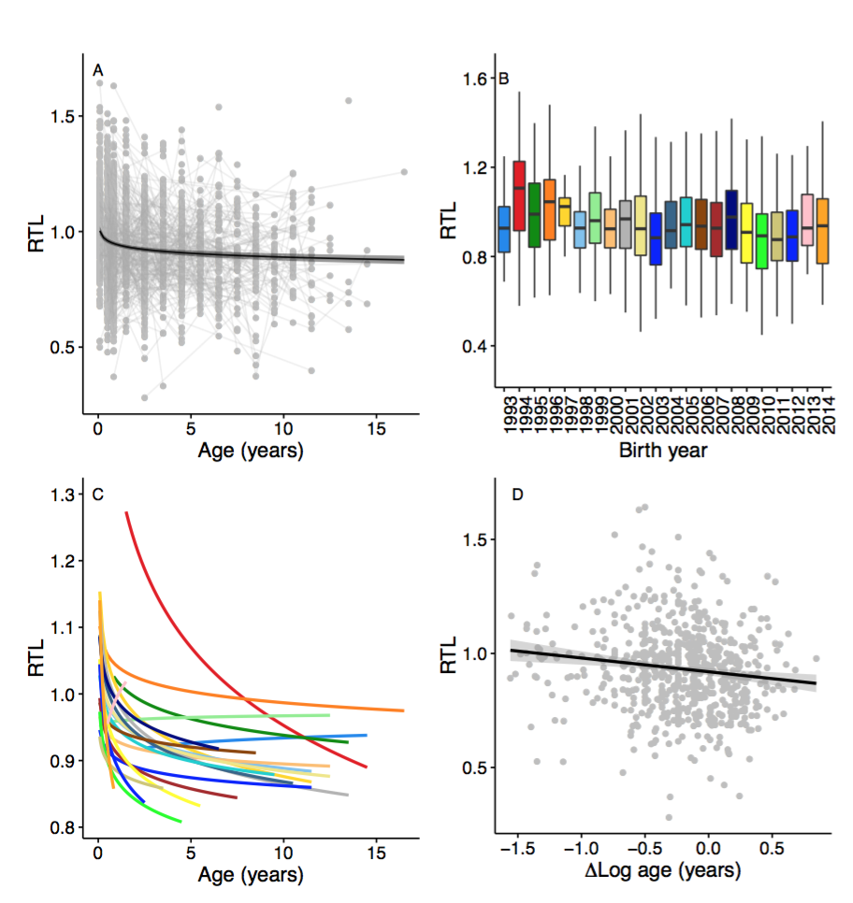

**Figure 1** Telomere dynamics in relation to age in Seychelles warbler cohorts. **A** RTL and age across all individuals. Points and thin grey lines represent individual samples and birds, respectively. The thick line and shaded area represent the fitted values and 95% confidence limits of a linear regression of RTL and log-transformed age.**B** Boxplot of variation in RTL among cohorts. **C** RTL and age among cohorts. Lines represent fitted values from a linear regression and log-transformed age, and colours correspond to **B**. **D** RTL in relation to and $Δ$ Log age (i.e. within indiviual variation in log age).

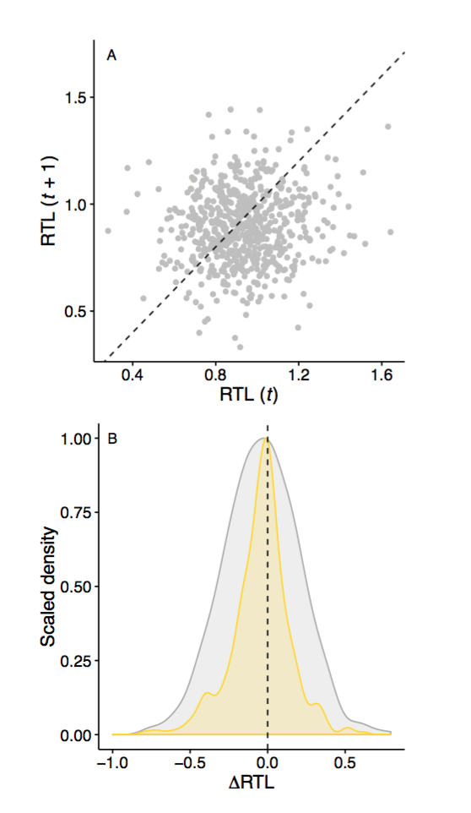

**Figure 2** Longitudinal telomere dynamics in the Seychelles warbler. **A** Variation in RTL within individuals sampled at different time points. The dotted line represents parity, and thus points above and below the line represent increases and decreases in RTL, respectively. **B** Scaled density plots of repeated RTL measurements among individual samples (grey), and among different samples taken from the same individual (yellow). Areas of the density plot to the left of the dotted line represent decreases in RTL, while areas to the right represent increases.

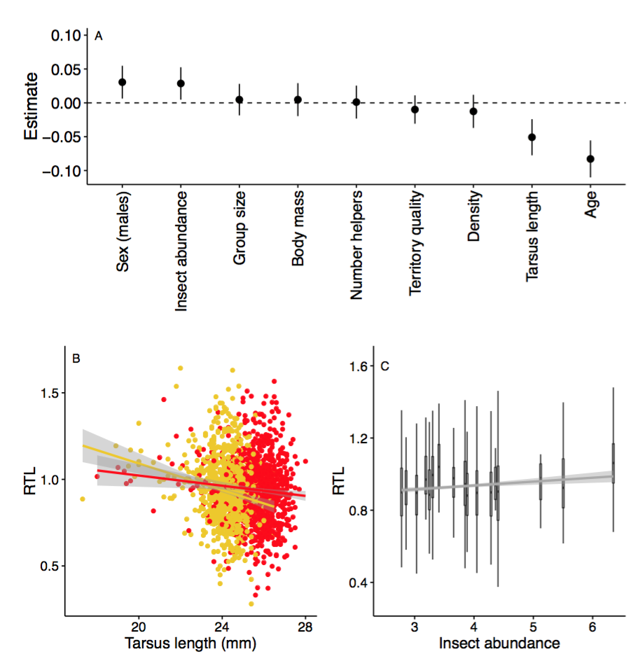

**Figure 3** Telomere length in relation to the social and ecological environment in the Seychelles warbler. **A** Estimates and 95% confidence intervals for all explanatory variables fitted in a linear mixed model (see methods for details). **B** RTL in relation to tarsus length and sex. **C** RTL in relation to variation in annual food availability. Lines and shaded areas represent the fitted values and 95% confidence limits from linear regressions.