### Supplementary information for Spurgin *et al.* "Telomeres reveal complex silver spoon effects in a wild population"

**Table S1** Model selection table for analysis of factors affecting early life telomere length in juvenile Seychelles warblers. Only models that remained in the top model set for model averaging (AICc 6 compared to the top model) are included here. i = intercept.

|  |  |  |  |  |
| --- | --- | --- | --- | --- |
| Model | df | AICc | Delta AICc | Weight |
| i + Body condition + Food av. | 5 | 760.034 | 0.000 | 0.102 |
| i + Body condition + Group size + Food av. | 6 | 760.175 | 0.142 | 0.095 |
| i + Body condition + Helper + Food av. | 6 | 760.839 | 0.805 | 0.068 |
| i + Food av. | 4 | 761.012 | 0.979 | 0.063 |
| i + Body condition + Food av. + TQ | 6 | 761.540 | 1.506 | 0.048 |
| i + Body condition + Group size + Food av. + TQ | 7 | 761.554 | 1.520 | 0.048 |
| i + Group size + Food av. | 5 | 761.632 | 1.599 | 0.046 |
| i + Sex + Body condition + Group size + Food av. | 7 | 761.899 | 1.865 | 0.040 |
| i + Sex + Body condition + Food av. | 6 | 761.955 | 1.921 | 0.039 |
| i + Helper + Food av. | 5 | 761.982 | 1.948 | 0.039 |
| i + Food av. + TQ | 5 | 762.166 | 2.132 | 0.035 |
| i + Body condition + Group size + Helper + Food av. | 7 | 762.213 | 2.179 | 0.034 |
| i + Body condition + Helper + Food av. + TQ | 7 | 762.522 | 2.489 | 0.029 |
| i + Group size + Food av. + TQ | 6 | 762.631 | 2.598 | 0.028 |
| i + Sex + Body condition + Helper + Food av. | 7 | 762.716 | 2.682 | 0.027 |
| i + Sex + Food av. | 5 | 762.847 | 2.814 | 0.025 |
| i + Sex + Group size + Food av. | 6 | 763.279 | 3.245 | 0.020 |
| i + Sex + Body condition + Group size + Food av. + TQ | 8 | 763.279 | 3.246 | 0.020 |
| i + Helper + Food av. + TQ | 6 | 763.329 | 3.295 | 0.020 |
| i + Sex + Body condition + Food av. + TQ | 7 | 763.477 | 3.443 | 0.018 |
| i + Group size + Helper + Food av. | 6 | 763.612 | 3.579 | 0.017 |
| i + Body condition + Group size + Helper + Food av. + TQ | 8 | 763.703 | 3.669 | 0.016 |
| i + Sex + Helper + Food av. | 6 | 763.767 | 3.733 | 0.016 |
| i + Sex + Body condition + Group size + Helper + Food av. | 8 | 763.977 | 3.943 | 0.014 |
| i + Sex + Food av. + TQ | 6 | 764.018 | 3.984 | 0.014 |
| i + Sex + Group size + Food av. + TQ | 7 | 764.277 | 4.243 | 0.012 |
| i + Sex + Body condition + Helper + Food av. + TQ | 8 | 764.421 | 4.387 | 0.011 |
| i + Group size + Helper + Food av. + TQ | 7 | 764.749 | 4.715 | 0.010 |
| i + Sex + Helper + Food av. + TQ | 7 | 765.138 | 5.104 | 0.008 |
| i + Sex + Group size + Helper + Food av. | 7 | 765.300 | 5.267 | 0.007 |
| i + Sex + Body condition + Group size + Helper + Food av. + TQ | 9 | 765.466 | 5.432 | 0.007 |
| i | 3 | 765.596 | 5.562 | 0.006 |
| i + Body condition | 4 | 765.769 | 5.735 | 0.006 |
| i + Body condition + Group size | 5 | 765.806 | 5.772 | 0.006 |
| i + Group size | 4 | 766.024 | 5.990 | 0.005 |

PAGEBREAK

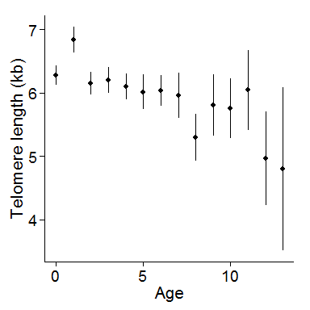

**Figure S1** Cross-sectional telomere length (mean s.e.) in relation to age in Seychelles warblers.

PAGEBREAK

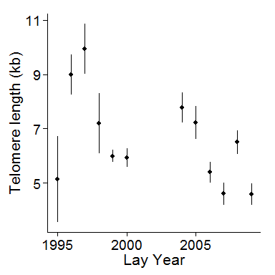

**Figure S2** Cross-sectional juvenile telomere length (mean s.e.) across birth years in Seychelles warblers

PAGEBREAK

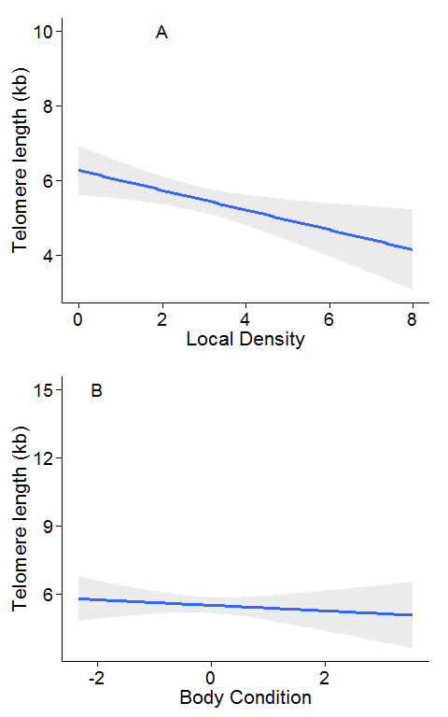

**Figure S3** Within cohort relationships between telomere length and **A** local density and **B** body condition in juvenile Seychelles warblers. Only years with juvenile sample sizes >20 are included. Lines and shaded areas represent fitted values and 95% confidence limits from linear regressions.