### Telomeres reveal silver spoon effects in a wild population

Lewis G. Spurgina,b, Kat Bebbingtona, Eleanor A. Fairfielda, Jan Komdeurc, Terry Burked, Hannah, L. Dugdalec,d, and David S. Richardsona,e,.

1. School of Biological Sciences, University of East Anglia, Norwich Research Park, NR4 7TJ, United Kingdom
2. Department of Zoology, Edward Grey Institute, University of Oxford, Oxford, UK
3. Behavioural Ecology and Self-organization Group, Centre for Ecological and Evolutionary Studies, University of Groningen, Groningen, The Netherlands
4. Department of Animal and Plant Sciences, NERC Biomolecular Analysis Facility, University of Sheffield, Sheffield, UK
5. Nature Seychelles, Roche Caiman, Mahé, Republic of Seychelles

**Correspondence:** Lewis Spurgin: [lewisspurgin@gmail.com](mailto:lewisspurgin@gmail.com); David Richardson: [david.richardson@uea.ac.uk](mailto:david.richardson@uea.ac.uk)

### Abstract

1. Favourable conditions early in life can confer delayed fitness advantages. However, the mechanistic basis of these 'silver spoon effects' remains poorly understood. Telomeres - protective caps on the ends of chromosomes - shorten in response to early life stress, and early life telomere shortening has been associated with reduced later-life survival. It is thus possible that telomeres provide a 'missing link' between early-life environmental variation and later-life fitness.
2. The prevalence and strength of silver spoon effects has consequences for individual fitness and population growth rates. Understanding the physiological and ecological links between early life experiences and later life survival is therefore fundamental to our understanding of life-history evolution and population ecology.
3. We studied how telomere length and shortening link spatiotemporal variation in early-life conditions to survival in the Seychelles warbler (*Acrocephalus sechellensis*). The Seychelles warbler system is excellently suited to addressing this question, due to the long-term longitudinal data on survival and senescence. We combined this with cross-sectional and longitudinal telomere measurements taken from over 300 birds from multiple cohorts, and analyse how variation in the early life environment within and across cohorts affects telomere dynamics and survival.
4. We show that early-life telomere length and shortening rates vary markedly across cohorts, and that this variation is related to temporal fluctuations in food availability. Individuals born in breeding seasons with high food availability have longer telomeres and reduced telomere shortening compared to individuals born in years with low food availability. Within cohorts, we found telomere length in chicks was related to growth, and to the number of helpers present in the natal territory. However, the number of helpers was not related to telomere shortening rates, nor to telomere length in fledgling or subadult birds. Finally, we found that longer telomeres and reduced telomere shortening rates in early life were associated with increased survival later in life.
5. Our results show that telomeres can reveal complex hidden costs at the individual and cohort levels, and suggest that they may provide a link between early-life conditions and late-life survival in wild populations.

**Keywords:** Ageing; Life-history; Seychelles warbler; Telomeres

### Introduction

Being subject to favourable environmental conditions during development and growth can confer fitness advantages later in life (so called 'silver spoon effects') (Grafen 1988; Monaghan 2008). There is now evidence that adult fitness can be affected by a range of early-life experiences, including variation in habitat quality and resource availability (Madsen & Shine 2000; Van de Pol *et al.* 2006; Hayward, Rickard & Lummaa 2013), population density (Nussey *et al.* 2007; Douhard *et al.* 2013) and natural or anthropogenic environmental disturbance (Reid *et al.* 2003; Cartwright *et al.* 2014). Understanding the causes and consequences of these early-life experiences is key to understanding many ecological and evolutionary processes, including patterns of natural and sexual selection, population growth rates and even local extinction (Coulson *et al.* 2001; Roach & Carey 2014). Understanding silver spoon effects is therefore of central interest to ecologists, evolutionary biologists and conservationists.

While it is clear that silver spoon effects can occur, we have little understanding of how and under what conditions early-life environments will affect adult fitness. Because the phenotypic consequences of an adverse environment can depend on an individual's genetic or epigenetic makeup (Hoffman & Hercus 2000; Richards 2006), the later-life consequences of a good/poor start are expected to vary among individuals, populations and species. Moreover, it is not always possible to fully quantify what constitutes a good or bad environment, and any 'hidden' environmental variation may obscure relationships relationships between the early-life conditions that are measured and adult phenotypes. Indeed, the pervasiveness of silver spoon effects varies between species (Drummond, Rodríguez & Oro 2011), cohorts (Reid *et al.* 2003) and sexes (Wilkin & Sheldon 2009). In order to better understand the later-life consequences of early-life experiences, we therefore need to understand, or at least be able to measure, how the environment differentially affects individuals within a population.

A key process that has been associated with adult survival is the rate at which telomere repeats are lost. Telomeres are protective caps on the ends of chromosomes which shorten with age (Monaghan & Haussmann 2006), and in response to oxidative damage that can occur due to environmental stress (Von Zglinicki 2002). When telomeres reach a critical shortness cells senesce (Campisi 2003), resulting in organismal senescence and death (Wong *et al.* 2003). These links between telomere length and senescence have inspired a great deal of recent research into telomere ecology (Haussmann & Marchetto 2010; reviewed in Horn, Robertson & Gemmell 2010; Monaghan 2014). While there is little evidence the relationship between telomere dynamics and survival is causal (Simons 2015), there is now excellent evidence that telomeres can act as biomarkers of cost in wild populations, retaining signatures of ecological stress that are otherwise difficult to detect (Monaghan 2014; Schultner *et al.* 2014; Asghar *et al.* 2015).

There is evidence from a range of taxa that the greatest rate of telomere loss occurs in early life (e.g. (Frenck, Blackburn & Shannon 1998; Haussmann, Vleck & Nisbet 2003)), and that the extent of this telomere shortening is influenced by the conditions experienced early in life (Price *et al.* 2013; Monaghan 2014; Reichert, Criscuolo & Zahn 2015; Nettle *et al.* 2015). Importantly, early-life telomere dynamics are related to both short-term and late-life survival (Heidinger *et al.* 2012; Boonekamp *et al.* 2014), and to other parameters such as cognition (Nettle, Andrews & Monaghan 2015). However, the extent to which telomeres provide a link between early-life conditions and late-life survival in the wild is very poorly understood. Moreover, how early life telomere dynamics vary over spatial and temporal scales is not known.

The longitudinal study (since 1986) of the Seychelles warbler (*Acrocephalus sechellensis*) population on Cousin Island provides an excellent model system for studying senescence in the wild (Hammers *et al.* 2015). Specifically, it is ideally suited for assessing the relationship between early-life environmental variation, telomere length and late-life fitness. Firstly, due to the isolated nature of the study population and intensive field monitoring, we have excellent survival data and sampling material spanning many years (see methods, below). Secondly, telomere length predicts survival independently of age in adult Seychelles warblers, suggesting that telomeres act as a biomarker of cost in this species (Barrett *et al.* 2013). Finally, ecological conditions on Cousin are variable over space and time due to spatiotemporal variation in foliage cover and food availability (Van de Crommenacker *et al.* 2011).

In Seychelles warblers, oxidative stress is linked to natal territory quality (Van de Crommenacker *et al.* 2011), but neither natal territory quality nor natal local density are linked to early-life or adult survival (Brouwer *et al.* 2006; Hammers *et al.* 2013). In this study we analyse patterns of early-life telomere length and subsequent survival to test the prediction that telomeres fill a missing link between early-life environmental variation and late-life fitness. Specifically we predict that: i) individuals raised in good quality conditions will have longer telomeres, and ii) having longer telomeres in early life is associated with greater short and long-term survival.

### Methods

##### Study species and sampling

The Seychelles warbler is a small (~15 g), insectivorous passerine bird with a mean life expectancy of 5.5 years at fledging (Hammers *et al.* 2013). The population on Cousin Island (04'20'S, 55'40'E) has been intensively studied since 1986 (Richardson, Burke & Komdeur 2003; Barrett *et al.* 2013). Individuals are usually ringed in their first year of life, and so are of known age. They are then followed throughout their lives, and as they are non-migratory endemics and are naturally confined to the island (Komdeur *et al.* 2004), a biannual census of birds on Cousin during the main (June-August) and minor (December-February) breeding seasons gives an accurate measure of levels of local density and individual survival rate (Barrett *et al.* 2013). Full details of catching and census methods can be found in Brouwer *et al.* (2012).

All territories are mapped during the main and minor breeding seasons based on detailed observational data of foraging and territorial defence behaviour, and surveyed for territory quality (Richardson *et al.* 2003). Territory quality is calculated based on territory size, foliage cover and insect abundance (Komdeur 1992) and averaged within territories (Hammers *et al.* 2013). Cousin is also subject to intra- and inter-annual variation in rainfall and food availability, and such island-wide temporal variation may override the effects of absolute territory quality. As an estimate of variation in food availability, we calculated an index of the number of insects across the entire island during each breeding season. This index represents the average number of insects found per unit leaf area over all surveys carried out on the island in a breeding season.

Each time a bird is caught on Cousin body mass and tarsus length are measured, and age is assessed on the basis of eye colour and previous captures (Richardson *et al.* 2003). A blood sample (ca 25 $μ$ l) is taken from each bird via brachial venipuncture, and stored in 1 ml absolute ethanol in a 1.5 ml screw-cap microfuge tube at room temperature.

##### Molecular methods

Genomic DNA was extracted from a ~2 mm2 flake of preserved blood using the DNeasy Blood and Tissue Kit (Qiagen), following the manufacturer's protocol, with the modification of overnight lysis at 37oC and a final DNA elution volume of 80 $μ$ l. DNA concentration and purity were quantified using a NanoDrop 8000 Spectrophotometer (ThermoScientific), and DNA integrity was validated by visualization with ethidium bromide after electrophoresis on a 1.2% agarose gel. Sex was determined using the molecular method outlined by Griffiths *et al.* (1998).

Telomere lengths were measured from 327 samples taken cross-sectionally from birds aged less than twelve months, between 1995 and 2012. Of these birds, 81 were nestlings less than two months old (chicks), 118 were aged between two and six months (fledglings), and 128 were aged seven to twelve months (subadults). For a subset of first-year birds (n = 83 individuals) we had longitudinal data, with samples from individuals caught both in their first year and then again within two years. We measured absolute telomere quantity per diploid genome for all samples using a quantitative PCR (qPCR) assay (full details in Barrett *et al.* 2012).

##### Statistical analyses

We performed all analyses using R version 3.0.1 (R Development Core Team 2011). Our sampling regime covers 17 years, and temporal variation in rainfall and food availability on Cousin over this period is expected to result in variation in a range of social and environmental variables (Brouwer *et al.* 2012). This makes it difficult to disentangle how spatial and temporal processes differentially affect early-life telomere dynamics. To get around this, we separately analysed how variation in early life conditions among and within breeding seasons was related to variation in early life telomere length.

First, to analyse whether temporal variation in food availability drives population-level variation in telomere dynamics, we calculated average telomere length among all birds born in a given breeding season (i.e. a cohort). We tested for a difference in telomere length among cohorts using a one-way ANOVA, and then used linear regression to test whether variation in mean telomere length among cohorts is explained by temporal variation in insect abundance.

We then tested tested how spatially varying early-life environmental and social conditions influence telomere length within cohorts using linear models. For these analyses, both response and explanatory variables were standardised by mean-centering within cohorts, thus controlling for any temporal variation in telomere length and the social and ecological environment. As explanatory variables we included tarsus length, sex, territory quality and the number of helping and non-helping subordinates present in the natal territory. We used model averaging to assess how these variables shape telomere length and dynamics in early life. We created a full model containing all of the above terms, and a top model set was then defined, containing all models with AICc $≤$ 6 compared to the best supported model (Burnham, Anderson & Huyvaert 2011). We report model averaged coefficients, confidence intervals, and 'relative importance', which reflects the relative weights of each predictor variable across the top model set. Model averaging was carried out using the MuMIn package (version 1.10.5) in R (Bartoń 2012).

For the individuals with longitudinal data we calculated a rate of telomere loss between the first-year sample and earliest adult sample by subtracting the adult telomere length from the early-life telomere length and dividing this difference by the length of time (in days) between sampling events. To account for regression to the mean effects, we applied a correction based on correlations among samples within individuals following Verhulst *et al.* (2013). Using this dataset we repeated the analyses of among and within cohort telomere dynamics, replacing telomere length with telomere loss as the response variable.

Finally, we analysed the effects of telomere dynamics on survival, again by looking at variation both within and among cohorts. First, we tested the prediction that cohort-level telomere dynamics are associated with survival by comparing the mean telomere length and loss of each cohort with the mean lifespan of all individuals, using linear regression. For this analysis we excluded any recent breeding seasons where >10% of individuals in a cohort were still alive. We then used parametric survival analysis,implemented in the FlexSurv package in R, to test whether individual-level telomere length and loss were related to to survival. Again, we mean-centred variables within cohorts to eliminate temporal variation in telomeres and survival. The survival time distribution was chosen by comparing the fit of a range of distributions (exponential, Weibull, log-normal, gamma, gompertz and generalized F) against the observed survival data, by visually inspecting plots and by comparing AIC values. As explanatory variables of survival we included early-life telomere length/loss (we ran a separate analysis for each, using the cross-sectional and longitudinal data, respectively), plus the factors identified as being related to telomere length in the previous analysis. With this approach we aimed to assess the effect of early-life telomere length on survival while controlling for potentially confounding variables that may be correlated with telomere dynamics.

### Results

##### Early-life telomere length and age

Mean ( $±$ standard error) telomere length in first-year birds was 5.15 $±$ 0.20 kb. This is lower than the mean for one year-old birds based on cross-sectional data (5.46 $±$ 0.15 kb). However, when we considered age classes separately, we found substantial age-related variation in telomere length within the first year of life (F = 8.84; *P* = < 0.01). Chicks had longer telomeres than any other age group, but there was an apparent increase in average telomere length from the fledgling to subadult stages (Fig. 1A). However, a longitudinal analysis of telomere loss showed that chicks, fledglings and subadults all lost telomeres early in life, but that there was no difference in the rate of telomere loss among age classes (F = 0.35; *P* = 0.71; Fig. 1B). This suggests that the apparent increase in telomere length between fledglings and subadults in the cross-sectional data was a result of the sampling, rather than telomere elongation.

##### Temporal variation in early life telomere dynamics

Early-life telomere length varied significantly among breeding seasons (one-way ANOVA, F = 2.22; *P* = < 0.001), and this variation in average telomere length over breeding seasons was positively related to island-wide food availability (linear regression, R2 = 0.40; F = 9.39; *P* = 0.008; Fig. 2A). Running the regression of cohort-level telomere length and food availability separately for each age class revealed positive but non-significant relationships in fledglings (R2 = 0.33; F = 4.41; *P* = 0.065) and subadults (R2 = 0.20; F = 2.47; *P* = 0.147), but a non-significant *negative* relationship in chicks (R2 = 0.52; F = 3.31; *P* = 0.167).

The rate of telomere shortening in early life did not vary significantly among breeding seasons (F = 0.94; *P* = 0.53); however, what variation there was in rates of telomere shortening could be explained by temporal variation in food availability (R2 = 0.30; F = 5.09; *P* = 0.04). This pattern corresponded with the cross-sectional data: individuals born in seasons with low food availability lost telomeres, on average, at a faster rate than those born in years with high food availability (Fig. 2B). Unfortunately our limited sample size within the longitudinal dataset precluded us from running this analysis separately for each age class.

##### Spatial variation in early life telomere dynamics

The top model explaining within-season variation in chick telomere length contained tarsus length and the number of helpers present in the natal territory (Table S1), and this model was a much better fit than the null model ($Δ$ AICc = 10.65). Both tarsus length and the number of helpers had high relative importance in the top model set (Fig. 3A), and the model containing these variables explained a reasonable amount of variation in telomere length (R2 = 0.24). Telomere length was positively related to the number of helpers (Fig. 3B), and negatively related to tarus length (Fig. 3C).

For fledglings, the null model was the top model explaining early-life telomere length (Table S1). None of the explanatory terms had high importance in the top model set, and confidence intervals of all estimates were close to zero (Fig. 4A), suggesting that none of the variables analysed had a significant effect on fledgling telomere length. For subadults, the top model contained territory quality (Table S1), which was negatively related to subadult telomere length (Fig. 4B). However, territory quality explained a tiny amount of variation in subadult telomere length (R2 = 0.03), and there was only a small difference in AIC between the model containing territory quality and the null model ($Δ$ AICc = 0.81). Moreover, the confidence intervals of the territory quality effect overlapped with zero (Fig. 4B), suggesting that any negative effect of territory quality on subadult telomere length was negligible.

For the subset of individuals with longitudinal data, we tested whether the factors previously identified as being related to early-life telomere length (i.e. tarsus length, sex and number of helpers) were also associated with differences in rates of early life telomere loss. Due to a limited sample size, we considered all age classes together for this analysis. We found that none of these variables were associated with differences in telomere loss (all *P* > 0.05).

##### Early life telomere dynamics and survival

At the population-level, we found no evidence that individuals born in breeding seasons with high food availability had longer lifespans (R2 = 0.09; F = 1.42; *P* = 0.25), nor that individuals born in years where average telomere length was longer had longer lifespans (R2 = 0.007; F = 0.13; *P* = 0.72; Fig. 5A). Testing the latter relationship separately for each age class revealed that there was no age-specific relationship between cohort-level telomere length and lifespan (all *P* > 0.2). There was a negative relationship between population-level telomere loss and lifespan, although this was marginally non-significant (R2 = 0.201; F = 3.78; *P* = 0.07; Fig. 5B).

For the individual-based survival analysis, a log-normal survival model best fitted the Seychelles warbler data (AIC = 1115.35, AIC of next best distribution (Weibull) = 1134.82). A survival model including all first year birds, early-life telomere length was not associated with survival (estimate = 0.064, CI = -0.060-0.189). However, we did find differential survival effects among age classes. Chick telomere length had no effect on survival (estimate = -0.080, CI = -0.287-0.127; Fig. 6A). However, telomere length at both the fledgling and subadult stage was significantly related to survival (fledglings: estimate = 0.249, CI = 0.018-0.481; subadults: estimate = 0.205, CI = 0.036-0.374). In both cases this effect was positive, with longer telomeres in early life associated with increased survival later in life (Figs 6B, 6C). Finally, using the longitudinal data, we found no effect of early-life telomere shortening on subsequent survival (estimate = 0.16, CI = -0.089-0.400).

### Discussion

Here we show that telomeres link early-life conditions to later-life survival in the Seychelles warbler. We first show that telomere length and rates of shortening in early life are subject to strong cohort effects, and that cohort-level telomere dynamics can be explained by island-wide temporal variation in food availability. We then show that within cohorts, the social environment (i.e. number of helpers) affects telomere length, but that this effect is age-dependent. Finally, we show that telomere length in early life predicts later-life survival. These findings have important implications for research on life history evolution in wild populations.

Our finding that food availability is related to early-life telomere length and rate of shortening adds to a growing body of evidence from humans and wild animals showing that the natal environment can have pronounced impacts on early-life telomere dynamics (reviewed in Price *et al.* 2013; Monaghan 2014). However, very few studies have shown that temporal variation in environmental conditions affects telomere dynamics in natural populations. In a recent study on black-tailed gulls (*Larus crassirostris*), Mizutani *et al.* (2013) showed that temporal variation in telomere shortening occurred over a two-year period, which they suggest was the result of changing climatic conditions. Similarly, Watson *et al.* (2015) studied telomere shortening in two cohorts of European storm petrel (*Hydrobates pelagicus*), and found that the cohort raised in more favourable conditions had, on average, longer telomeres. The long-term Seychelles warbler dataset has allowed us, using many more cohorts than has been possible in other studies, to show that temporal variation in environmental conditions does indeed affect telomere dynamics, and that this effect can be seen at the population level. Interestingly, in the Seychelles warbler annual variation in food availability is not directly linked to survival (Brouwer *et al.* 2006; Hammers *et al.* 2013). Our results therefore suggest that telomeres can detect hidden costs in natural populations that are not detectable using life-history data alone (Asghar *et al.* 2015)

We suspect the current lack of information on temporal variation in telomere dynamics is more due to a lack of available long-term datasets with telomere screening, rather than the Seychelles warbler being unique. Indeed, the environment on Cousin is benign in comparison with many regions outside the tropics, where populations undergo large fluctuations in size (e.g. Coulson *et al.* 2001). We therefore expect that as more long-term studies generate telomere datasets, the effects of temporal changes in the environment on telomere dynamics will become increasingly clear. If our findings are replicated in other systems and temporal variation in early-life telomere dynamics is common in nature, this has a number of ramifications for our understanding of senescence in natural populations. First, our findings suggest that telomere dynamics of a population at a given point in time represent a snapshot of a temporally varying process. More research is now needed within and across multiple cohorts and populations to better understand the complexity of telomere evolutionary ecology. Secondly, our findings raise the interesting prospect of using telomeres as indicators of population health - an approach that would be useful to a broad range of conservation and animal health practitioners. However, our analyses are confined to a single island, and research across populations with different environments and genetic histories is required in order to provide further insight into the usefulness of telomeres as biomarkers of population health.

We found that when looking within cohorts, tarsus length and the number of helpers were the most important predictors of telomere length in Seychelles warbler chicks. The tarsus effect most likely reflects the fact that in passerine birds tarsus length is correlated with age during the nestling stage (DAVE DO YOU HAVE A REF??). Telomere loss is most rapid early in life due to ongoing cell replication, and a negative correlation between telomere length and body size in early life is therefore expected (REF). However, ours is the first study to show that the presence of helping co-breeders has a beneficial effect on offspring in terms of their telomeres. In the Seychelles warbler the survival benefits of having helpers in the natal territory is well established (Komdeur 1994; Brouwer *et al.* 2012), and that this effect is detected in the telomere data is therefore encouraging. However, we found no evidence that tarsus length or the number of helpers was related to telomere loss - this is perhaps surprising as telomere loss is expected to be a better indicator of stress than telomere length *per se* (Boonekamp *et al.* 2014). Our (lack of) finding here is probably due to the limited nature of our longitudinal dataset, both in terms of sample size and resolution (i.e. time between sampling events). Seychelles warblers have not rarely been sampled multiple times within their first year of life, so much of the telomere shortening that occurs in early life will be missed with our sampling regime. It is likely, therefore that in this system the effects of environmental variation on telomere loss will only be detected when they are very strong, and that telomere length constitutes a better indicator of early life stress.

While the relationship between telomeres and mortality in adults has been established for some time (Cawthon *et al.* 2003), only recently has the link between early-life telomere dynamics and later-life survival been studied. In captive zebra finches, juvenile telomere length predicts late-life survival (Heidinger *et al.* 2012), and in wild bird populations early-life telomere dynamics have been linked to survival during the nestling-phase (Watson *et al.* 2015), and survival to adulthood (Boonekamp *et al.* 2014). Our results are, to our knowledge, the first to demonstrate that early-life telomere length is associated with later-life survival in a wild population. This effect can be seen at the individual level, and (to a lesser extent) at the cohort level, although the nature of the relationship varies according to to age class, and depending on whether cross-sectional or longitudinal data are used (Figs 5,6). At the individual level, we found that telomere length in fledglings and subadults, but not chicks, was related to survival. This is unsurprising, as at the chick stage telomere length at the fledgling and subadult stage is likely to be the best indicator of early life stress (see also previous paragraph). The lack of correlation between population-level telomere length and lifespan is more difficult to explain, and given the sample size and resolution of the data, the replationship between population-level telomere loss and lifespan should be cautiously interpreted. Nonetheless, our data do support the general conclusion that early-life telomere dynamics are important indicators of early-life stress.

There are numerous promising avenues for future research into telomere evolutionary ecology in this system and others. Here we have considered survival, but telomere length and shortening in early life may also be linked to other components of fitness (Monaghan 2014). Reproductive senescence occurs in the Seychelles warbler (reviewed in Hammers *et al.* 2015), making this system well suited to examining how telomere length affects lifetime reproductive success. A further avenue for future research will be examining, in a quantitative genetic framework, how genetic and environmental components, and their interactions, affect telomere dynamics and senescence in natural populations (**???**). We expect that by gaining a fuller understanding of telomere dynamics in natural populations, the fields of life-history evolution and evolutionary ecology will be greatly enhanced.

### Data accessibility

This manuscript was written in R Markdown (<http://rmarkdown.rstudio.com/>). All data and scripts required to reproduce the manuscript, and all figures and analyses contained within it, will be made available on GitHub.

### Acknowledgements

Nature Seychelles facilitate the long-term Seychelles warbler project, allowing us to stay on Cousin Island, and providing accommodation and facilities during field work. The Seychelles Bureau of Standards and Department of Environment gave permission for sampling and fieldwork. Emma Barrett laid the foundations for this study, generating much of the telomere data. We thank everyone who has helped in the field, and the current Seychelles warbler research group for useful discussions. This work was funded by two Natural Environment Research Council (NERC) grants to DSR (NE/F02083X/1 and NE/K005502/1) on which JK, TB and HLD were project partners. HLD was funded by a NERC fellowship.

### References

Asghar, M., Hasselquist, D., Hansson, B., Zehtindjiev, P., Westerdahl, H. & Bensch, S. (2015) Hidden costs of infection: Chronic malaria accelerates telomere degradation and senescence in wild birds. *Science*, **347**, 436–438.

Barrett, E.L.B., Boner, W., Mulder, E., Monaghan, P., Verhulst, S. & Richardson, D.S. (2012) Absolute standards as a useful addition to the avian quantitative PCR telomere assay. *Journal of Avian Biology*, **43**, 571–576.

Barrett, E.L.B., Burke, T., Hammers, M., Komdeur, J. & Richardson, D.S. (2013) Telomere length and dynamics predict mortality in a wild longitudinal study. *Molecular Ecology*, **22**, 249–259.

Bartoń, K. (2012) Package ‘MuMIn’. Model selection and model averaging base on information criteria. R package version 1.7.11. *R foundation for statistical computing*.

Boonekamp, J.J., Mulder, G.A., Salomons, H.M., Dijkstra, C. & Verhulst, S. (2014) Nestling telomere shortening, but not telomere length, reflects developmental stress and predicts survival in wild birds. *Proceedings of the Royal Society B: Biological Sciences*, **281**, 20133287.

Brouwer, L., Richardson, D. & Komdeur, J. (2012) Helpers at the nest improve late-life offspring performance: evidence from a long-term study and a cross-foster experiment. *PLoS ONE*, **7**, e33167.

Brouwer, L., Richardson, D.S., Eikenaar, C. & Komdeur, J. (2006) The role of group size and environmental factors on survival in a cooperatively breeding tropical passerine. *Journal of Animal Ecology*, **75**, 1321–1329.

Burnham, K., Anderson, D. & Huyvaert, K. (2011) AIC model selection and multimodel inference in behavioral ecology: some background, observations, and comparisons. *Behavioral Ecology and Sociobiology*, **65**, 23–25.

Campisi, J. (2003) Cellular senescence and apoptosis: How cellular responses might influence aging phenotypes. *Experimental Gerontology*, **38**, 5–11.

Cartwright, S.J., Nicoll, M.A.C., Jones, C.G., Tatayah, V. & Norris, K. (2014) Anthropogenic natal environmental effects on life histories in a wild bird population. *Current Biology*, **24**, 536–40.

Cawthon, R.M., Smith, K.R., O’Brien, E., Sivatchenko, A. & Kerber, R.A. (2003) Association between telomere length in blood and mortality in people aged 60 years or older. *Lancet*, **361**, 393–395.

Coulson, T., Catchpole, E.A., Albon, S.D., Morgan, B.J., Pemberton, J.M., Clutton-Brock, T.H., Crawley, M.J. & Grenfell, B.T. (2001) Age, sex, density, winter weather, and population crashes in Soay sheep. *Science (New York, N.Y.)*, **292**, 1528–31.

Douhard, M., Gaillard, J.-M., Delorme, D., Capron, G., Duncan, P., Klein, F. & Bonenfant, C. (2013) Variation in adult body mass of roe deer: early environmental conditions influence early and late body growth of females. *Ecology*, **94**, 1805–1814.

Drummond, H., Rodríguez, C. & Oro, D. (2011) Natural ’poor start’ does not increase mortality over the lifetime. *Proceedings of the Royal Society B: Biological Sciences*, **278**, 3421–7.

Frenck, R.W., Blackburn, E.H. & Shannon, K.M. (1998) The rate of telomere sequence loss in human leukocytes varies with age. *Proceedings of the National Academy of Sciences of the United States of America*, **95**, 5607–5610.

Grafen, A. (1988) On the uses of data on lifetime reproductive success. *Reproductive success* (ed T. Clutton-Brock).

Griffiths, R., Double, M.C., Orr, K. & Dawson, R.J. (1998) A DNA test to sex most birds. *Molecular Ecology*, **7**, 1071–5.

Hammers, M., Kingma, S.A., Bebbington, K., Crommenacker, J. van de, Spurgin, L.G., Richardson, D.S., Burke, T., Dugdale, H.L. & Komdeur, J. (2015) Senescence in the wild: Insights from a long-term study on Seychelles warblers. *Experimental Gerontology*.

Hammers, M., Richardson, D.S., Burke, T. & Komdeur, J. (2013) The impact of reproductive investment and early-life environmental conditions on senescence: support for the disposable soma hypothesis. *Journal of Evolutionary Biology*, **26**, 1999–2007.

Haussmann, M.F. & Marchetto, N.M. (2010) Telomeres: Linking stress and survival, ecology and evolution. *Current Zoology*, **56**, 714–727.

Haussmann, M.F., Vleck, C.M. & Nisbet, I.C.T. (2003) Calibrating the telomere clock in common terns, Sterna hirundo. *Experimental Gerontology*, **38**, 787–789.

Hayward, A.D., Rickard, I.J. & Lummaa, V. (2013) Influence of early-life nutrition on mortality and reproductive success during a subsequent famine in a preindustrial population. *Proceedings of the National Academy of Sciences of the United States of America*, **110**, 13886–91.

Heidinger, B.J., Blount, J.D., Boner, W., Griffiths, K., Metcalfe, N.B. & Monaghan, P. (2012) Telomere length in early life predicts lifespan. *Proceedings of the National Academy of Sciences of the United States of America*, **109**, 1743–8.

Hoffman, A.A. & Hercus, M.J. (2000) Environmental Stress as an Evolutionary Force. *BioScience*, **50**, 217–226.

Horn, T., Robertson, B.C. & Gemmell, N.J. (2010) The use of telomere length in ecology and evolutionary biology. *Heredity*, **105**, 497–506.

Komdeur, J. (1992) Importance of habitat saturation and territory quality for evolution of cooperative breeding in the Seychelles warbler. *Nature*, **358**, 493–495.

Komdeur, J. (1994) Experimental evidence for helping and hindering by previous offspring in the cooperative-breeding Seychelles warbler Acrocephalus sechellensis. *Behavioral ecology and sociobiology*, **34**, 175–186.

Komdeur, J., Piersma, T., Kraaijeveld, K., Kraaijeveld-Smit, F. & Richardson, D.S. (2004) Why Seychelles Warblers fail to recolonize nearby islands: Unwilling or unable to fly there? *Ibis*, **146**, 298–302.

Madsen, T. & Shine, R. (2000) Silver spoons and snake body sizes: prey availability early in life influences long‐term growth rates of free‐ranging pythons. *Journal of Animal Ecology*, **69**, 952–958.

Mizutani, Y., Tomita, N., Niizuma, Y. & Yoda, K. (2013) Environmental perturbations influence telomere dynamics in long-lived birds in their natural habitat. *Biology Letters*, **9**, 20130511.

Monaghan, P. (2008) Early growth conditions, phenotypic development and environmental change. *Philosophical Transactions of the Royal Society B: Biological sciences*, **363**, 1365.

Monaghan, P. (2014) Organismal stress, telomeres and life histories. *Journal of Experimental Biology*, **217**, 57–66.

Monaghan, P. & Haussmann, M.F. (2006) Do telomere dynamics link lifestyle and lifespan? *Trends in Ecology and Evolution*, **21**, 47–53.

Nettle, D., Andrews, C. & Monaghan, P. (2015) Developmental and familial predictors of adult cognitive traits in the European starling. *Animal Behaviour*, **107**, 239–248.

Nettle, D., Monaghan, P., Gillespie, R., Brilot, B., Bedford, T. & Bateson, M. (2015) An experimental demonstration that early-life competitive disadvantage accelerates telomere loss. *Proceedings of the Royal Society B: Biological Sciences*, **282**, 20141610.

Nussey, D., Kruuk, L., Morris, A. & Clutton-Brock, T. (2007) Environmental conditions in early life influence ageing rates in a wild population of red deer. *Current Biology*, **17**, R1000–R1001.

Price, L.H., Kao, H.T., Burgers, D.E., Carpenter, L.L. & Tyrka, A.R. (2013) Telomeres and early-life stress: An overview. *Biological Psychiatry*, **73**, 15–23.

R Development Core Team. (2011) R: A Language and Environment for Statistical Computing (ed RDC Team). *R foundation for statistical computing*, **1**, 409.

Reichert, S., Criscuolo, F. & Zahn, S. (2015) Immediate and delayed effects of growth conditions on ageing parameters in nestling zebra finches. *The Journal of Experimental Biology*, **218**.

Reid, J.M., Bignal, E.M., Bignal, S., McCracken, D.I. & Monaghan, P. (2003) Environmental variability, life-history covariation and cohort effects in the red-billed chough Pyrrhocorax pyrrhocorax. *Journal of Animal Ecology*, **72**, 36–46.

Richards, E.J. (2006) Inherited epigenetic variation–revisiting soft inheritance. *Nature Reviews Genetics*, **7**, 395–401.

Richardson, D.S., Burke, T. & Komdeur, J. (2003) Sex-specific associative learning cues and inclusive fitness benefits in the Seychelles warbler. *Journal of Evolutionary Biology*, **16**, 854–861.

Roach, D.A. & Carey, J.R. (2014) Population Biology of Aging in the Wild. *Annual Review of Ecology, Evolution, and Systematics*, **45**, 421–443.

Schultner, J., Moe, B., Chastel, O., Bech, C. & Kitaysky, A.S. (2014) Migration and stress during reproduction govern telomere dynamics in a seabird. *Biology Letters*, **10**, 20130889.

Simons, M.J. (2015) Questioning causal involvement of telomeres in aging. *Ageing Research Reviews*.

Van de Crommenacker, J., Komdeur, J., Burke, T. & Richardson, D.S. (2011) Spatio-temporal variation in territory quality and oxidative status: A natural experiment in the Seychelles warbler (Acrocephalus sechellensis). *Journal of Animal Ecology*, **80**, 668–680.

Van de Pol, M., Bruinzeel, L.W., Heg, D., Van der Jeugd, H.P. & Verhulst, S. (2006) A silver spoon for a golden future: long-term effects of natal origin on fitness prospects of oystercatchers (Haematopus ostralegus). *Journal of Animal Ecology*, **75**, 616–626.

Verhulst, S., Aviv, A., Benetos, A., Berenson, G.S. & Kark, J.D. (2013) Do leukocyte telomere length dynamics depend on baseline telomere length? An analysis that corrects for ’regression to the mean’. *European Journal of Epidemiology*, **28**, 859–66.

Von Zglinicki, T. (2002) Oxidative stress shortens telomeres. *Trends in biochemical sciences*, **27**, 339–344.

Watson, H., Bolton, M. & Monaghan, P. (2015) Variation in early-life telomere dynamics in a long-lived bird: links to environmental conditions and survival. *The Journal of Experimental Biology*, **218**, 668–674.

Wilkin, T.A. & Sheldon, B.C. (2009) Sex differences in the persistence of natal environmental effects on life histories. *Current Biology*, **19**, 1998–2002.

Wong, K.-K., Maser, R.S., Bachoo, R.M., Menon, J., Carrasco, D.R., Gu, Y., Alt, F.W. & DePinho, R.A. (2003) Telomere dysfunction and Atm deficiency compromises organ homeostasis and accelerates ageing. *Nature*, **421**, 643–648.

**Figure Legends**

**Figure 1** Telomere length (mean $±$ s.e.) and age Seychelles warblers, based on cross-sectional **(A)** and longitudinal **(B)** data. In **B**, telomere loss is a standardised and corrected rate (see methods for details) based on the difference in telomere length from the sample taken from birds in their first year of life, and the first available sampling as an adult. Values above zero indicate telomere shortening in early life.

**Figure 2** Temporal variation in early-life telomere dynamics in the Seychelles warbler based on cross-sectional **(A)** and longitudinal **(B)** data (see Fig. 1 and main text for details). Points and error bars represent mean and standard error telomere length for all birds born in each summer (black) or winter (grey) breeding season, in relation to island-wide food availability. Trend lines represent fitted values from a linear regression.

**Figure 3** Factors affecting telomere length in Seychelles warbler chicks. **A** Model averaged estimates and 95% confidence intervals for all explanatory terms used in a linear model with telomere length as the response variable. Numbers in brackets are the relative importance of each term in the top model set (see main text for details; TQ = territory quality). **B** Presence/absence of helpers and **C** tarsus length in relation to raw telomere length. Points and error bars in **B** are mean $±$ s.e., and the trend line in **C** represents fitted values from a linear regression.

**Figure 4** Factors affecting telomere length in Seychelles warblers fledglings **(A)** and subadults **(B)**. Points and error bars represent model averaged estimates and 95% confidence intervals for all explanatory terms used in a linear model with telomere length as the response variable. Numbers in brackets are the relative importance of each term in the top model set (see main text for details; TQ = territory quality).

**Figure 5** Cohort-level variation in early-life telomere dynamics and lifespan in the Seychelles warbler, based on cross-sectional **(A)** and longitudinal **(B)** data (see Fig. 1 and main text for details). Points and error bars represent means and $±$ s.e., respectively, of all birds born in each summer (black) or winter (grey) breeding season.

**Figure 6** Kaplan-Meier curves showing the relationship between telomere length and survival in chick (**A**), fledgling (**B**) and sub-adult (**C**) Seychelles warblers. Telomere length is binned into groups here for visualisation purposes only (long and short = greater than or less than median telomere length, repectively).

**Figure 1**

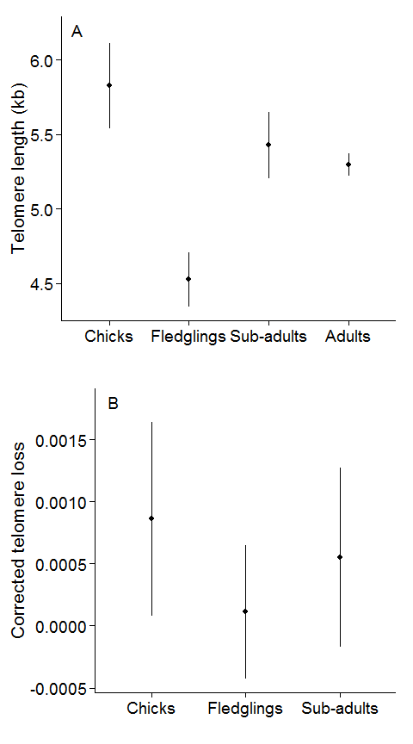

**Figure 2**

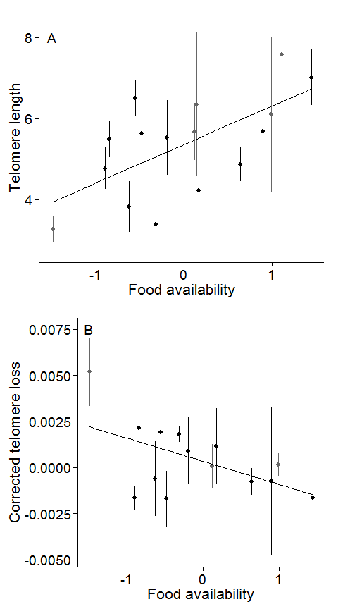

**Figure 3**

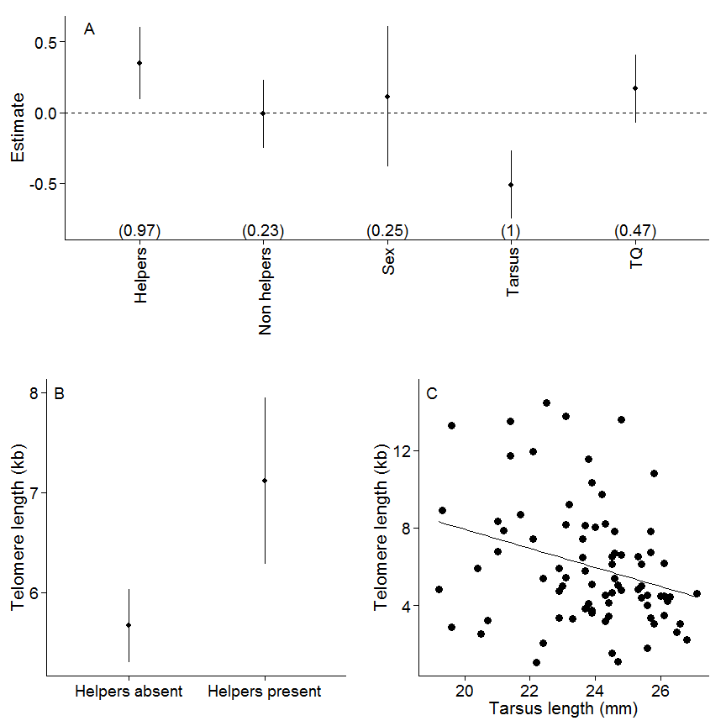

**Figure 4**

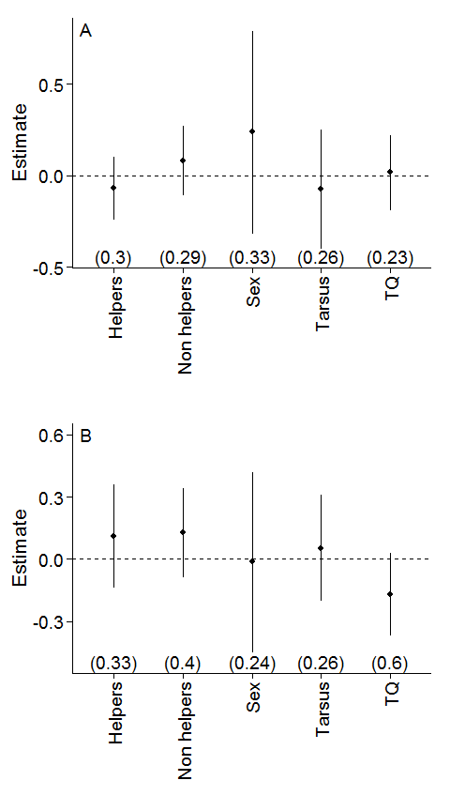

**Figure 5**

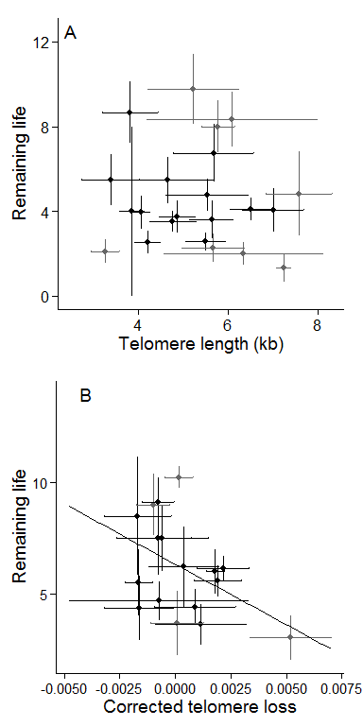

**Figure 6**

