Objective: To test basic programming knowledge (conditional constructs , loop,collection etc) and collections. Implement all possible conditions.

Create a shopping cart with the following basic functionalities:

* Display a menu of items with the corresponding quantities available in the store and the cost of the items.
* Accept customer input for the items required.
* Display a message if the item is out of stock.
* Take input of customer details.
* Calculate delivery charges based on the distance from the store.
* Display a final bill with the items purchased and the customer details.

For delivery charges

If upto 15 km then 50 Rs

If 15 to 30 km then 100 rs

Else

No delivery available

Create a console application for shopping cart program

Sample screen shot for reference. You are allowed to do slight modifications and additions to given requirements

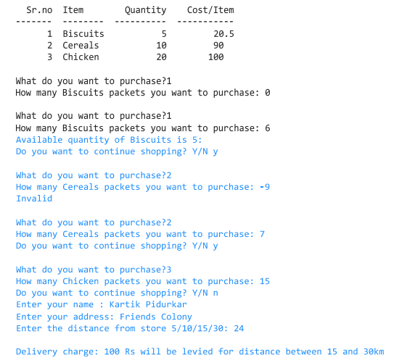

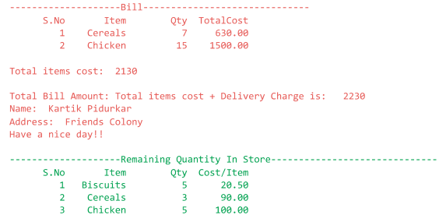

Part 1 : Complete console based, no file or db required. But during single run it should maintain data properly

Part 2 : Add Mysql/any database as back end and store and retrieve data from database