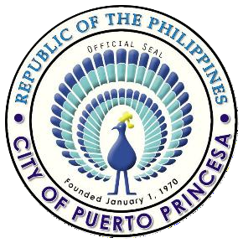

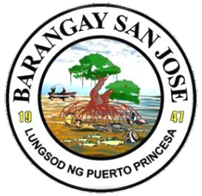

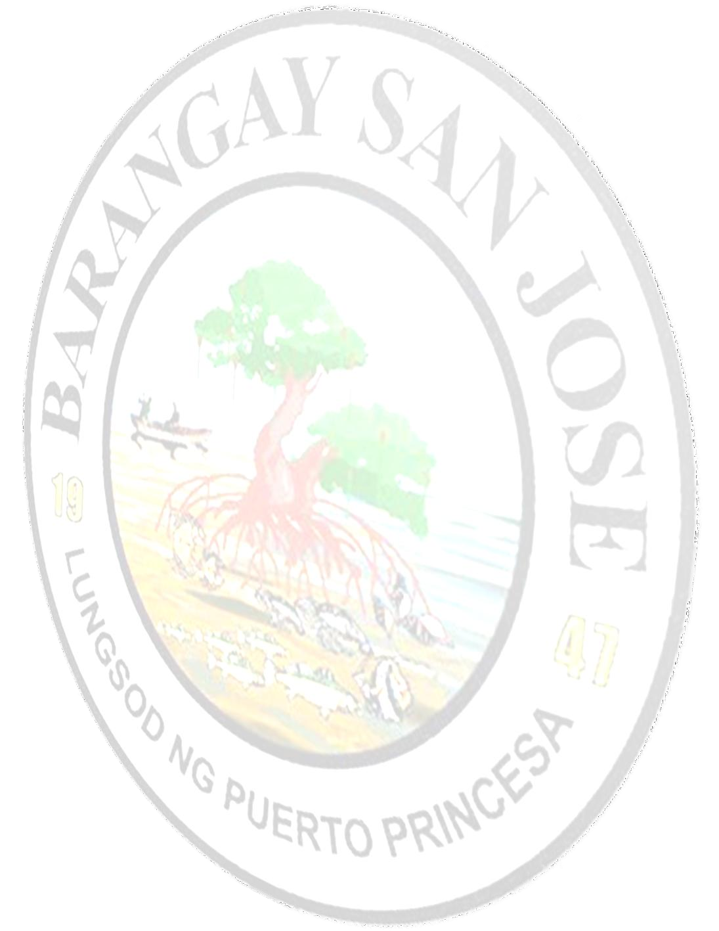
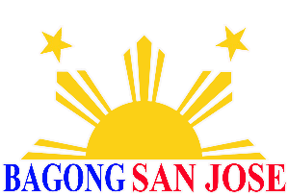
Republic of the Philippines
City of Puerto Princesa
BARANGAY SAN JOSE
Office of the Punong Barangay

C E R T I F I C A T I O N
${control_number}
TO WHOM IT MAY CONCERN;

This is to certify that the person whose name, photo, signature/thumbmark appears herein is bona fide resident of ${purok} , Barangay San Jose, Puerto Princesa City, Palawan.
NAME: ${resident’s_name}
SEX: ${gender}
NATIONALITY: FILIPINO
BIRTHDAY: ${date_of_birth}
BIRTH PLACE: PUERTO PRINCESA CTY
BARANGAY ADDRESS: PUROK MASAYAHIN, BGY.SAN JOSE PPC
FULL NAME OF THE FATHER; ${father’s_name}
MAIDEN NAME OF THE MOTHER: ${mothers_maiden_name} DATE AND PLACE OF MARRIAGE OF PARENTS: ${parents_marriage_details}

This is to certify further that the person named above has been a resident of this Barangay from ${residency_period}.
This certification is issued upon the request of the above-named person for the purpose of
DELAYED REGISTRATION OF BIRTH.

${resident’s_name}

Name and signature/thumbmark of the resident
Issued on this ${current_date} at Barangay Hall, Barangay San Jose, City of Puerto Princesa.

HON. JENNIFER CALINGAO TRINIDAD
Punong Barangay

By the Authority of the Punong Barangay,

${signatory_name}

Officer on duty

Note: This Certification is valid only for Three (3) Months from the day this was issued.
Do not accept if a photocopy of this Certification is not a Certified true Copy, with erasures or Alterations.

