NJL Operations visual review
Annotated prototype review for workflow, tracking, and cognitive load. Ponytail principle: keep one next action and avoid duplicate workflow state.
Inventory
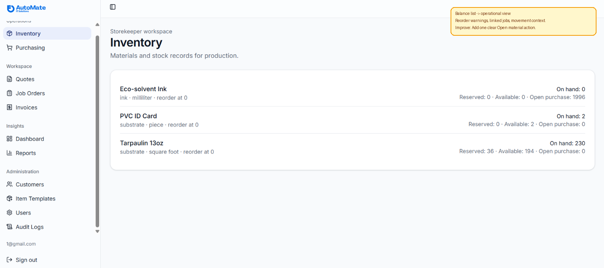
What changed: Balance list -> operational view
What was added: Reorder warnings, linked jobs, and movement context.
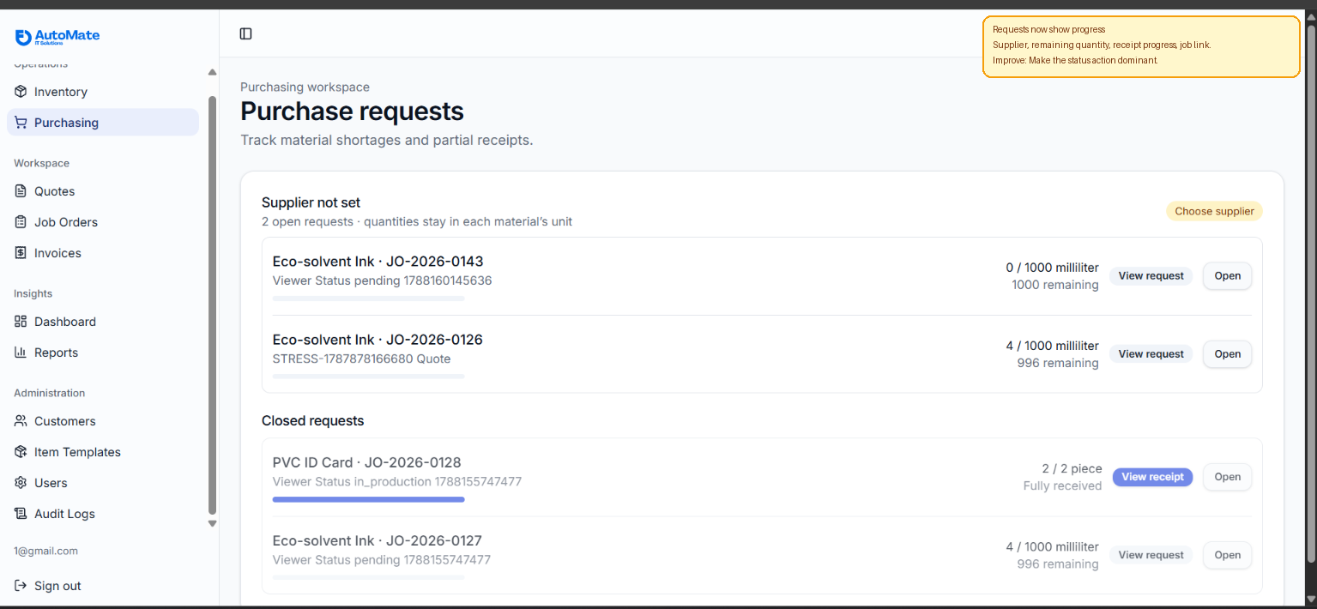
What changed: Requests now show progress
What was added: Supplier, remaining quantity, receipt progress, and job link.

Production / BOM
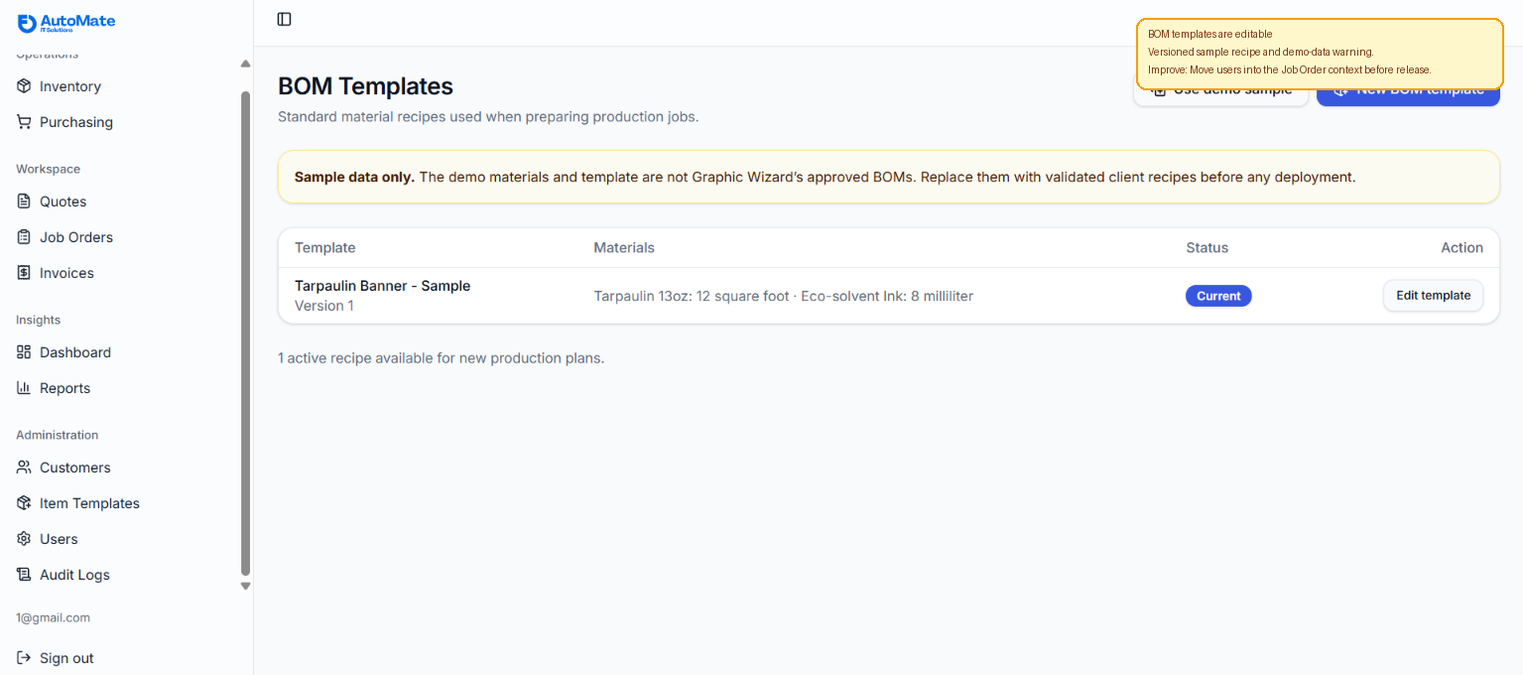
What changed: BOM templates are editable
What was added: Versioned sample recipe and demo-data warning.
Smallest improvement: Move users into the Job Order context before release.
Review conclusion
The four screens now read as connected operational documents: Calendar points to the Job Order, Production explains readiness, Inventory explains stock truth, and Purchasing explains shortage resolution. The next UI improvement is to keep the blocker and next action visible at the same point where the user decides what to do.

