Visual UI Changes Summary
Recent visual changes only. Each section includes the changed area with a red arrow callout.
Quote Detail: Cleaner Summary And Workflow
The quote detail page now reads in a cleaner order: quote total first, customer and quote details together, then line items. The workflow is shown as an intentional checklist instead of loose date text.
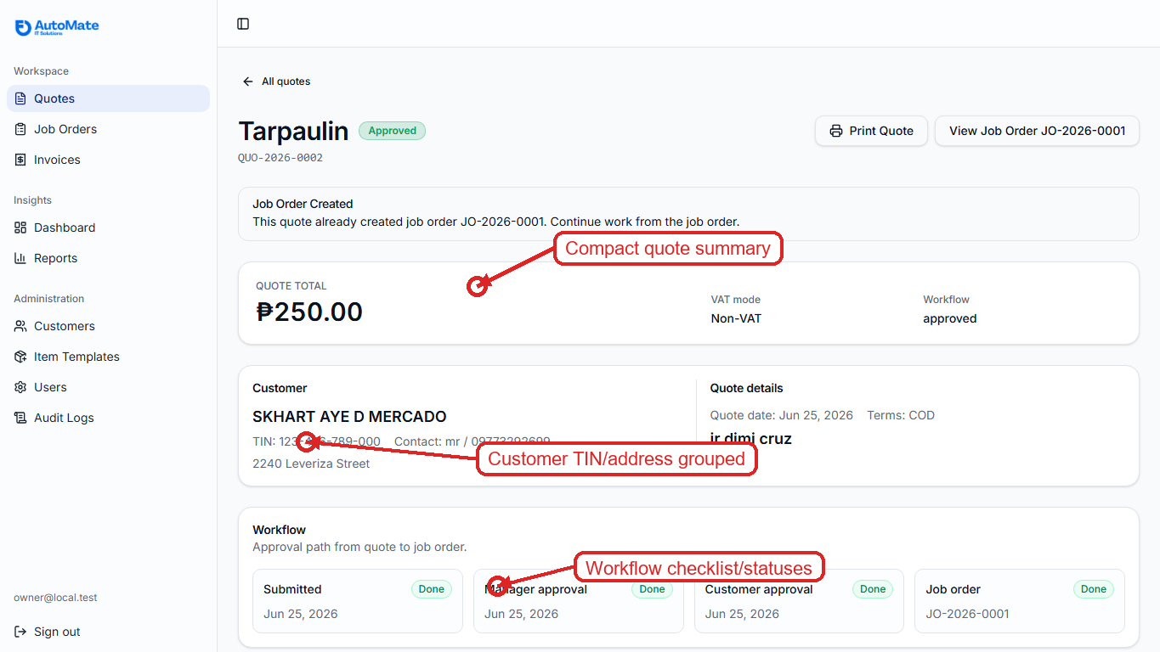

Job Order Detail: Completed State Feels Closed
Completed jobs now feel finished instead of looking like another active step. The guidance and status treatment make it clear that production is done and accounting can continue with invoicing.
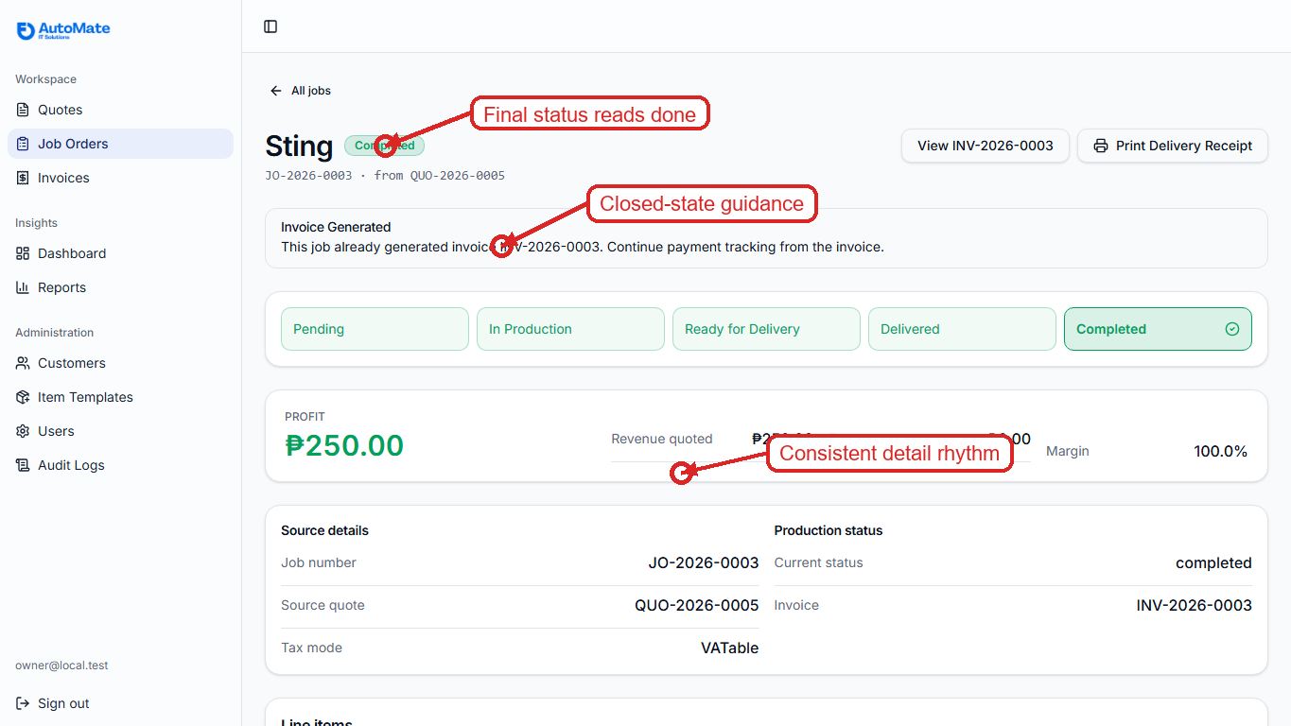

Invoice Detail: Document-Like Layout
The invoice detail page now uses a document-style structure: balance first, invoice/customer details next, then line items. This reduces the dashboard-card feeling and makes the accounting state easier to scan.
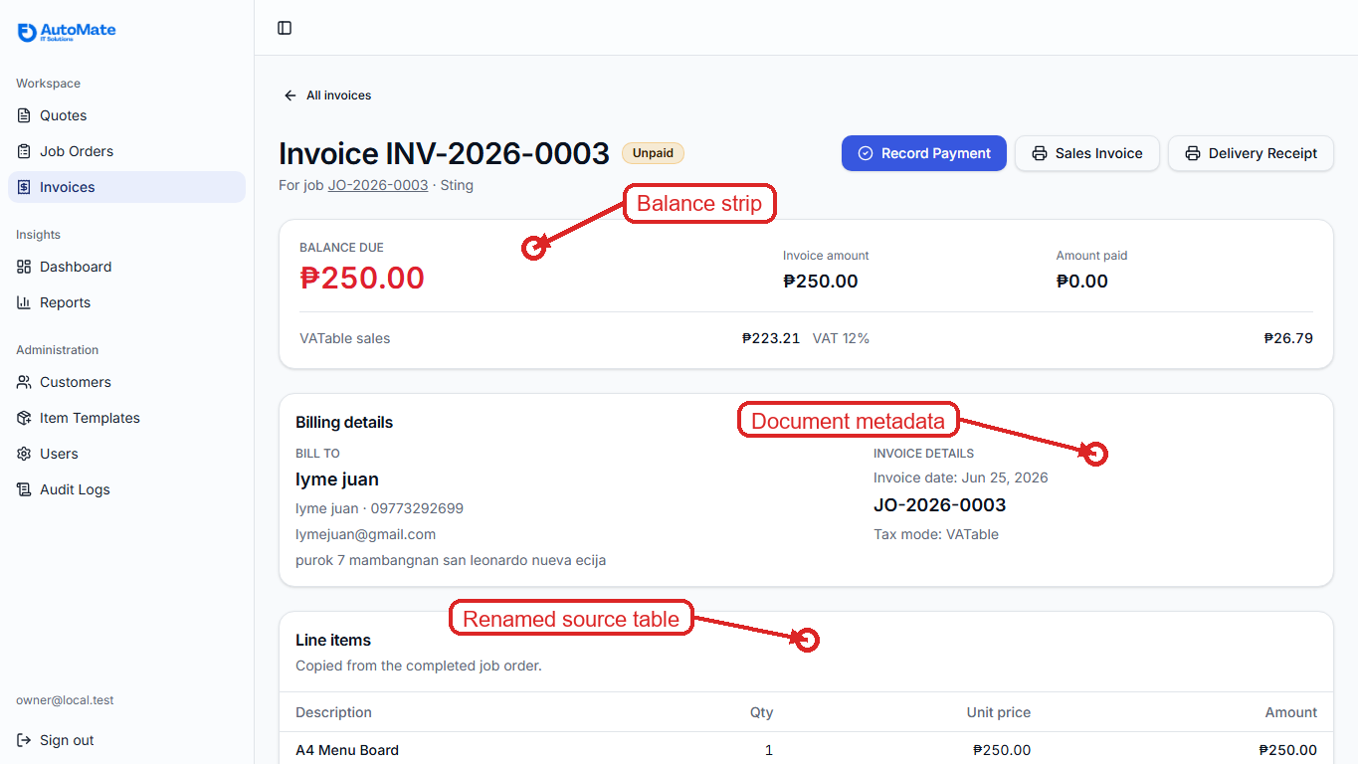

Delivery Receipt: VAT Context On Priced DR
The priced delivery receipt now shows the transaction tax mode and VAT computation when the job is VATable. Non-priced receipts remain clean and do not expose amounts.
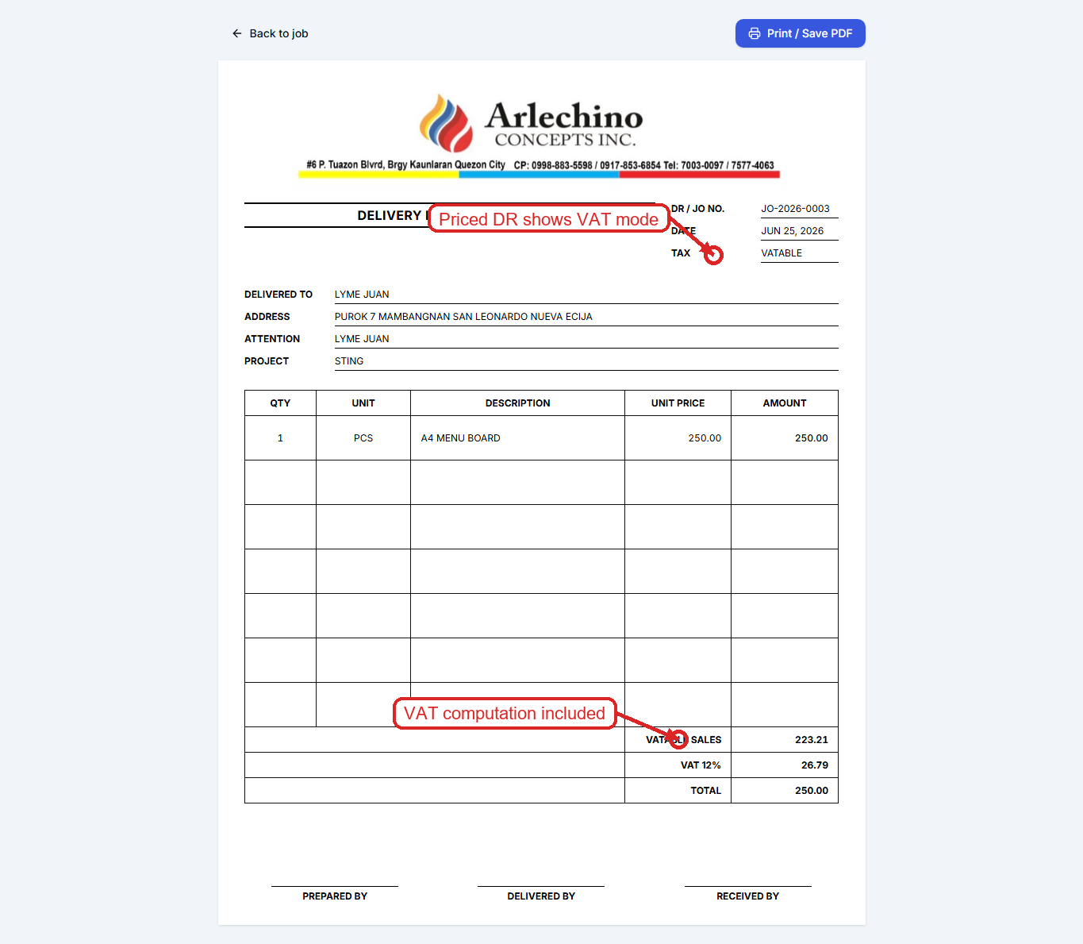

Customer Form: TIN Formatting
TIN input now formats into the expected pattern while typing. This makes customer entry easier to verify and supports the unique-TIN rule without making users memorize formatting.
