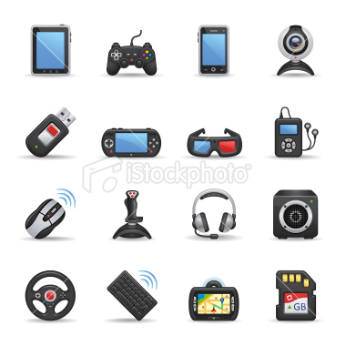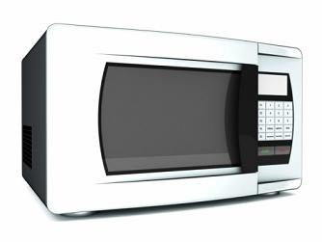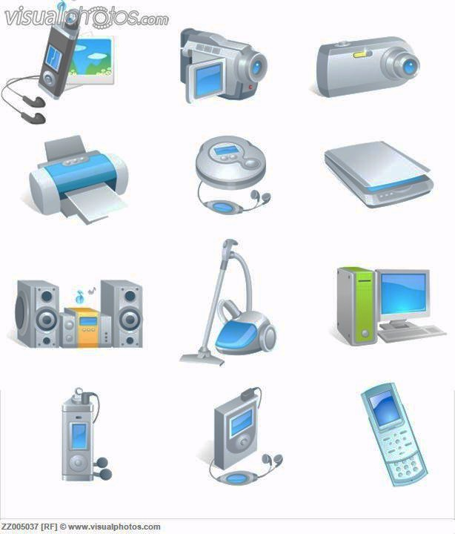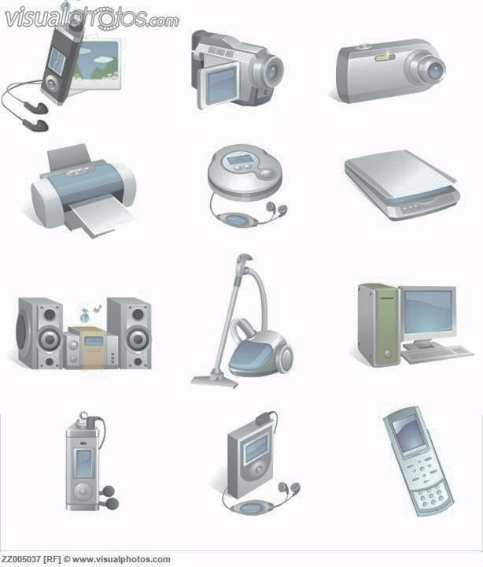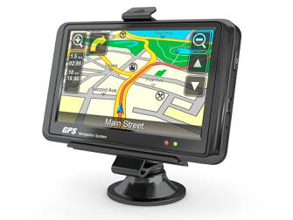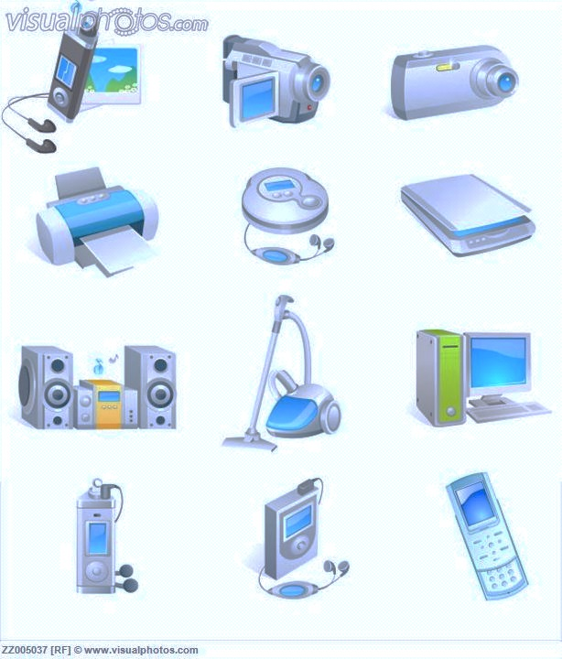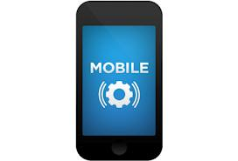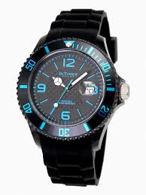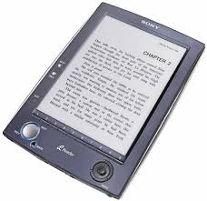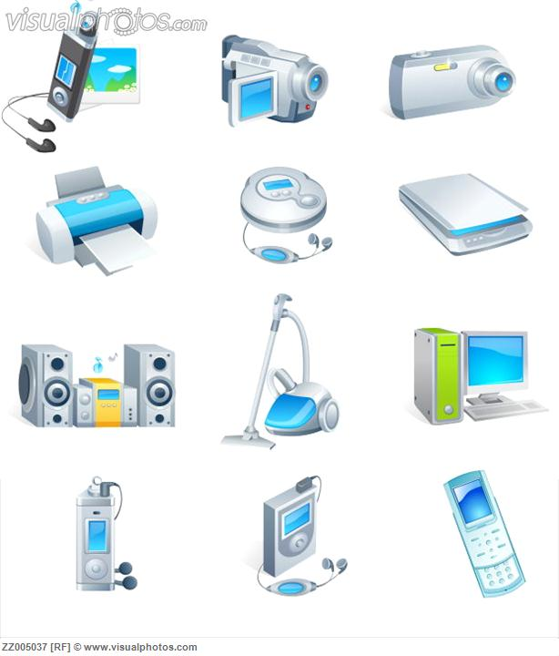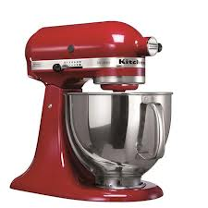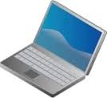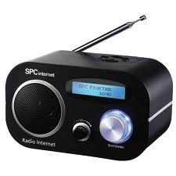Macintosh HD:Users:isabel:Desktop:images-7.jpeg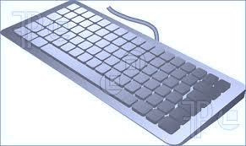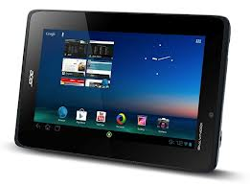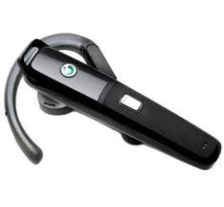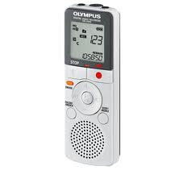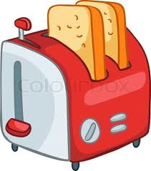

now use them in context. choose one of the words to complete the sentences

1. My ______________ is almost empty. I only have a few eggs, some cheese and a bottle of beer in it.
2. I think I'd like to buy a/an _______________ which can brown up to four pieces of bread
3. Put the saucepan on the ____________ and simmer for three minutes.
4. Throw your wet clothes into the __________________. They should be ready in about 20 minutes.
5. Could you get the ___________ out and clean the living room?
6. Many students have a __________________ in their rooms so they can at least cook melted toast and cheese.
7. Put the roast into the ______________ and let it roast for 45 minutes.
8. I bought ten pounds of salmon and put it all into the _____ to keep until the party next week.
9. There's nothing like a **___________**to make cleaning up after dinner easy.

**1.**you wash clothes in it

**2.**you bake food in it

**3.** you press clothes flat and remove wrinkles with it

4. you keep food frozen with it

5. you wash your dishes in it

6. you heat food with it using energy waves

7. you dry clothes with it

8. you keep food cold with it

9. you heat pots and pans on it

10. you toast food

11. you clean the floor with it

what about household appliances? match the with their use.

**A. freezer**

**B. cooker**

**C. dishwasher**

**D. iron**

**E. refrigerator**

**F. dryer**

**G. toaster**

**H) washing machine**

**I) vacuum cleaner**

**J) microwave**

**K) oven**

**18. Mouse**

**19. Printer**

**20. Loud speaker**

**21. Bluetooth Headset**

**22. Wrist watch**

**23. Web cam**

**24. Camera**

**25. Joystick**

**26. television**

**27. Cordless pnone**

**28. Headphones**

**29. kitchen robot 30. mixer**

**31. Gamepad**

**32. Gameboy**

**33. Radio**

**34. Scanner.**

**35. Pen drive**

**write the correct name under the picture**

1. **Memory card**
2. **Pda**
3. **Cd player**
4. **Mp3 player**
5. **Stereo**
6. **Microwave**
7. **Mobile phone**
8. **Steering wheel**
9. **Tablet**
10. **Dictaphone**
11. **Video camera**
12. **Fax machine**
13. **Gps**
14. **Laptop**
15. **3d glasses**
16. **E-book**
17. **Keyboard**

**TECHNOLOGY**

what do you need If you want to…

1. **take a picture _____________________________________**
2. **record some images __________________________________**
3. **listen to music _____________________________________**
4. **type on your computer_________________________________**
5. **control the cursor without keying _____________________**
6. **store digital information_____________________________**
7. **control your video games______________________________**
8. **send scanned printed material__________________________**
9. **play games in a handheld console_______________________**
10. **make or recive telephone calls__________________________**
11. **scan images or printed text to convert it to a digital image______________________________________________**
12. **answer someone calling you while driving____________________________________________**
13. **cook, bake, defrost, and heat _________________________**
14. **catching up on news, soaps, matches and sitcoms_________________________**
15. **determine your vehicle's current position and location and be guided in your way ahead.___________________________**
16. **know the time_______________________________________**

|  |  |  |  |  |
| --- | --- | --- | --- | --- |
|  |  |  |  |  |
|  |  |  |  |  |
|  |  |  |  |  |
|  |  |  |  |  |
|  |  |  |  |  |
|  |  |  |  |  |
|  |  |  |  |  |
|  |  |  |  |  |
|  |  |  |  |  |
|  |  |  |  |  |
|  |  |  |  |  |
|  |  |  |  |  |
|  |  |  |  |  |
|  |  |  |  |  |



All of the biggest technological inventions created by man - the airplane, the automobile, the computer - says little about his intelligence, but speaks volumes about his laziness.  ~Mark Kennedy

If Life Were Like A Computer:

* You could add/remove someone in your life using the control panel.
* You could put your kids in the recycle bin and restore them when you feel like it!
* You could improve your appearance by adjusting the display settings.
* You could turn off the speakers when life gets too noisy.
* You could click on “find” (Ctrl, F) to recover your lost remote control and car keys.
* To get your daily exercise, just click on "run"!
* If you mess up your life, you could always press "Ctrl, Alt, Delete" and start all over!

reading

The availability of electronic gadgets has multiplied over the years, and the technology of these devices has only improved. They exist for every facet of life, from entertainment to education and from work to play. Entertainment gadgets include **mp3 players**, **book e-readers**, **portable movie players, cell phones, and digital cameras**. Gadgets for work include **cell phones**, **portable computers and tablets**, **digital watches**, and many more. Gadgets seem to be available to suit any need in the modern age.

The general purpose of most electronic gadgets is to make life easier, more fun, or more efficient. **Computers** are perhaps the most sought-after electronic gadgets that fall into just about any category. **Tablets** are thin, small computers that are touch-screen activated and navigated. Another gadget close to such tablets is the **smart phone**, which is a combination of a computer, telephone, and camera.

**Digital cameras** are increasingly popular electronic gadgets because they have become much easier to use and produce better pictures than ever before. The photos can be uploaded quickly to computers for display on websites or printing onto traditional photo paper. Smaller cameras are so small as to fit in one's pocket, and now even high definition **video cameras** are made to fit too, yet still high quality enough to produce sharp, attractive videos.

The impact of all these products can be tremendous, in fact, new technology can completely revolutionize the way we play, communicate, work and live our lives.

|  |  |  |
| --- | --- | --- |
|  | **agree** | **disagree** |
| 1. Technological advances make life better for everyone. |  |  |
| 2. It’s important for adults to find out where their children are going online and who they are talking |  |  |
| 3. Computer technology makes finding information faster and easier. |  |  |
| 4. If people let machines do too much for them, eventually people will no longer be able to do things for themselves. |  |  |
| 5. Children should be given more freedom in deciding what they do online |  |  |
| 6. It is impossible to become addicted to the Internet. |  |  |
| 7. It is dangerous to place too much faith in technology. |  |  |
| 8. Children who play computer games often believe that the violent games they play portray life as it actually is. |  |  |
| 9. Most teenagers are online too much. |  |  |
| 10. Those who worry about the negative effects of technology should think about the modern conveniences available today. |  |  |
| 11. Adults too often use the computer games as a kind of babysitter for their children. |  |  |

before the computer

An **application** was for employment

A **program** was a TV show

A **cursor** used profanity

A **keyboard** was a piano!

**Memory** was something that you lost with age

A **CD** was a bank account!

And if you had a **broken disk**,

It would hurt when you found out!

**Compress** was something you did to garbage

Not something you did to a file

And if you **unzipped** anything in public

You'd be in jail for a while!

**Log on** was adding wood to a fire

**Hard drive** was a long trip on the road

A **mouse pad** was where a mouse lived

And a **backup** happened to your commode!

**Cut** , you did with a pocket knife

**Paste** you did with glue

A **web** was a spider's home

And a **virus** was the flu!

From my english pages

based on the reading answer the following questions.

1. Can you name some general uses of technology?

________________________________________________________________________________________

2. What is the main purpose of using technology?

________________________________________________________________________________________

3. Among the gadgets mentioned in the text which ones appeal to you the most? Why?

____________________________________________________________________________________________________________________________________

4. Which is people’s favourite gadget?

____________________________________________

5. What are new digital cameras so popular for?

________________________________________________________________________________________

We live in a society exquisitely dependent on science and technology, in which hardly anyone knows anything about science and technology. Carl Sagan

"Never before in history has innovation offered promise of so much to so many in so short a time."  **--Bill Gates**

The production of too many useful things results in too many useless people.  ~Karl Marx