C Programming Assessment
Graphics option

Examination number: REDACTED

Deadline: 14th January 2014

Requirements
The task for the assessment is to write a computer program to a particular set of requirements.
This is a list of the requirements according to the assessment brief:
- The program must be written in the C programming language.
- The program must be a game.
- Playing the game must involve throwing or launching some kind of object.
  - Implied by this requirement is a requirement for part of the game play to involve the player attempting to hit a target.
- The area between the throwing/launching position and the target must be obstructed in such a way that hitting the target is made challenging.
- The simulation of the object being thrown must account for gravity.
- The game must include some other difficulty.
  - This implies that static obstructions alone will not suffice.
  - Examples of other difficulties include wind and 'passing birds' (birds are merely moving obstructions).
- The game must be enjoyable and playable by somebody inexperienced with computers
  - This implies that the controls must be intuitive and easy to master. The way the game world reacts should be familiar. (It should act like the real world where possible.)

The brief also makes recommendations that are not strict requirements. These are listed here.
- The game could have a theme.
- The game could have several different levels of difficulty.
- The game could provide the user with scores and statistics.
- The game should not be frustrating to play.
- The game should be innovative.

Analysis
The requirements for this assessment clearly require that a shooting or throwing target game is written. The game will therefore involve a character of some description using a bow and arrow to attempt to hit a target.

Inputs and outputs
This game requires graphics output window. The size of the window that displays the graphics can vary and so should be designed to work on most reasonable screen sizes. Information will be displayed to the user using text in the game window. The graphics, including text, will be the most important output from the program.

Part of the requirement is to make it easy to play for someone with little experience operating a computer and so the controls should be kept as simple as possible. The most intuitive control available on most personal computers is the mouse. As much of the control system as possible will be based on pointing with the mouse cursor and clicking. When aiming and firing, the mouse should be the only input needed. The character on the screen will aim towards the mouse cursor. The distance from the character to the cursor will determine a relative power for the bow (how far back the character pulls the bow). The program will need to be able to respond to the mouse wherever it is on the window.

Other controls may be required for moving the character. For this a keyboard can be used, the number of keyboard controls should be kept to a minimum. Using the arrow keys on the keyboard will provide an intuitive method for the user to move the character in a particular desired direction. It is safe to assume that anyone wanting to play this game will have at least the knowledge of how to operate these controls and understand the basic concept of the game.

According to data collected by w3schools.com1, in January 2012, on their visitor's screen specifications, the game would be compatible with at least 97% of users screens if it supports displays from minimum resolutions of 800×600 pixels and colour depths of 16,777,216 colours (24 bits per pixel).

The game will therefore use these minimum settings and expect the mouse pointer to be somewhere in a rectangle that is at least 800×600 pixels. The graphics window that is displayed will default to a size of 800×600 pixels and be set to use 24bpp colour depth. This size will be adjustable to better fit the screens of each individual user.

So to summarise the inputs and outputs, the game will accept input from the user by means of the left and right arrow keys on the keyboard, the mouse pointer location and the mouse buttons.
The game must respond appropriately when the mouse pointer is moved anywhere within the game window. The game will require a screen with at least 800×600 pixels and 24bit colour depth.

Important formulae and algorithms

The game will implement a basic simulation of physics. This must account for Newton's three laws of motion. To provide an over-simplification of the three well-known laws; An object in motion remains in motion unless acted on by an external force. The net force applied to an object is proportional to the mass of the object multiplied by its acceleration. Any action (force) causes an equal and opposite reaction.

So to simulate physics in a way that complies with these laws, the simulation will need to know the current velocity, the mass and the sum of all forces acting upon each simulated object. The acceleration caused by each force can be calculated by dividing the force by the mass of the object.

The change in velocity can then be calculated by multiplying the acceleration by the time in which it happens. This change in velocity can then be applied. The total velocity can then be multiplied by the time difference to get a displacement and thus calculate a new location.

The simulation also needs to look for collisions. For reasons of simplicity, this will be kept to just circle collisions for now as these are simple to detect. Two circles are touching If the distance between their centres is less than the sum of their radii. The simulation uses discreet time steps however and so will need to check the path that each object takes to see if it passed through another object in that step. Where this happens, the simulation should detect a collision. Drawing 7 On page 17 shows how the physics simulation can miss a collision when the step distance is too great.

This will simulate the motion of objects according to the three laws. This is summarised by the pseudo code in 'Appendix 1: Pseudo code, Basic physics algorithm' on page 12.

Another important equation is the one that calculates the angle at which the stickman must aim his bow and arrow to point it at the mouse cursor. This is just basic trigonometry. The theory is outlined in Drawing 5 on page 16.

The aim angle is the sum of two angles. The first is the angle between the X-axis line and the line from the pivot point (the stickman's neck) to the cursor. This is equal to the arctangent of the difference in Y divided by the difference in X between those two points. The second is the angle between the same line from pivot to cursor and the line that the arrow would take when fired (if there was no gravity). This is calculated by the arcsine of 'neck to bow' distance divided by the distance from the pivot to the cursor.

Other details
The game must have various difficulties. It will have different types of obstructions on potential paths to the target and wind will affect the path of the arrow.
The game will have multiple levels of difficulty. Each level must be completed before the next level is reached and so the game will get more difficult as it is played. Levels further on in the game will have more obstructions, increasingly awkward obstructions and increasingly strong winds.

Some details of the game are not so explicitly defined by the requirements however.
They will now be discussed.

Details of the simulation of the path of the object are not made fully clear. There is no requirement that air resistance is simulated despite recommending wind as a potential difficulty. The force of gravity is also not specified as a detail of the simulation. The game will simulate air resistance and will assume that the character is standing somewhere near sea level on earth as this is likely to be a familiar scenario for the user. The gravity will therefore be roughly 9.8 m/s² in the direction of the centre of the earth. The physics simulation within the game will account for gravity, air resistance, wind and collisions (both with obstructions and with the ground).

No specific library is required for producing the graphical output. This decision has been left open and familiarity will be preferred. The game will use OpenGL along with FreeGLUT to display the graphics. This choice was helped by the fact that OpenGL is well documented and well supported.

There is no specific requirement for the exact aim of the game or how many chances a player should be given to complete the game once started. The aim of the game will be to complete as many levels as possible without losing more than three lives.

The number of players is not mentioned in the requirements. The game will be for one or two players. The two player mode will allow a player to play until they lose a life, the next player is then allowed to play until they lose a life and so the process repeats. The winner is the last player standing.

The way the scene is viewed is also not specified. I will have my scene viewed as if by a third person standing at ground level, looking forwards and seeing the character to their left and the player's target to their right.

This covers most of the basic ideas for the way the game will work.

Specification

This is a more detailed specification for how the game will work.

The basic application
When the program starts, the user should be presented with the main window, showing the main menu. This menu should allow the user to start a game for one or two players. It should also provide a means of viewing credits and instructions on how to play. These actions should all be accessible using clickable buttons. The menu should have a similar look and feel to the main game view. This is not mandatory to meet the requirements but makes the game easier to use and understand.

Once the game is started, the menu should disappear, the current level number and number of lives remaining should be displayed somewhere easily readable but not be intrusive into the rest of the game area. An indication of wind speed and direction should be provided when needed. A character should be shown on a flat surface, towards the left of the screen and various obstructions and a target to the right side of the screen. In the interests of simplicity, the character will be rendered as a simple stickman.
The player should be able to click and hold, using the mouse, somewhere on the scene to aim the bow and arrow and determine its firing power. Releasing the click should fire the arrow. This part of the program satisfies most of the mandatory requirements.

The game will advance itself to the next level once the player succeeds in hitting the target with the arrow. When the game is finished, either by completing the ultimate level or losing all lives, the main game scene should disappear and the main menu should appear again.

A clickable button will be provided for exiting the game early. The menu should also provide an option to make the game appear full-screen. These are both not required but will make the game more user friendly.

Design

Basic visual design
The user interface will be presented in a single window. This window will be used to display the menu system and the game scene. These should have a similar look and feel to ensure that they appear to be part of the same game. Fonts used for buttons should be consistent and easily readable. Fonts used for larger titles and instructions should also be consistent and easily readable but can be more detailed as they will be larger. An example of the menu and the game scene can be found in Drawing 1 and Drawing 3 (Starting on page 14).

The design is kept simple with all views showing the same grass and sky combination. The buttons will have a uniform look to them to make it obvious where all of the buttons are.

The basic backdrop will be the sky and the grass and so these are drawn first. The sky will be a solid light-blue colour and so to start drawing, the window will be cleared to light blue. The grass will then be drawn at the bottom of the window using a grass-like bitmap texture. This will be on all parts of the game.

The main menu
The main menu will draw the title near the top of the window “Shooting Practice”. It will then draw all of the buttons. The buttons for starting the game (in one or two player mode) will be in the middle of the screen, just above the grass, so that they are seen to be the two most important buttons. Although Drawing 1 suggests that the “How to play” button will be here too, it will be better to have this on the grass, lower down, as this is not a button that will be needed regularly. This button should only be needed once for any one user.
Credits and full-screen buttons will also be drawn on the grass, as close to the bottom as possible.
The default button colour will be a light-red colour as it will provide good contrast on both blue and green backgrounds. The two player button will be a darker blue colour which will allow quick distinction between the two player and one player buttons.

The game scene
The main game scene will also have the standard sky and grass. The game scene however will then draw some statistics at the top of the screen. These include number of lives remaining and the current level number. The number of lives will be drawn at the top right corner of the screen preceded by the text “Lives: ” with a visual representation of the remaining lives in the form of a number of mini stick-men. The level number will be drawn in the top left corner preceded by the text “Level: ”.

A stickman will be drawn standing on the grass towards the left of the screen. The stickman can move left and right with input from the keyboard arrow keys. The position of the stickman will be limited. The stickman cannot move off the left of the screen and cannot get within half a meter (simulation distance) of the centre of the screen.

If the user is holding the mouse button down then the stickman will be drawn in the firing position with his bow pulled back. The bow will aim towards the mouse cursor if it is in-front of the stickman. If it is behind the stickman then it will aim away from the cursor. The distance from the stickman's neck decides how far back the bow is pulled (and so the speed of the launch). The user can place the cursor anywhere on the window to do this and so it must be limited. The limit will be the furthest the stickman can pull the bow back without extending his right arm behind his right elbow (the arm towards the left of the screen).

When the user releases the mouse button, a physics simulation will begin that simulates the arrow being fired and reacting with obstacles. If the arrow reaches the target then the game will advance to the next level and reset the physics simulation.

Each level has its own pattern of obstructions. Some of them you must not hit, some of them you can hit (the arrow bounces off) and there is at least one that you must hit to complete the level (the target). These are simply circles drawn in the right half of the screen. Green circles are bouncy, red circles are 'instant death' and yellow circles are targets.

The last element drawn is the exit button in the bottom left corner. This is yellow so that is stands out easily and gives a hint towards its function. Clicking this button exits the game and returns to the main menu.

The credits page
This page will be shown when the user clicks on the 'Credits' button from the main menu. On the same sky and grass background, the title will be displayed at the top just as in the main menu. There will be the credits text on the rest of the sky and a button at the bottom to exit the credits page.

The manual
The manual will be made of many pages. It will be a series of images with text explaining various aspects of the game. A 'next page' button and 'previous page' button will be displayed on the grass to move between the pages of the manual.

Structure of the program

Important parts of the code
Some of these are shown in Appendix 1: Pseudo code on page 11.

The pseudo code shows the basic flow of the program. When it starts, it must initialise a window for drawing, load any resources it needs to play the game and then start looping around the function that draws the next frame. There is much more depth to the program however. It also shows some details of the important algorithms needed.

The basic flow of the program is shown in Drawing 6 on page 17.

The program will use OpenGL and FreeGLUT. FreeGLUT will do the handling of the loop that calls the draw function. OpenGL will be used for all of the rendering

The basic libraries that will be required are listed here;
- A graphics library (OpenGL and FreeGLUT)
- An input event handler (Part of FreeGLUT)
- A custom library for managing a graphics window (A wrapper around FreeGLUT)
- A custom library for drawing a stickman
- A simple [custom] physics library (some example pseudo code shown)
- A [custom] image loading library for textures.
- A [custom] library for rendering text (from font files or from image files)

Some libraries ideal for these purposes may be available already and some may need to be written.

Overview of files
The game will be written as many different files and will require many libraries. Each library will consist of at least a header file (.h) and a source code file (.c). Individual libraries may need more than one header and source code file in the interest of keeping the code manageable.
The main program will also have a header file and source file.
There will also be a series of test programs for some parts of the code. These tests will each have a header file and source file.

The source files can be organised into folders and so groups of files for libraries can be kept from other files. This also makes the project, as a whole, more manageable

The planned file structure should be something like the following:

Folder: user_interface
mainWindow.c
mainWindow.h
uiButtons.c
uiButtons.h
imageFileLoader.c
imageFileLoader.h
Folder: physics
mainPhysicsLibrary.c
mainPhysicsLibrary.h
physicsObjects.c
physicsObjects.h
collisionDetection.c
collisionDetection.h
Folder: stickman
stickman.c
stickman.h
Folder: tests
userInterfaceTest.c
userInterfaceTest.h
imageLoaderTest.c
imageLoaderTest.h
physicsTest.c
physicsTest.h

This is not set in stone at this point and could change massively during the implementation.

The functions that will be required for each of these will be something like the following;

mainWindow:
structure: windowStruct A structure that defines a window
show(windowStruct); Display a window
setDrawingFunction(function pointer); Register a callback for drawing the scene
setKeyboardFunction(function pointer); Register a callback for keyboard events
setMouseFunction(function pointer); Register a callback for mouse events

uiButtons:
structure: button A structure that defines a button
drawButton(button); Draws a button on the windowstruct
buttonClickFunction(button, function pointer); Set the button click event

imageFileLoader:
structure: image A structure that contains an image
loadImage(filename); Load an image from a file
imageToTexture(image); Turn an image into an OpenGL texture for drawing

mainPhysicsLibrary:
structure: physicsWorld The world for a physics simulation
stepWorld(physicsWorld, time); Make a time step in a physics simulation

physicsObjects:
structure: physicsObject An object in a physics simulation
stepObject(physicsObject, time); Make a time step for simulated physics object
applyImpulse(physicsObject, force, time); Simulate an impulse on an object

collisionDetection:
objectsHaveCollided(physicsObject, physicsObject); check to see if two physics objects have collided. This must return a boolean value and the collision's normal vector.

Stickman:
drawStickman(pose); draw a stickman either standing or ready to fire (depending on pose)

Test functions
userInterfaceTest: must test the UI window and its basic functions
imageLoaderTest: must load various compatible images to confirm the library can load them
physicsTest: must provide a basic test of the physics library.

Like the files structure, these functions may change, they may be removed if not needed or more functions added if these are not enough.

This is the last part of the design stage for the game. It is now ready to be written.

Implementation Report
As the program was implemented, doxygen style comments were used. The doxygen program was then used to generate a list of files used and of functions within each file. The entire documentation of the implementation is available and should be supplied with this report (look for documentation/doxy/html/index.html)
The file list is shown in Appendix 2: Final File List on page 13. To avoid documenting over 130 functions in this report, individual function documentation is in the doxygen documentation.

Changes made
Some minor changes were made to the structure of the files in that better names were chosen for many of them. A 'utils' folder was added which contained files that defined some useful types for the program. These were a C++ style 'bool' type and a 'vector3' type which simply stores a 3D vector. Lots of functions for manipulation of these vectors are contained in a file in this folder.
The other big change was the addition of a countdown timer for each player in two player mode. This was added to make the game go faster and be more of a challenge and try to ensure that each player gets a fair chance.
Another small change was to have mostly just text in the user manual. This made the program simpler and used less system memory and hard disk space as there are no images to store or load.

Testing and Verification
Individual parts of the program were tested to ensure that they worked properly.
The test programs were written to test libraries that were written for this assessment to ensure that they worked properly.
Four test programs were written. These were written at various times during the writing of the main program.
The first test written was the 'glWindowANDglDrawFuncsTest' program. This was written to test the 'glwindow' library that was written as a wrapper around FreeGLUT. The test was written as a quick way of testing the window and drawing functions to ensure that they worked to eliminate causes for bugs in the main program. Several bugs were found using this test program and were fixed. These included the mouse position not lining up correctly, the 'glwindow' library's rotation wasn't fully working and some drawing functions were not drawing anything.
A test program for the stickman was written, 'stickmanTest'. This was mostly for convenience as the causes of problems with drawing the stickman should be obvious anyway.
The third test was for the bitmap loader. This allowed the testing of bitmap image loading and bitmap font files. This made it easy to confirm that all images would be correctly positioned and text would be rendered in the right place. To do this in the main program would take much longer.
The last test was for part of the physics library that was written for this project. 'lineCircleIntersectTest' was written to make sure that collisions could be detected between lines and circles. The simulation moves in discreet time steps. Objects that move in large steps, either by moving fast or by taking long time steps, may pass through other objects without collision being detected. The problem is illustrated in Drawing 7 on page 17. To solve this problem, the path of an object (the object being a circle in this case) can be modelled using a straight line from its centre before its step to where its centre would be after the step. The simulation can then check to see if this line would cut a given circle and therefore detect if a moving circle will pass through that circle. This effectively allows the circle's collision to be detected before it even happens.
Other parts of the program didn't need as thorough testing as it would be obvious, from the use of them, if they worked or because they were to be written directly in the main program anyway. These included button handling for the menus, the aiming and firing of the stickman and the loading of level data.
To test the game as a whole, it was played with a wide range of possible scenarios. The firing of the bow and arrow was tested by placing the mouse in as many different places and checking to see that the bow fired correctly when the mouse was clicked. The logic of the game (deduction of lives, time limits, which player is currently playing, etc.) was tested by having many different combinations of wins, losses and time-outs during the game. Some bugs were found including only player two's lives being shown in two player mode and the game not resetting after a time-out.
As problems were found, the causes were found by debugging the program using various methods. In most cases, trace code was added that would allow the program to run as normal but report the current state of particular variables at set points using calls to 'printf'. In cases where a more in-depth look was required, the application was compiled with GDB (Gnu Debugger) debugging info enabled and was examined using the GDB debugger front-end that is part of the CDT (C / C++ Development Tooling) plug-in for the Eclipse IDE. This allowed the program to be paused and stepped-through line by line and allowed viewing of nearly any variable that needed examining.
The program was tested on two very different machines to ensure that it worked well anywhere. It was tested on a 32 bit machine running Ubuntu with a low-end graphics card and a 0.8GHz processor and on a slightly more powerful 64 bit machine running Debian with a mid-range graphics card and 2GHz processor. It was found that on the less capable machine, the texture size limit prevented a particular bitmap font texture being loaded. This problem was solved by adding in code to find out the texture limit and load a smaller bitmap if needed. This causes one of the fonts in the game to look pixelated on some computers. This is the cost of getting it working on a wider range of PCs.
Testing the program on different machines helps to find various problems and instabilities. The program was thoroughly tested on both machines and found to be very stable.

Appendix 1: Pseudo code

Main program
This is the most fundamental part of the program. The main function and the draw loop.

Begin main_program

do: Initialise OpenGL context
do: Register keyboard event handlers
do: Register mouse event handlers
do: Register draw loop callback
do: Load image resources

variable last_time = get_current_time

variable game_mode = MainMenu

do: run_draw_loop

End main_program

Begin function run_draw_loop
Repeat
do: draw_loop
Until game_exited
End

Begin function draw_loop

variable time_delta = get_current_time – last_time

Begin selection for game_mode
If MainMenu Then
do: draw_main_menu(time_delta)
If OnePlayer Then
do: draw_one_player_game(time_delta)
If TwoPlayer Then
do: draw_two_player_game(time_delta)
If Credits Then
do: draw_credits_screen(time_delta)
If Manual Then
do: draw_user_manual(time_delta)
End selection

End draw_loop

Stickman Aiming code
This is the code used to determine the angle that the bow should aim.

Begin function get_bow_aim (Parameters: mousePos, myStickMan)
define variable B1 = (mousePos.x - myStickMan.neck.x)
define variable P1 = (mousePos.y - myStickMan.neck.y)
define variable theta1 = (arctangent(P1 / B1))
define variable hyp = square_root((B1*B1) + (P1*P1))
define variable P2 = DISTANCE_TO_BOW
define variable theta2 = (arcsine(P2/hyp))
Result = theta1 + theta2
End function

Basic physics algorithm
This is the basic flow of the code that steps an individual physics object

Begin Function physics_object_step (parameters: object, time_delta)

If object.isEnabled Then Begin

If Not object.isStatic Then Begin

set object.airResistance =
-object.velocity * object.airResistanceFactor

object.previous_position = object.current_position;

object.total_acceleration =
result of get_total_acceletaion(object)

define variable change_in_velocity =
object.total_acceleration * time

set object.velocity =
object.velocity + change_in_velocity

define variable this_step = object.velocity * time

object.current_position = object.current_position + thisStep

define variable step_distance =
result of calculate_distance_between
(object.current_position, object.previous_position)

object.computed_speed = step_distance / time;
End

If object_violates_constraint(object) Then Begin
do: move object within constraints
End
End

End Function

This is the function that provides an impulse on the object. It is used to fire the arrow from the bow.

Begin Function physics_object_impulse (object, impulse_force, duration)

define variable adjustment = impulse_force * (duration / object.mass)
set object.velocity = object.velocity + adjustment

End Function

Appendix 2: Final File List

(Root Folder) | (FOLDER)
clab_assignment_graphics.h & .c | The main program
myColours.h | Definitions of basic colours for use in the game
MyCoords.h | Header file containing fixed coordinates and vectors
simLevels.h & .c | Simple fixed level data source
ogl_gui | (FOLDER)
bitmapFonts.h & .c | Functions for drawing fontmap texture in OpenGL
bitmaps.h & .c | Functions for loading bitmaps and generating textures in OpenGL
buttons.h & .c | Allows drawing of buttons on an OpenGL context
colours.h & .c | Utility for handling colours in OpenGL
errors.h & .c | Reports full error messages from OpenGL
glDrawFuncs.h & .c | Provides many useful OpenGL drawing functions for basic shapes
glwindow.h & .c | A small wrapper around FreeGLUT
vector3.h & .c | Structures and functions for handling vectors
physics | (FOLDER)
collisions.h & .c | Detects collisions between various objects
collisionTypes.h | Defines collision types
constraints.h | Defines constraints
forces.h | Defines forces
objects.h & .c | Objects used by a physics world
physics.h & .c | A simple physics library
world.h & .c | Utilities for handling lots of physics objects at once
stickman | (FOLDER)
stickman.h & .c | For drawing stickmen
tests | (FOLDER)
bitmapTest.h & .c | A quick test of the bitmap loader and the font rendering libraries
glWindowANDglDrawFuncsTest.h & .c | A quick test of the glWindow library
lineCircleIntersectTest.h & .c | A quick test of line to circle collisions.
stickmanTest.h & .c | A quick test of the stickman library
utils | (FOLDER)
boolean.h | Provides a C++ style boolean type
keys.h & .c | Simple FreeGLUT keyboard handler

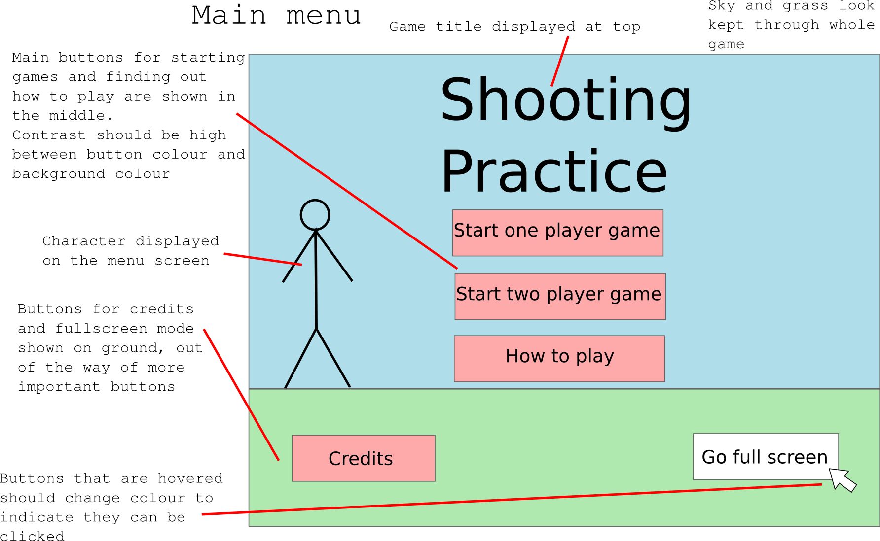Drawing 1: Main menu design and layout
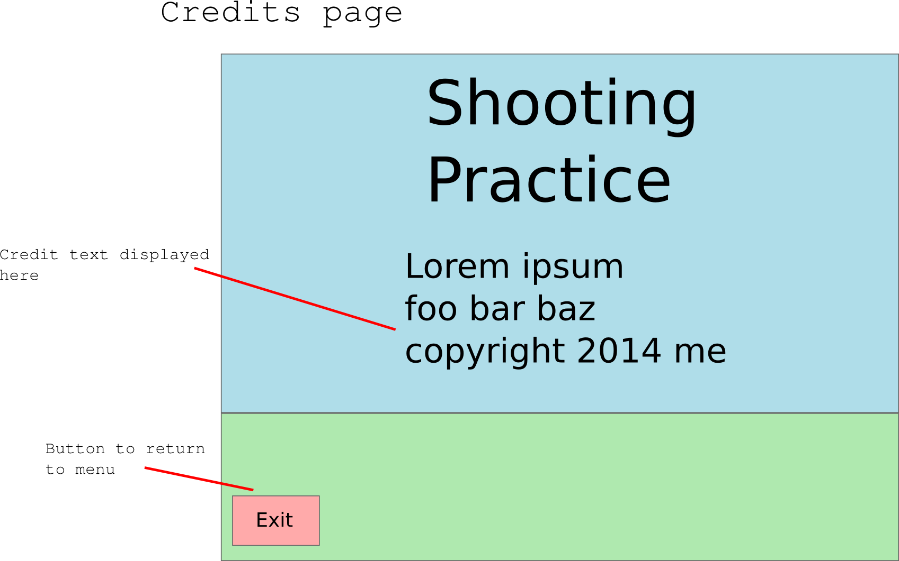Drawing 2: Credits page design and layout

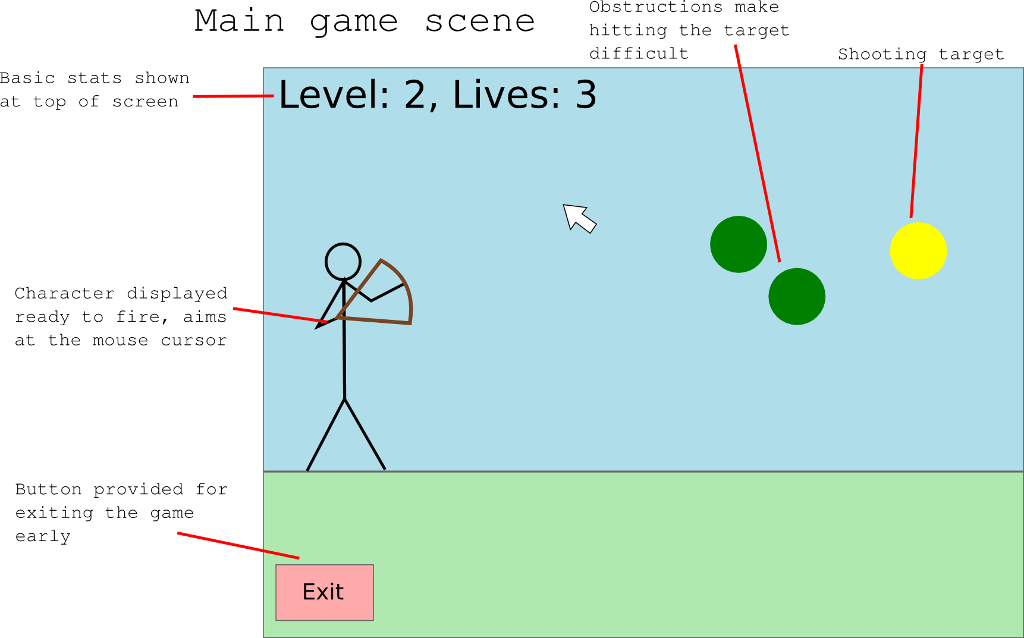Drawing 3: Main game scene design and layout
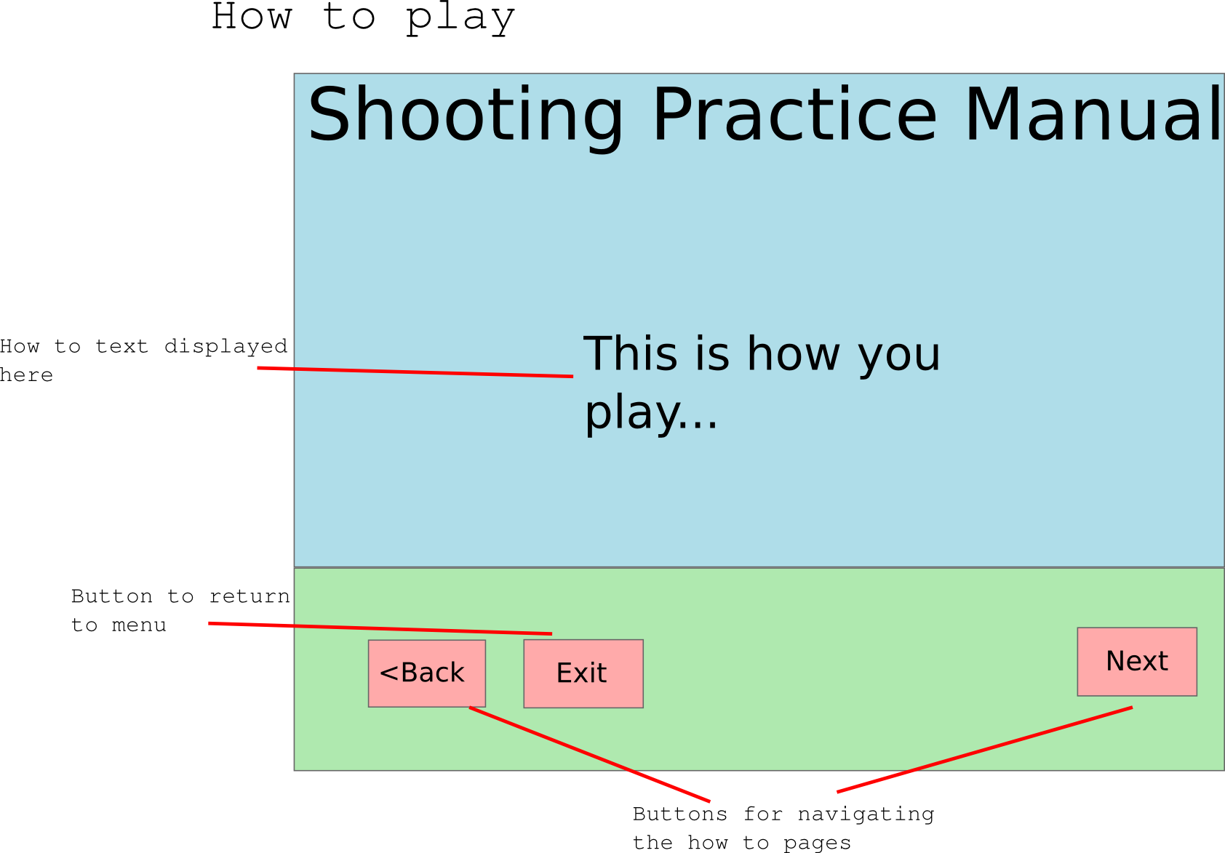Drawing 4: 'How to play' guide page

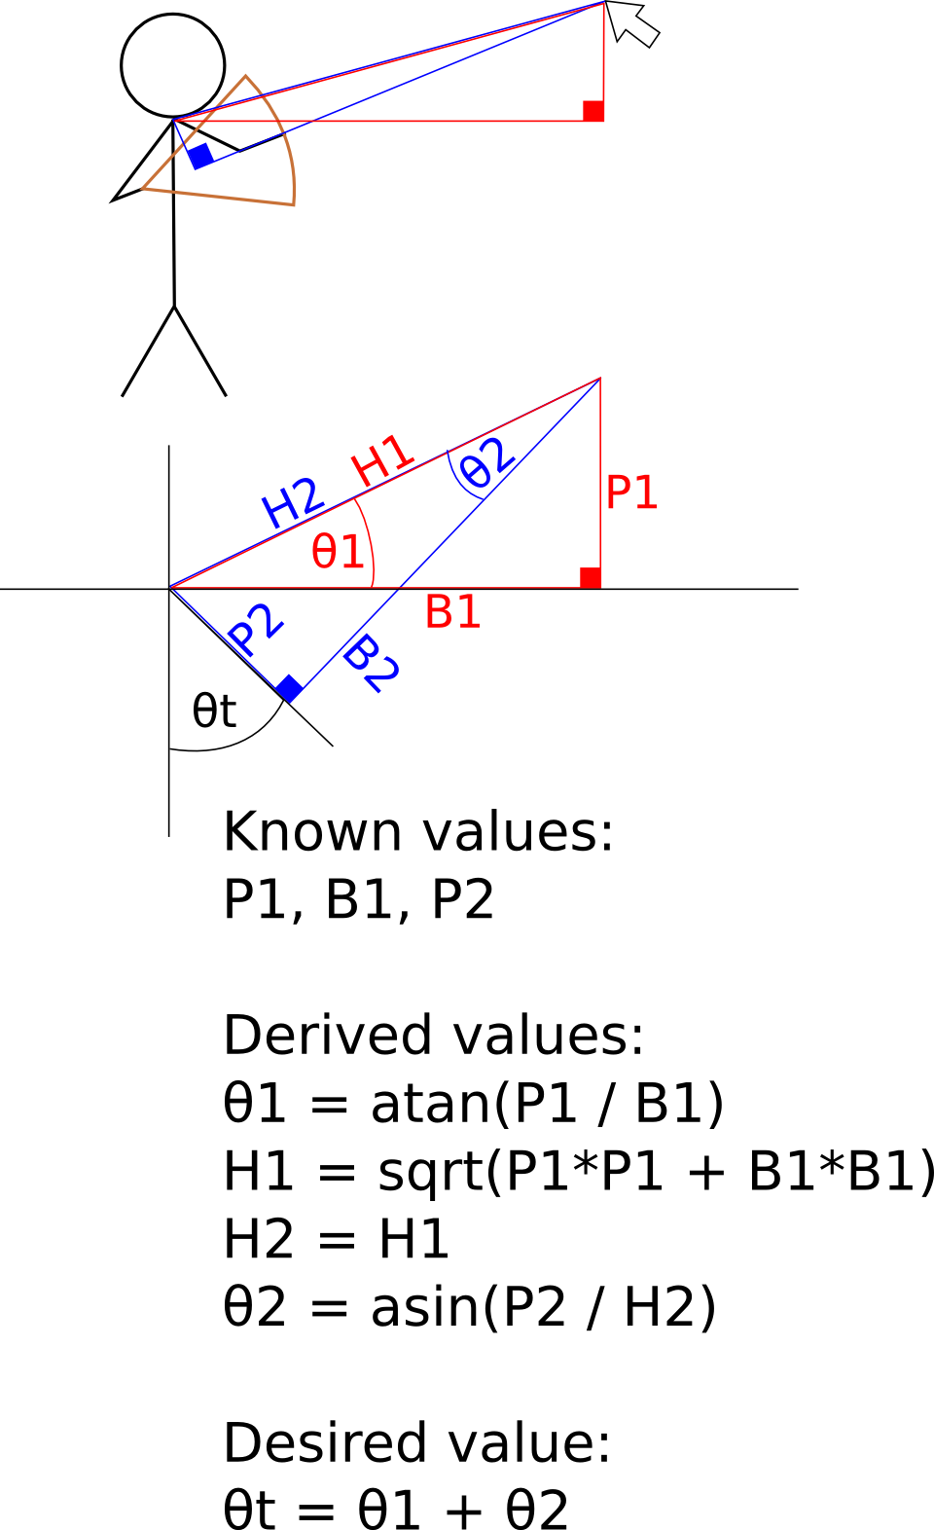Drawing 5: Aim angle formula explanation

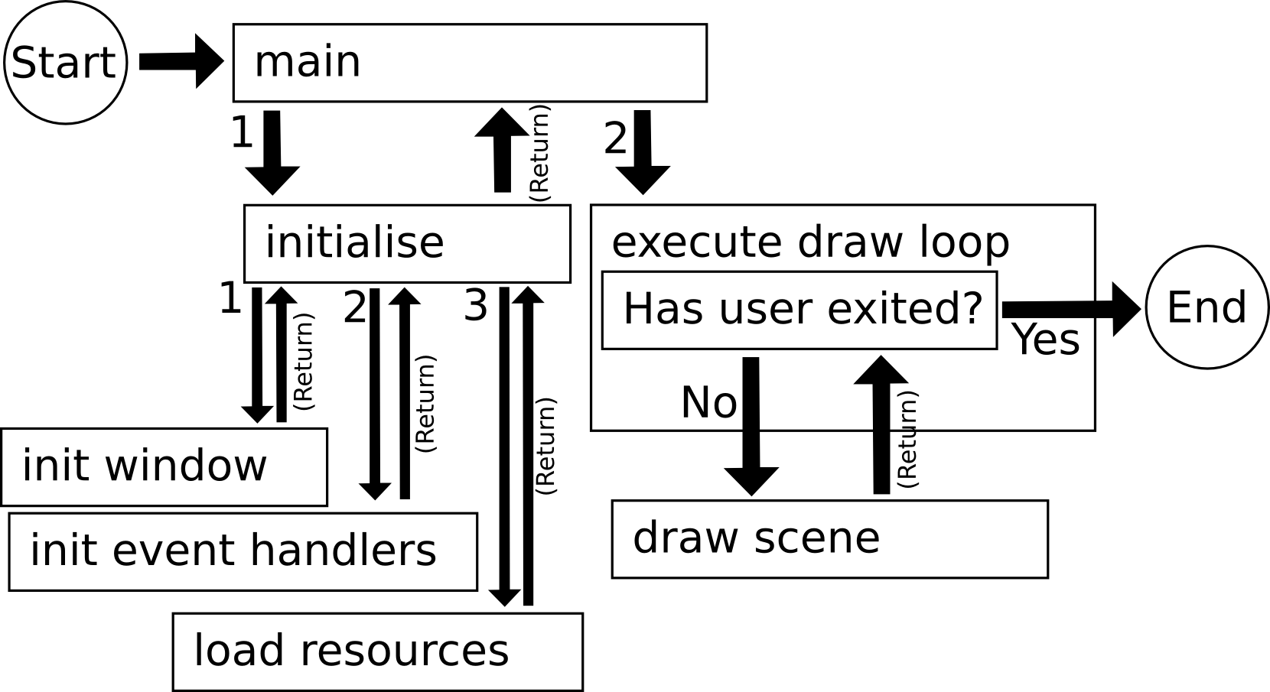Drawing 6: Basic program flow

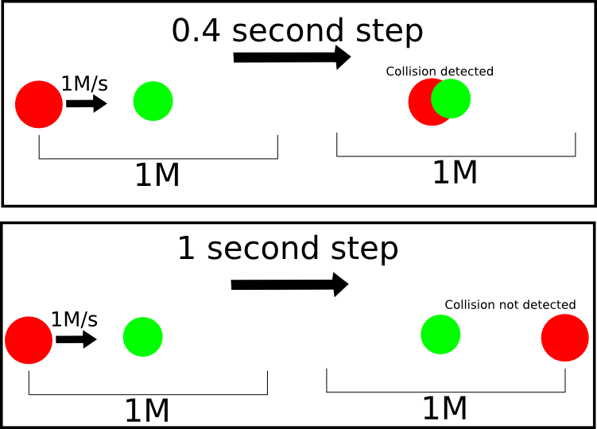Drawing 7: Physics engine missing collisions for larger step distances
These are references relating to resources used in the code for the assessment program.

Kevin Hawkins, 2002. OpenGL Game Programming w/CD (Prima Tech's Game Development). 1 Edition.

NeHe Productions. n.d. Using gluUnProject. [ONLINE] Available at: http://nehe.gamedev.net/article/using_gluunproject/16013/. [Accessed 08 January 2014].

Stack Overflow. 2014. algorithm - Circle line collision detection. [ONLINE] Available at: http://stackoverflow.com/questions/1073336/circle-line-collision-detection. [Accessed 08 January 2014].

1 W3 Schools. 2014. Browser Display Statistics. [ONLINE] Available at: http://www.w3schools.com/browsers/browsers_display.asp. [Accessed 08 January 2014].

