Shooting Practice Game User Manual
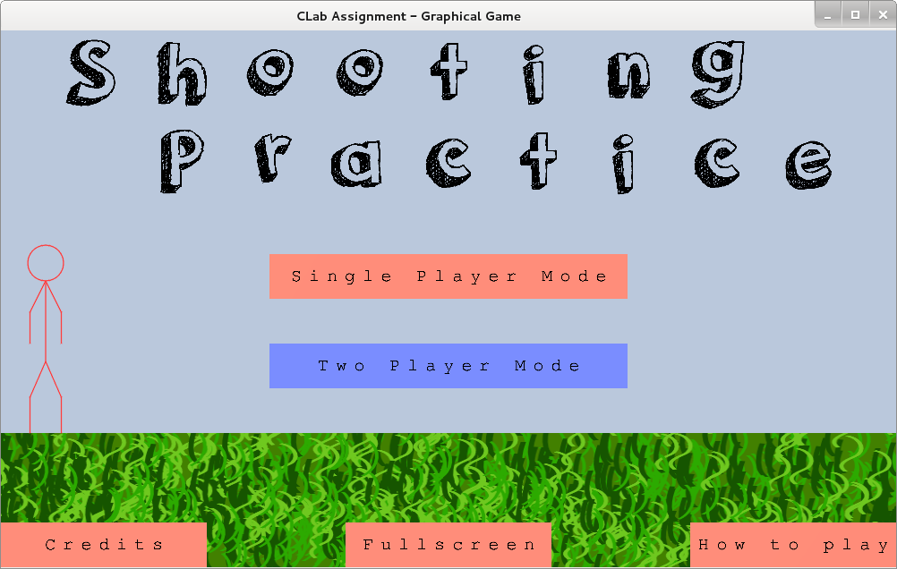

Installation
How to install the Shooting Practice game.

System requirements
To install and run this game you will require a PC with the following specifications
- OS: most GNU/Linux distributions will work (Tested on Debian and Ubuntu)
- Graphics card: Any Linux compatible card with OpenGL support
- Hard disk space: approximately 70MB free space
- Processor: x86 compatible. (Recommended: at least a 2GHz clock speed)
- RAM: (Recommended at least 1GB)

Before installing
Unfortunately this game is not yet packaged in a .deb file and so you must install and run it manually.
Before you install the game you will need to make sure that your system has some required library packages. Many of these may already be on your system.
To do this, first open a terminal window.
Then type this command:

sudo apt-get install libdrm2 freeglut3 libxext6 libexpat1 libxxf86vm1 libxcb-glx0 libffi5 libgl1-mesa-glx libx11-6 libxfixes3 libxi6 libxdmcp6 libxdamage1 libx11-xcb1 libxau6 libglu1-mesa libxcb1 libglapi-mesa libgl1-mesa-dri
You may be asked for your administrator password after this. If you are, type your password and press enter.
A confirmation prompt may appear asking if you want to install extra packages. If this happens then type 'Y' and press enter.
If you get any errors at this point, the installation will not work.
Depending on your graphics card, you may have other packages already on your system that act as an alternative to some of these packages, if this is the case then you should not get any errors and can continue even if not all packages were installed by the command above.

Installing the game
Two folders containing the main program file are provided. One is called “shootingpractice(32-bit)” and the other is “shootingpractice(64-bit)” the folder you want depends on your system's architecture. For most modern systems, you will want to use the 64 bit version. If in doubt, the 32 bit version should work on all systems.
To install the game, all you need to do is copy the main program folder (one of the folders mentioned above) to a suitable folder on your system. A good place might be the home folder e.g. '/home/YOURNAME/shootingpractice'.
You should now be able to run the game by double clicking on the 'clab_assignment_graphics' file in this folder.

Troubleshooting
If the file will not run, it is possible that you have not installed the packages correctly or perhaps that the program file has been marked as not executable.
Use a terminal window to execute the program to diagnose the problem.
Open a terminal window and type the full path to the program file (e.g. '/home/YOURNAME/shootingpractice/clab_assignment_graphics') and then press enter.
If you get a message that says 'Permission denied' then you need to mark the program as executable. To mark the program as executable use a command like this:
chmod +x home/YOURNAME/shootingpractice/clab_assignment_graphics
If the message implies that the system cannot find a specific '.so' file then it is possible that not all packages were installed and you will need to install them. Repeat the instructions in the 'Before installing' section above.

The main menu
From the main menu you can; start a one or two player game, toggle full-screen mode, view the credits and view the how to play guide.
Three buttons are displayed at the bottom of the menu screen. From left to right; the first will show you the credits page, the second toggles full-screen mode, the third shows you the 'how to play' guide. The same content from the 'how to play' guide is shown on page 3.
The centre buttons on the main menu let you start a game. You can start a game for one or two players.

How to play
The aim of the game is to hit the yellow target with your bow and arrow. You must reach the target on each level before you can move to the next level.
The targets look like this.

To aim the bow you can click and hold in the main game scene. As you move the mouse, the stickman will point his bow at the cursor. The further the cursor is from the bow, the more the stickman will pull the bow back.
The stickman will fire the bow when you release the mouse button.
If you need to do so, you can stop an arrow early by clicking and holding again. This can be useful if you think that the arrow will miss or might hit an instant death obstacle. This is also helpful when trying to find a precise angle at which to fire.
You can move the stickman left or right to get into a better position for reaching the target by using the left and right arrow keys on your keyboard.
Obstructions will appear in most levels to make reaching the target more difficult. Red obstructions must be avoided. If you hit one you will lose a life. Lose all your lives and it's game over. Green obstructions are not deadly. Arrows will rebound when they hit green obstructions.
Deadly objects look like this

Bouncy objects look like this

When using two player mode, each player is timed. They have 15 seconds per level.
Run out of time and you forfeit two lives.
Any time a player loses a life, the next player is then allowed to play. The winner is the one that reaches the end first or is last to lose all of their lives.
Enjoy!

