1. Change the name Jon to Jonathan.

sed s/Jon/Johnathan/ datebook

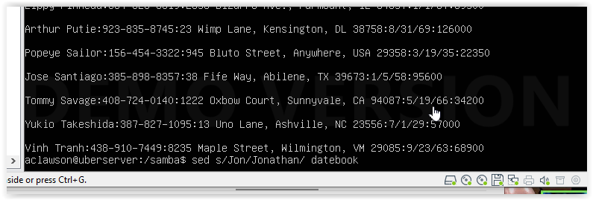

S for substitute

2.Delete the first four lines.

sed '1,4d' datebook

1,4 represents the lines we want to delete with d

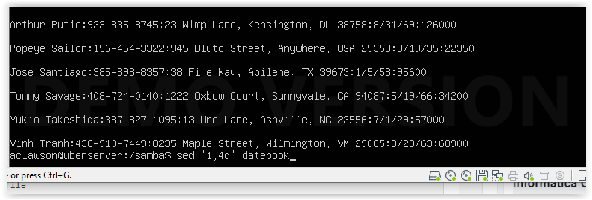

3. Print lines Print lines 7 through 11.

sed -n '7,11p' datebook

7,11 are the lines we are looking for and p will print

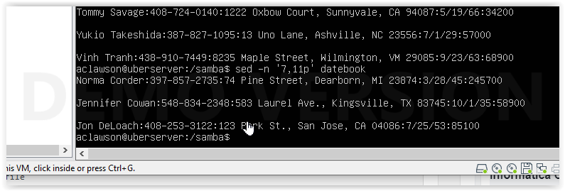

4. Delete lines containing Lane.

sed '/Lane/d' datebook

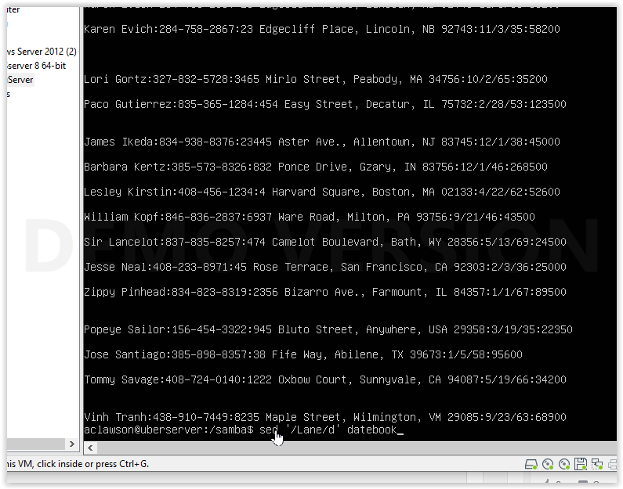

Lane is what we are looking for and d will erase

5. Print all lines where the birthdays are in November or December.

sed -rn '/^[^:]*:[^:]*:[^:]*:(11|12)\//p' datebook 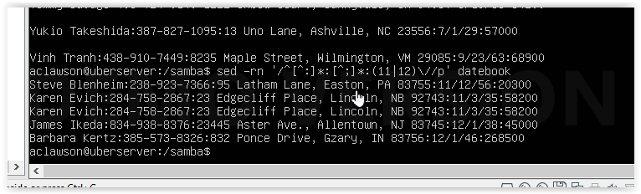

6. Append three asterisks to the end of lines starting with Fred.

sed -e '/^Fred/a\*** ' datebook

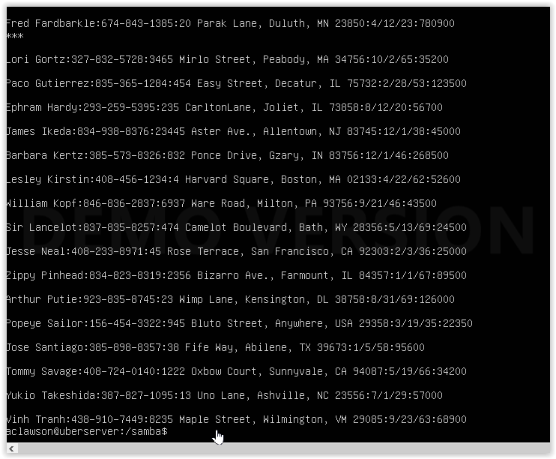

^(anchor)Fred is to make sure the line starts with FRED, appended /a with three asterisks

7. Replace the line containing Jose with JOSE HAS RETIRED.

sed -e 's/.*Jose.*/JOSE HAS RETIRED\./g'

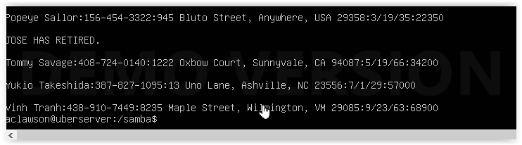

S/ is the whitespace, .(matches any character) Jose is what we are looking for and we replace with /Jose has retired. /g is the global metacharacter in case there is more than on instance

8. Change Popeye 's birthday to 11/14/99. Assume you do not know Popeye's original birthday. Use a regular expression to search for it.

sed '/^Popeye Sailor:/s/:[^:]*\(:[^:\/]*\)$/:11\/14\/46\1/' datebook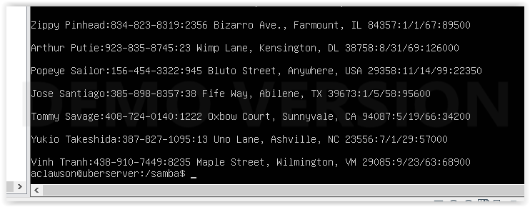

Popeye Sailor ^ searches for the name, the /s white space and the subsequent numbers in first half are searching for the birthday, The second half changes it to his actual birthday of 11/14/99

9. Delete all blank lines.

sed '/^$/d' datebook

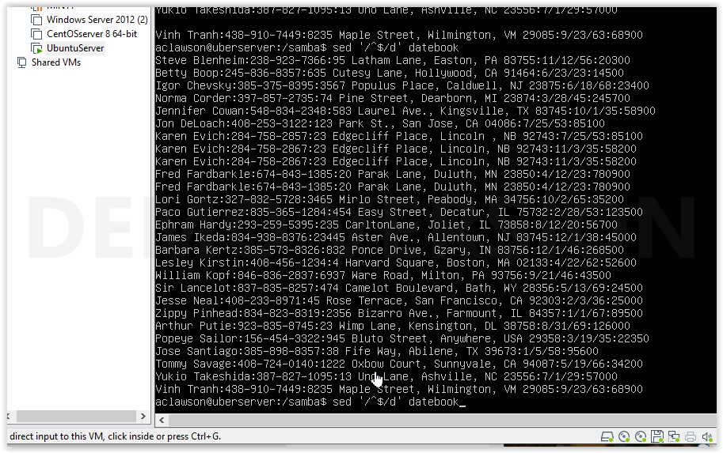

^is for the beginning anchor $ flags the end of the string, d for delete

10. Write a sed script that will

## For each of these part 10a-d We have to make it a SCRIPT so I set them up #!/bin/ bash and named them sed10a.sh and so on, and gave permissions to the script with $ sudo chmod +x sed10a.sh $ sudo chmod +x sed10b.sh…..

And filled each script as follows

1. Insert above the first line the title -PERSONNEL FILE-.

sed ‘li -PERSONNEL FILE-‘ datebook

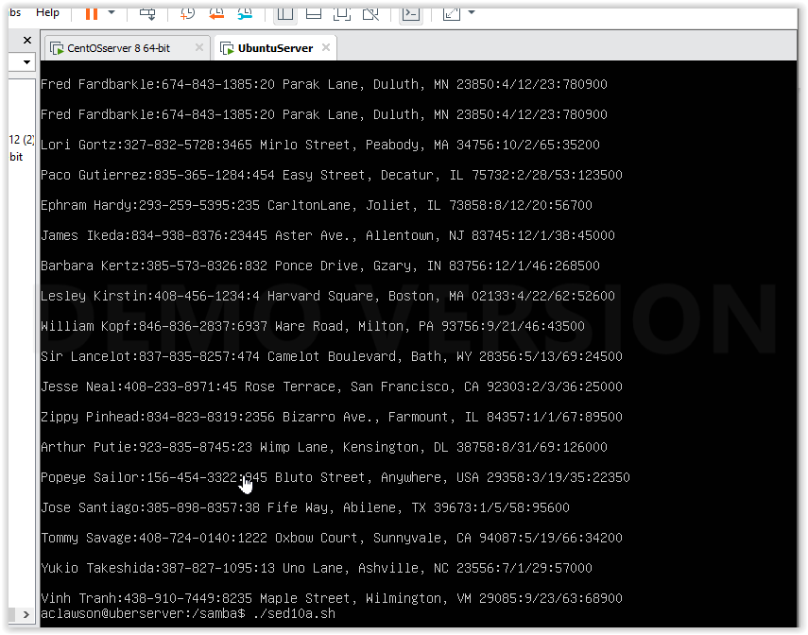

1. Remove the salaries ending in 600.

sed ‘/600$/d’ datebook ($end of line) (d, delete)

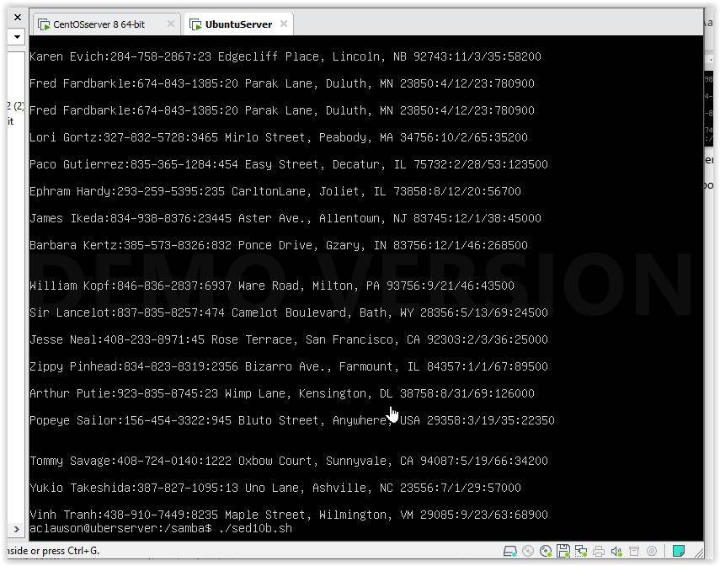

1. Print the contents of the file with the last names and first names reversed.

sed 's/\([[:alpha:]]\+\) \([[:alpha:]]\+\):.*/\2 \1/' datebook

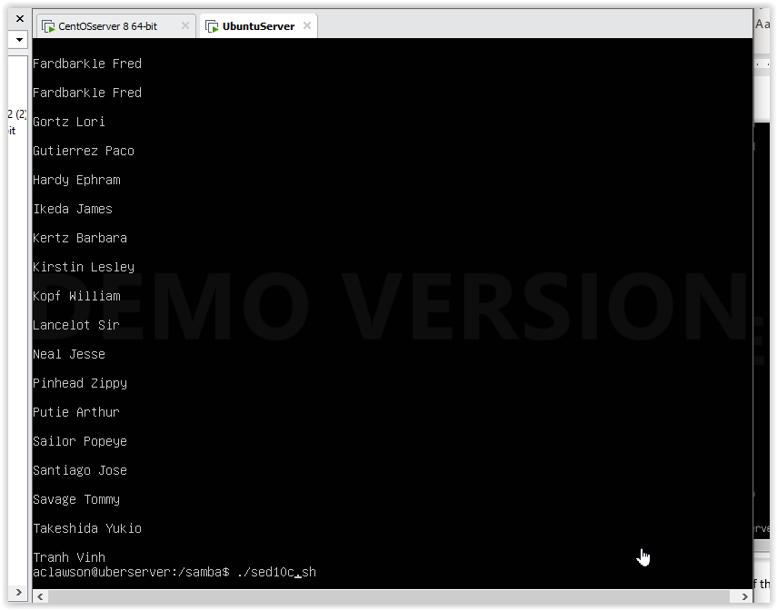

d. Append at the end of the file THE END.

Sed ‘$a\THE END’ datebook (&, end anchor (a, append))

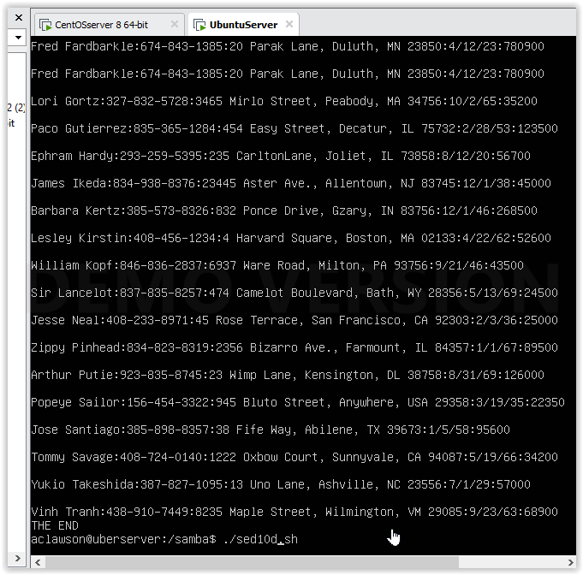

The sources I used were the chapter that were included reading, <https://regexone.com/>, and <https://regexr.com/>