# Installing Linux Servers on a Virtual Machine

VMware

First go to VMware’s Official Website, <https://www.vmware.com/>. If you do not have an account create one, otherwise login.

Select the VMware product that will be used. Once purchased the Product Registration Number will be sent to the email address you used to create your account. Go to the computers download folder and open VMware installation wizard. Keep everything at its defaults and click through the series of next buttons till reaching finish. If VMware prompts you to install the VMware tools click yes.

Creating the Virtual Machine

To create the Virtual machine first we must get the iso image of for each Linux distro that we intend to use, for this instance Debian 10 and CentOS 8. Which can be found at <https://www.debian.org/distrib/> and <https://www.centos.org/download/> . Once each iso is downloaded open VMware and click “Create a New Virtual Machine”. Select the iso image you want to use, the iso image will act as an installation disk. 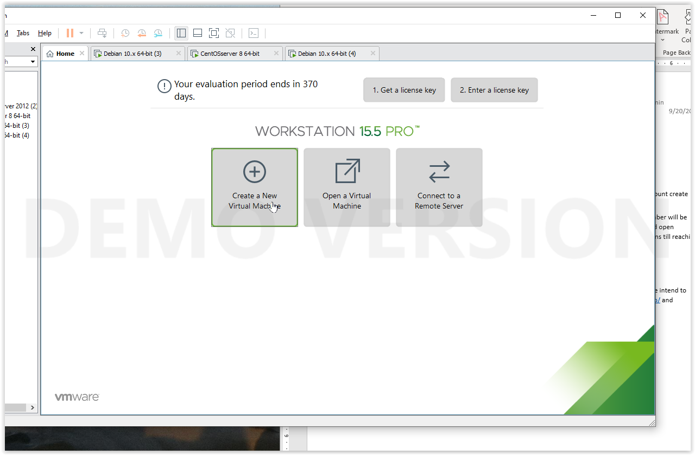

CentOS

The CentOS installation Summary Will appear with a few items highlighted with red text. Each of those items need to be taking care of before the installation can finalize

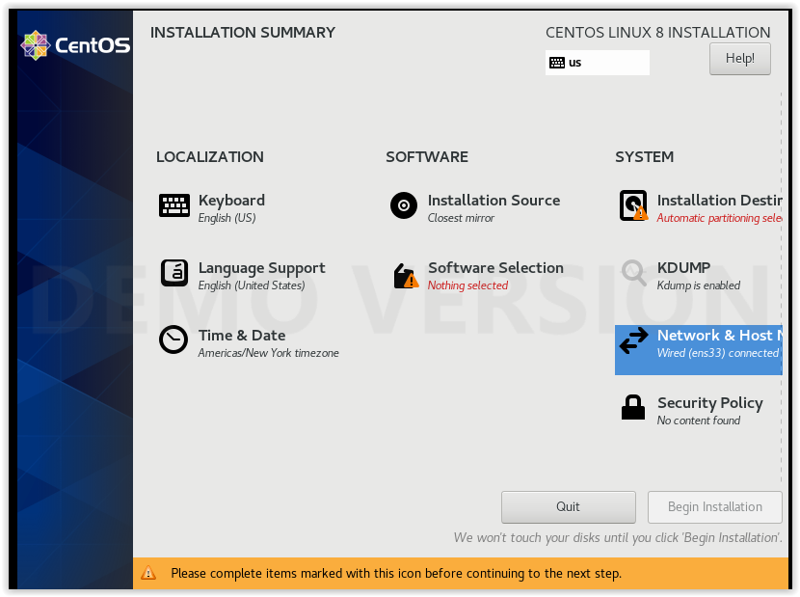 Choose your internet connection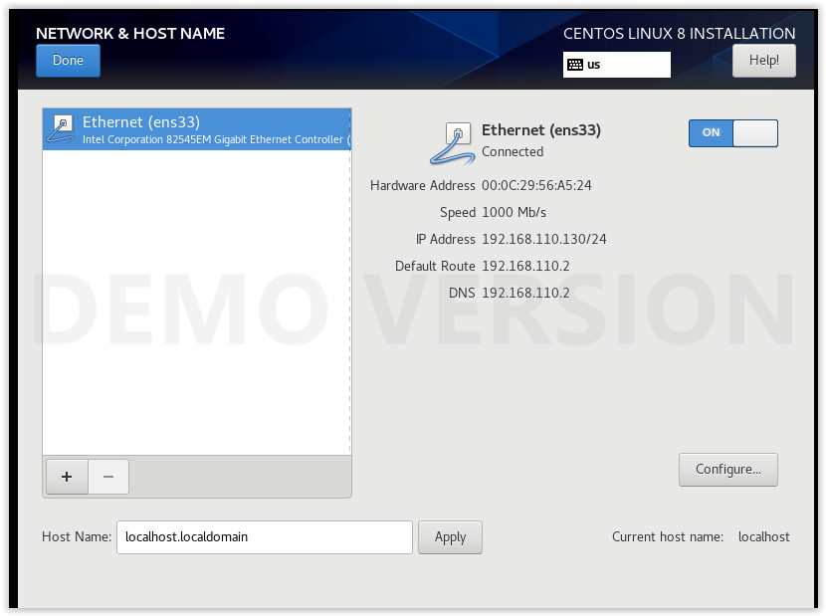

Choose server for base environment

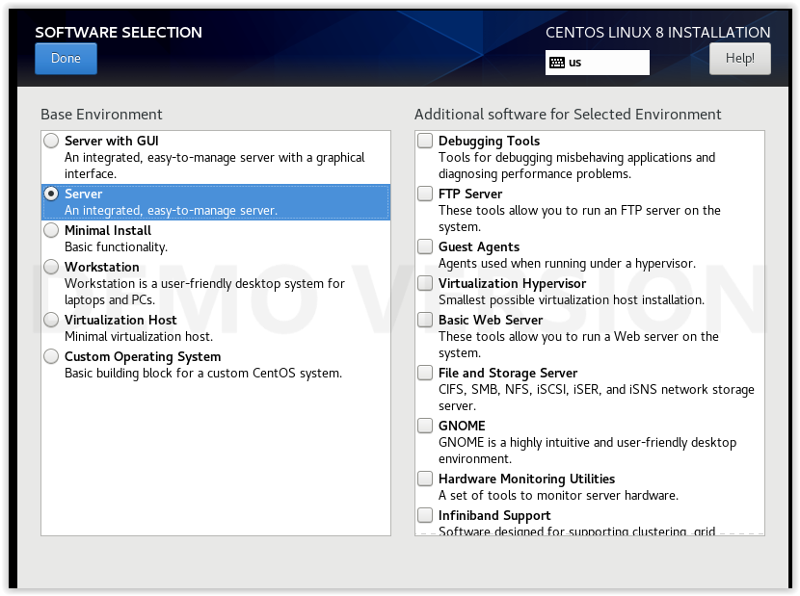

Set up a root password and first user account

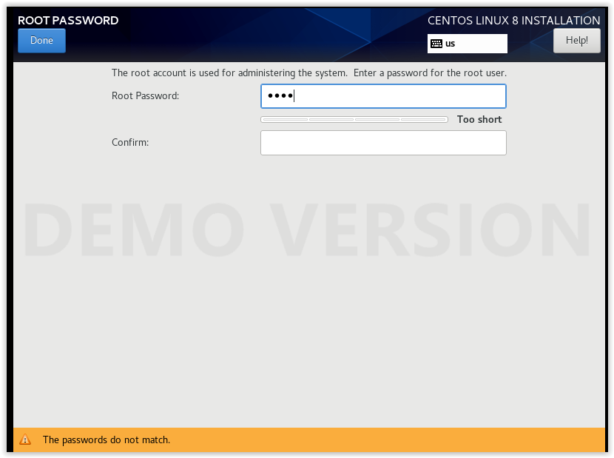

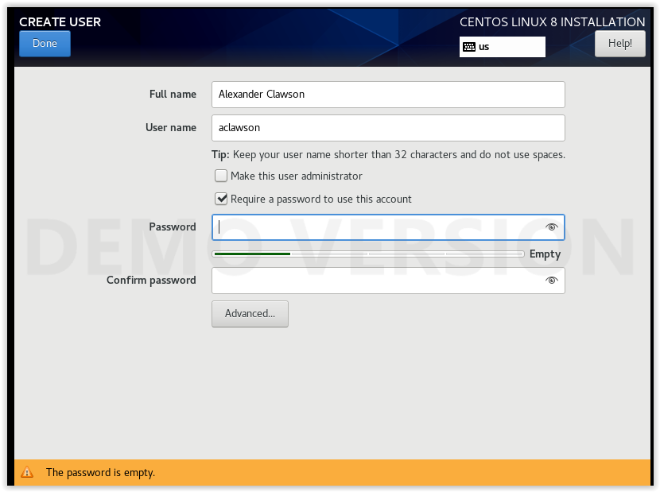

Reboot the server and login to root

Add your first user to the wheel group (giving the user access to use sudo) using the command:

$ usermod -aG wheel username

Now login to the user you just gave permissions to. Install Samba with the command:

$ sudo yum install samba samba-client samba-common

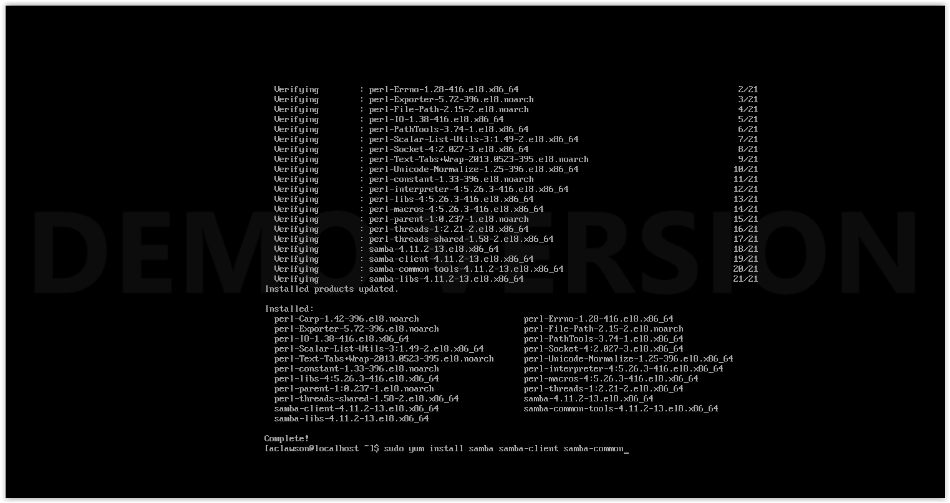

Ubuntu

Create a new machine using the Ubuntu iso image. You will be prompted to pick a language and to select a drive

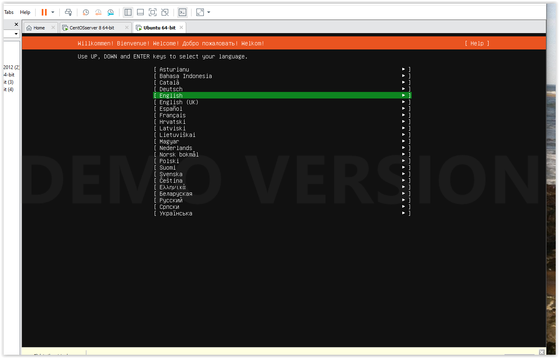

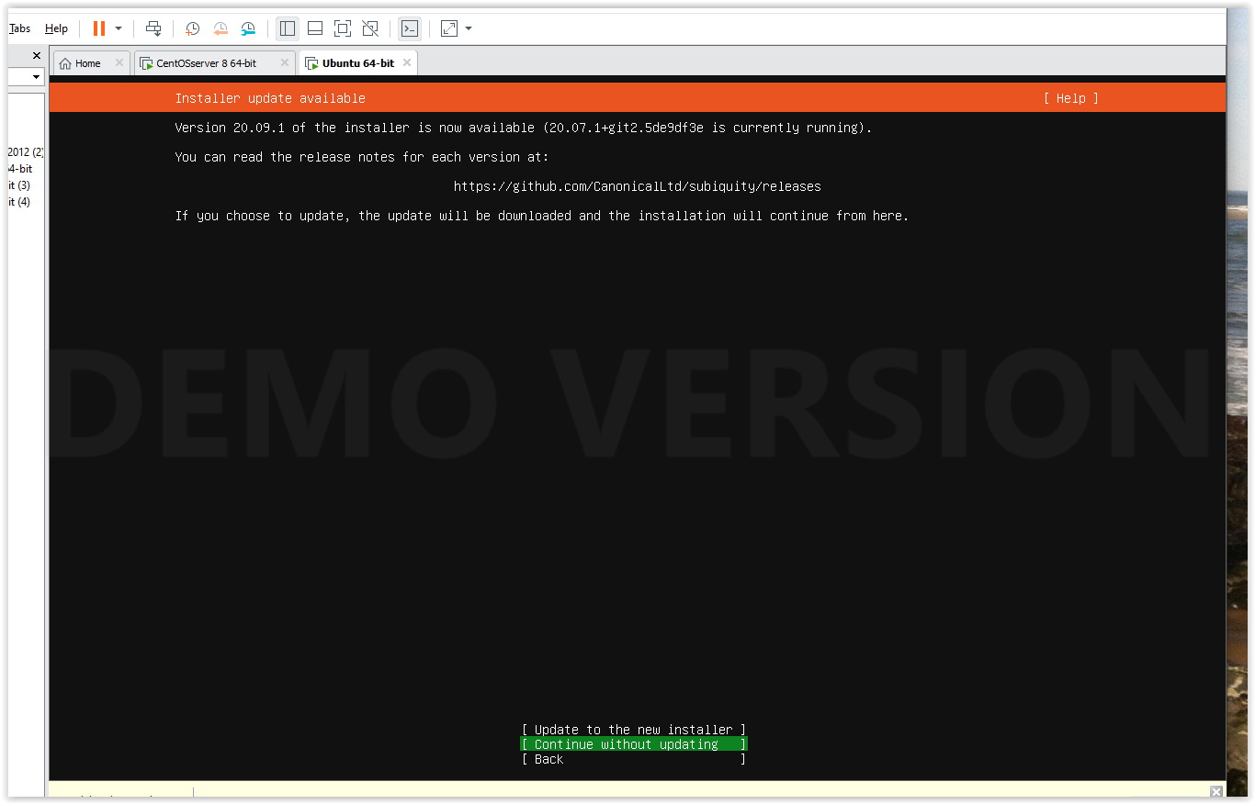

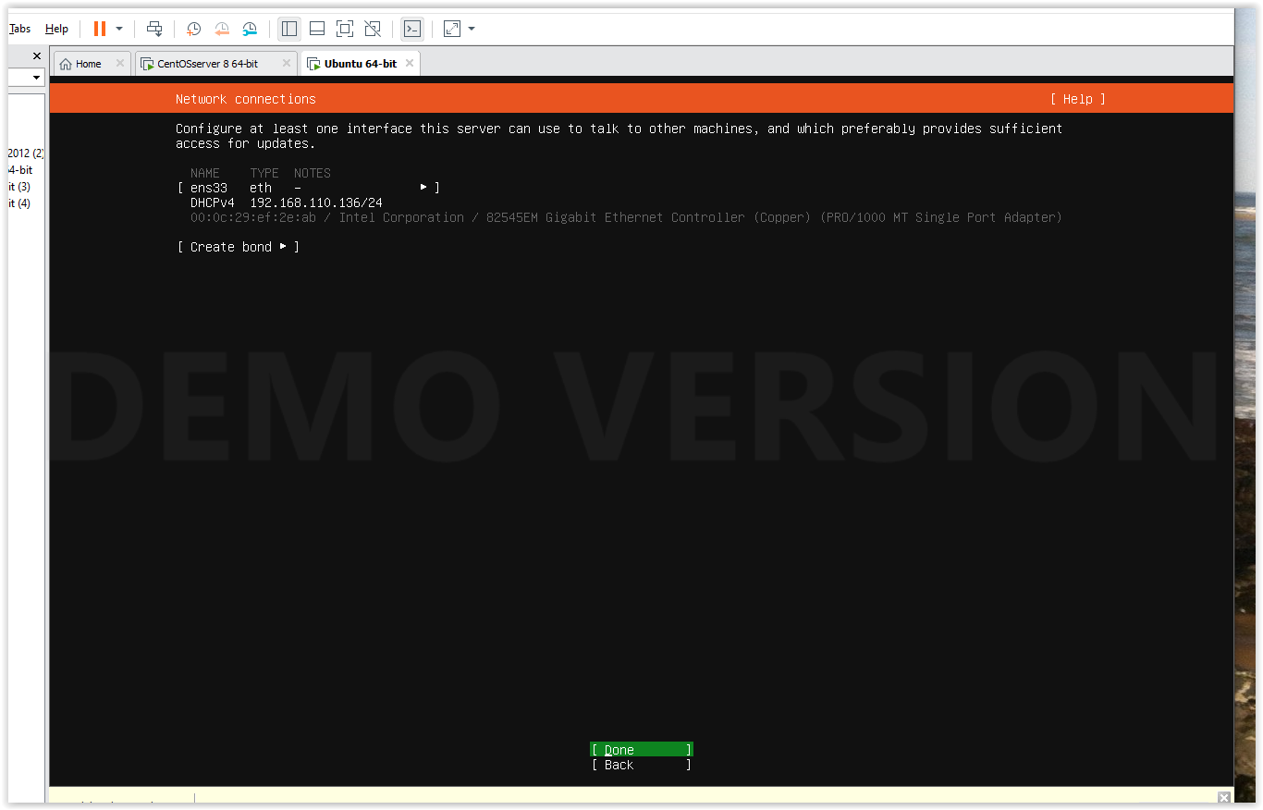

Use entire disk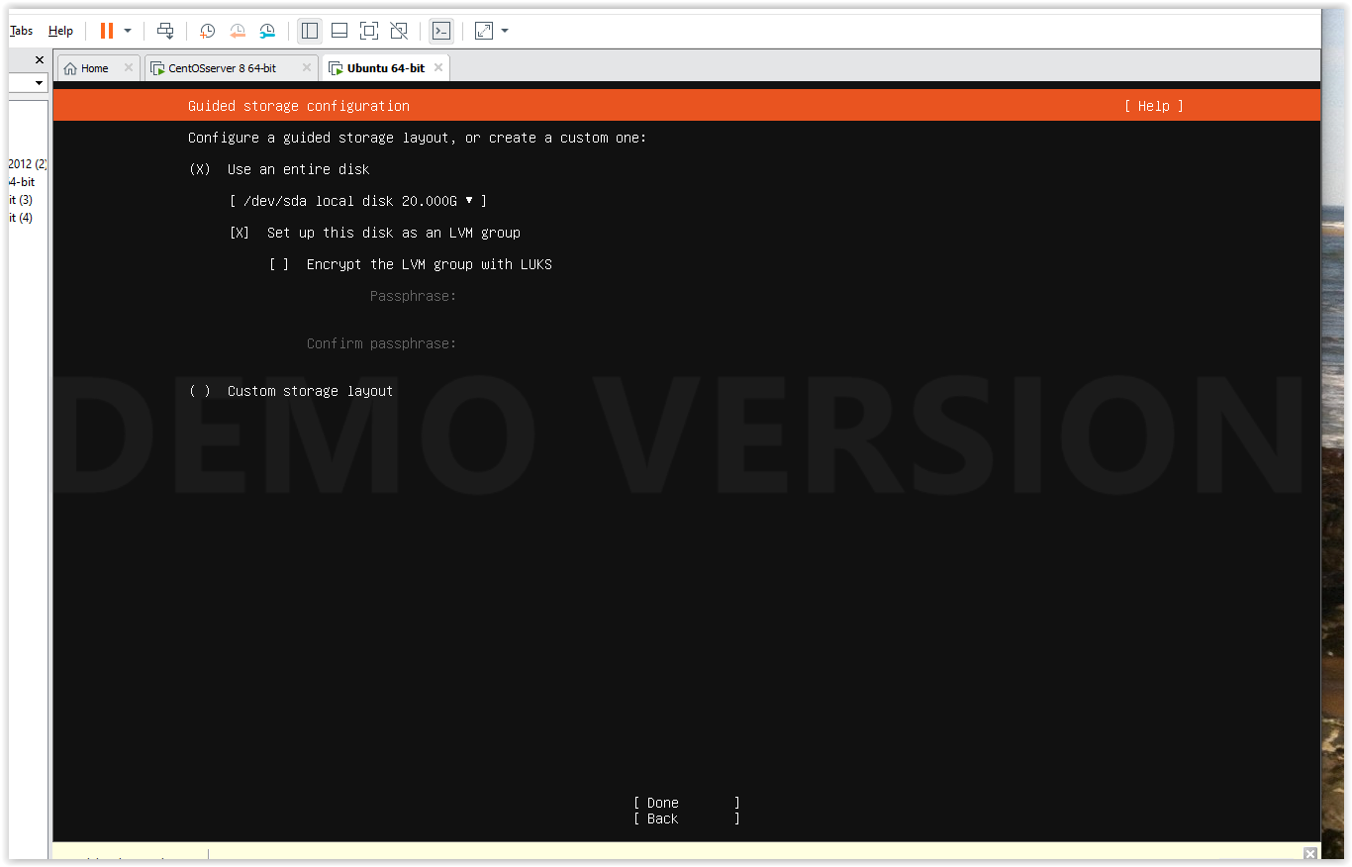

I chose to install SSH, PowerShell, and Python add-ons

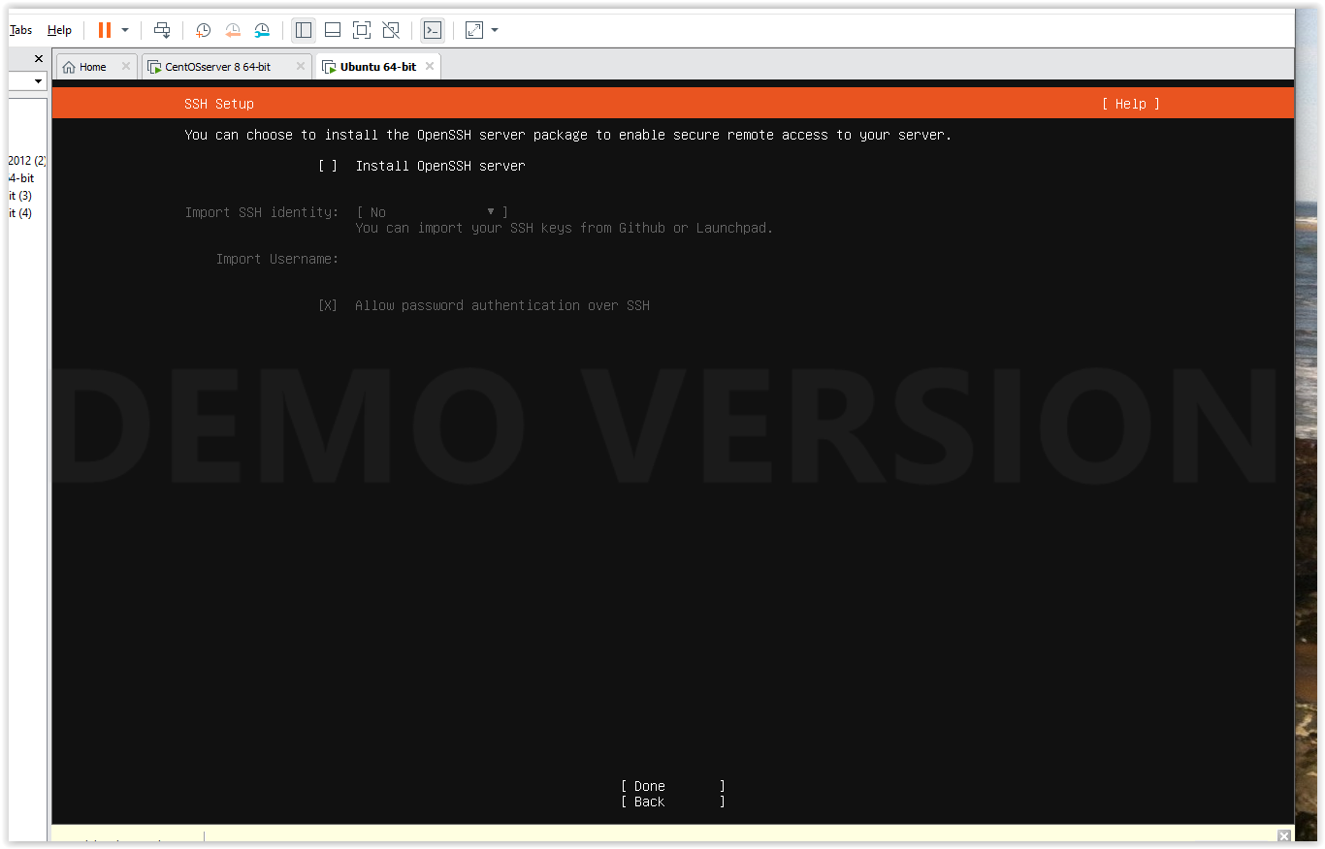

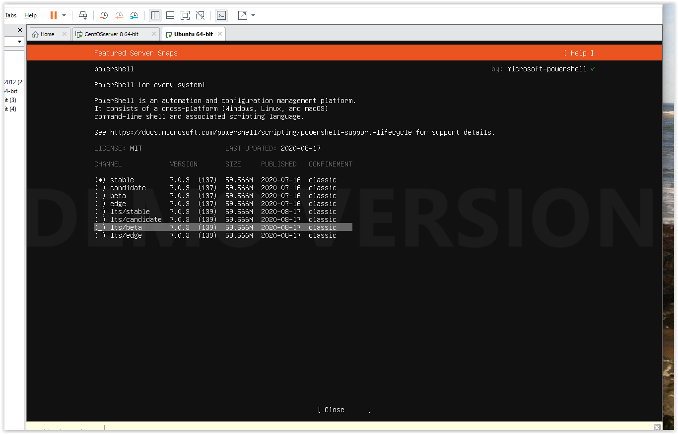

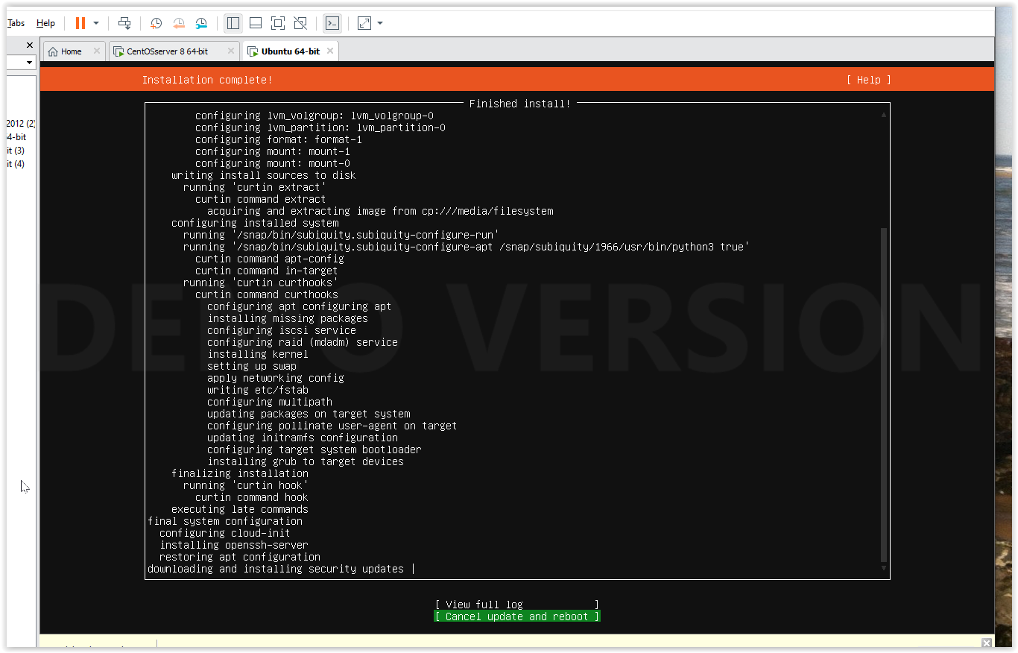

Setting up Samba Share

Install using commands

$ apt-get update

$ apt-get install -y samba samba-common python-glade2 system-config-samba

* Configure Samba using commands

$ mkdir /samba

$ chmzod 777 /samba

$ chown -R nobody:nogroup /samba

$ nano /etc/samba/smb.conf

(add this to end of file)

[Public]

path = /samba

browsable =yes

writable = yes

guest ok = yes

read only = no

force user = nobody

Restart service smbd

CREATE NEW USER

$ addgroup smbgrp

$ adduser test01

CHANGE USER GROUP

$ usermod test01 -G smbgrp

$ smbpasswd -a test01

CREATE NEW Share folder

$ mkdir –p /data

$ chmod -R 0770 /data

$ chown root:smbgrp /data

sudo nano /etc/samba/smb.conf

(add to end of file)

[data]

path = /data

valid users = @smbgrp

guest ok = no

writable = yes

browsable = yes

Enter VM Server IP address in file explorer \\ipaddress

Now we can share files between Windows and our Virtual Machine

