Date: July 8, 2019

To: Dishes A Mousetrap

From: Chen Zhang

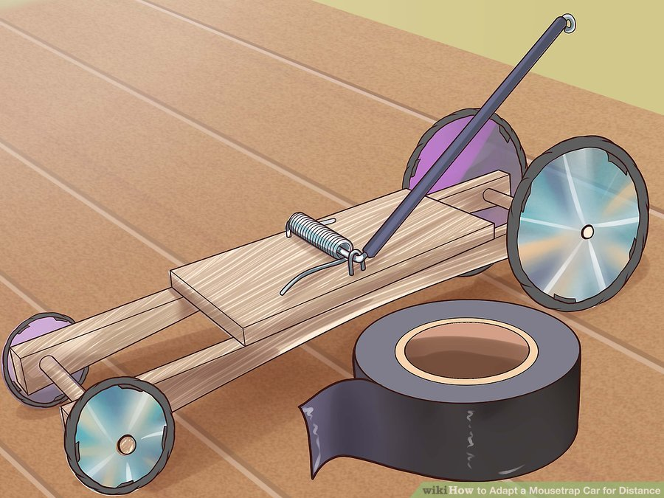Subject: Benchmarking Report

The picture to the left is a typical mousetrap car with subtle improvement on its wheels, and this one is closer to my prototype. This mousetrap car uses the following materials:

* Mousetrap
* Tape
* String
* Disk
* Dowels
* Woody Frame

The design of this mousetrap car includes several aspects, both of them have its own functionality distribute to the propose of this car. The large rear wheels have greater rotational inertia than small wheels which means once they start to roll, they are harder to stop. The second element is use thin and light wheels because thinner wheels have less friction, and due to the friction force between two surfaces after sliding begins is the product of the coefficient of kinetic friction and the normal force. In other words, less contact and light weight may reduce the friction between two surfaces. The third crucial aspect is use narrow rear axle in order to convert more times rotation based on same length of string attached on it. But in this part, I may go further when selecting materials of the axle, wooden dowel rods or metal rods. Last but not least, increase the wheels’ friction by giving its edges extra materials in order to avoid slip when the wheels roll on the ground.

In this design, it solved many potential problems such as use inertia to provide more energy, especially given a solution to deal with the friction between the car and ground. This solution's main idea is that use lightweight materials to build the mousetrap car, however, the pursuit of lightweight could increase the cost of this project because of lightweight firm materials are more expensive compared to heavy firm one. For instance, in order to gain less friction and lightweight, the cost of an axle made of aluminum is much expensive than an axle made of paper or wood. Despite the details of the design, this project is to find a balance between the car's performance and its cost. In our case, we will balance the expense and our car's speed.

Reference: WikiHow. (2019, June 12). How to Adapt a Mousetrap Car for Distance. Retrieved from

<https://www.wikihow.com/Adapt-a-Mousetrap-Car-for-Distance>