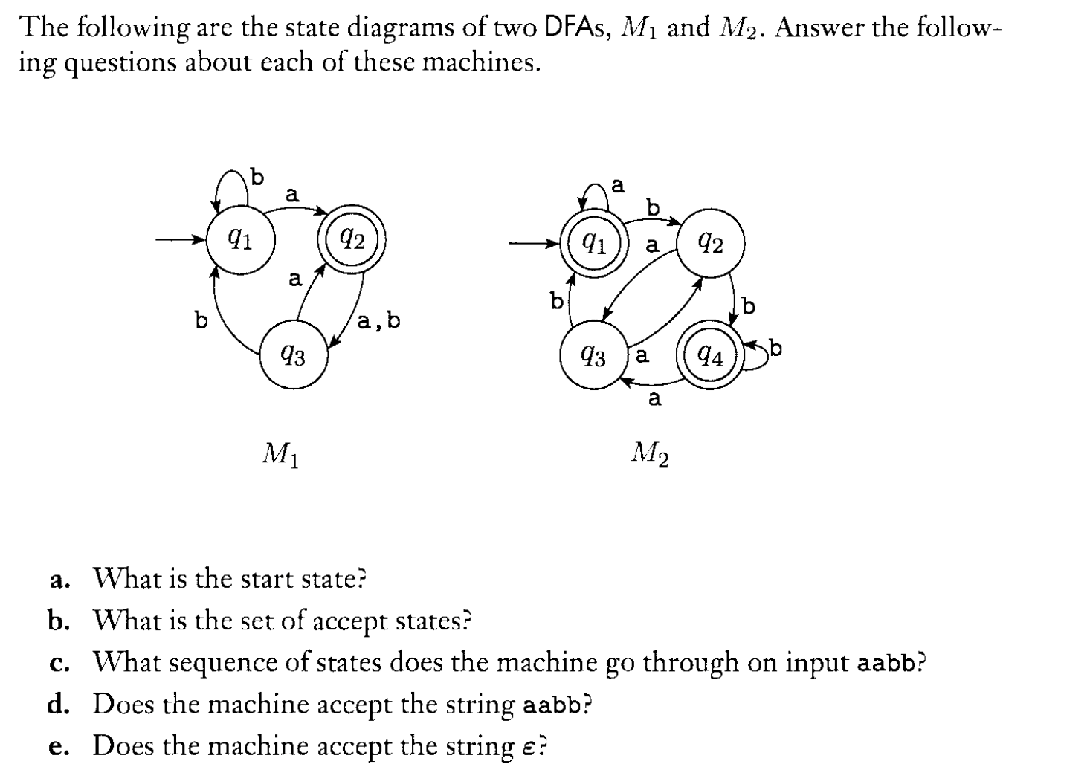

For M1,

1. The start state is q1
2. {q2}
3. Q1,q2,q3,q1,q1
4. No
5. No

For M2

1. Q1
2. {q1,q4}
3. Q1,q1,q1,q2,q4
4. Yes
5. Yes
6. Give a formal description of the above two DFAs by specifying the 5-tuple.

For M1,

Q – {q1,q2,q3}

Σ – {a,b}

Transition - {((q1,a),q2), ((q1,b),q1), ((q2,a),q3), ((q2,b),q3), ((q3,a),q2), ((q3,b),q1)}

Start state – q1

Final state – q2

For M2

Q – {q1,q2,q3,q4}

Σ – {a,b}

Transition - {((q1,a),q1), ((q1,b),q2), ((q2,a),q3), ((q2,b),q4), ((q3,a),q2), ((q3,b),q1), ((q4,a),q3), ((q4,b),q4)}

Start state – q1

Final state – {q1,q4}

1. Construct a Deterministic Finite Automata accepting each of the following:

2.1 {}

2.2 {}

2.1

2.2

