Homework – 5

1. Consider the grammar $G=(V,Σ,R,S)$, where

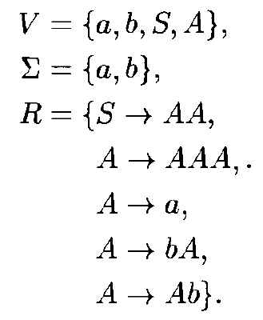

a). Give a string of $L(G)$ that can be produced by applying the rules at most 4 times

answer:

S->AA

A->a (aA)

A->bA (abA)

A->a (aba)

So, after four times, the final string is aba

b). Same string can be derived in different ways, e.g., $S⇒AA⇒aA⇒aa$, $S⇒AA⇒Aa⇒aa$. Give at least 2 distinct derivations for the string $babbab$

answer:

S->AA

A->bA (bAA)

A->bA (bAbA)

A->bA (bAbbA)

A->Ab (bAbbAb)

A->a (babbAb)

A->a (babbab)

c). For any $m,n,p>0$, describe a derivation in $G$ of the string $b^{m}ab^{n}ab^{p}$

answer:

S -> AA

by m applications of rule A -> bA ($b^{m}AA)$

A -> a ($b^{m}aA)$

by n applications of rule A -> bA ($b^{m}ab^{n}A)$

by p applications of rule A -> Ab ($b^{m}ab^{n}Ab^{p})$

by rule A -> a ($b^{m}ab^{n}ab^{p}$)

1. Consider the grammar $G=(V,Σ,R,S)$, where

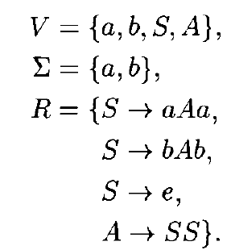

Give a derivation of the string $baabbb$ in $G$.

Answer:

S->bAb

A->SS (bSSb)

S->aAa (baAaSb)

S->bAb (baAabAbb)

A->SS (baSSabSSbb)

S->e (baabbb)

1. Show that the following languages are context-free by exhibiting contextfree grammars generating each.

a). $\{a^{m}b^{n}:m≥n≥0\}$

answer:

S->aAb

S->e

A->aS

A->SS

b). $\{a^{m}b^{n}c^{2m+n}:m,n≥0\}$

answer:

S->aAc

A->aAc

A->bBc

B->bBc

B->e