Homework – 7

1.

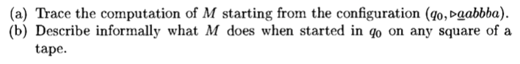

Answer:

1. (q0,>aabbba)

(q1,>babbba)

(q0,>babbba)

(q1,>bbbbba)

(q0,>bbbbba)

(q1,>bbabba)

(q0,>bbabba)

(q0,>bbaaba)

……

(q1,>bbaaab)

(q0,>bbaaab )

(h,>bbaaab_)

1. It change every a to b and change every b to a.

2.



Answer:

(q0,>abbsbbsssaba)

(q0,>abbsbbsssaba) – (move right if meet a “b”during state q0.

(q0,>abbsbbsssaba) – (move right if meet space)

(q1,>abbsbbsssaba)

(q1,>abbsbbsssaba)

(q2,>abbsbbsssaba)

(h,>abbsbbsssaba)