CS4392/5376: Computer Networks/Communication Networks

Summer II 2021

Homework #3

• Full name only: ____________Chen Zhang_________________________

• Release date: July 21th, 2021 (Wednesday)

• Due date: July 27th, 2021 (Tuesday) before midnight, 11:59 PM

• It should be done INDIVIDUALLY; Show ALL your work; Write your answer in a Word file and

submit it through the Blackboard; You can screen capture for print.

• Total: 15 pts

Answers for question 1 and 2:

Client computer:

IP: 100.64.6.91

Port: 53069

Destination computer: gaia.cs.umass.edu

IP: 128.119.245.12

Port: 80

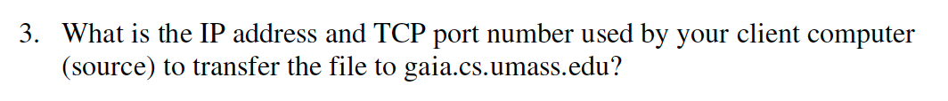

Answer:

According to above figure:

IP: 100.64.6.91

Port: 53069

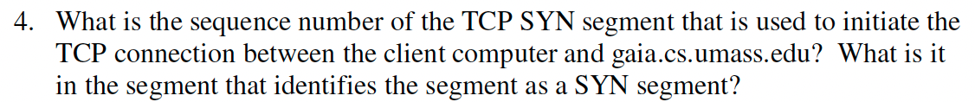

Answer:

The sequence number of the TCP SYN segment is 0 since it is used to imitate the TCP connection between the client computer and gaia.cs.umass.edu

Based on above screenshot, in Flags section, the Syn flag is set to 1 which indicates that this segment is a SYN segment.

Answer:

According to the above figure, the sequence number of the SYNACK segment sent by gaia.cs.umass.edu to the client computer is replay to the SYN is 0.

The value of the acknowledgement field in the SYNACK segment is 1. The value of the ACK field in the SYNACK segment is determined by the server. The server adds 1 to the initial sequence number of SYN segment form the client computer. For this case, the initial sequence number of SYN segment from the client computer is 0, so the value of the ACK field is 1.

A segment will be identified as a SYNACK segment is both SYN flag and ACK in the segment are set to 1.

Answer:

According to the screenshot, the segment contains the HTTP POST command, the sequence number of this segment is 1.

7. Consider the TCP segment containing the HTTP POST as the first segment in the

TCP connection. What are the sequence numbers of the first six segments in the

TCP connection (including the segment containing the HTTP POST)? At what

time was each segment sent? When was the ACK for each segment received?

Given the difference between when each TCP segment was sent, and when its

acknowledgement was received, what is the RTT value for each of the six

segments? What is the EstimatedRTT value (see Section 3.5.3, page 242 in

text) after the receipt of each ACK? Assume that the value of the

EstimatedRTT is equal to the measured RTT for the first segment, and then is

computed using the EstimatedRTT equation on page 242 for all subsequent

segments.

Note: Wireshark has a nice feature that allows you to plot the RTT for

each of the TCP segments sent. Select a TCP segment in the “listing of

captured packets” window that is being sent from the client to the

gaia.cs.umass.edu server. Then select: Statistics->TCP Stream Graph-

>Round Trip Time Graph.

Answer:

According to the screenshot, the segments 1-6 are No.36,37,38,39,40,41.

The ACK of segments 1-6 are No.50,52,55,56

|  |  |  |  |  |
| --- | --- | --- | --- | --- |
|  | Sequence# | Sent Time | ACK received | RTT |
| Segment 1 | 1 | 12.8736 | 12.9335 | 0.0599 |
| Segment 2 | 739 | 12.874565 | 12.9335 | 0.0589 |
| Segment 3 | 2187 | 12.874565 | 12.9336 | 0.059 |
| Segment 4 | 3635 | 12.874566 | 12.9370 | 0.0624 |
| Segment 5 | 5083 | 12.874567 | 12.9370 | 0.061 |
| Segment 6 | 6531 | 12.874567 | 12.9370 | 0.053 |

According to the formula: EstimatedRTT = 0.875 x EstimatedRTT + 0.125 x SampleRTT

For Segment 1: EstimatedRTT = 0.0599s

For Segment 2: EstimatedRTT = 0.0612s

For Segment 3: EstimatedRTT = 0.0622s

For Segment 4: EstimatedRTT = 0.0597s

For Segment 5: EstimatedRTT = 0.0614s

For Segment 6: EstimatedRTT = 0.0623s

8. What is the length of each of the first six TCP segments?

Answer:



The length of the first TCP segment is 738 bytes and the length of each of the following five TCP segments is 1448 bytes.

9. What is the minimum amount of available buffer space advertised at the received

for the entire trace? Does the lack of receiver buffer space ever throttle the

sender?

Answer:

The minimum amount of available buffer space advertised at the received for the entire trace is indicated first ACK from the server, its value is 28960 bytes.

According to the trace, the sender is never throttled due to lacking of receiver buffer space.

10. Are there any retransmitted segments in the trace file? What did you check for (in

the trace) in order to answer this question?

Answer:

There is no retransmitted segments in the trace file due to good networking conditions. You can tell based on the time sequence graph, all sequence numbers are monotonically increasing.

11. How much data does the receiver typically acknowledge in an ACK? Can you

identify cases where the receiver is ACKing every other received segment (see

Table 3.2 on page 250 in the text).

Answer:

The difference between the acknowledged sequence numbers of two consecutive ACKs indicates the data received by the server between these two ACKs.

The receiver is ACKing every other segment.

12. What is the throughput (bytes transferred per unit time) for the TCP connection?

Explain how you calculated this value.

Answer:

The throughput for the TCP is:

File size / download time = 152,138 bytes / 0.8235 s = 184745.59bytes/sec

13. Use the Time-Sequence-Graph(Stevens) plotting tool to view the sequence

number versus time plot of segments being sent from the client to the

gaia.cs.umass.edu server. Can you identify where TCP’s slowstart phase begins

and ends, and where congestion avoidance takes over? Comment on ways in

which the measured data differs from the idealized behavior of TCP that we’ve

studied in the text.

Answer:

The slow start of the TCP begins at 0.07 seconds and end at 0.14. Congestion avoidance takes over at 0.18.

14. Answer each of two questions above for the trace that you have gathered when

you transferred a file from your computer to gaia.cs.umass.edu

Answer:

I’ve answered.