CS 4354 Database Systems Project
Project Report 1

Design a database on a special topic for your group. In your first report, you should have the following materials:

- Group member (4 or 5 people in a group)
- Database requirements on all Entity types (minimum 5 entity types)
- ER diagram
- Specify all relationship types (minimum 7 relationship types including at least one recursive relationship.) For each relationship, you need to explain cardinal ratio and total or partial participation constrain in English
- Every notation in the following table should appear at least once in the ER diagram.

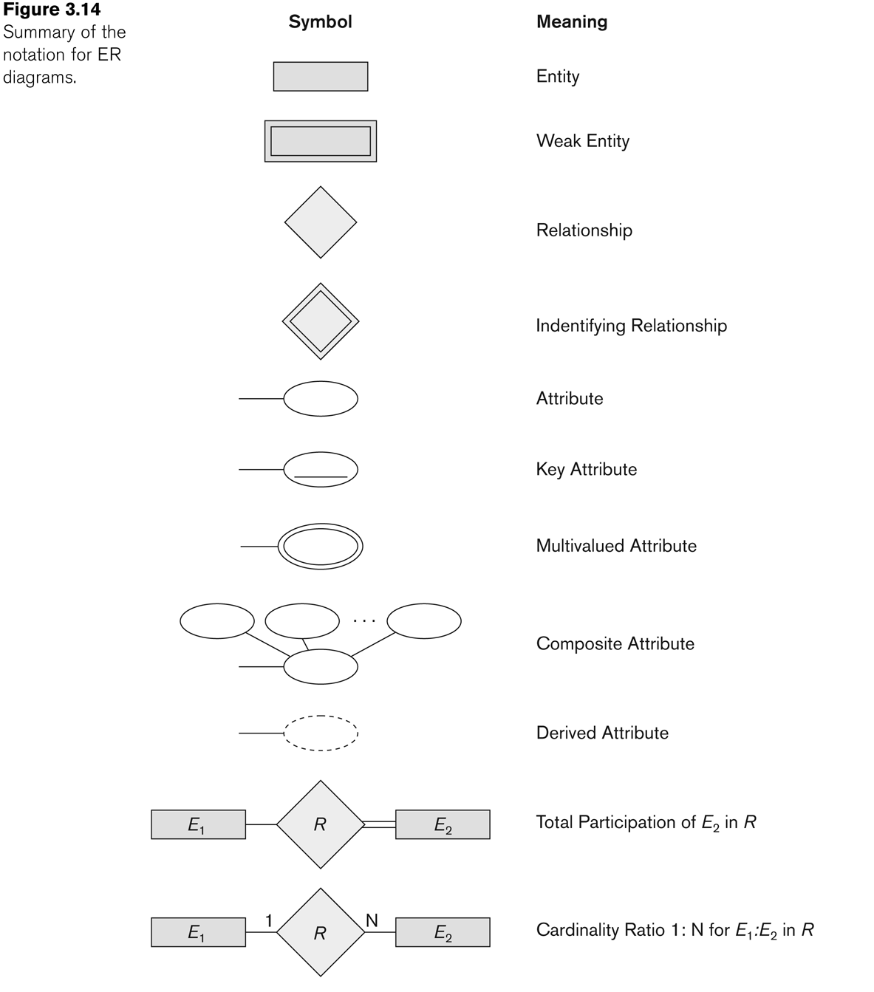

Besides, each group prepares a short presentation (10 minutes) to present the database you design.

Example of the project:

- Database requirements on all Entity types (only four entity types in this example)

  - The company is organized into DEPARTMENTs. Each department has a name, number and an employee who manages the department. We keep track of the start date of the department manager. A department may have several locations.
  - Each department controls a number of PROJECTs. Each project has a unique name, unique number and is located at a single location.
  - We store each EMPLOYEE’s name, social security number, address, salary, sex, and birthdate.
    - Each employee works for one department but may work on several projects.
    - We keep track of the number of hours per week that an employee currently works on each project.
    - We also keep track of the direct supervisor of each employee.
  - Each employee may have a number of DEPENDENTs.
    - For each dependent, we keep track of their name, sex, birthdate, and relationship to the employee.

- ER diagram
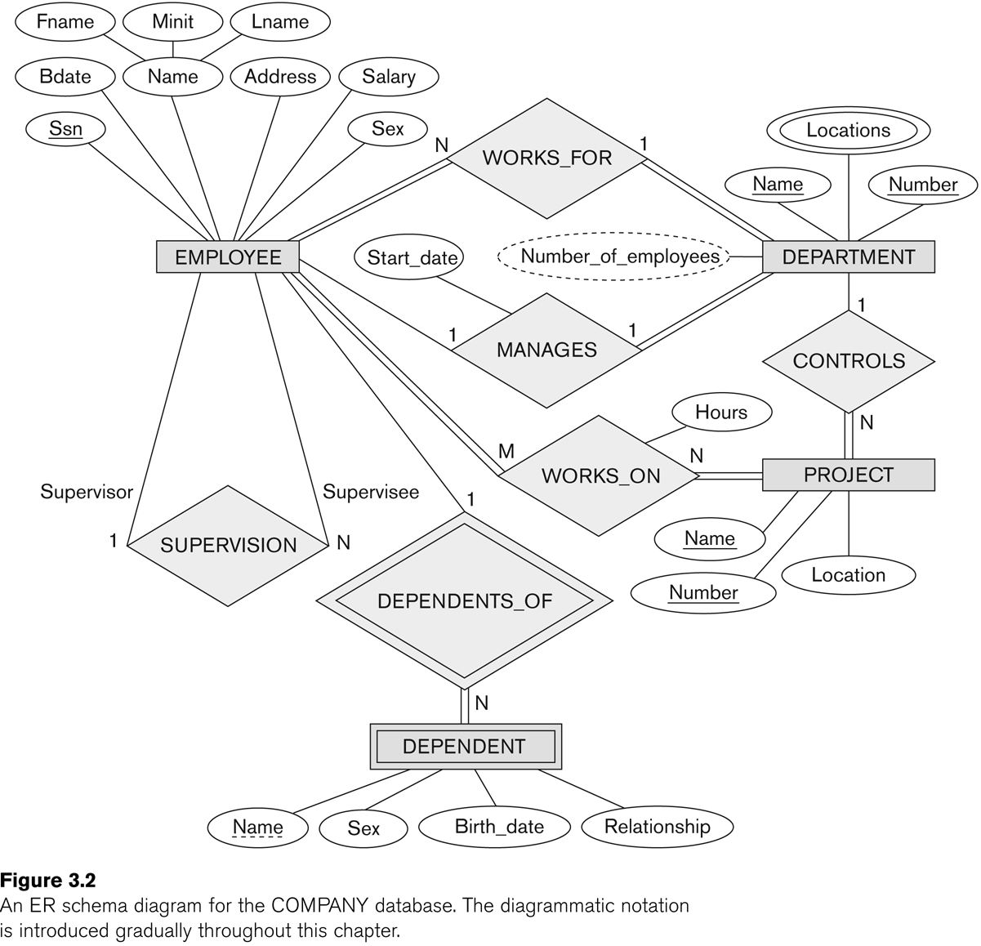

- Specify all relationship types

