**COMP4004 Assignment 2 – Cucumber**

Lexi Brown

100956208

**Traceability Matrix**

|  |  |  |  |  |  |  |  |  |  |  |  |  |  |  |  |  |
| --- | --- | --- | --- | --- | --- | --- | --- | --- | --- | --- | --- | --- | --- | --- | --- | --- |
| Feature/Scenario | Tv1 | Tv2 | Tv3 | Tv4 | Tv5 | Tv6 | Tv7 | Tv8 | Tv9 | Tv10 | Tv11 | Tv12 | Tv13 | Tv14 | Tv15 | Tv16 |
| Use Case Dependencies |  |  |  |  |  |  |  |  |  |  |  |  |  |  |  |  |
| User Test Cases | **x** | **x** |  |  |  |  |  |  |  |  | **x** |  |  |  |  |  |
| Title Test Cases |  |  | **x** | **x** |  |  |  |  |  | **x** |  | **x** |  |  |  |  |
| Item Test Cases |  |  |  |  | **x** | **x** | **x** |  | **x** |  |  |  |  |  |  |  |
| Borrow Test Cases |  |  |  |  |  |  |  | **x** |  |  |  |  |  |  | **x** |  |
| Return Test Cases |  |  |  |  |  |  |  |  |  |  |  |  |  |  |  |  |
| Renew Test Cases |  |  |  |  |  |  |  |  |  |  |  |  | **x** | **x** |  | **x** |
| Collect Fee Test Cases |  |  |  |  |  |  |  |  |  |  |  |  |  |  |  |  |

|  |  |  |  |  |  |  |  |  |  |  |  |  |  |  |  |  |
| --- | --- | --- | --- | --- | --- | --- | --- | --- | --- | --- | --- | --- | --- | --- | --- | --- |
| Feature/Scenario | Tv17 | Tv18 | Tv19 | Tv20 | S4 | Ti1 | Ti2 | Ti3 | Ti4 | Ti5 | Ti6 | Ti7 | Ti8 | Ti9 | Ti10 | Ti11 |
| Use Case Dependencies |  |  |  |  | **x** |  |  |  |  |  |  |  |  |  |  |  |
| User Test Cases |  |  |  |  |  | **x** |  |  |  |  |  |  |  |  |  |  |
| Title Test Cases |  |  |  |  |  |  |  | **x** |  |  |  |  |  |  |  |  |
| Item Test Cases |  |  |  |  |  |  | **x** |  |  |  |  |  |  | **x** | **x** | **x** |
| Borrow Test Cases |  |  |  |  |  |  |  |  | **x** | **x** | **x** | **x** | **x** |  |  |  |
| Return Test Cases |  | **x** | **x** | **x** |  |  |  |  |  |  |  |  |  |  |  |  |
| Renew Test Cases |  |  |  |  |  |  |  |  |  |  |  |  |  |  |  |  |
| Collect Fee Test Cases | **x** |  |  |  |  |  |  |  |  |  |  |  |  |  |  |  |

|  |  |  |  |  |  |  |  |  |  |  |  |  |  |  |  |
| --- | --- | --- | --- | --- | --- | --- | --- | --- | --- | --- | --- | --- | --- | --- | --- |
| Feature/Scenario | Ti12 | Ti13 | Ti14 | Ti15 | Ti16 | Ti17 | Ti18 | Ti19 | Ti20 | Ti21 | Ti22 | Ti23 | Ti24 | Ti25 | Ti26 |
| Use Case Dependencies |  |  |  |  |  |  |  |  |  |  |  |  |  |  |  |
| User Test Cases |  |  |  | **x** |  |  | **x** | **x** |  |  |  |  |  |  |  |
| Title Test Cases | **x** | **x** | **x** |  |  |  |  |  | **x** |  |  |  |  |  |  |
| Item Test Cases |  |  |  |  |  |  |  |  |  | **x** |  |  |  |  |  |
| Borrow Test Cases |  |  |  |  |  |  |  |  |  |  | **x** |  |  |  |  |
| Return Test Cases |  |  |  |  |  |  |  |  |  |  |  |  |  | **x** | **x** |
| Renew Test Cases |  |  |  |  | **x** |  |  |  |  |  |  | **x** | **x** |  |  |
| Collect Fee Test Cases |  |  |  |  |  | **x** |  |  |  |  |  |  |  |  |  |

**Test Cases**

Features: Use Case Dependencies, User Test Cases, Title Test Cases, Item Test Cases, Borrow Test Cases, Return Test Cases, Renew Test Cases, Collect Fee Test Cases

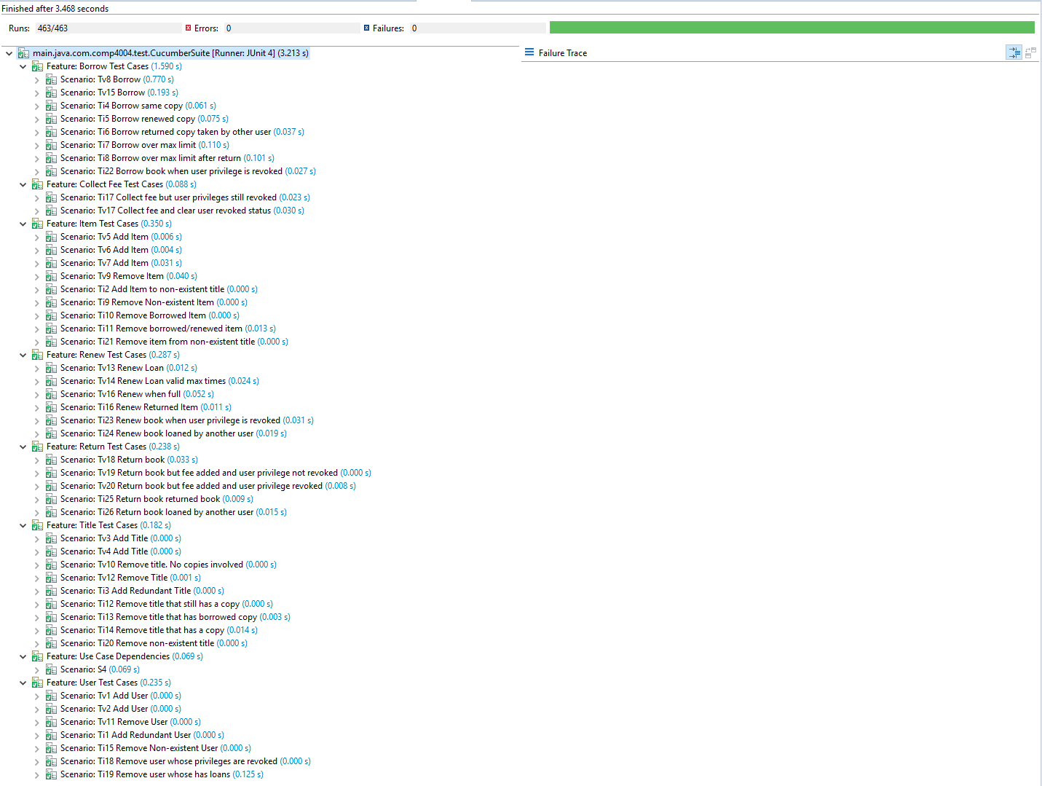

# Extra Test **invalid** paths of use cases

**Ti17 Collect fee but user privileges still revoked**

Create user u1

Create title t1

Create copies 1 of t1

Have user u1 borrow copy1 of t1

Have user u1 return copy1 of t1 overdue

Collect partial fee for user u1 but not full fee

Attempt to have user u1 borrow copy1 of t1

**Ti18 Remove user whose privileges are revoked**

Create user u1

Revoke user u1 privileges

Attempt to remove user u1

**Ti19 Remove user whose has loans**

Create user u1

Create title t1

Create copies 1 of t1

Have user u1 borrow copy1 of t1

Attempt to remove user u1

**Ti20 Remove non-existent title**

Attempt to remove t1 (i.e. without having created it)

**Ti21 Remove item from non-existent title**

Attempt to remove copy1 of t1 (i.e. without having created it)

**Ti22 Borrow book when user privilege is revoked**

Create user u1

Revoke user u1 privileges

Create title t1

Create copies 1 of t1

Attempt to have user u1 borrow copy1 of t1

**Ti23 Renew book when user privilege is revoked**

Create user u1

Create title t1

Create copies 1 of t1

Have user u1 borrow copy1 of t1

Revoke user u1 privileges

Attempt to have user u1 renew copy1 of t1

**Ti24 Renew book loaned by another user**

Create user u1 and u2

Create title t1

Create copies 1 of t1

Have user u1 borrow copy1 of t1

Attempt to have user u1 renew copy1 of t1

**Ti25 Return book returned book**

Create user u1

Create title t1

Create copies 1 of t1

Have user u1 borrow copy1 of t1

Have user u1 return copy1 of t1

Attempt to have user u1 return copy1 of t1 again

**Ti26 Return book loaned by another user**

Create user u1 and u2

Create title t1

Create copies 1 of t1

Have user u1 borrow copy1 of t1

Attempt to have user u2 return copy1 of t1

# Extra Test **valid** paths of use cases

**Tv17 Collect fee and clear user revoked status**

Create user u1

Create title t1

Create copy 1 of t1

Have user u1 borrow copy1 of t1

Have user u1 return copy1 of t1 overdue

Collect full fee for user u1

Have user u1 borrow copy1 of t1

**Tv18 Return book**

Create user u1

Create title t1

Create copy 1 of t1

Have user u1 borrow copy1 of t1

Have user u1 return copy1 of t1

**Tv19 Return book but fee added, and user privilege not revoked**

Create user u1

Create title t1

Create copy 1 of t1

Have user u1 borrow copy1 of t1

Have user u1 return copy1 of t1 late

Ensure fees were applied to user u1

**Tv20 Return book but fee added, and user privilege revoked**

Create user u1

Create title t1

Create copy 1 of t1

Have user u1 borrow copy1 of t1

Have user u1 return copy1 of t1 late

Ensure fees were applied to user u1 and privileges were revoked