

Azure  
Total Cost of Ownership (TCO) summary

Prepared for

Lexi Brown

April 2018

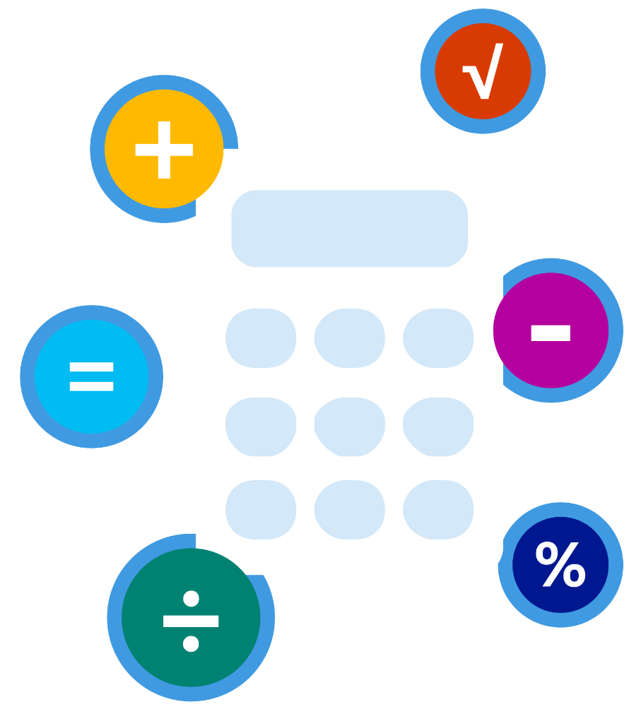

Assumptions and inputs

|  |
| --- |
| Compute |
| **Physical servers**   |  |  |  |  |  |  |  | | --- | --- | --- | --- | --- | --- | --- | | **# Servers** | **OS** | **Proc(s) per server** | **Total cores** | **RAM (GB)** | **Optimize by** | **GPU** | | 100 | Linux | 2 | 8 | 56 | CPU | None | |
|  |
| **Virtual machines**   |  |  |  |  |  |  | | --- | --- | --- | --- | --- | --- | | **# VMs** | **OS** | **Virtualization** | **Core(s)** | **RAM (GB)** | **Optimize by** | |

|  |
| --- |
| Storage |
| |  |  |  |  |  |  | | --- | --- | --- | --- | --- | --- | | **Storage type** | **Disk type** | **Capacity** | **Backup** | **Archive** | **Accessibility %** | | Local Disk/SAN | HDD | 1 TB | 0 TB | 0 TB | 100 | |

|  |
| --- |
| Networking |
| **Outbound bandwidth (GB)/Month** |
| 5 GB |

|  |
| --- |
| Azure region |
| US East 2 |

Your estimated savings are **$ 2,591,689 (71%)**  
over **3** year(s) with Microsoft Azure.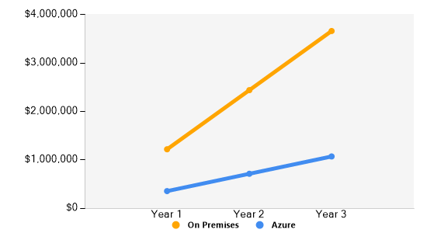

On-Premises vs. D5v2 Azure Costs

|  |  |
| --- | --- |
| On-premises cost breakdown summary | Azure cost breakdown summary |
| |  |  | | --- | --- | | Category | Costs | | Compute | $2,436,108 | | Hardware Software Electricity | $2,256,800 $0 $179,308 | | Data Center | $470,646 | | Networking | $677,076 | | Storage | $2,662 | | IT labor | $78,398 | | Total | **$3,664,890** | | |  |  |  |  | | --- | --- | --- | --- | |  |  |  |  | | Category | **Web direct cost** | **1 Year Reserved VM** | **3 Years Reserved VM** | | Compute | $2,407,248 | $1,563,600 | $1,013,700 | | Data center | $0 | $0 | $0 | | Networking | $0 | $0 | $0 | | Storage | $921 | $921 | $921 | | IT labor | $58,581 | $58,581 | $58,581 | | Total | $2,466,750 | $1,623,102 | $1,073,202 | |

*The Azure Compute pre-purchase (CPP) plan offers you discounts up to 63 percent off standard prices on virtual machines in Azure, for an upfront pre-purchase of 12 months of a particular instance (instance family, size, region, and operating system).

Estimated on-premises cost (three years) vs. estimated Azure cost (three years)

## Compute cost

|  |  |  |  |  |  |  |  |  |  |  |  |  |  |  |  |  |  |  |  |  |  |  |  |  |  |  |  |  |  |  |  |  |  |  |  |  |  |  |  |  |  |  |  |  |  |  |  |  |  |  |  |  |  |  |  |  |  |  |  |  |  |  |  |  |  |  |  |  |  |  |  |  |  |  |
| --- | --- | --- | --- | --- | --- | --- | --- | --- | --- | --- | --- | --- | --- | --- | --- | --- | --- | --- | --- | --- | --- | --- | --- | --- | --- | --- | --- | --- | --- | --- | --- | --- | --- | --- | --- | --- | --- | --- | --- | --- | --- | --- | --- | --- | --- | --- | --- | --- | --- | --- | --- | --- | --- | --- | --- | --- | --- | --- | --- | --- | --- | --- | --- | --- | --- | --- | --- | --- | --- | --- | --- | --- | --- | --- |
| |  |  | | --- | --- | |  |  | | Hardware cost | | Physical Servers Costs | | Cost per 2 proc 8 core, 64GB RAM physical server | $14,105 | | Number of server(s) required | 100 | | **Total cost for physical server(s)** | **$1,410,500** | | Cost of maintaining physical server(s) - 20% of cost of physical server(s) | $282,100 | | **Total cost of maintaining server(s) over 3 year(s)** | **$846,300** | | **Total hardware costs over 3 year(s)** | **$2,256,800** | | Software cost | | Physical Servers Costs | | **Total Windows licensing costs over 3 year(s)** | **$0** | | Electricity cost | | Price of electricity per kWh | $0.1 | | Physical Servers Costs | | Power rating of 2 proc 8 core, 64 GB RAM server | 682 Watts | | Total electricity cost consumed by 100server(s) - 2 proc, 8 core, 64 GB RAM server per month | $4,978.60 | | **Total electricity costs over 3 year(s)** | **$179,308** | |  | |  |  | | --- | --- | |  |  | | Web direct cost | | Number of hours per month | 730 | | Average utilization | 100% | | Physical Servers Costs | | D5v2 Standard (16 vCPU, 56 GB RAM)Linux | $0.916/ hr | |  | SKU# 997-02661 | | Number of virtual machine(s) needed | 100 | | **Total virtual machine costs per month** | **$66,868** | | **Total web direct virtual machine costs over 3 year(s)** | **$2,407,248** | | 1 Year Reserved VM | | Number of hours per month | 730 | | Average utilization | 100% | | Physical Servers Costs | | DS5v2 Standard (16 vCPU, 56 GB RAM)Linux | $0.595/ hr | | Number of virtual machine(s) needed | 100 | | **Total 1-Year Reserved Cost over3 year(s)** | **$1,563,600** | | 3 Years Reserved VM | | Number of hours per month | 730 | | Average utilization | 100% | | Physical Servers Costs | | DS5v2 Standard (16 vCPU, 56 GB RAM)Linux | $0.386/ hr | | Number of virtual machine(s) needed | 100 | | **Total 3-Year Reserved Cost over 3 years** | **$1,013,700** | |
| |  |  | | --- | --- | |  |  | | **Total compute cost over 3 year(s)** | **$2,436,108** | |  | |  |  | | --- | --- | |  |  | | **Total Azure compute cost over 3 year(s)** | **$1,013,700** | |

## Datacenter cost

|  |  |  |  |  |  |  |  |  |  |  |  |  |  |  |  |  |  |  |  |  |  |  |  |  |  |  |  |
| --- | --- | --- | --- | --- | --- | --- | --- | --- | --- | --- | --- | --- | --- | --- | --- | --- | --- | --- | --- | --- | --- | --- | --- | --- | --- | --- | --- |
| |  |  | | --- | --- | |  |  | | Data center Compute cost | | Number of rack units per rack | 42 | | Physical Servers Costs | | Total number of rack units required | 400 | | Total number of rack units required for all server(s) | 400 | | Number of racks required | 10 | | Data Center construction cost per rack amortized over 20 years | $14,262 | | **Total Data center compute costs over 3 year(s)** | **$427,860** | | Data center storage cost | | Rack mounting/installation cost | $14,262 | | **Total Data center storage costs over 3 year(s)** | **$42,786** | |  | |  |  | | --- | --- | |  |  | | Total Azure Data center costs over 3 year(s) | $0 | |
| |  |  | | --- | --- | |  |  | | **Total Data Center cost over 3 year(s)** | **$470,646** | |  | |  |  | | --- | --- | |  |  | | **Total Azure Data center costs over 3 year(s)** | **$0** | |

## Networking cost

|  |  |  |  |  |  |  |  |  |  |  |  |  |  |  |  |  |  |  |  |  |  |  |  |  |  |  |  |  |
| --- | --- | --- | --- | --- | --- | --- | --- | --- | --- | --- | --- | --- | --- | --- | --- | --- | --- | --- | --- | --- | --- | --- | --- | --- | --- | --- | --- | --- |
| |  |  | | --- | --- | |  |  | | Networking cost | | Total hardware + software costs over 3 year(s) | $2,256,800 | | Network hardware and software costs assumed to be 25% of hardware and software costs over 3 year(s) | $564,200 | | Network maintenance cost assumed to be 20% of network hardware and software costs over 3 year(s) | $112,840 | | Service provider cost/GB per month | $0.20 | | Amount of bandwidth needed (GB) per month | 5 | | **Total service provider cost per month** | **$1** | | **Total network hardware and software cost over 3 year(s)** | **$677,076** | |  | |  |  | | --- | --- | |  |  | | Azure Networking cost | | Total outgoing bandwidth needed/month | 5 | | Total outgoing bandwidth cost/month | $0 | | **Total networking cost for 5 GB / Month over 3 year(s)** | **$0** | |
| |  |  | | --- | --- | |  |  | | **Total estimated on-premises networking cost over 3 year(s)** | **$677,076** | |  | |  |  | | --- | --- | |  |  | | **Total estimated Azure networking cost** | **$0** | |

## Storage cost

|  |  |  |  |  |  |  |  |  |  |  |  |  |  |  |  |  |  |  |  |  |  |  |  |  |  |  |  |  |  |  |  |  |  |  |  |  |  |  |  |
| --- | --- | --- | --- | --- | --- | --- | --- | --- | --- | --- | --- | --- | --- | --- | --- | --- | --- | --- | --- | --- | --- | --- | --- | --- | --- | --- | --- | --- | --- | --- | --- | --- | --- | --- | --- | --- | --- | --- | --- |
| |  |  | | --- | --- | |  |  | | Storage cost | | Hardware infrastructure | | **Local Disk/SAN-HDD** | | Cost per GB | $2 | | Amount of HDD (RAID 10) storage needed (TB) | 1,024.00 | | **Total storage procurement cost over 3 year(s)** | **2,048** | | Storage maintenance | | **Storage maintenance cost (% of storage procurement cost) over 3 year(s)** | **$614** | | **Total storage maintenance over3 year(s)** | **$614** | |  | |  |  | | --- | --- | |  |  | | Azure storage cost | | Storage maintenance | | **Page Blob storage - LRS** | | Usable storage volume (RAID 10 configuration) in GB | 512.00 | | Storage cost per GB | $0.05 | | **Annual storage cost per usable volume** | **$307** | | Number of storage transactions required per usable volume | 5,000 | | Azure page blob transaction pricing per 10000 transactions | $0.00036 | |  | SKU# N9H-00439 | | **Total annual transactions cost** | **$0** | | **Total LRS storage maintenance cost over 3 year(s)** | **$921** | |
| |  |  | | --- | --- | |  |  | | **Total estimated on-premises storage cost** | **$2,662** | |  | |  |  | | --- | --- | |  |  | | **Total estimated Azure storage cost** | **$921** | |

## IT labor cost

|  |  |  |  |  |  |  |  |  |  |  |  |  |  |  |  |  |
| --- | --- | --- | --- | --- | --- | --- | --- | --- | --- | --- | --- | --- | --- | --- | --- | --- |
| |  |  | | --- | --- | |  |  | | On-premises IT labor cost | | Number of IT admin hour(s) needed per year | 522.66 | | Hourly rate for IT administrator | $50 | |  | |  |  | | --- | --- | |  |  | | Azure IT labor cost | | Number of IT admin hour(s) needed per year | 390.53 | | Hourly rate for IT administrator | $50.00 | |
| |  |  | | --- | --- | |  |  | | **Total estimated on-premises IT labor cost** | **$78,398** | |  | |  |  | | --- | --- | |  |  | | **Total estimated Azure IT labor cost** | **$58,581** | |

|  |  |  |  |  |  |  |  |  |  |  |
| --- | --- | --- | --- | --- | --- | --- | --- | --- | --- | --- |
| |  |  | | --- | --- | |  |  | | **Total on-premises cost over 3 year(s)** | **$3,664,890** | |  | |  |  | | --- | --- | |  |  | | **Total Azure cost over 3 year(s)** | **$1,073,202** | |

Learn more about Azure

What is Azure?

Learn how Microsoft Azure cloud services enable developers and IT professionals to build, deploy, and manage applications in the cloud, wherever they want, and with the freedom to use their preferred tools, applications, and frameworks. Find out more at:

<https://azure.microsoft.com/en-us/overview/what-is-azure>

The Trusted Cloud

Microsoft makes security, privacy, and compliance a top priority.   
With more certifications than any cloud provider, Azure provides the most comprehensive compliance coverage. Learn more at:

<https://azure.microsoft.com/en-us/support/trust-center>

Customer innovations

World-class organizations all over the world are driving innovation and getting results with Azure. Find out more at:

<https://azure.microsoft.com/en-us/case-studies>

Azure solutions

With everything you need to get quickly started—from technical documentation to partner resources—Azure provides complete solutions for your needs. Learn more about Azure solutions areas:

<https://azure.microsoft.com/en-us/solutions>

Get started with Azure today—for free

It’s easy to get started. Sign up and deploy your first Azure   
solution in under 5 minutes:

<https://azure.microsoft.com/en-us/get-started>