Lexi Brown - 100956208

COMP4906 Honours thesis: Skydot

pre-proposal

# Introduction

Skydot is a cloud based project that allows companies to minimize the cost of cloud and on-premise services, and provides an environment where developers can utilize any language that best suits their needs and/or skills. It does this by having auto scaling of web services while offering a universal REST API for all client applications. Skydot also fronts backend services and/or databases with a REST API. This way backend services won’t have to change to adopt new technologies and new services won’t have to accommodate for old technologies. The project will be presented as a mobile banking service providing data for Android, Web and, if time permits, iPhone mobile application.

## Problem

Skydot will be addressing the high cost of maintaining on-premise technology and the hidden transition costs to cloud based services while maximizing the productivity of software development. These problems encompass the following issues in today’s industry:

* On-premise technology costs are very high
* Maintenance costs increase as hardware gets older and therefore must be replaced
* Many people are needed to manage the infrastructure of on-premise technologies
* Disaster recovery sites are needed to reduce risk and are costly to maintain
* Cloud resources can be expensive if not handled efficiently
* Incorporating new technologies while maintaining old software frameworks can become unmanageable and can cause licensing and compatible issues
* Lack of collaboration between teams causes duplication of code and effort, and risks reduction of data integrity

## Motivation

The inspiration for this project came from a company I worked with previously who wanted to move to cloud based services. The industry was, and still is, moving in the direction of cloud based technologies since it can be cost effective, and forward-thinking companies want to stay ahead on the latest technologies. In the end, the company I worked with decided upon out-of-the-box software that does much of what I’ve outlined for this project but is more limiting and costly. I believe there is a cheaper, more efficient and more inclusive way of utilizing cloud services. Many frameworks cost from thousands to millions, depending on the needs of the company purchasing the product, and only provide a limited amount of compatible languages and frameworks that developers can use.

Skydot provides solutions for small, start-up companies. These companies are trying to decide between on-premises services or cloud services while also keeping the costs low. This project presents a quick and cost-effective way of utilizing technology they need within a budget they can afford.

## Project Goals

1. Decrease the amount of people needed to maintain software and decrease the cost of maintaining software.
2. Increase code integrity and decrease code development time between teams.
3. Counter long, multi-step manual deployment with simple, quick, autonomous cloud deployment.
4. Handle cloud resources as efficiently as possible.
5. Provide a common point of access for client applications.
6. Create a layered framework that separate client applications from common services.
7. Provide a common point of access to host services and data.
8. Utilize Skydot as the server side of a mobile banking application to present the capabilities of the project.

## Pre-Proposal Objectives

1. Set up an application container that wraps the entire project and is used for deployments.
2. Establish an API gateway through which micro-apps can register and client applications can send requests.
3. Establish a service gateway that allows micro-apps to make REST requests to micro-services.
4. Establish a host gateway that provides a REST API for micro-services to access backend services. The backend consists of REST and WSDL services.
5. Build an authentication database server to generate and keep tokens for client application requests.
6. Build backend services. At least one WSDL service must be provided.
7. Provide micro-services in multiple languages. Java must be one of them to show scaling cost. Possible micro-services: Authentication, Account summary and details, Transfers, Bill payment.
8. Build front end Android and web application to display services.

## Possible Features

1. DevOps: Dashboard, health checking, logging, monitoring, continuous integration and continuous development (CICD).
2. Populate a string database with error and warning messages (en_CA and fr_CA).
3. Build an iPhone and/or tablet application.
4. Integrate oAuth2 and LDAP authentication.
5. Use Swagger for design and documentation.

## Equipment Requirements

* Microsoft Azure (Any cloud provider could be used)
* Android device(s)

# timeline

## Sept 17-30

* Determine what software to use for the application container (DC/OS, Cloud Foundry, Kubernetes, Docker Swarm, etc.).
* Compare application containers to find best fit.

## Oct 1-14

* Determine technologies for web and Android applications (.NET, JavaScript, React, NodeJS, etc.).
* Setup certificate and DNS for testing.

## Oct 15-28

* Test and determine the micro-app and micro-services REST technologies and languages (Jersey, GraphQL, Spring, Java, Python, Go, etc.).
* Test and determine the API and service gateway technologies. (Apigee, Tyk, MuleSoft, Sentinet, etc.). Some technologies may be provided by application container.

## Oct 29-Nov 11

* Test and determine authentication technologies that will be used.
* Test and determine caching and database technologies (MySQL, SQLServer, Redis, MongoDB, DocumentDB, Cassandra, etc.).

## Nov 12-25

* Test and determine technology for host gateway, build or use a framework (Sentinet, MuleSoft, Apigee, Tyk, etc.).
* Determine mock data for backend services (REST and WSDL).
* Work on first draft of project proposal.

## Nov 26-Dec 8

* Complete project proposal.
* Identify outstanding tasks and resource requirements.
* Determine what technologies to use for “Possible Features” if time allows.

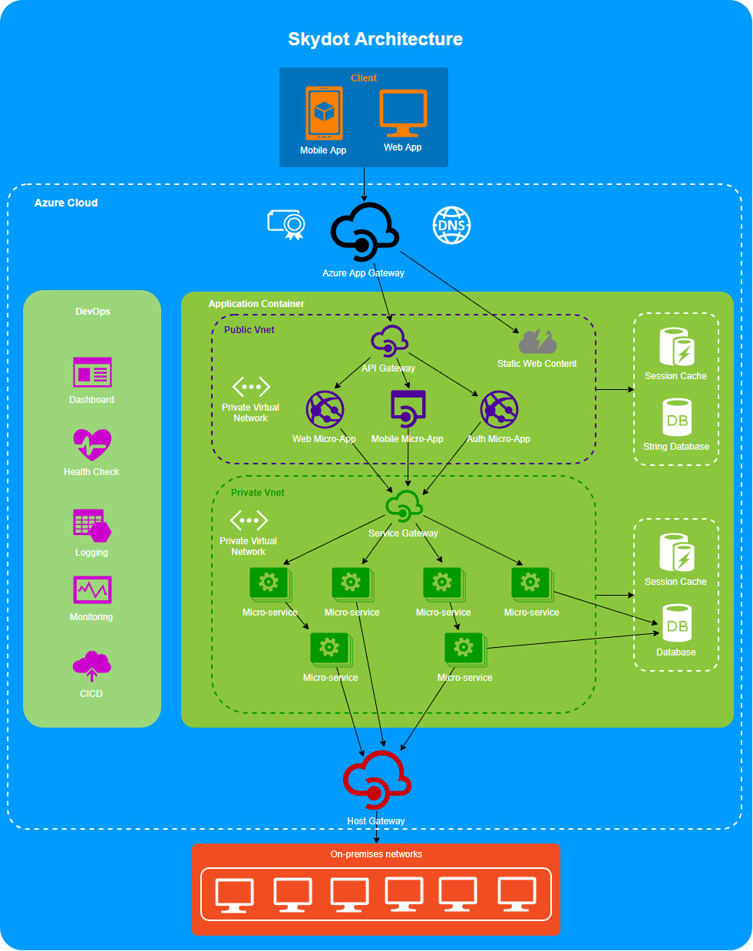

COMP4906 Honours thesis: Skydot

final report outline

# Introduction

## Problem

## Motivation

## Goals

## Objectives

## Outline

# Background

# approach

# results/validation

# conclusion

## Future Work

# refernces

