

Design and Implementation of Analytics System

Modeling Shelf Life: Predictive Analytics for Food Quality and Waste Reduction
Group 1: Elizabeth Harris and Lexington Trotta

School of Graduate Professional Studies
Data Analytics
DAAN 888 – Design and Implementation of Analytics System

Fall, 2025

Document Control

Work carried out by Team (Name):
Members | Email Address | Task description
Lexington Trotta | Ljt5199@psu.edu
Elizabeth Harris | Ejh6175@psu.edu

Revision Sheet

Release No. | Date | Revision Description
1 | 9/7/2025 | Lesson 2 group-based assignment: Created project proposal and description, timeline and data sources for our project.
2 | 9/21/2025 | Lesson 4 group-based assignment: Finalized sources, established project background and scope.  Added References section.
3 | 9/23/2025 | Added Table 1: Data Dictionary to Lesson 4
4 | 9/28/2025 | Removed the 7th source (Arxiv FoodX-251 dataset)
5 | 10/5/2025 | Added Lesson 6 material (Table 3, descriptive stats and visuals, data pre-processing steps, explanation of database used for each data source, framing questions for predictive analytics, data modeling and data population explanation)  Added Appendix B: Code Used
6 | 10/15/2025 | Added Lesson 8 material  Added descriptive statistics about Foodi and Kaggle NGL (sources 5 and 6) to Lesson 6
7 | 11/1/2025 | Added Lesson 10 material
8 | 11/16/2025 | Added Lesson 12 material
9 | 11/28/2025 | Removed any unused data and images/tables associated with it  Added Lesson 13 material
10 | 11/30/2025 | Removed Code from Appendix

TABLE OF CONTENTS
Document Control
Works Carried Out By…………………………………….#
Revision Sheet……………………………………………………..#
Lesson 2: Project Background…………………………………#
Lesson 4: Data Creation via Simulation……………………#
Lesson 6: Data Preprocessing…………………………………….#
Lesson 8: Variable Selection and Data Transformation………...#
Lesson 10: Predictive Modeling Plan…………………………….#
Lesson 12: Modeling, Evaluation and Validation…………………#
Lesson 13: Model Visualization…………………………………….#
References………………………………………………….
Appendices…………………………………………………………

Lesson 2: Project Background

Project Background

Food waste is a huge problem around the world. In fact, it is estimated that 1.3 billion tons of food is thrown out each year (Food and Agriculture Organization of the United Nations, 2011). This waste reflects a significant loss of money, time, and energy, which is felt by both companies and consumers alike. This problem could be reduced significantly if companies and citizens had access to models that are able to accurately predict when meat, fish, or other produce expires, resulting in more accurate expiration dates and a better knowledge of when food should be tossed and when it is still safe to eat.

Scope

The scope of this project begins by compiling open-source databases that contain information about age of food, food sensor outputs, biological contents, etc. We will first clean the data by removing any outliers or missing values, so that it can be imported into our modeling software. Our project will use this data to build three different models: linear, classification, date-to-event.
These models will be able to answer questions like:
- How fresh is the food?
- Is the food fresh?
- How many days will the food be fresh for?
Beyond the three models, we will create visualizations and report basic analytics of the data, which will be used to support the models’ validity. The results of this project will allow both manufacturers and buyers to reduce the number of resources dedicated to acquiring food, resulting in a more efficient process where everyone benefits.
Lesson 4: Data Collection via Existing Data
Structured datasets such as the Chicken Meat Freshness dataset from Kaggle and the Mendeley Shelf-Life Estimation dataset can be downloaded directly in CSV or Excel format. These are best suited for regression and time-to-event models, and we plan to store the Kaggle datasets and the Mendeley dataset in R Studio and Windows PowerShell respectively.
The datasets will require specific preprocessing steps, including normalizing freshness stages, resampling time-series data and one-hot encoding of ingredients. This approach ensures that our regression, classification, and time-to-event models are supported by properly structured and prepared data across multiple formats.

Sources:

- https://www.kaggle.com/datasets/ziya07/chicken-meat-freshness-dataset
- https://www.kaggle.com/datasets/rafimahfuz/e-nose-based-fish-freshness-evaluation
- https://data.mendeley.com/datasets/kphtgxn3ff/4

Table 1: Data Dictionary
Dataset | Primary Key | Attributes | Data Types | Measurement Types
Chicken Meat Freshness (Kaggle) | sample_id | day, freshness_stage, sensor_readings | Integer, Categorical, Float | Discrete (days), Nominal (stage labels), Continuous (sensor readings)
Fish Freshness (Kaggle) | index number | Ammonia MQ135, Co2, Alcohol, Methane, Hydrogen Sulfide, LPG, Hydrogen, Ammonia MQ137, label, Time, TVC | Float, Categorical | Continuous (time, TVC, etc.), discrete (label)
Mendeley Shelf-Life Estimation | experiment_id | temperature, time_elapsed, spoilage_status | Float, Integer, Categorical | Continuous (°C), Discrete (time), Ordinal (spoilage levels)

Table 2: Tasks by Week
Week | Tasks to be Completed
3 | Determine what specific datasets will be used
4 | Retrieve the data
5 | Import and pre-process the data
6 | Perform exploratory data analysis to see what variables have the best predictive power
7 | Perform initial modeling for the linear regression
8 | Finish up linear regression model and start on classification model
9 | Finish up classification model and work on time-to-event model
10 | Select the final models for each category
11 | Interpret the final models and explain in terms of business and social value
12 | Evaluate and validate models’ outputs
13 | Complete visualizations for the models and submit the project report
14 | Record the video demonstration and submit

Lesson 6: Data Pre-Processing
Total Datasets Used: 3
Table 3: Data Exploration
Dataset | Number of Variables / Columns | Explanatory Variable Names | Response Variable | Total Records | Storage
Chicken Meat Freshness (Kaggle) | 15 | Category, Shelf Life, Sensor 1-10, Mean Value, Variance | Target | 1,000 | SQL Database
Fish Freshness (Kaggle) | 11 | Ammonia MQ135, Co2, Alcohol, Methane, Hydrogen Sulfide, LPG, Hydrogen, Ammonia MQ137, Time | Label, TVC | 336,977 | SQL Database
Mendeley Shelf-Life Estimation | 2 | temperature, time_elapsed, spoilage_status | Shelf life | Float, Integer, Categorical | Data Lake

Data Pre-Processing Steps (preparation for predictive modeling):

- Check and remove NA values
- Identify any inconsistencies in spelling or format
- Determine if there are any outliers and remove them
- Reformat variables’ data types as needed
- Conduct feature selection
- Data Partitioning
Descriptive Statistics and Visuals:
- Kaggle Fish Freshness
- 336,977 samples, 11 columns
- 1:2 ratio of fresh to not fresh fish
- TVC (Freshness) is numerical and ranges between 3.57 and 6.3164
- Kaggle Chicken
- 1,000 samples, 15 columns.
- Shelf life: 0–8 days, mean ≈ 4 days.
- Balanced classes: 500 Fresh, 500 FrozenThawed.
- Sensor averages around 0.42, very low variance.
- Mendeley Shelf-Life
- Variables: Time and Temperature
- 4801 entries
- Sensors: average 24.6°C, range 2.4–28°C, duration up to 10,974 minutes (~7.6 days).
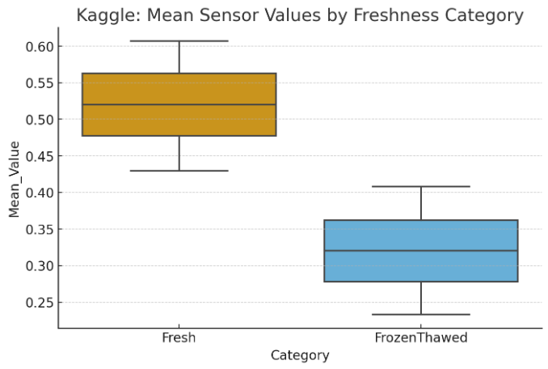
Figure 1: Boxplot of Kaggle Mean Sensor Values by Freshness. Fresh mean value is about 0.20 degrees greater than frozen/thawed indicating that the meat that had just been procured is fresher than the meat that has been frozen then thawed.
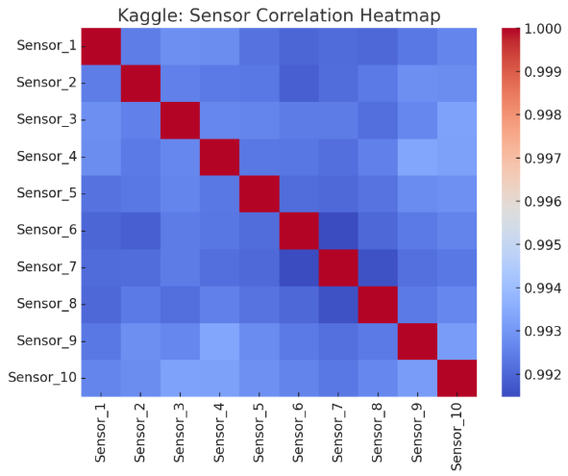
Figure 2: Correlation Heatmap of Kaggle sensors. This heat map displays the correlation matrix for the ten sensors in the Kaggle dataset. Overall, the sensors exhibit extremely high correlations with one another, with values generally above 0.992. This suggests that the sensor signals are highly similar and may contain redundant information, which is important to consider when selecting features or performing dimensionality reduction.
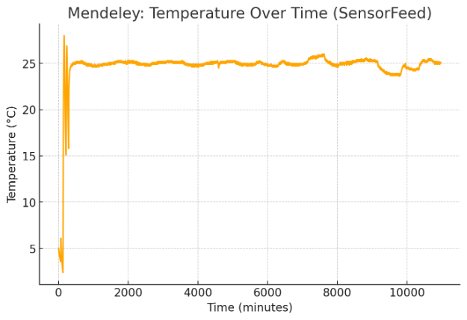
Figure 3: Mendeley plot of Temperature per minute (Time). After an initial period of fluctuation during the first few minutes, the temperature quickly stabilizes around 24 to 26 °C for most of the time series. Although minor variations occur throughout the recording, the overall pattern indicates a generally stable thermal environment. This consistent temperature profile is important for interpreting spoilage timing because it suggests that external temperature changes were minimal and unlikely to introduce major variability into the survival modeling process.

Databases used for each data source:
For the first 2 data sources (Kaggle meat and fish), an SQL database was used to store the structured data. For the third source (the Mendeley dataset), a miniature data lake was used to accommodate the different types of data in one database. Windows PowerShell was used to create the “lake-ish” database.

Data Modeling and Data Population:
The data population phase will focus on loading, cleaning, and enriching the raw datasets to ensure analytical reliability. Data will be collected from 2 open-source repositories (3 datasets), including Kaggle’s Chicken Meat Freshness Dataset and Mendeley’s Fruit Shelf-Life Dataset.
The data modeling phase will involve designing a structured and analytical framework to support predictive modeling of food shelf life and quality. The Kaggle datasets will be uploaded into R, while the Mendeley dataset will be uploaded onto Windows PowerShell. Both will go through the ETL process - the code will be typed directly in R console, and a “bronze, silver and gold” script pipeline will be used in PowerShell to run the Mendeley dataset through.
In both processes, missing values will be handled through median imputation and unit inconsistencies (e.g., °C vs °F) will be standardized and continuous variables such as temperature and humidity will be normalized. Integrity checks and summary statistics will be performed to validate the completeness of the populated tables.

Lesson 8: Variable Selection and Data Transformation
For our business questions, one model per question will be used. The regression model will answer the question of how fresh the food is, the classification model will answer if the food is considered fresh, and lastly the time-to-event model will answer how many days the food will stay fresh. The regression model will be measured by RSME and R², classification model by accuracy and F-1 score, and time-to-event by MAE and C-index with a Cox hazard model.
For the linear regression model, we will be using nine predictor variables: Ammonia MQ135, Alcohol, Methane, Hydrogen Sulfide, LPG, Hydrogen, Ammonia MQ137, Time, and Ammonia MQ135*Ammonia MQ137. One interaction term will be created using base R for the linear regression and will examine the relationship between Ammonia 135 and Ammonia 137. The linear model will then go through a stepwise selection process (forward and backward) to determine if any variables are unnecessary for the effective prediction of TVC (fish freshness). No variable transformation was required for the linear regression.
Our classification model will be using ten predictor variables, taken from ten sensors monitoring chicken freshness. After performing a correlation matrix, we decided against adding any interaction terms, as correlation was too high between the variables and would result in high multicollinearity. Variable transformation included changing the label from a character type to a factor type.
For our time-to-event model, the target variables are for duration, representing the number of days until spoilage/ the end of observation, and event, a binary indicator of either fresh or spoiled. Because this dataset does not include indicators of when spoilage became onset, another source will be used to determine when spoilage occurred (Harrison et. al., 2015). We will create a script for the transformation (Silver) stage to include a duration variable, defined as time in minutes and an event variable indicating whether spoilage had occurred – duration, event and temperature were the remaining variables/columns.
To improve predictive accuracy and capture nonlinear relationships, interaction terms will be included between key variables that are likely to have compounding effects on spoilage. Examples include temperature × relative humidity, temperature × packaging type, pH × product category, and microbial load × storage duration, which can reveal synergistic or antagonistic effects that single variables cannot fully explain.

Lesson 10: Predictive Modeling Plan
Before beginning our regression model, we will split our Kaggle Fish data into three subsets, training, test, and validation at a 60/20/20 ratio. We will be utilizing r-squared and residuals as performance metrics for this regression model. R-squared will measure how much variance is explained by the model, and our residuals will tell us how far off, on average, our model is compared to the actual values. We will then complete a 10-fold cross validation to get a better sense of how consistent our model is. Our final model will attempt to minimize residuals, while maintaining the highest possible r-squared value.
Data for our classification model (Kaggle Chicken) will be split at the same ratio as our regression model, with stratified sampling used. Stratified sampling will ensure an equal distribution of fresh and spoiled data remains in each of the three subsets of data. For our classification model, accuracy will be our performance metric, as our data set is balanced between fresh and spoiled data. We will continue to use 10-fold cross validation to examine the reliability of the model. Our final model seeks to maximize accuracy.
For the time-to-event model, we will implement a survival pipeline script to include stratified sampling due to the imbalance between fresh and spoiled samples. We will compute the survival targets (duration and event) and then split the dataset into training, validation, and test subsets using a 60/20/20 ratio to ensure sufficient training representation. Hyperparameter tuning will be conducted using Random Search combined with 10-fold cross validation to identify the best Cox proportional hazards model configuration. Performance will be evaluated using MAE as the primary measure and concordance index (C-index) as a secondary measure, since the dataset is imbalanced and accuracy would not correctly reflect survival performance. The final model will be selected based on lowest error and highest concordance and then tested on the held-out test set to estimate generalization performance.

Lesson 12: Modeling, Evaluation and Validation
Regression Modeling:
Our initial regression model used eight variables to predict TVC, a measure of fish freshness. This model utilized the 60% training data and resulted in an adjusted r-squared value of 0.9953. However, after examining VIF values to check for the presence of multicollinearity, we found many variables had VIF values above 10, which indicated high multicollinearity. To prevent this, we started by removing the variable with the highest VIF, methane (22.41). We then ran the model again, checking VIF and removing the highest one, until all VIF values were under 4. Our final model used five predictor variables; Ammonia MQ135, Hydrogen Sulfide, Hydrogen, Ammonia MQ137, and time. We put this refined model through a stepwise selection, but no variables were removed. Our final performance metrics for this initial model included an adjusted r-squared value of 0.9952, a residual mean of – 0.00127, and a residual standard deviation of 0.0485.
We also established another refined model that incorporated our interaction variables, Ammonia MQ135*Ammonia MQ137, but after stepwise selection, only the interaction variable was removed, demonstrating that it was not beneficial to the model.
After our first model was completed, we performed our 10-fold cross validation, which resulted in an r-squared of 99.52 and a MAE of 0.0398. Finally, we completed five iterations of the entire experiment to ensure quality of work, with the resulting performance metrics as follows:

Table 4: Mean, Standard Deviation, R-squared and MAE value of Regression Iterations
 | Iteration 1 | Iteration 2 | Iteration 3 | Iteration 4 | Iteration 5 | Average
Residual Mean | 0.000157 | -0.000049 | -0.000173 | -0.000213 | -0.000176 | -0.000091
Residual Standard Deviation | 0.049085 | 0.0491113 | 0.0490659 | 0.0490361 | 0.0491477 | 0.0490892
R-squared | 0.9951861 | 0.9951638 | 0.9952243 | 0.9951906 | 0.9952207 | 0.9951971
MAE | 0.0399342 | 0.0401525 | 0.0398717 | 0.0399870 | 0.0397907 | 0.03994722

Classification Modeling:
For our classification models, we began by comparing the accuracy of CART and Random Forest. We used ten variables to predict the variable target (fresh/unfresh_day). Both models were created using the 60% training data and tested using the 20% test data. Over 200 observations, the CART model demonstrated an accuracy of 97%, while the random forest showed an accuracy of 100%. After our models were finalized, we again performed our five iterations of each model using 10-fold cross validation. To determine if there is a significant difference in accuracy (predictive power) between the models, we performed a two-sample paired t-test using the accuracy from the cross-fold validation iterations. The resulting p-value was 0.05677, which is just short of significance at the more common alpha=0.05 level, but is significant at the alpha=0.06 level. Therefore, we can say with 94% confidence that there is a difference in mean accuracy between the CART model and the random forest model, with the random forest model experiencing higher mean accuracy.
Table 5: CART Model
 | Iteration 1 | Iteration 2 | Iteration 3 | Iteration 4 | Iteration 5 | Average
Accuracy (Test) | 96.5% | 97.5% | 95.5% | 97.5% | 96.5% | 96.7%
Accuracy (Validation) | 93.5% | 91.5% | 93.5% | 94.5% | 94% | 93.4%
The confidence interval for this model’s test data accuracy is (0.9292, 0.9858).

Table 6: Random Forest Model
 | Iteration 1 | Iteration 2 | Iteration 3 | Iteration 4 | Iteration 5 | Average
Accuracy (Test) | 100% | 100% | 100% | 100% | 100% | 100%
Accuracy (Validation) | 94.5% | 93% | 96.5% | 94.5% | 95% | 94.7%
The confidence interval for this model’s test data accuracy is (0.9817, 1).

Time-Series Modeling:
The data lake architecture for the survival analysis followed a structured bronze–silver–gold workflow, allowing the Mendeley dataset to be progressively refined into a model-ready form. Modeling was then performed using a survival pipeline script, which included the stratified sampling, train/test, random search, and validation to identify the best Cox hazards model.
In the bronze layer, the original Mendeley Shelf-Life data was extracted exactly as provided, including the time (in minutes) and temperature measurements collected during the experiment. This raw form was preserved without modification to ensure traceability throughout the modeling pipeline. Since the dataset did not include labels identifying when spoilage occurred, the bronze data served as the foundational input from which the survival targets would be engineered.
In the silver layer, the dataset was transformed into a structured survival-analysis format. This required the creation of a duration variable (Harrison et. al., 2015), defined as the elapsed time in minutes, and an event variable indicating whether spoilage had occurred. Observations equal to or exceeding this threshold were classified as spoiled (event = 1), while all others were treated as right-censored observations (event = 0). At this stage, unnecessary columns were removed, and the dataset was reduced to the essential modeling features: duration, event status, and temperature. The resulting silver dataset represented a clean, survival-ready but not yet fully standardized version of the data.
The gold layer finalized the dataset for use in the Cox proportional hazards model. Numerical predictors were standardized to ensure stable coefficient estimation, and the script also removed any zero-variance features that could interfere with model convergence. While the Mendeley dataset contained no categorical variables requiring encoding, the gold process was designed to one-hot encode such features when present. The final output, saved as gold_survival.csv, consists of duration and event variables along with a standardized temperature predictor. This gold dataset served as the direct input to the hyperparameter tuning and model-fitting procedures used in the survival analysis.
The survival analysis was conducted using the gold dataset derived from the Mendeley time–temperature series. A scientifically reasonable threshold of 4,000 minutes (approximately 2.8 days) was selected based on published produce shelf-life ranges roughly under similar temperature conditions (Harrison et. al., 2015). This threshold allowed for the construction of the two essential survival variables: duration, representing the elapsed time in minutes, and event, representing whether spoilage had likely occurred. With these targets defined, a Cox proportional hazards model was selected to estimate the relationship between temperature and the hazard of spoilage while properly handling censored observations.
To ensure a robust evaluation, the dataset was split into training, validation, and testing subsets using a stratified 60/20/20 split based on the event variable. A random search procedure with 25 iterations was then applied to tune the Cox model’s penalizer and L1 ratio hyperparameters. Each sampled parameter combination was evaluated using 10-fold cross-validation on the training partition, and the best configuration, based on maximizing the concordance index and minimizing MAE, was then refit on the combined training and validation sets. The final model was evaluated on the held-out test set to assess generalization performance.
The best hyperparameter configuration included a penalizer of approximately 1.3×10⁻⁵ and an L1 ratio of 0.10, indicating that the model performed best with light regularization. Cross-validation produced a concordance index of 0.5111 and a mean absolute error (MAE) of 2,614.71 minutes. When evaluated on the test set, the model achieved a C-index of 0.4940 and an MAE of 2,621.13 minutes. These results suggest that the Cox model exhibited limited predictive ability, performing only slightly above chance in cross-validation and near chance on the test set. This outcome is consistent with the nature of the dataset: the event labels were derived from a fixed time threshold rather than observed spoilage, and temperature alone may not provide sufficient variability or predictive power to meaningfully separate hazard levels.

Lesson 13: Model Visualization
Linear Regression
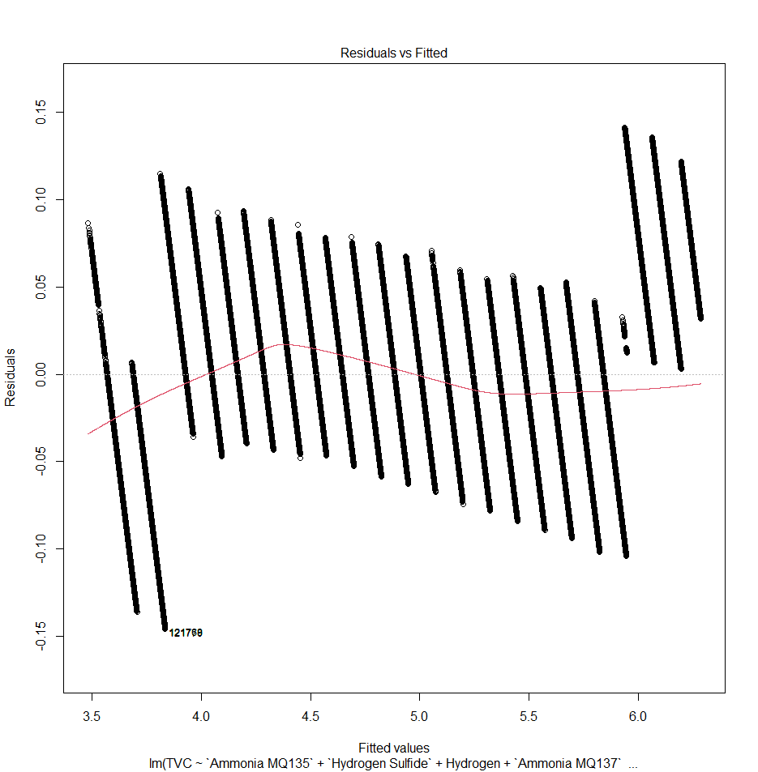  Residuals vs Fitted Plot | 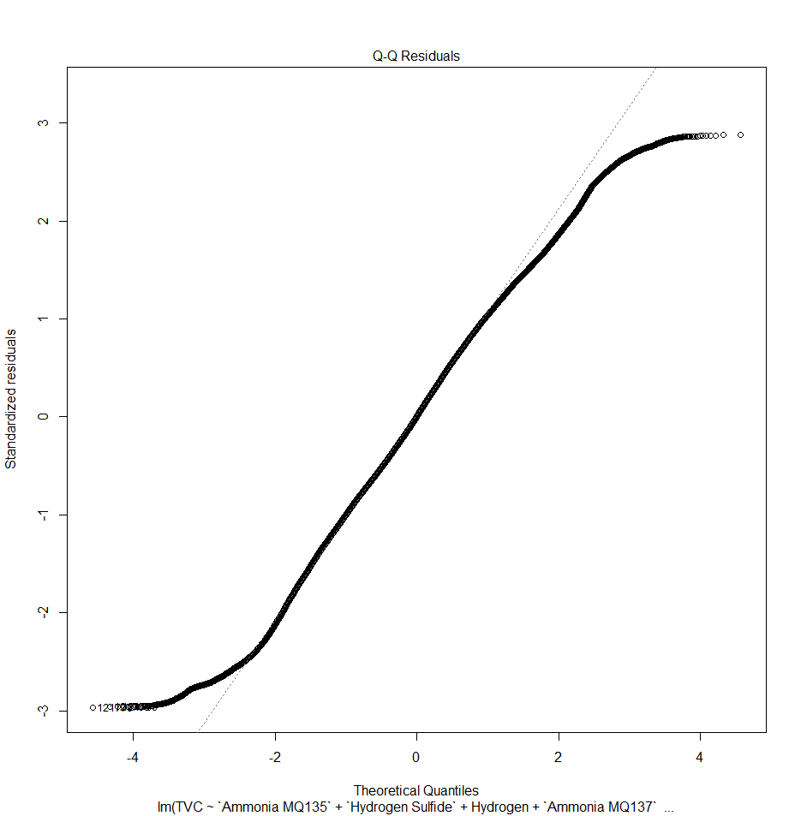  Q-Q Plot
Figure 4A Figure 4B
Figure 4: Checking Assumptions via Residuals vs Fitted Plot and Q-Q Plot.
Multiple linear regression models follow four assumptions: independence, constant variance, normal distribution, and a linear relationship between the predictor variables and response variable. These first three assumptions can be proven by the two graphs provided above. Independence and constant variance can be shown by looking at the residual vs fitted plot (left). The equal distance of residuals from the center horizontal line shows constant variance, while the random spread of residuals demonstrates independence. Normal distribution is proven by the Q-Q plot (right), as the data points overlap with the theoretical normal distribution line. The linear relationship is checked using the five graphs below.

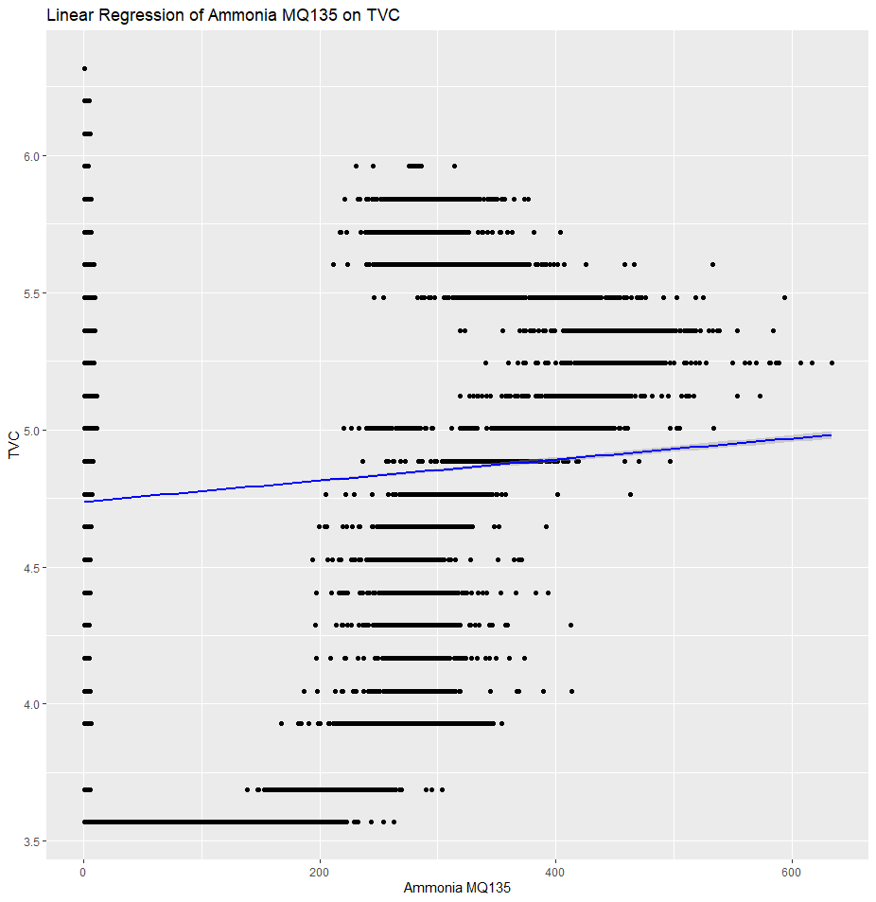  Ammonia MQ135 vs TVC | 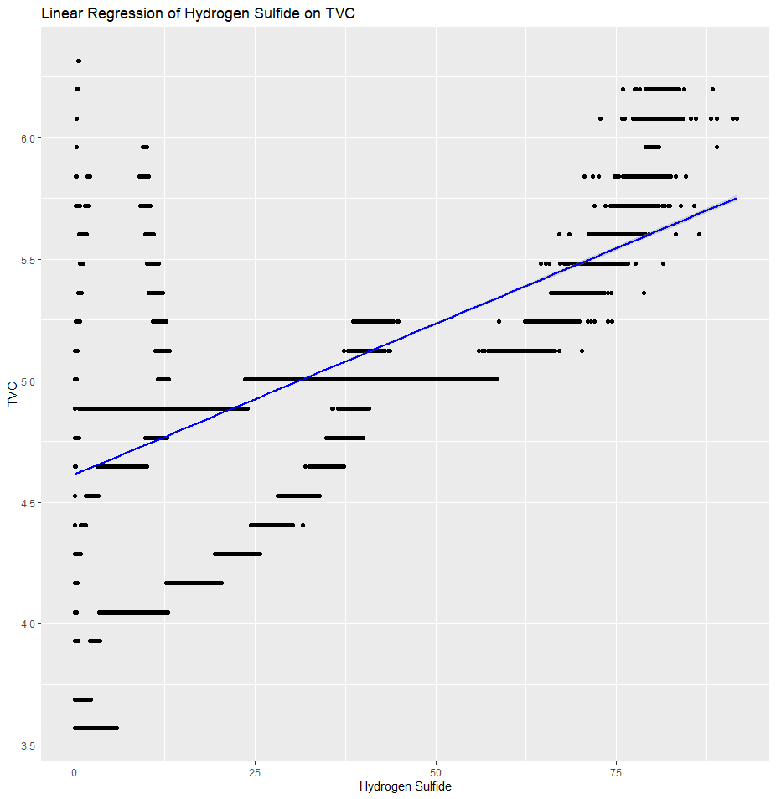  Hydrogen Sulfide vs TVC | 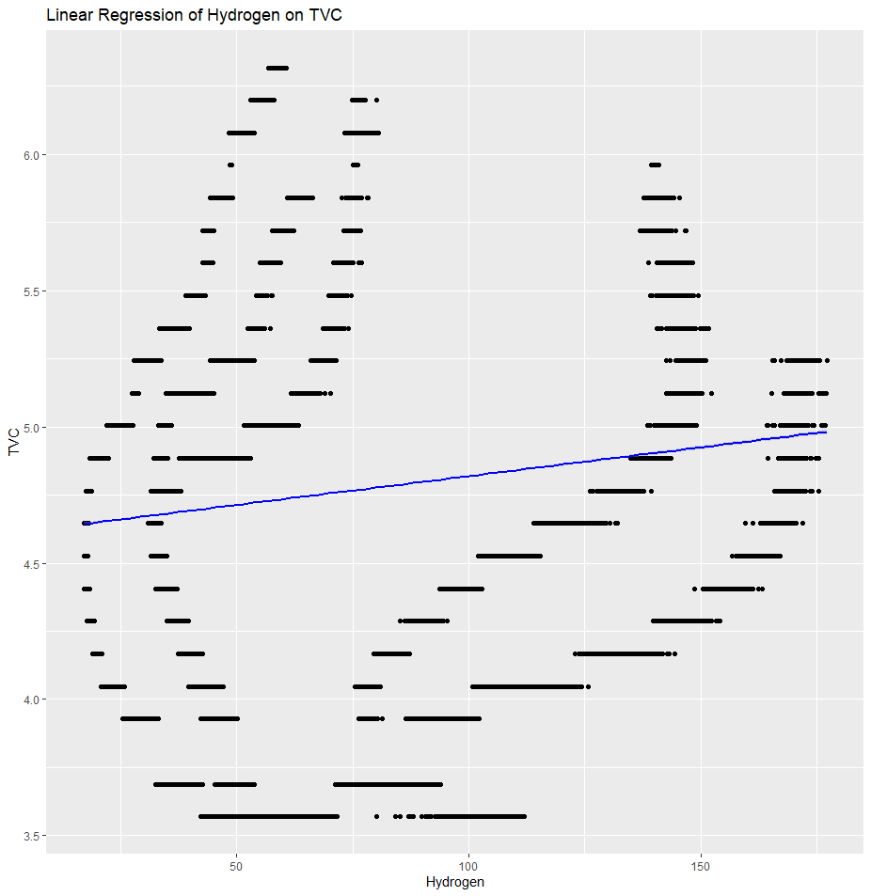  Hydrogen vs TVC
Figure 5A Figure 5B Figure 5C
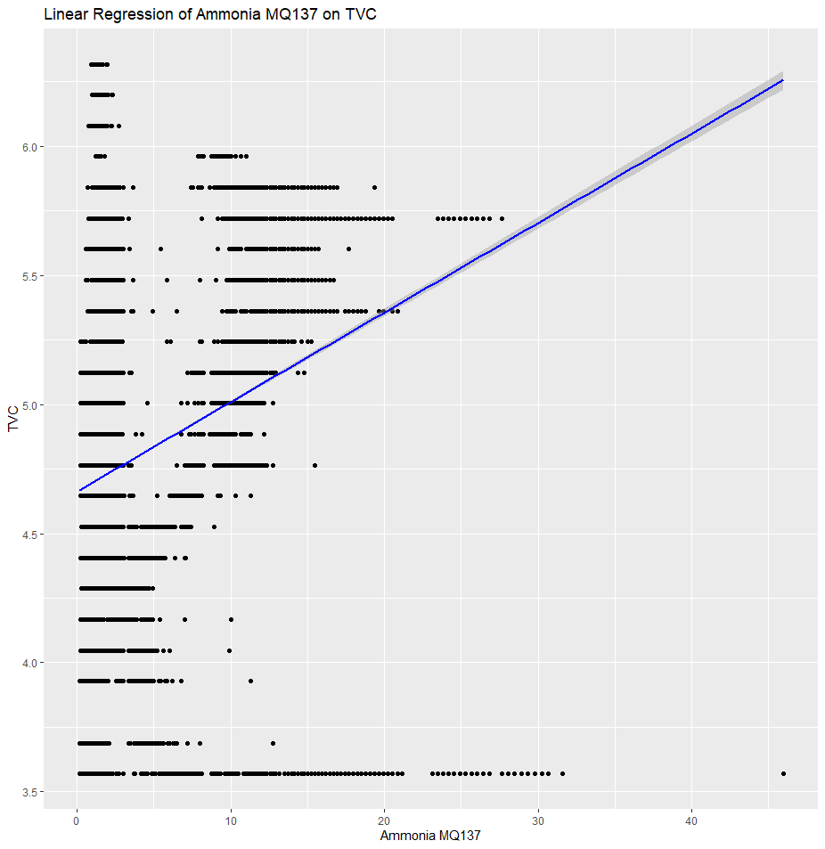 | 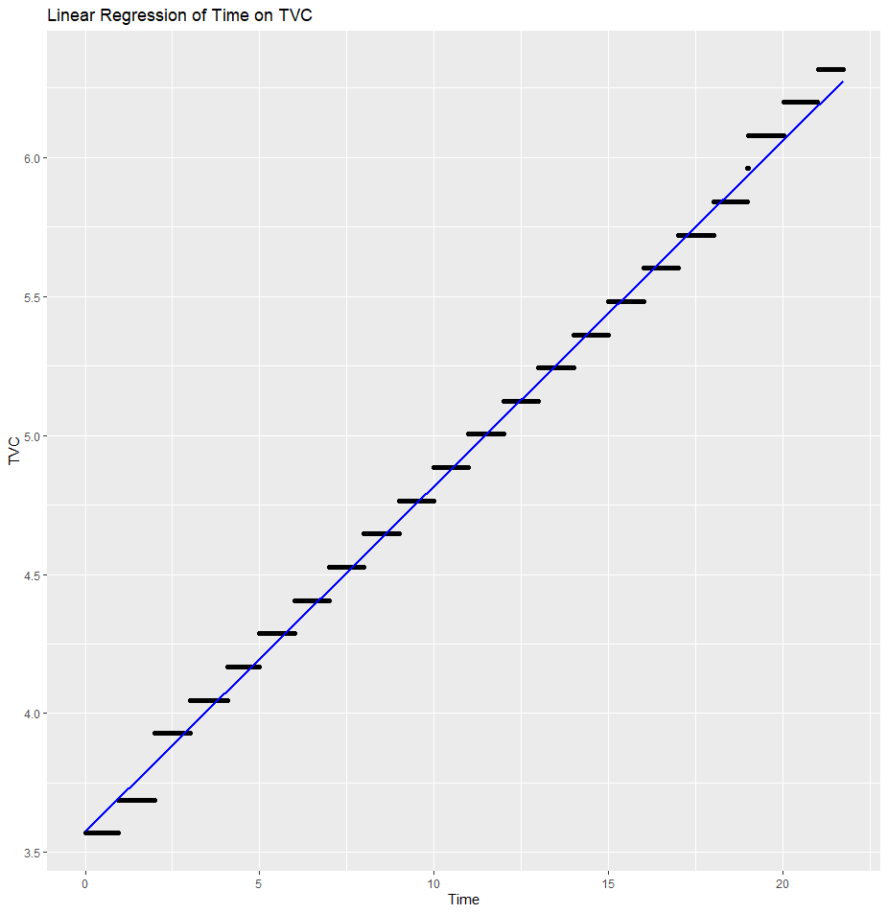
Ammonia MQ137vs TVC | Time vs TVC
Figure 5D Figure 5E
Figure 5: Predictor Variables vs Response Variable. Across all five simple linear regression plots, the visual patterns indicate varying levels of association between each gas sensor reading and the Total Viable Count (TVC).
After analyzing the different predictor variable vs response variable graphs, we can see that all five of our variables have a positive linear relationship with our response variable. The strongest relationship appears to be Time vs TVC, which makes sense; the longer fish remains uneaten, the more likely it is to spoil, as explained by rising TVC values.

Classification Models
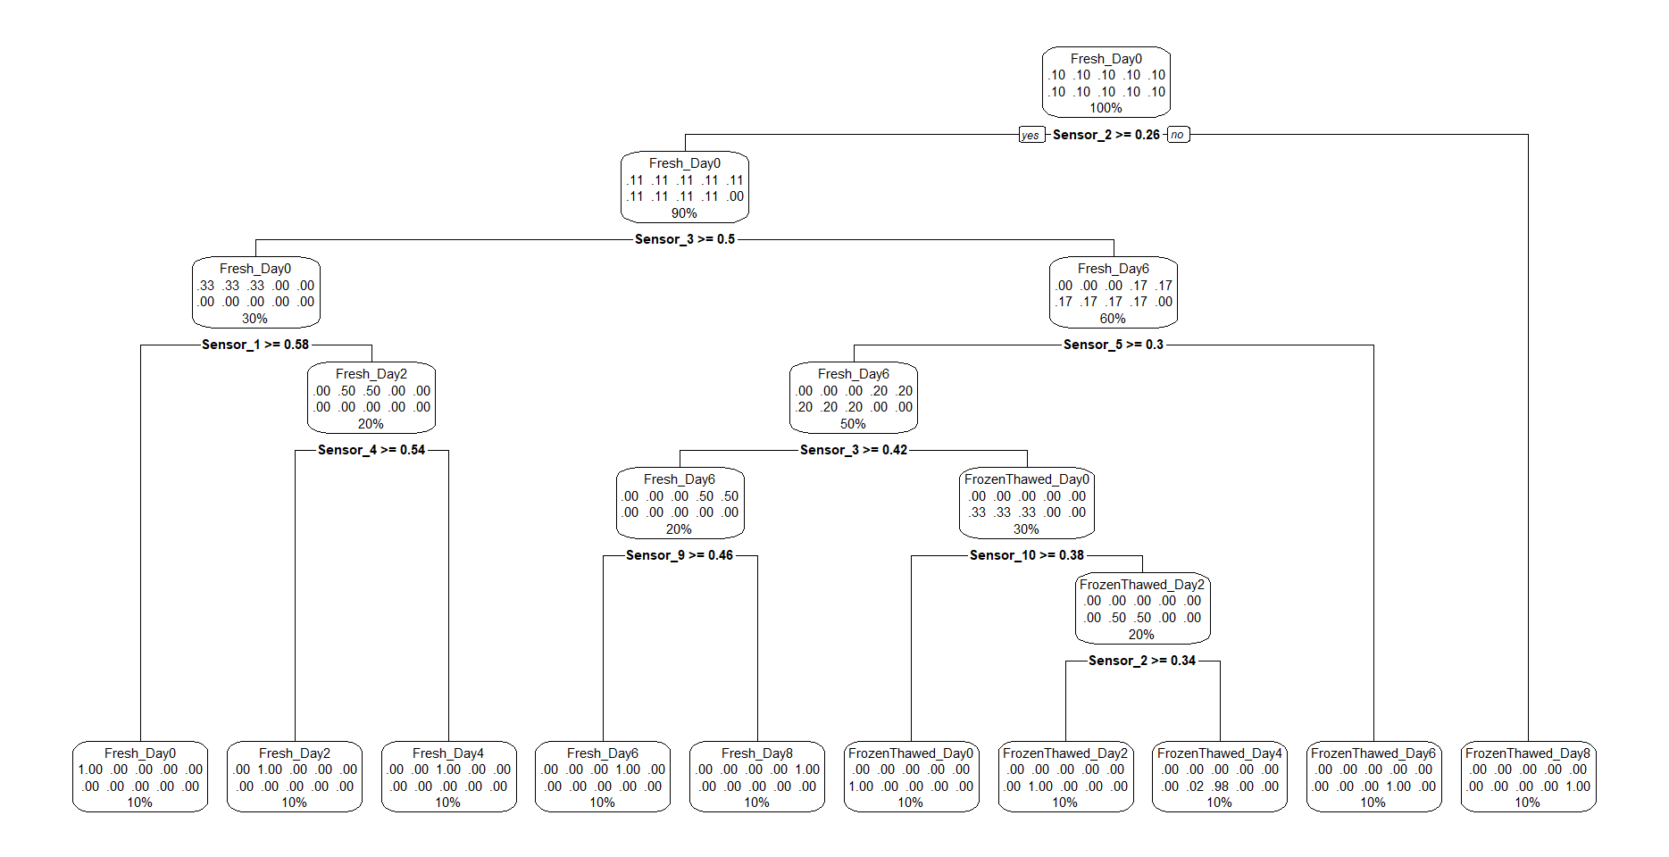CART Model for Training Data
Figure 6: CART model. The CART classification tree illustrates how different gas sensor readings (particularly Sensor 3, Sensor 2, and Sensor 5) sequentially split the data to distinguish between fresh, aged, and frozen–thawed samples, revealing the most influential sensors and decision pathways used to predict spoilage class.
The CART model resulting from the train data contains nine splits with 10 outcomes. From the visualization, we can see that sensors one through 5 and sensors nine and ten are all used for classification, with sensors two and three used twice.

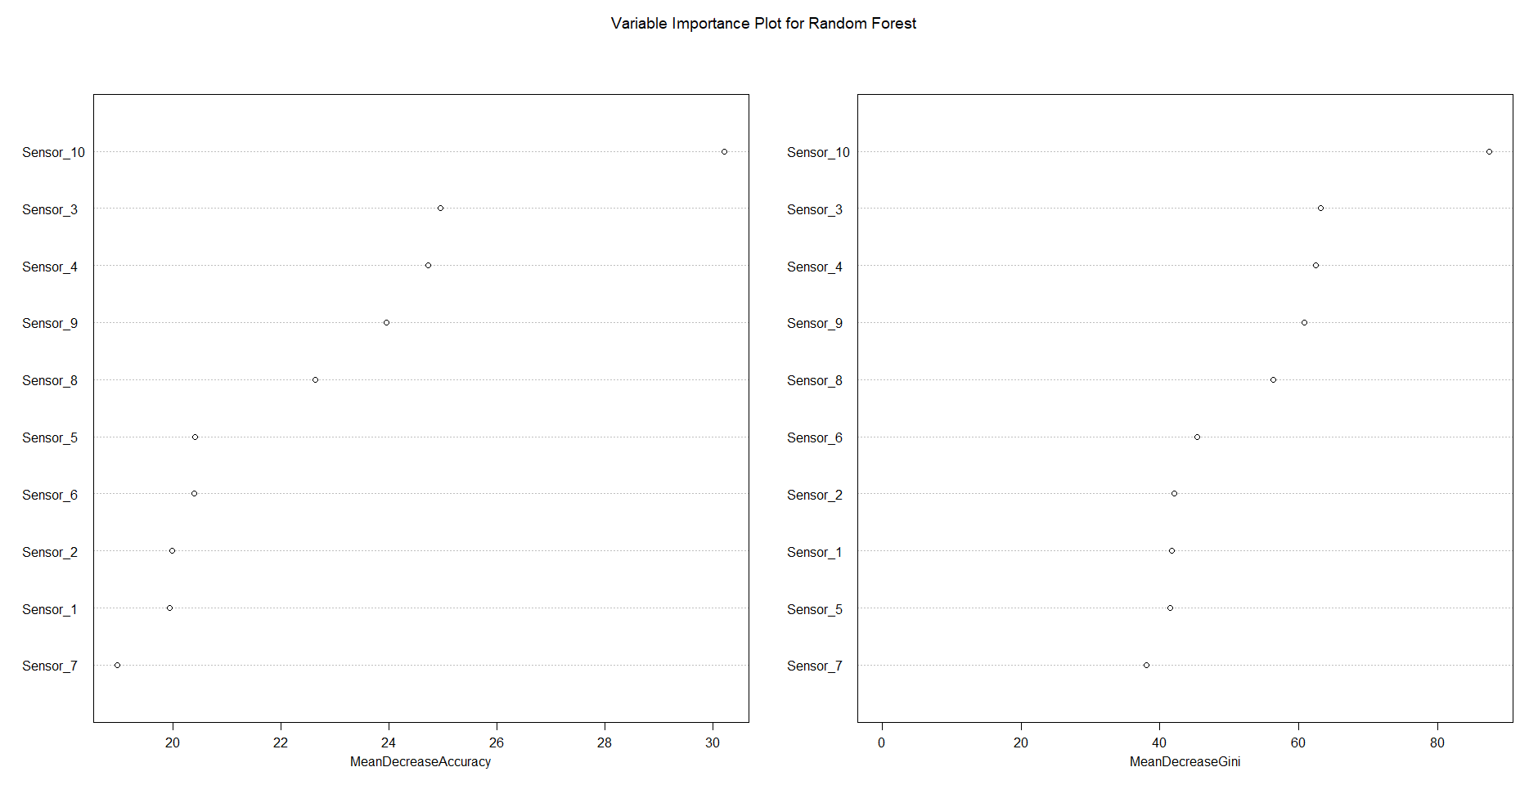
Variable Importance Plot for Random Forest
Figure 7: Random Forest plots. This shows that Sensor 10 is the most influential predictor, followed by sensors 3 then 4.
The graph above ranks each sensor, and their respective mean decreases in accuracy if they were to be removed from the random forest model. It appears that sensor ten has the highest mean decrease in accuracy, should it be removed, and sensor seven has the lowest mean decrease in accuracy. However, it is important to note that all ten sensors appear to have a mean decrease in accuracy of at least ten.

Time to Event:

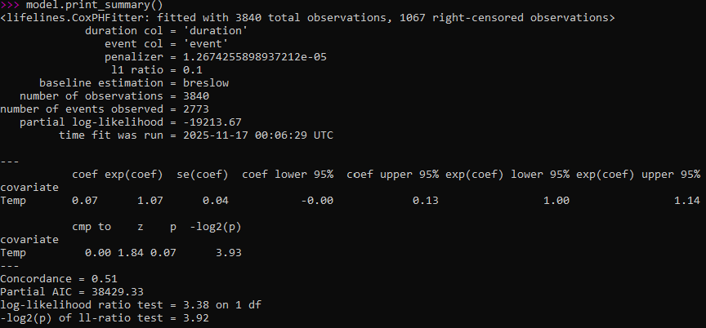
Figure 8: The model summary displays the estimated Cox proportional hazards coefficient for temperature. The coefficient is approximately 0.07, with a hazard ratio of 1.07, but the 95 percent confidence interval includes zero, indicating that the effect is not statistically significant. The concordance index is 0.51, reflecting performance just above random chance and confirming limited discriminative power.
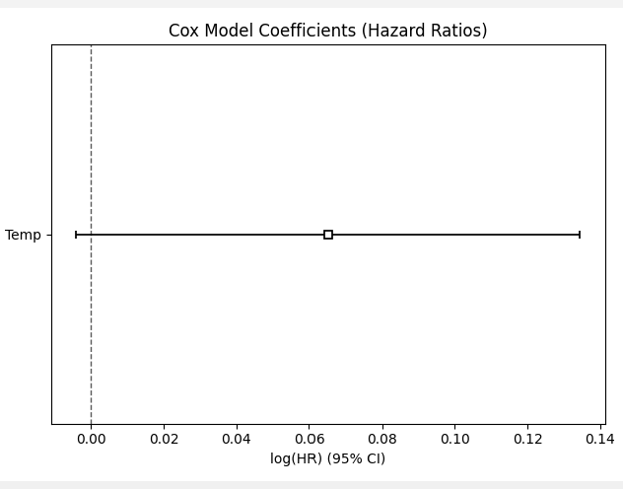
Figure 9: The coefficient plot shows the log-hazard ratio estimate for temperature along with its 95 percent confidence interval. The estimate is small, and the confidence interval extends across zero, visually reinforcing that temperature does not exhibit a statistically meaningful effect on the hazard of spoilage within this dataset.

The Cox model summary and coefficient visualization together illustrate that temperature has only a very weak influence on spoilage risk in the engineered survival dataset. In the numerical output, the temperature coefficient is estimated at about 0.07, corresponding to a hazard ratio of 1.07. This suggests a slight tendency for higher temperatures to be associated with increased hazard, yet the 95 percent confidence interval ranges from approximately −0.00 to 0.13. Because the interval crosses zero, the model cannot conclusively determine whether temperature meaningfully increases or decreases spoilage risk. The concordance index of 0.51 further supports this conclusion, since a C-index of 0.5 represents random prediction. So, the model is functioning correctly but is detecting only minimal signal in the predictor provided.

The coefficient plot provides a visual confirmation of these findings. The log-hazard estimate is represented by a small square at roughly 0.06, and the confidence interval line spans both positive and negative values. This pattern indicates statistical uncertainty and aligns with the weak predictive performance demonstrated by the concordance index. These results are not unexpected given the structure of the time-to-event model. The Mendeley dataset contained only one predictor (temperature) which showed limited variation and was paired with a spoilage label based on a fixed time threshold rather than true biological spoilage. As a result, the model had insufficient informative features to meaningfully differentiate hazard levels among observations.
Business Question Answers:
Question 1: How fresh is the food?
Answer: Our regression model estimates how fresh the food is by predicting the Total Viable Count (TVC), a numeric indicator of microbial load. Because our final regression model achieved an extremely high adjusted R² of 0.9952, along with a very low MAE of 0.0399, it can accurately estimate the level of freshness on a continuous scale. Higher TVC values correspond to older or more spoiled fish, while lower values indicate fresher samples. Therefore, our regression model provides a precise, quantitative assessment of freshness based on sensor readings.
Question 2: Is the food fresh?
Answer: Our classification models determine whether the food should be labeled fresh or not fresh. Both models performed extremely well—CART reached 96.7% accuracy on average, and Random Forest achieved 100% accuracy on the test set. The paired t-test also showed that Random Forest was significantly more accurate at the 0.06 level. This means our system can reliably classify food into “fresh” versus “spoiled/frozen–thawed” categories based on sensor signals.
Question 3: How many days will the food be fresh for?
Answer: Our survival model estimates how long the food will remain fresh, which corresponds to predicting spoilage time. The Cox proportional hazards model used engineered duration and event variables to estimate time until spoilage based on temperature trends. While our model’s predictive power was limited (C-index ≈ 0.49, MAE ≈ 2,621 minutes, or ≈ 1.8 days), it still provides a structured method for forecasting remaining freshness time. The model suggests approximate spoilage timing but also reveals that temperature alone is not strongly predictive. Additional features, such as TVC, would test better for higher accuracy.
References

      - Food and Agriculture Organization of the United Nations. (2011). Global food losses and food waste: Extent, causes and prevention. FAO. https://www.fao.org/3/mb060e/mb060e00.htm
      - Harrison, J. A., Critzer, F. J., & Wszelaki, A. L. (2015). Storage of fresh produce (Publication FDNS-E-168-27). University of Georgia Cooperative Extension. https://rutherford.tennessee.edu/wp-content/uploads/sites/200/2022/05/SP768-F-Storage-of-Fresh-Produce.pdf

Appendices

Appendix A
Project Guidelines

General Guidelines

- To complete all the homework assignments for this course please use this template document.
- Each assignment has to be submitting by Sunday 11:59 PM EST.
- Each figure should be followed by a brief description about the figure.
- The figures can be hand drawn and scanned in some circumstances but the hand drawn figure should be clear and legible to obtain full credits. Unclear hand drawn figures will receive partial credits. For constructing figures and diagrams it is advised to use tools.
- Figures and tables should have appropriate captions. For documenting and referencing styles please follow the APA or MLA writing style.
- Please make sure that you provide a reference section.
- Any material text or figure taken from books, journals or Internet should be referenced. If you have a sentence or a figure that does not belong (authorship) to you they need to be clearly referenced. If you fail to do so your report will be considered as a case for plagiarism. It is your duty to make sure that your report is free from any activity related to plagiarism. In case you are suspected of attempting plagiarism then you will be responsible for the cause. The penalty for plagiarism will be a “0” awarded to your report. So it is good to keep simple, always have the principle to acknowledge people for their contributions.

Please go through the following instructions before submitting the report

Academic Integrity
Academic integrity — scholarship free of fraud and deception — is an important educational objective of Penn State. Academic dishonesty can lead to a failing grade or referral to the Office of Student Conduct.
Academic dishonesty includes, but is not limited to:
- cheating
- plagiarism
- fabrication of information or citations
- facilitating acts of academic dishonesty by others
- unauthorized prior possession of examinations
- submitting the work of another person or work previously used without informing the instructor and securing written approval
- tampering with the academic work of other students

How Academic Integrity Violations Are Handled
In cases where academic integrity is questioned, procedure requires an instructor to notify a student of suspected dishonesty before filing a charge and recommended sanction with the college. Procedures allow a student to accept or contest a charge. If a student chooses to contest a charge, the case will then be managed by the respective college or campus Academic Integrity Committee. If a disciplinary sanction also is recommended, the case will be referred to the Office of Student Conduct.
All Penn State colleges abide by this Penn State policy, but review procedures may vary by college when academic dishonesty is suspected. Information about Penn State's academic integrity policy and college review procedures is included in the information that students receive upon enrolling in a course.
Additionally, Penn State students are expected to act with civility and personal integrity; respect other students' dignity, rights, and property; and help create and maintain an environment in which all can succeed through the fruits of their own efforts. An environment of academic integrity is requisite to respect for oneself and others, and a civil community.

For More Information on Academic Integrity at Penn State
Please see the Academic Integrity Chart for specific college contact information or visit one of the following URLs:
- Penn State Senate Policy on Academic Integrity
- iStudy for Success! — learn about plagiarism, copyright, and academic integrity through an educational module
- Turnitin a web-based plagiarism detection and prevention system

Lesson 2 Predictive Analytics System Group-Based Assignment

Purpose:
To describe the purpose/objectives of the proposed predictive analytics system (project)
Tasks:
- After the meeting with the instructor in week 1 the group will put together a proposal for designing a predictive analytics system.
- Clearly list the task that will be completed in the following weeks. I should have provided the directions in regard to completing the tasks for different weeks during the week 1 meeting with the team.

Lesson 4 Predictive Analytics System Group-Based Assignment

Purpose:
To layout the plan for collecting data for the predictive analytic system.
Tasks:
- After the meeting with the instructor in week 3 the group will put together a plan for collecting data for the proposed predictive analytics system.
- List the different sources for data collection. Also update the progress on the data collection (if any).
- Clearly list the task that will be completed in the following weeks. I should have provided the directions in regard to completing the tasks for different weeks during the week 3 meeting with the team.

Lesson 6 Predictive Analytics System Group-Based Assignment

Purpose:
To layout the plan for preparing data for conducting predictive analytics.
Tasks:
- After meeting with the instructor in week 5 the group will put together a plan for preparing the data for performing analytics.
- Submit a report with details on data collection. Your data collection step should have been completed by now.
- List all the steps for preparing the data for predictive modeling. I should have provided the directions in regard to completing the tasks for preparing the data during the week 5 meeting with the team.

Lesson 8 Predictive Analytics System Group-Based Assignment

Purpose:
To layout the plan for cleaning the data for conducting predictive analytics.
Tasks:
- After meeting with the instructor in week 7 the team will complete the steps for data preparation.
- List all the steps for variable (feature) selection and variable transformation. I should have provided the directions in regard to completing the tasks for variable selection and transformation during the week 7 meeting with the team.

Lesson 10 Predictive Analytics System Group-Based Assignment

Purpose:
To detail the variable selection and Transformation steps
Tasks:
- After meeting with the instructor in week 9 the team will complete the steps for variable selection and Transformation.
- List all the steps for predictive analytics modeling. I should have provided the directions in regard to completing the tasks for predictive analytics modeling during the week 9 meeting with the team.

Lesson 12 Predictive Analytics System Group-Based Assignment

Purpose:
To detail the modelling, evaluation and validation of the Predictive Analytics system
Tasks:
- After meeting with the instructor in week 11 the team will complete the steps for modelling, evaluating and validation of the Predictive Analytics system.
- Submit the report detailing about the modelling, evaluating and validation of the Predictive Analytics system.

Lesson 13 Predictive Analytics System Group-Based Assignment

Purpose:
To complete all the modules of the Predictive Analytics System
Tasks:
- Submit the final project report of your team’s Predictive Analytics system by the end of week 13. In this week the team is supposed to complete the visualization of the Predictive Analytics system.
- The team should set up an appointment with me to discuss about the project report feedback before the final project report submission. The team meeting has to be scheduled as early as Friday and no later than Sunday.
- More instructions about the final submission of the project report, datasets, scripts etc. will be provided by the instructor over the e-mail.

Lesson 14 Predictive Analytics System Group-Based Assignment

Purpose:
To provide a demonstration of your team’s Predictive Analytics System
Tasks:
- The team should prepare to demonstrate the designed Predictive Analytics System in this capstone course.
- The demonstration should be video recorded and shared with the instructor through the box/Canvas.
- Every team will have an opportunity to go through the demonstration of the Predictive Analytics system designed by different teams. I will share the video recording from different teams using the box.
- The team should set up an appointment with me to discuss about the feedback on the project report and on the demonstration video in this week, one day after the final submission is done.
- Team members should submit the peer evaluation form latest by Thursday 11:59 PM EST in week 14.
- More instructions will be provided by the instructor over the e-mail.

