TestLink Uploader Tool
Guideline

TestLink Uploader tool is a handy tool to work with TestLink with less touching to browser. This tool provides better ways to work with multiple testcases and auto arrange testcases in testplan. Please note, this tool is not a replacement of TestLink client browser, just a support tool with more extentions. Thank you!

Below are advantages of Uploader Tool compare to traddition browser method:
- Upload/Get testcases in TestPlan in batch to excel xls file
- Auto create new TestPlan, TestBuild
- Auto add testcases in batch to TestPlan
- Auto assigne/reassign testcases to TestBuild with expected Tester
- Auto mark test results in batch to testcase executions
- Better performance in testcases writing and modifying due to support excel interface
- Suitable for teamwork (multi Testers work in same TestPlan)

- Installation

This tool runs on Python platform (currently support Python 2.7). Please make sure you have installed Python before lauching the package.
Source link: git@gitlab.nexcel.vn:lex.khuat/TestLink_Uploader_Tool.git
Installation steps by order:
- Install python 2.7 (recommended 2.7.14): https://www.python.org/ftp/python/2.7.14/python-2.7.14.msi
- Clone the tool folder from git link above using Git Tool
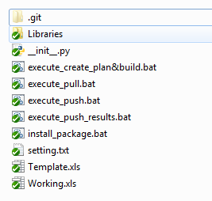
- Run install_package.bat, make sure all libraries are done downloading as below
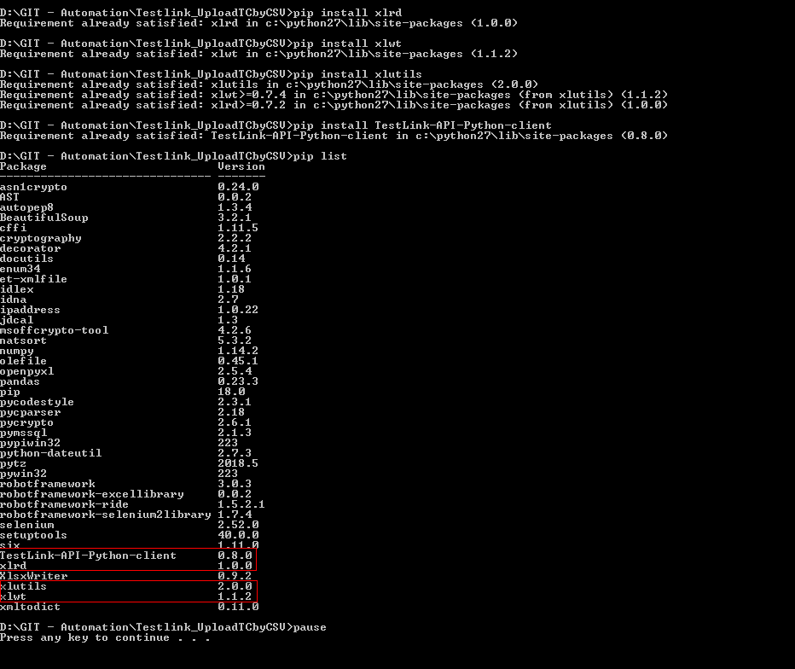
- Finished

- Settings

In order to work with the tool, you need a TestLink account and granted permission for a specific project. Each working session need 4 kind of info:
- Your devkey (Login to http://testlink.nexcel.vn/index.php >> My Settings >> Generate a new key)
I.e: c6a9f5dff1bfff1bad8655a7d4d4b4bb
- Project name (the project you are working under, has format: Prefix:Name)
I.e:
Prefix: Demo
Name: Demo TestLink
- TestPlan name (the testplan you are selecting)
I.e: 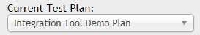
- TestBuild name
I.e: 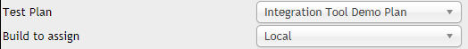
The file setting.txt provides the following settings:
- USERNAME: hold your TestLink username
- DEVKEY: hold your devkey (above), this value is required to connect to TestLink server from your machine
- EXCEL_PATH: hold the path to excel file you expect to work, you can copy the file Template.xls and rename it for your own using.
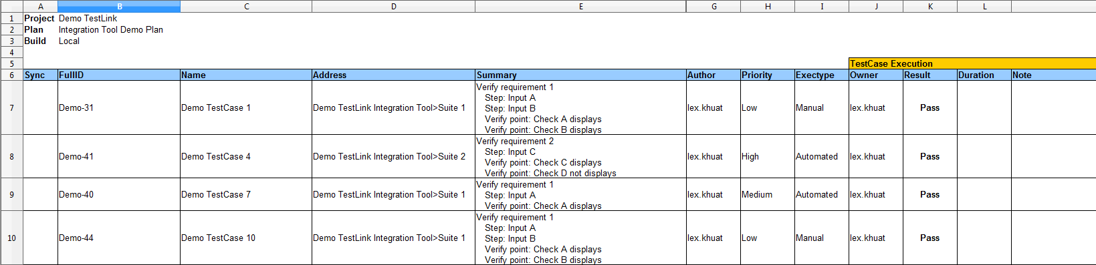
- SHEET_NAME: sheet name of the excel file above
- TESTCASE_PATH_DELIMETER (default as “>”): the delimeter for full path of the testcase in excel file, change it to the special character you expect in case you don't want “>”.
- AUTO_ADD_TESTPLAN (default as “True”): Turn on when uploading/modifying testcase(s) in excel file with push command will auto add to the TestPlan, TestBuild under working
- USE_DEFAULT_RESULT (default as “False”): Turn on this setting will mark the same execution result to all testcases linked to the TestPlan, TestBuild under working. The execution result can be defined in “DEFAULT_RESULT_IN_BATCH” setting.
- DEFAULT_RESULT_IN_BATCH (default as “Pass”): if “USE_DEFAULT_RESULT” is True, activate execute_push_results.bat will auto mark all testcases with the excution result defined in this setting

- Functions usage

- execute_create_plan&build: run this command to auto create the TestPlan & TestBuild defined at the header of your excel sheet
- execute_pull: run this command to get all testcases linked to TestPlan & TestBuild to your excel sheet. Please note, for which pulled testcaseID(s) already exist in your excel sheet, the pulled content will overwrite the existing content.
- execute_push: run this command to push new/modified testcases in your excel sheet to TestLink. Please note that only testcases marked with “X” under Sync column will be pushed. There are 2 ways to support pushing a testcase step details (or both, you can choose your way. Keep blank if you don't want sumarry or step. The step format must be the same as in example):
- Provide step details in summary
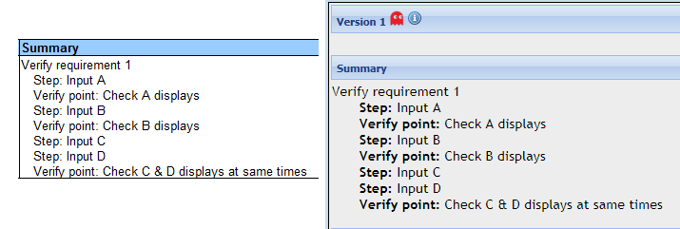
- Provide step details in steps
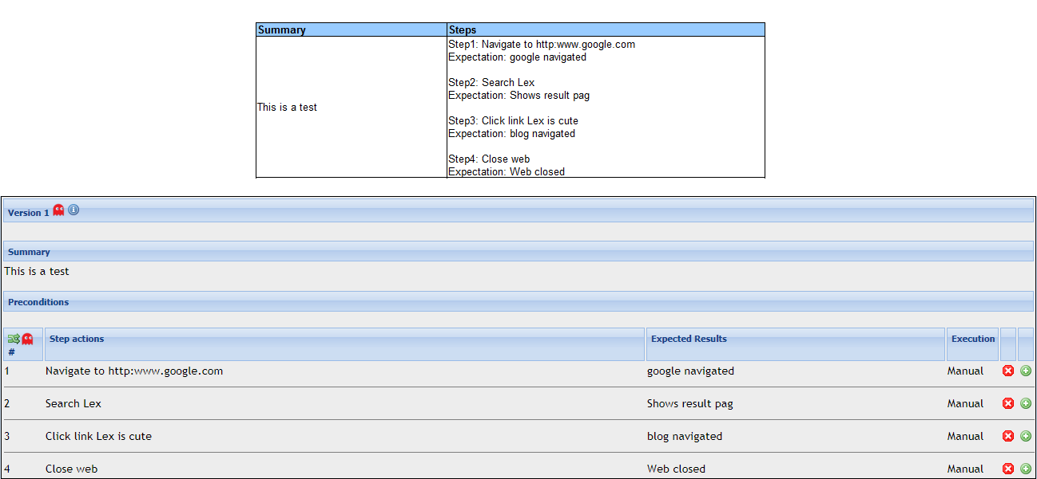
- execute_push_results: for which row of testcase in your excel sheet with “Pass/Fail/Block” execution result, run this command will push those execution results to TestLink (overwite the existing results if any). Note that if “USE_DEFAULT_RESULT” setting turned True in setting.txt file, running this command will bypass the execution results in excel sheet and push default value to all testcases linked to TestPlan on TestLink
- Notes – known issues
- This tool has not supported .xlsx extention yet. The reason is because open office and libre office (which preferred to use in Nexcel) both have lack options to save and work on .xlsx type
- Python excel library still does not support formating excel file by condition on .xls so please use your own format during work but pull command will reset the format
- This tool has no UI yet, hopefully in next version
- “Template.xls” are current supported template, clone it and rename for each of your working TestPlan
- This tool is a part of bigger QC working process solution. Best if it can be used in combine with Robot-framework TestLink API tool
- For any troubleshoot please contact Lex for support

