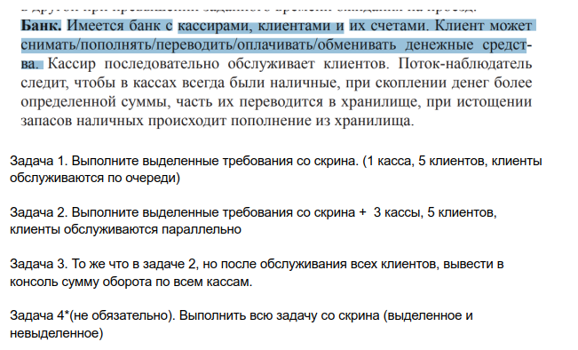

<https://github.com/lexkhortic/HomeWork36>