LIUM Notes

Resources
Santa Barbara Corpus
http://www.linguistics.ucsb.edu/research/santa-barbara-corpus#SBC001

Java 1.8 appears to have some problems with JDK 1.8 (Check below for project with new build script)
https://github.com/ahmetaa/lium-diarization
Build command: ant -d stand-alone-jar (requires that ant be installed)

Lium File Restrictions
Audio can be in Sphere format or Wave format (16kHz / 16bit PCM mono) [Auto-detected by extension]
*.seg is the output file containing the segmentation

Script to convert audio to proper Wave format (16kHz/16bit PCM mono)
ffmpeg -i test1.wav -acodec pcm_s16le -ac 1 -ar 16000 test2.wav

Tool Files
Input:
Diarization file (*.seg? File)
File containing acoustic vector or an audio file.

Diarization parameters (segmentation files)
Input
--sInputMask=<path> (Diarization file)
Can be
- absolute path: /home/myseg.seg
- relative path from the current directory: seg/myseg.seg
- a path where the %s is substituted: seg/%s.seg (%s is substituted by the show name param)

--sInputFormat

Output
-sOutputMask
-sOutputFormat

Feature Parameters (sound files)
Input:
-fInputMask
- absolute path: /home/myfile.mfcc
- relative path: file/myfile.wav
- %s is substituted: ./file/%s.sph (like ./file/myshow.sph)

-fInputDesc=type[:deltatype] (e.g. ="audio16kHz2sphinx,1:3:2:0:0:0,13,1:1:300:4")

Output:
-fOutputMask
-fOutputDesc
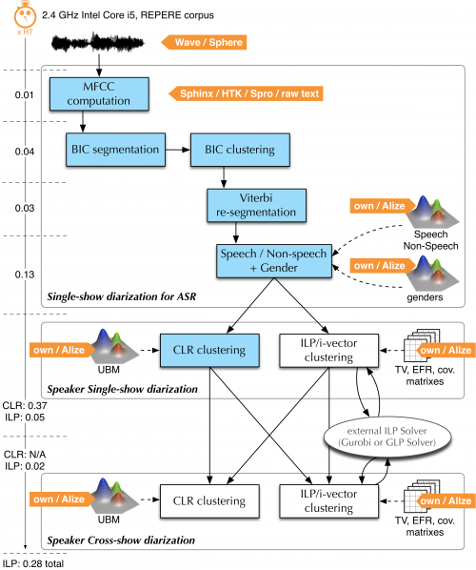
fr.lium.spkDiarization.
Compute the MFCC (tools.Wave2FeatureSet)
- Convert .wav to .mfcc in test_out/t001/%s.mfcc
Check the MFCC (programs.MsegInit)
- Performs safety checks on generated file
GLR based segmentation, make small segments (programs.Mseg)
- Segmentation detection softare that finds instantaneous change point corresponding to segment boundaries.
Segmentation: linear clustering (programs.MClust)
- Hierarchical agglomerative clustering. Using Gaussians only.
hierarchical clustering (programs.MClust)
initialize GMM (programs.MtrainInit)
- Initialize the GMMs
EM computation (programs.MtrainEM)
- Train of a GMM using the EM algorithm
Viterbi decoding (programs.MDecode)
- Basic Viterbi decoder using a set of GMMs
Speech/Music/Silence segmentation (programs.MDecode)
filter spk segmentation according pms segmentation (tools.Sfilter)

Set gender and bandwith (programs.Mscore)
- A program that computes the likelihood scores given a set of GMMs

ILP Clustering (programs.ivector.ILPClustering)

Example of

Wave2FeatureSet
--fInputMask=./test_wav/t001-1.wav
–fInputDesc=audio16kHz2sphinx,1:1:0:0:0:0,13,0:0:0
--fOutputMask=././test_out/t001-1/%s.mfcc
--fOutputDesc=sphinx,1:1:0:0:0:0,13,0:0:0

MSegInit
--fInputMask=././test_out/t001-1/%s.mfcc
--fInputDesc=sphinx,1:1:0:0:0:0,13,0:0:0
--sInputMask=
--sOutputMask=././test_out/t001-1/%s.i.seg

MSeg
--fInputMask=././test_out/t001-1/%s.mfcc
--fInputDesc=sphinx,1:1:0:0:0:0,13,0:0:0
--sInputMask=././test_out/t001-1/%s.i.seg
--sOutputMask=././test_out/t001-1/%s.s.seg

MClust
--fInputMask=././test_out/t001-1/%s.mfcc
--fInputDesc=sphinx,1:1:0:0:0:0,13,0:0:0
--sInputMask=././test_out/t001-1/%s.s.seg
--sOutputMask=././test_out/t001-1/%s.l.seg

MTrainInit
--fInputMask=././test_out/t001-1/%s.mfcc
--fInputDesc=sphinx,1:1:0:0:0:0,13,0:0:0
--sInputMask=././test_out/t001-1/%s.h.3.seg
--tOutputMask=././test_out/t001-1/%s.init.gmms

MTrainEM
--fInputMask=././test_out/t001-1/%s.mfcc
--fInputDesc=sphinx,1:1:0:0:0:0,13,0:0:0
--sInputMask=././test_out/t001-1/%s.h.3.seg
--tOutputMask=././test_out/t001-1/%s.gmms
--tInputMask=././test_out/t001-1/%s.init.gmms

MDecode
--fInputMask=././test_out/t001-1/%s.mfcc
--fInputDesc=sphinx,1:1:0:0:0:0,13,0:0:0
--sInputMask=././test_out/t001-1/%s.h.3.seg
--sOutputMask=././test_out/t001-1/%s.d.3.seg
--tInputMask=./test_out/t001-1/%s.gmms

MDecode
--fInputDesc=sphinx,1:3:2:0:0:0,13,0:0:0:0
--fInputMask=././test_out/t001-1/%s.mfcc
--sInputMask=././test_out/t001-1/%s.i.seg
--sOutputMask=././test_out/t001-1/t001-1.pms.seg
--tInputMask=./models/sms.gmms

SFilter
--fInputDesc=sphinx,1:3:2:0:0:0,13,0:0:0:0
--fInputMask=././test_out/t001-1/%s.mfcc
--sFilterMask=././test_out/t001-1/t001-1.pms.seg
--sInputMask=././test_out/t001-1/%s.d.3.seg
--sOutputMask=././test_out/t001-1/t001-1.flt.3.seg

MScore
--fInputDesc=sphinx,1:3:2:0:0:0,13,1:1:0:0
--fInputMask=././test_out/t001-1/%s.mfcc
--sInputMask=././test_out/t001-1/t001-1.flt.3.seg
--sOutputMask=././test_out/t001-1/t001-1.g.3.seg
--tInputMask=./models/gender.gmms

echo initialize GMM
java -Xmx$mem -classpath "$LOCALCLASSPATH" fr.lium.spkDiarization.programs.MTrainInit --help --nbComp=8 --kind=DIAG --fInputMask=$features --fInputDesc=$fDesc --sInputMask=./$datadir/%s.h.$h.seg --tOutputMask=./$datadir/%s.init.gmms $show

echo EM computation
java -Xmx$mem -classpath "$LOCALCLASSPATH" fr.lium.spkDiarization.programs.MTrainEM --help --nbComp=8 --kind=DIAG --fInputMask=$features --fInputDesc=$fDesc --sInputMask=./$datadir/%s.h.$h.seg --tOutputMask=./$datadir/%s.gmms --tInputMask=./$datadir/%s.init.gmms $show

