Supplementary Materials: Who Starts and Who Stays? Behavioral-Economic Correlates of Blood Donor Status

Table of Contents
Supplementary Materials 3
(S1) Behavioral Economic Measure’s 3
(S2) – Full Main Effect Regression Table 4
(S3) – Main Effect Regression Table with 1:1 and 1:3 matching 5
(S4) – Donation Frequency Regression Table 6
(S5) – General population and Whole Sample Regression Table (Blood Donors) 7
Survey Materials 9
(S6) Survey Items for NHSBT and Prolific (General Population Sample) 9
(S7) Risk Preference Measure Question Set 11
Quantitative Initial Node: 11
Quantitative Follow-up Nodes: 11
Qualitative Question 12
(S8) Patience Preference Measure Question Set 13
Quantitative Initial Node: 13
Quantitative Follow-up Nodes: 13
Qualitative Question 14
(S9) Graphical Representation of Staircase Preference Elicitation 15
(S10) Demographic Questions 16
(S11) Donation Histories Questions 20

The data and analysis code will be made available on the following OSF repository (XXX).

Supplementary Materials

(S1) Behavioral Economic Measure’s

The Altruism index combines the standardized qualitative (z-scored; z-qual) and quantitative (z-scored; z-quant) measures as follows:
Altruism = (0.6350048 × z-qual) + (0.3649952 × z-quant)
The Patience index is constructed by weighting the standardized quantitative staircase measure (z-quant) and the qualitative measure (z-qual):
Patience = (0.7115185 × z-quant) + (0.2884815 × z-qual)
For the Risk-taking index, the quantitative component was first reverse coded to ensure higher values correspond to greater risk affinity. The standardized quantitative (z-quant) and qualitative (z-qual) parts were combined with the following weights:
Risk Taking = (0.4729985 × z-quant) + (0.5270015 × z-qual)
Finally, as the Trust measure was derived from a single qualitative question, the index is simply its z-standardized value:
Trust = z-qual

(S2) – Full Main Effect Regression Table
 | Blood Donor (Y/N) |  | Current (vs. Lapsed)
 | Pre-Matching | Post-Matching | Pre-Matching | Post-Matching
 | 1 | 2 | 3 | 4
Risk | 0.213* | 0.188* | 0.051 | 0.048
 | -0.086 | -0.092 | -0.134 | -0.147
Patience | -0.049 | 0.056 | 0.237 | 0.374**
 | -0.078 | -0.085 | -0.131 | -0.136
Altruism | 0.271** | 0.255** | 0.480** | 0.516**
 | -0.087 | -0.097 | -0.152 | -0.163
Trust | 0.189** | 0.192* | 0.218 | 0.21
 | -0.071 | -0.078 | -0.125 | -0.134
Age | 0.026*** | 0.001 | -0.055*** | -0.003
 | -0.005 | -0.006 | -0.009 | -0.01
Tertiary Education (Bin.) | 0.381** | -0.302 | 0.112 | 0.011
 | -0.145 | -0.169 | -0.258 | -0.265
Sex | -0.218 | 0.093 | 0.107 | 0.113
 | -0.135 | -0.147 | -0.226 | -0.245
Constant | -1.649*** | 0.153 | 1.565*** | -0.913
 | -0.276 | -0.312 | -0.472 | -0.562
Observations | 1,039 | 818 | 423 | 377
Log Likelihood | -663.415 | -477.418 | -246.914 | -215.87
Akaike Inf. Crit. | 1,342.83 | 970.836 | 509.828 | 447.739
Note: *p<0.05; **p<0.01; ***p<0.001

(S3) – Main Effect Regression Table with 1:1 and 1:3 matching
Main effects Table with 1:1 and 1:3 Matching
 | Blood Donor (Y/N) |  | Current vs. Lapsed
 | 1:1 | 1:3 |  | 1:1 | 1:3
 | 1 | 2 |  | 3 | 4
Risk | 0.186 | 0.182* |  | 0.022 | 0.062
 | -0.105 | -0.089 |  | -0.163 | -0.142
Patience | -0.061 | 0.084 |  | 0.413** | 0.382**
 | -0.095 | -0.082 |  | -0.15 | -0.134
Altruism | 0.267* | 0.284** |  | 0.427** | 0.539***
 | -0.107 | -0.094 |  | -0.176 | -0.158
Trust Index | 0.198* | 0.202** |  | 0.319* | 0.268*
 | -0.087 | -0.073 |  | -0.147 | -0.133
Age | 0.004 | 0.001 |  | -0.009 | -0.006
 | -0.006 | -0.005 |  | -0.011 | -0.01
Tertiary Education (Bin.) | -0.277 | -0.389* |  | -0.267 | -0.114
 | -0.188 | -0.164 |  | -0.281 | -0.254
Sex | 0.08 | 0.03 |  | 0.204 | 0.153
 | -0.165 | -0.142 |  | -0.261 | -0.238
Constant | 0.424 | 0.093 |  | -0.725 | -0.657
 | -0.352 | -0.3 |  | -0.6 | -0.535
Observations | 688 | 897 |  | 352 | 387
Log Likelihood | -500.973 | -559.925 |  | -184.696 | -211.71
Akaike Inf. Crit. | 1,017.95 | 1,135.85 |  | 385.393 | 439.419
Note: *p<0.05; **p<0.01; ***p<0.001

(S4) – Donation Frequency Regression Table
 | Blood Donation Frequency Regression Table
 | Blood Donation Frequency
 | General Sample | NHSBT Sample | Combined Sample
 | 1 | 2 | 3
Risk | -0.029 | -0.0002 | -0.008
 | -0.051 | -0.01 | -0.012
Patience | 0.114* | 0.019* | 0.034**
 | -0.048 | -0.009 | -0.011
Altruism | 0.074 | 0.003 | -0.016
 | -0.054 | -0.01 | -0.012
Trust | -0.018 | 0.009 | -0.007
 | -0.046 | -0.008 | -0.01
Age | 0.021*** | 0.013*** | 0.017***
 | -0.003 | -0.001 | -0.001
Tertiary Education | 0.006 | -0.011 | 0.01
 | -0.094 | -0.017 | -0.021
Sex | -0.025 | -0.074*** | -0.025
 | -0.085 | -0.016 | -0.019
Constant | 0.652*** | 1.860*** | 1.513***
 | -0.178 | -0.038 | -0.045
Observations | 423 | 2,511 | 2,934
Log Likelihood | -796.292 | -3,990.10 | -5,159.90
Akaike Inf. Crit. | 1,608.59 | 7,996.19 | 10,335.80
Note: *p<0.05; **p<0.01; ***p<0.001

(S5) – General population and Whole Sample Regression Table (Blood Donors)
General population and NHSBT Sample Blood Donor Status
 | Blood Donor (Y/N)
 | Pre-General population | Pre-Whole | Post-General population | Post-Whole
 | 1 | 2 | 3 | 4
Risk | 0.213* | 0.193** | 0.188* | 0.343***
 | -0.086 | -0.064 | -0.092 | -0.067
Patience | -0.049 | 0.032 | 0.056 | -0.026
 | -0.078 | -0.056 | -0.085 | -0.059
Altruism | 0.271** | 0.06 | 0.255** | -0.089
 | -0.087 | -0.06 | -0.097 | -0.064
Trust Index | 0.189** | 0.027 | 0.192* | -0.051
 | -0.071 | -0.049 | -0.078 | -0.051
Age | 0.026*** | 0.062*** | 0.001 | 0.003
 | -0.005 | -0.004 | -0.006 | -0.004
Tertiary Education (Bin.) | 0.381** | 0.625*** | -0.302 | -0.231*
 | -0.145 | -0.102 | -0.169 | -0.116
Sex | -0.218 | 0.315** | 0.093 | 0.1
 | -0.135 | -0.098 | -0.147 | -0.102
Constant | -1.649*** | -1.877*** | 0.153 | 1.801***
 | -0.276 | -0.198 | -0.312 | -0.233
Observations | 1,039 | 3,553 | 818 | 3,434
Log Likelihood | -663.415 | -1,449.29 | -477.418 | -1,313.93
Akaike Inf. Crit. | 1,342.83 | 2,914.59 | 970.836 | 2,643.86
Note: *p<0.05; **p<0.01; ***p<0.001

Survey Materials
The questions asked for the purposes of this paper were part of a larger study on Post Donation tests. For the full survey materials, see OSF link (10.17605/OSF.IO/W5P28).

(S6) Survey Items for NHSBT and Prolific (General Population Sample)
 | Prolific | NHSBT donors
Preference measures (order randomised)  (See S1 for how these measures are constructed for the analysis) | Questions surrounding risk, time, and social preferences as described in Falk et al. (2018):  Patience  - Intertemporal choice sequence using staircase method  - Self-assessment: willingness to wait  Risk taking  - Lottery choice sequence using staircase method  - Self-assessment: willingness to take risks in general  Altruism  - Donation decision  - Self-assessment: willingness to give to good causes  Trust  - Self-assessment: people have only the best intentions  See: Falk, A., Becker, A., Dohmen, T., Enke, B., Huffman, D. and Sunde, U., 2018. Global evidence on economic preferences. The quarterly journal of economics, 133(4), pp.1645-1692. | Questions surrounding risk, time, and social preferences as described in Falk et al. (2018):  Patience  - Intertemporal choice sequence using staircase method  - Self-assessment: willingness to wait  Risk taking  - Lottery choice sequence using staircase method  - Self-assessment: willingness to take risks in general  Altruism  - Donation decision  - Self-assessment: willingness to give to good causes  Trust  - Self-assessment: people have only the best intentions  See: Falk, A., Becker, A., Dohmen, T., Enke, B., Huffman, D. and Sunde, U., 2018. Global evidence on economic preferences. The quarterly journal of economics, 133(4), pp.1645-1692.
Donor status | Blood donor status (donor, when last donated if so, and how many donations made) | Blood donor status (when last donated if so, and how many donations made)
Demographics | All standard demographic questions from Office for National Statistics (ONS) (https://www.ons.gov.uk/):  - Age  - Sex  - Gender  - Ethnicity  - Religion  - Income  - Education  - Politics  - Region | All standard demographic questions from Office for National Statistics (ONS) (https://www.ons.gov.uk/) (a smaller set)  - Age  - Sex  - Gender  - Ethnicity  - Education

(S7) Risk Preference Measure Question Set

Quantitative Initial Node:
You are reminded that the scenarios that we present are hypothetical. Please consider the following scenario. You can choose between a sure payment of a particular amount of money, OR a draw, where you would have an equal chance (50/50 chance) of getting £300 or getting nothing.
In thinking about the scenario, please assume there is no inflation – that is, the future prices are the same as today’s prices. You will be presented with 5 different scenarios. Scenario 1: What would you prefer: a draw with a 50 percent chance of receiving £300 and the same 50 percent chance of receiving nothing, OR the amount of £160 as a sure payment?
- 50/50 chance (1)
- Sure payment (0)

Quantitative Follow-up Nodes:
If node 1 = 1
Scenario 2: Please consider the following: would you prefer the 50/50 chance or the amount of £240 as a sure payment?
- 50/50 chance (1)
- Sure payment (0)
If node 1 = 0
Scenario 2: Please consider the following: would you prefer the 50/50 chance or the amount of £80 as a sure payment?
- 50/50 chance (1)
- Sure payment (0)
This updating continues to the final nodes, see S9 (also Figure 2 in the main manuscript) for graphical representation of the choice sets.

Qualitative Question
risk_qual: Please tell me, in general, how willing or unwilling you are to take risks, using a scale from 0 to 10, where 0 means you are “completely unwilling to take risks” and 10 means you are “very willing to take risks”.
- (0)Not willing at all (0)
- (1) (1)
- (2) (2)
- (3) (3)
- (4) (4)
- (5) (5)
- (6) (6)
- (7) (7)
- (8) (8)
- (9) (9)
- (10)Very willing (10)

(S8) Patience Preference Measure Question Set

Quantitative Initial Node:
You are reminded that the scenarios that we present are hypothetical. Please consider the following scenario. Imagine you were given the choice between receiving some money today or some money in 12 months.
In thinking about the scenario, please assume there is no inflation – that is, the future prices are the same as today’s prices. You will be presented with 5 different scenarios. The money you would receive today is the same in each of these scenarios. The money you would receive in 12 months varies across the 5 scenarios. For each scenario, please indicate whether you would choose the money today or the money in the future. Scenario 1: Would you rather receive £100 today or £154 in 12 months?
- Receive £100 Today (1)
- Receive £154 In 12 months (0)

Quantitative Follow-up Nodes:
If node 1 = 1
Scenario 2: Please consider the following: would you rather receive £100 today or £185 in 12 months?
- Receive £100 today (1)
- Receive £185 in 12 months (0)

If node 1 = 0
Scenario 3: Please consider the following: would you rather receive £100 today or £169 in 12 months?
- Receive £100 today (1)
- Receive £169 In 12 months (0)

This updating continues to the final nodes, see S9 for graphical representation of the choice sets.

Qualitative Question
time_qual How willing are you to give up something that is beneficial for you today in order to benefit more from it in the future?
- (0)Not willing at all (0)
- (1) (1)
- (2) (2)
- (3) (3)
- (4) (4)
- (5) (5)
- (6) (6)
- (7) (7)
- (8) (8)
- (9) (9)
- (10)Very willing (10)

(S9) Graphical Representation of Staircase Preference Elicitation

- Intertemporal Preference (Patience) | - Risk Preferences
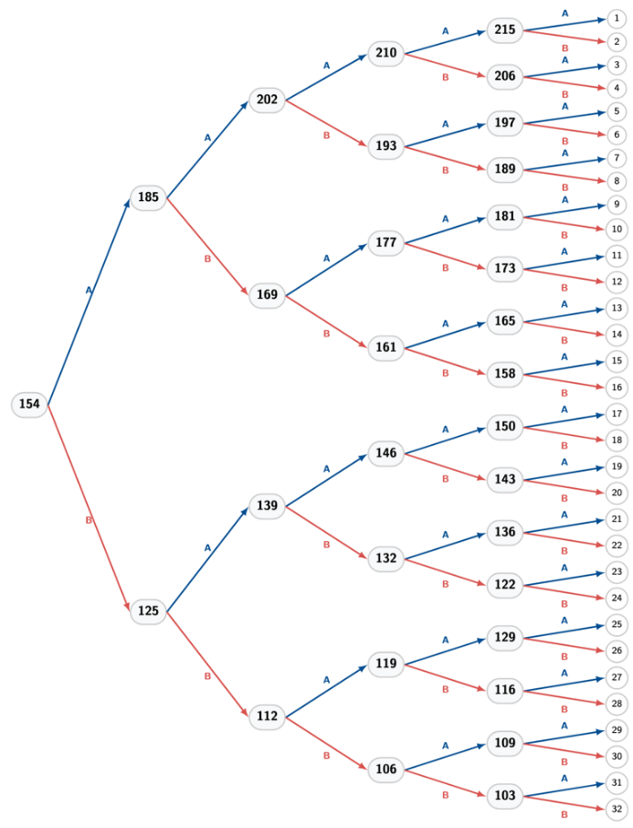 | 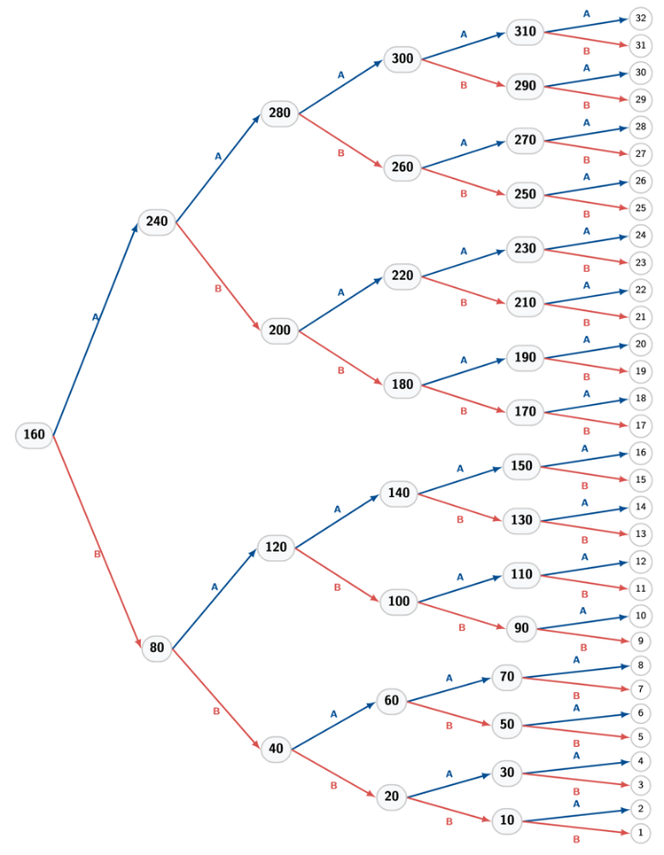
Figure S1 (Figure 2 in the manuscript): Staircase Elicitation Methods. Tree diagrams illustrating the method for intertemporal (Left Panel) and risk (Right Panel) preferences. Both tasks utilize a sequential branching logic to identify the participant's indifference point. In each iteration, participants face a binary choice between a fixed option (A) and a variable option (B). The value of the variable option updates based on the previous response: selecting the fixed option (A) results in an upward adjustment of the variable offer in the subsequent iteration, whereas selecting the variable option (B) results in a downward adjustment. Specifically: Left Panel (Intertemporal Preference): Participants choose between a fixed immediate reward (“£100 today”; A) and a variable delayed reward (“£x in 12 months”; B), commencing with a choice between £100 today and £154 in 12 months. Right Panel (Risk Preference): Participants choose between a fixed lottery (50% chance of £300, 50% chance of nothing; A) and a variable sure payment (B), commencing with a choice between the lottery and a guaranteed £160. Adapted from Falk (2018

(S10) Demographic Questions
Q179 Age
age How old are you in years?
________________________________________________________________
sex What is your sex? (A question on your gender identity will follow)
- Female (1)
- Male (2)
- Prefer not to say (3)
gender_different Is the gender you identify with the same as your sex registered at birth?
- Yes (1)
- No (2)
- Prefer not to say (3)
Display this question: If gender_different = 2
gender_identity Please provide your gender identity
- Trans woman (1)
- Trans man (2)
- Non-binary (3)
- Other gender identity (if selected, please enter preference) (4) __________________________________________________
- Prefer not to say (5)
ethnicity What ethnic group best describes you?
- Asian or Asian British (1)
- Black, African, Caribbean or Black British (2)
- Mixed or multiple ethnic groups (3)
- White (4)
- Other ethnic group (optional) (5) __________________________________________________
- Prefer not to say (6)
Display this question: If ethnicity = 4
ethnicity_detailed1 Which of the following best describes your White background?
- English, Welsh, Scottish, Northern Irish or British (1)
- Irish (2)
- Gypsy or Irish Traveller (3)
- Any other White background (optional) (4) __________________________________________________
- Prefer not to say (5)
ethnicity_detailed2 Which of the following best describes your mixed or multiple ethnic groups background?
- White and Black Caribbean (1)
- White and Black African (2)
- White and Asian (3)
- Any other mixed or multiple ethnic background (optional) (4) __________________________________________________
- Prefer not to say (5)
Display this question: If ethnicity = 1
ethnicity_detailed3 Which of the following best describes your Asian or Asian British background?
- Indian (1)
- Pakistani (2)
- Bangladeshi (3)
- Chinese (4)
- Any other Asian background (5) __________________________________________________
- Prefer not to say (6)
Display this question: If ethnicity = 2
ethnicity_detailed4 Which of the following best describes your Black, African, Caribbean or Black British background?
- African (1)
- Caribbean (2)
- Any other Black, African or Caribbean background (3) __________________________________________________
- Prefer not to say (4)
religion What is your religion?
- Christianity (1)
- Islam (2)
- Hinduism (3)
- Sikhism (4)
- Buddhism (5)
- Judaism (6)
- No religion (7)
- Any other religion (8) __________________________________________________
- Prefer not to say (9)
religion_strength To what extent does your religion influence your life and your choices?
- Strong influence (1)
- Some influence (2)
- Minor influence (3)
- No influence at all (4)
- Prefer not to say (5)
income What is your household pre-tax income last year?
- Less than £20,000 (1)
- £20,000-£39,999 (2)
- £40,000-£59,999 (3)
- £60,000-£99,999 (4)
- £100,000-£149,999 (5)
- More than £150,000 (6)
- Prefer not to say (7)
What is the highest level of education you have completed to date?
- Left school with no qualifications (1)
- GCSEs, O-Levels, or equivalent (2)
- A-Levels, BTEC, Scottish Highers, or equivalent (3)
- Foundation degree, Higher National Diploma (HND), or equivalent vocational qualifications (4)
- Undergraduate/Bachelors degree (5)
- Postgraduate degree (e.g., Master’s, PhD, Professional qualifications like LLB, LPC, MBBS, BDS, MBA) (6)
- Prefer not to say (7)
Q185 Political Affilation
Here is a 7-point scale on which the political views that people might hold are arranged from extremely liberal (left) to extremely conservative (right). Where would you place yourself on this scale?
Extremely liberal Extremely conservative
{1 2 3 4 5 6 7}
Q186 Region
region In which region do you currently live in the UK?
▼ Yorkshire and The Humber (1) ... I do not reside in the United Kingdom (13)

(S11) Donation Histories Questions
Donor History
blood_recipient Have you ever been a recipient of blood or blood products?
- Yes (1)
- No (2)
- I'm not sure (3)
- Prefer not to say (4)
blood_donor Have you ever donated blood?
- Yes (1)
- No (2)
- I'm not sure (3)
- Prefer not to say (4)
Display this question: If blood_donor = 1
lood_donation_time When did you last donate blood?
- Within the last month (1)
- 1- 6 months ago (2)
- 6 months - 1 year ago (3)
- 1 to 2 years ago (4)
- 2+ years ago (5)
- I can't remember (6)
- Prefer not to say (7)
Display this question: If blood_donor = 1
blood_donation_freq Roughly, how many times have you donated blood in your lifetime?
- 1 time (1)
- 2-3 times (2)
- 4-6 times (3)
- 7-10 times (4)
- 11-15 times (5)
- More than 15 times (6)
- Prefer not to say (7)
iron_deferral Have you ever tried to donate blood, but not be allowed to due to low Hb (iron) levels?
- Yes (1)
- No (2)
- Not sure (3)
- Prefer not to say (4)
Display this question: If iron_deferral = 1
iron_deferral_open Please provide more detail.
________________________________________________________________
Display this question: If iron_deferral = 1
iron_deferral_times How many times have you been deferred for this reason?
- 3 times (3)
- 2 times (2)
- More than 3 times (4)
__________________________________________________
deferral_other Have you ever tried to donate blood, and not be allowed to due to some other reason than low Hb (iron) levels?
- Yes (1)
- No (2)
- Not sure (3)
- Prefer not to say (4)
Display this question: If deferral_other = 1
deferral_other_open What was the reason?
__________________________________________________

(S12) Attribute Correlations
To be consistent with the outputs in Falk et al. (2018), we examined the internal correlations between the four preferences (see table below). We found a significant positive correlation between all our preference measures. Notably, Altruism and Trust (r = 0.210, p < 0.001), indicating that donors who are more altruistic also tend to hold more trusting views of others.
Table 3: Participant Preference Correlations
 | Risk | Patience | Altruism
Risk
Patience | 0.079***
Altruism | 0.108*** | 0.063***
Trust | 0.082*** | 0.098*** | 0.210***
Note: *p<0.05; **p<0.01; ***p<0.001

