Node.js – Chapter 2 Lab Handbooks

Link git: https://github.com/lexuansang2004/NewTechnologies

Lab 1: Node.js Fundamentals (3 hours)
Objectives:
- Understand Node.js runtime
- Create and use modules
Tasks:
1. Install Node.js
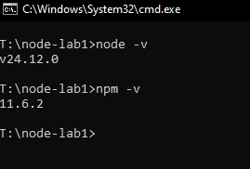
2. Create a simple Node.js program
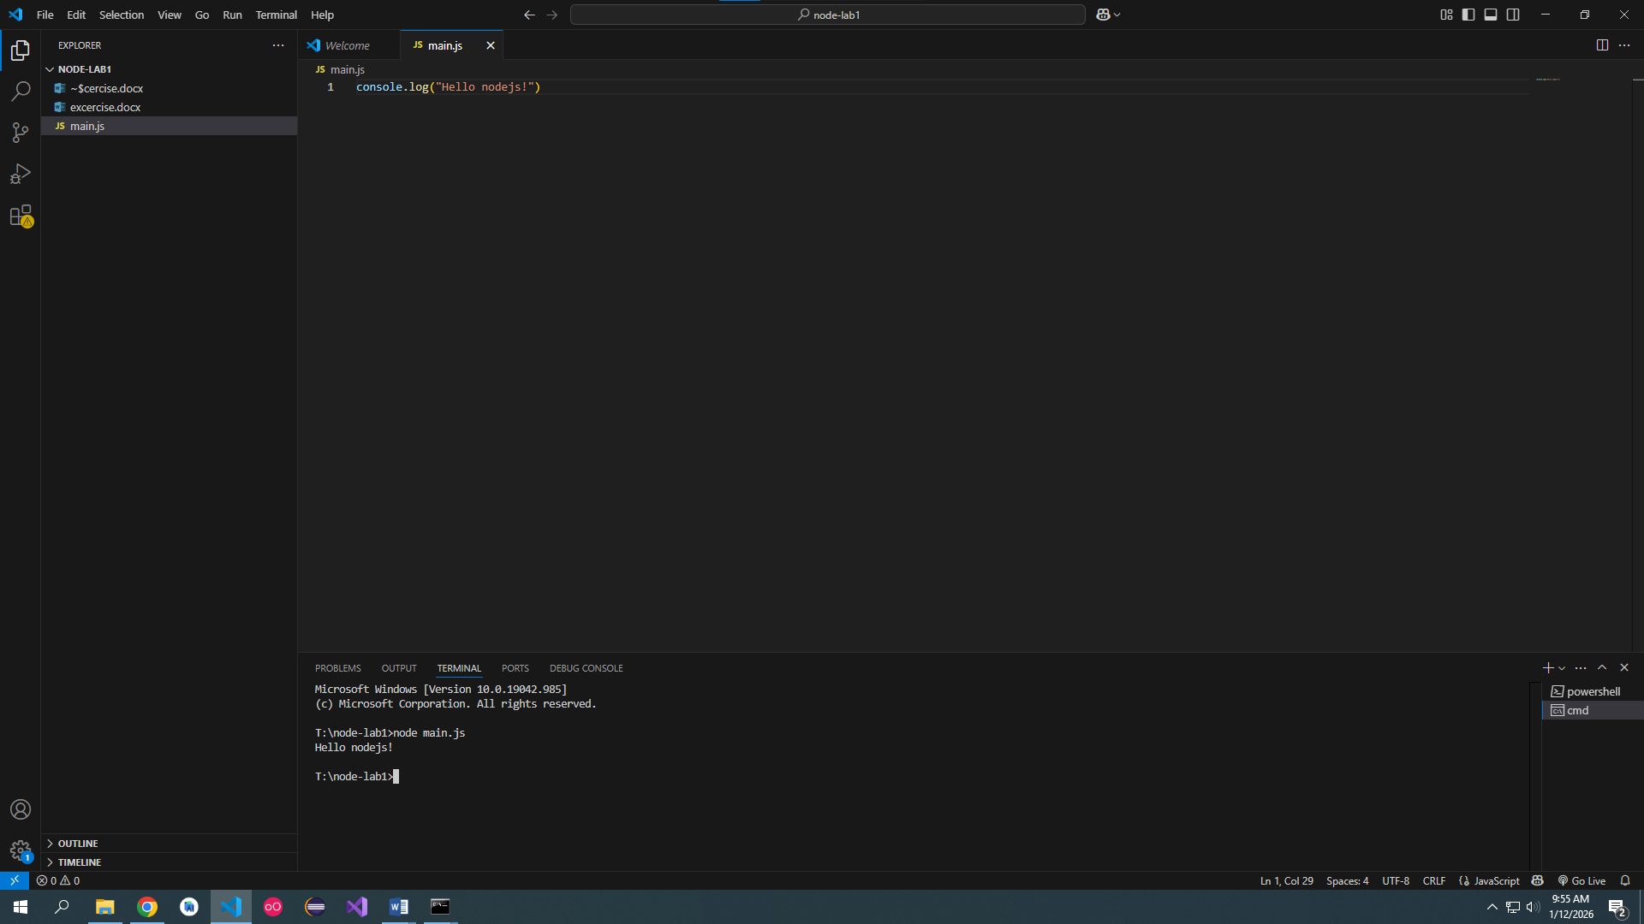

3. Create a custom module and import it
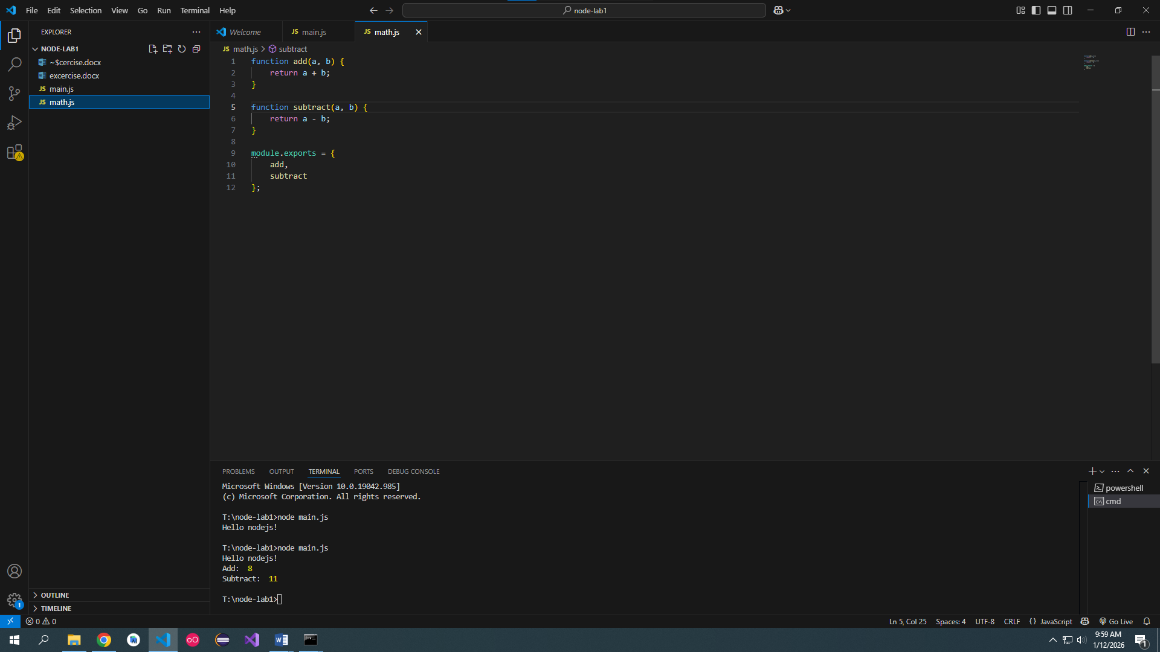
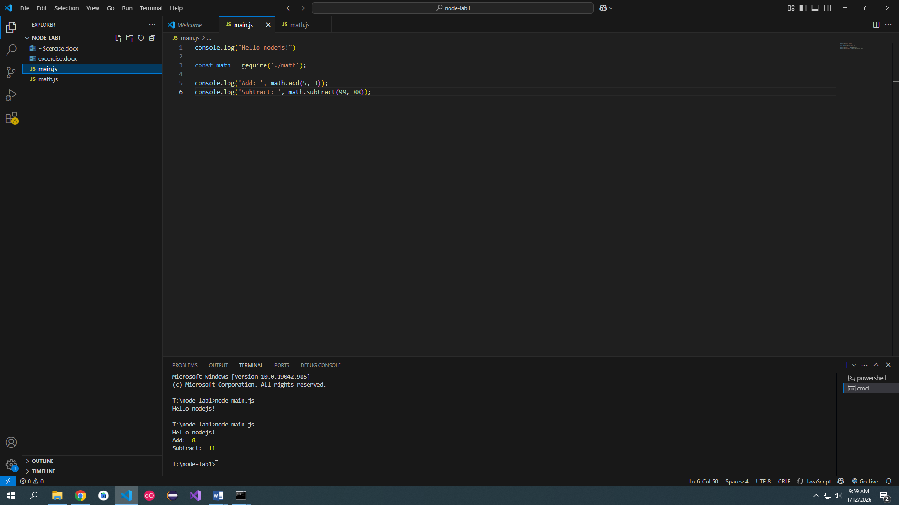

Lab 2: File System & NPM (3 hours)
Objectives:
- Use fs module
- Manage dependencies with npm
Tasks:
1. Read and write files asynchronously
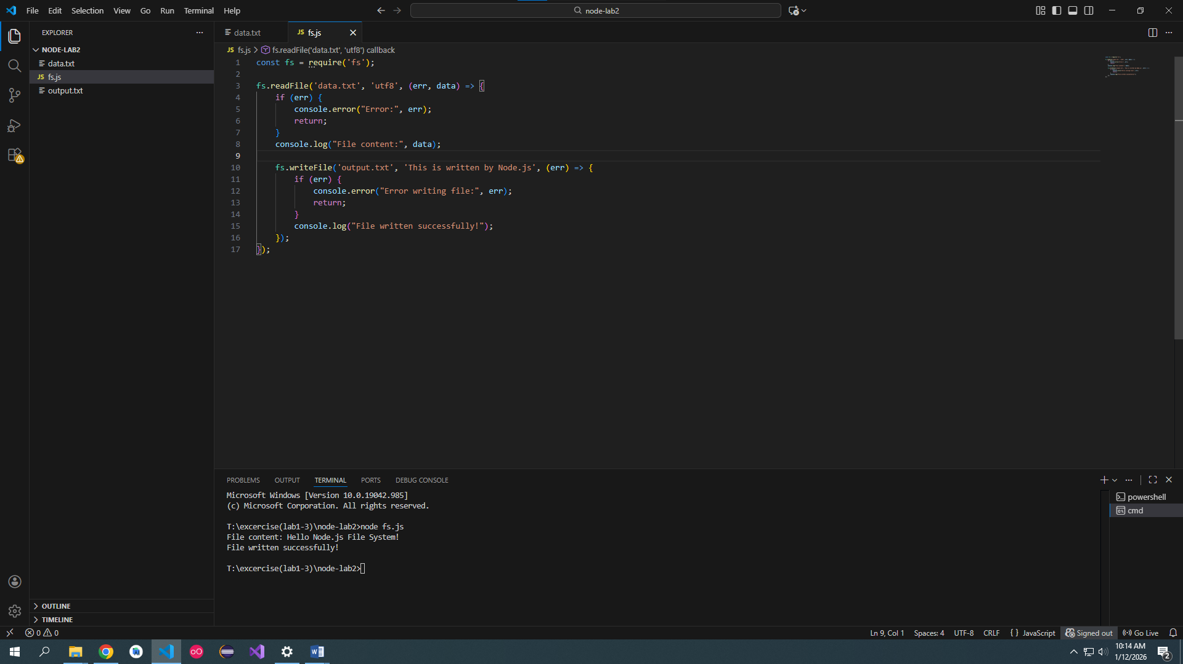
2. Initialize npm project
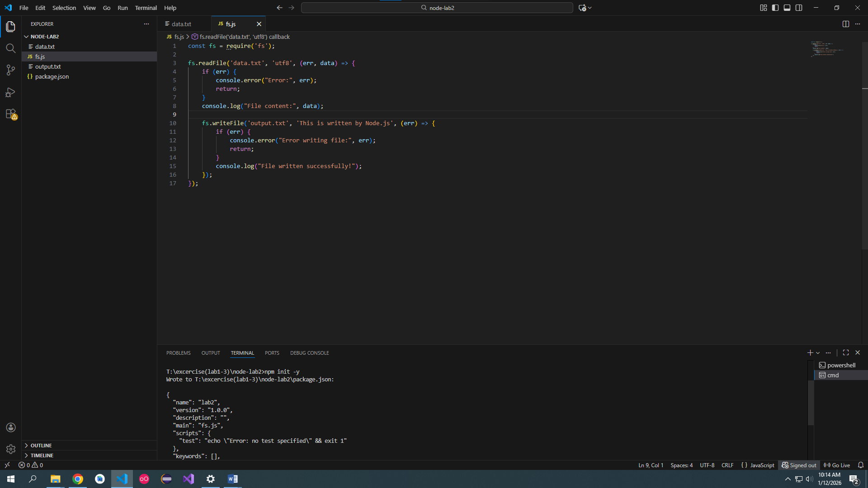

3. Install and use third-party package
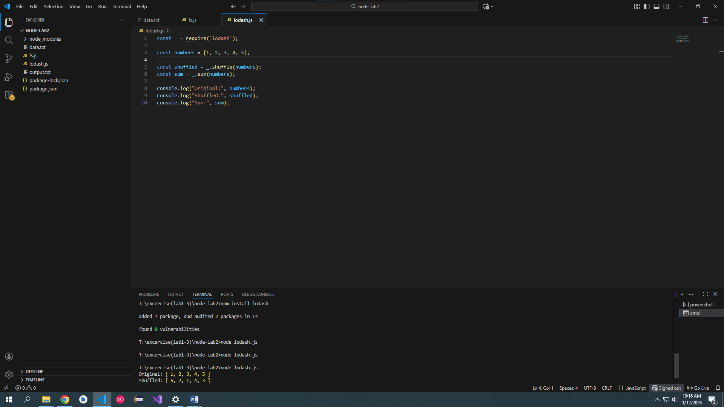

Lab 3: Event-driven Mini Project (3 hours)
Mini Project: Student Activity Logger
- Emit events when student action occurs
- Log activities to file
- Use EventEmitter and fs
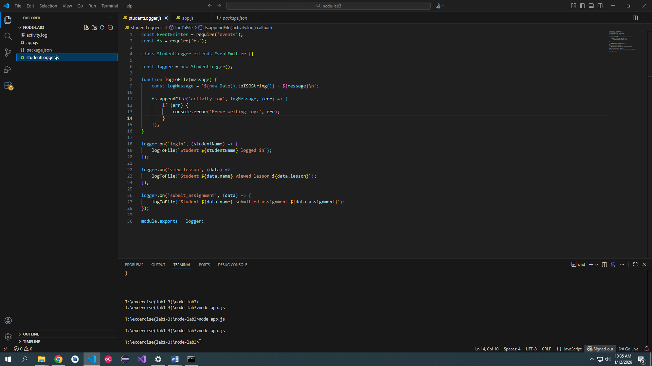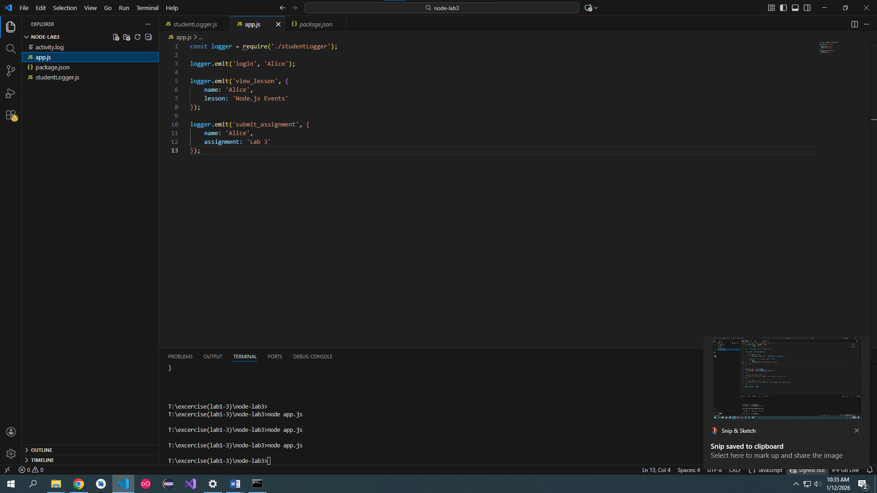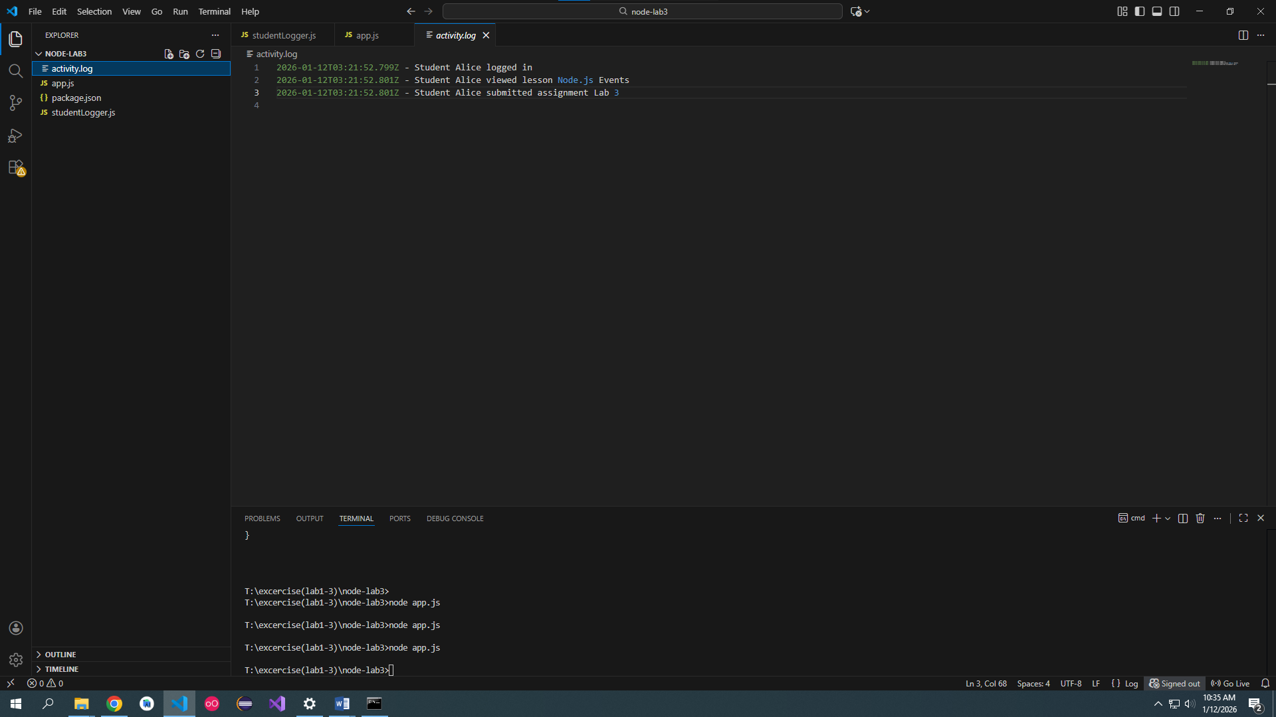

Bonus:
