**SERVER - XAMPP [ LOCALHOST ]**

**http://localhost/phpmyadmin/**

***( LHMS ) - DATABASE***

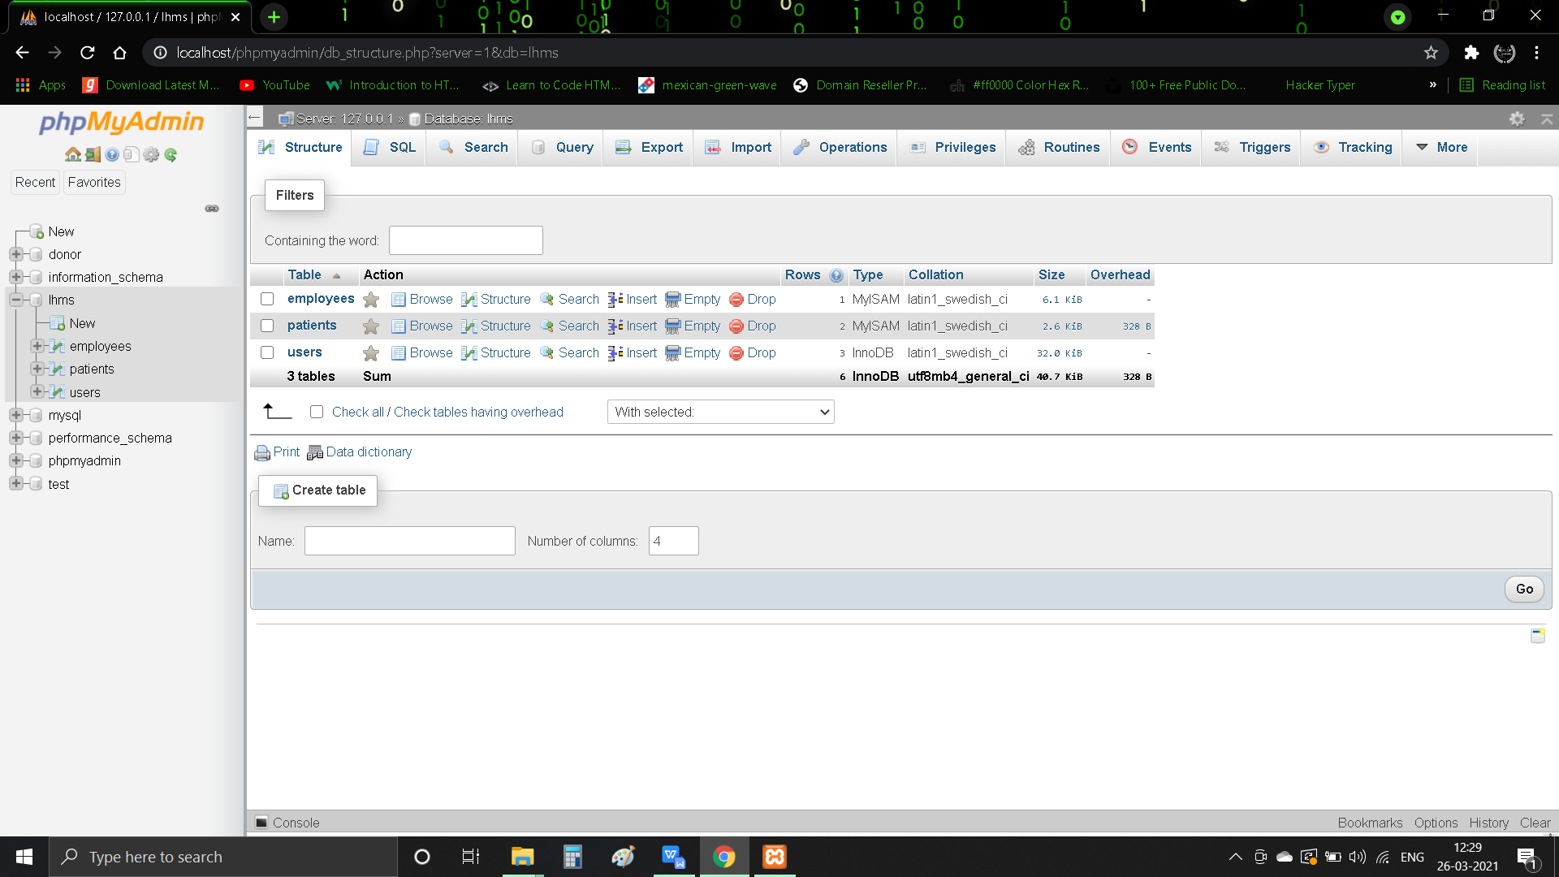

**[ Employees ] - Table**

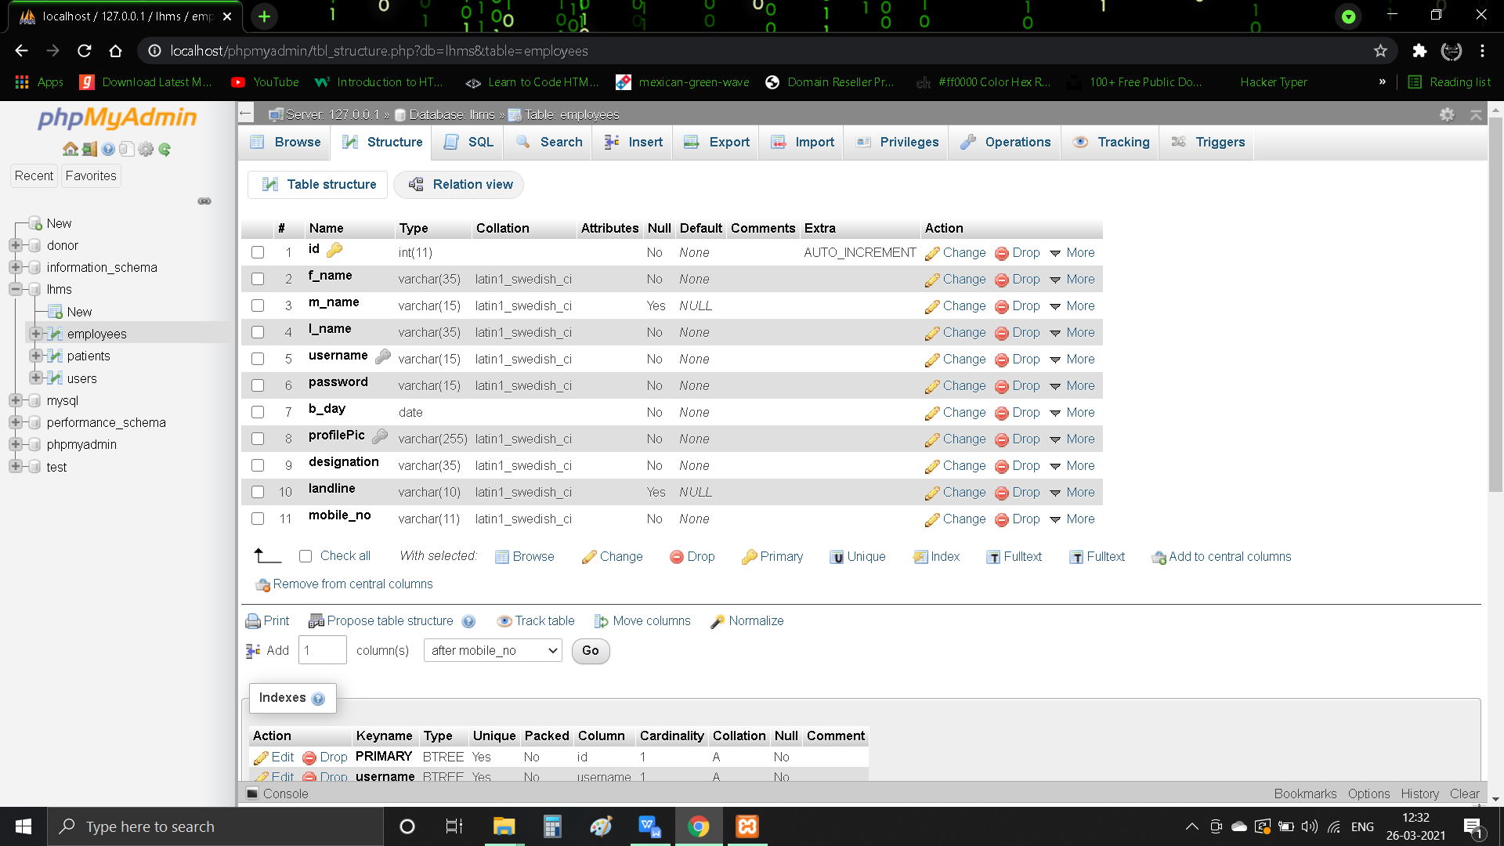

**[ Employees ] - Table Data**

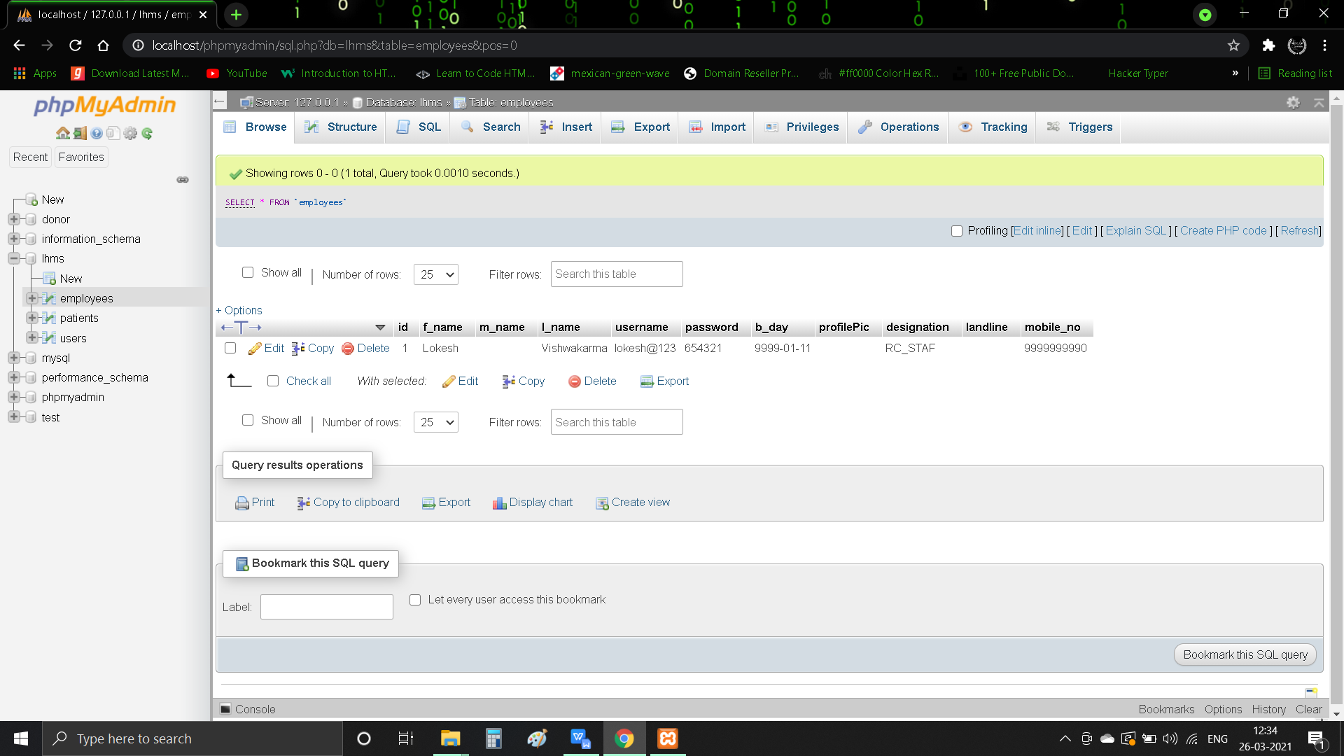

**[ Patients ] - Table**

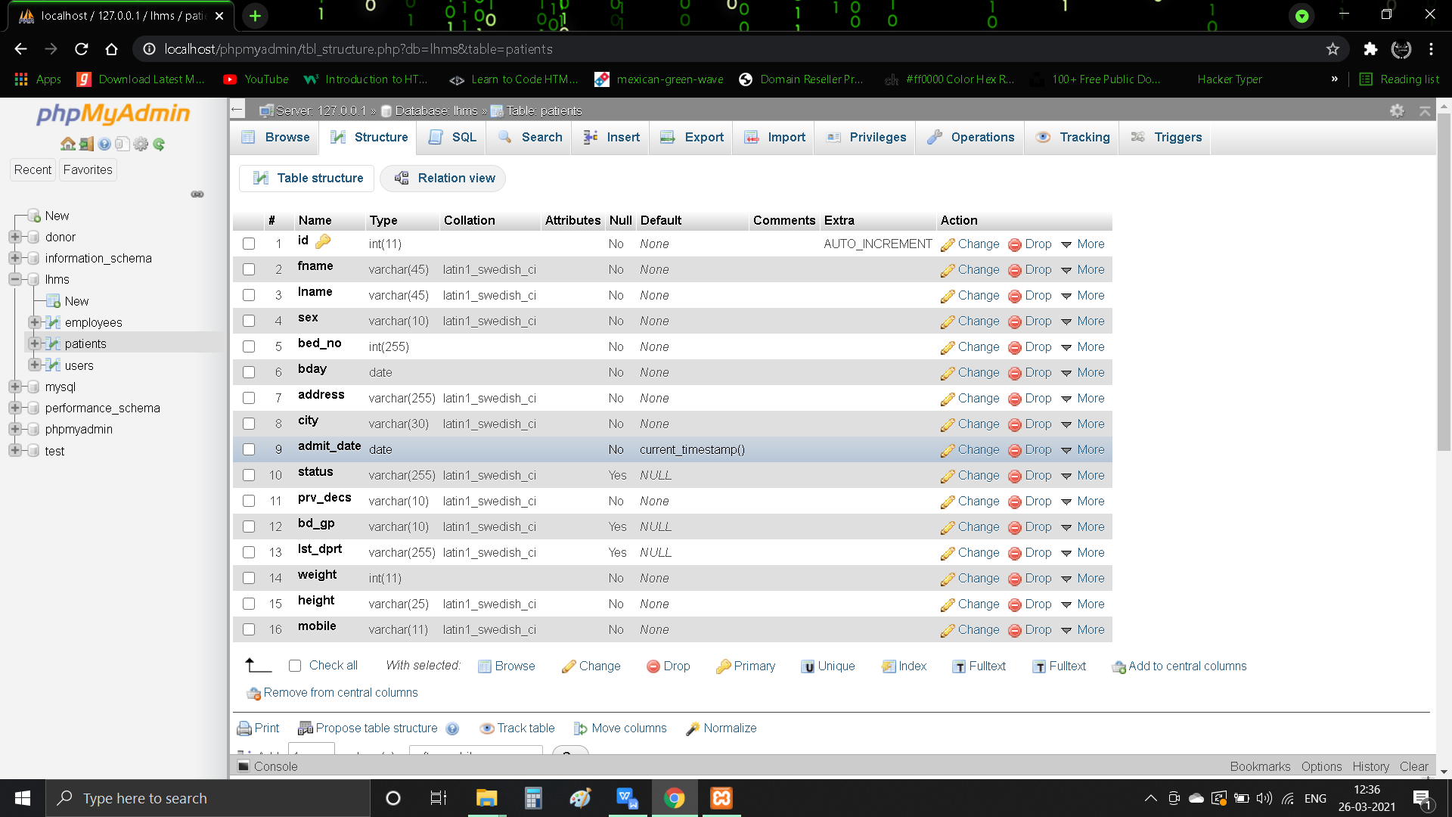

**[ Patients ] - Table Data**

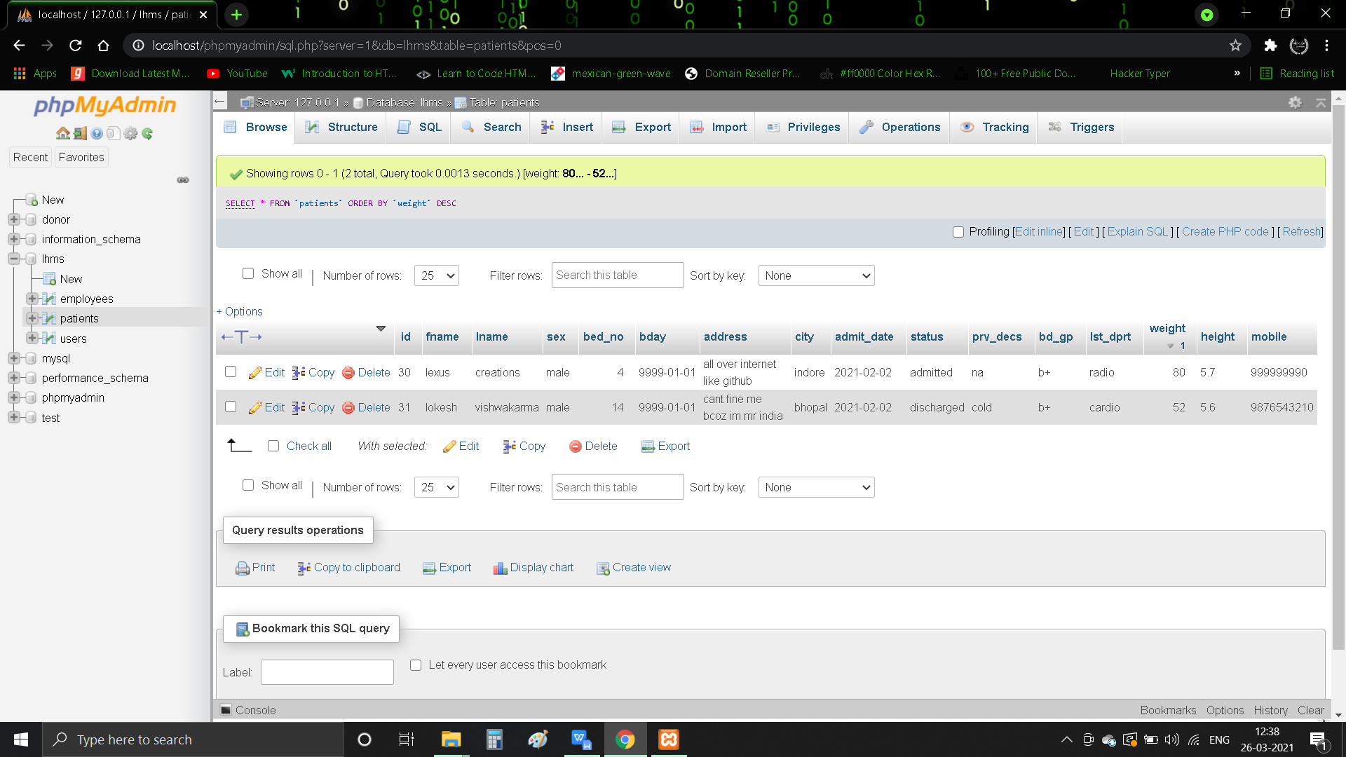

**[ Users ] - Table**

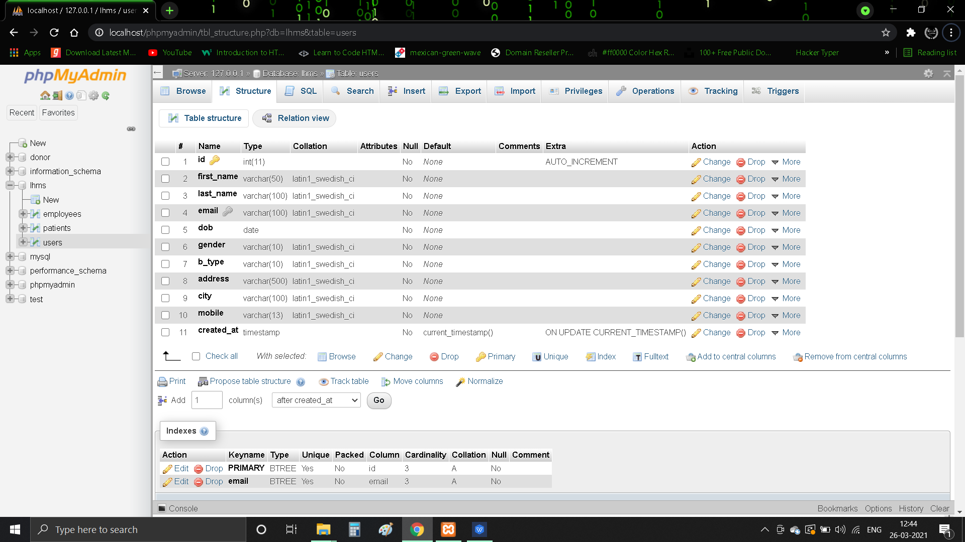

**[ Users ] - Table Data**

