**TESTING:**

Testing is a process of executing a program with the aim of finding error. To make our software perform well it should be error free. If testing is done successfully it will remove all the errors from the software.

**Unit Testing:**

Unit testing is defined as a type of software testing where individual units/components of a software are tested. UNIT testing of software application is done during the development (coding) of an application. The objective of unit testing is to isolate a section of code and verify its correctness. Unit testing is usually performed by the developer. In SDLC, STLC, unit testing is first level of testing done before integration testing.

**Integration Testing:**

Integration testing is the process of testing the interface between two software units or module. It’s focus on determining the correctness of the interface. The purpose of the integration testing is to expose faults in the interaction between integrated units. Once all the modules have been unit tested, integration testing is performed.

**System Testing:**

In this software is tested such that it works fine for different operating system. It is covered under the black box testing technique. In this we just focus on required input and output without focusing on internal working.

**Regression Testing:**

Every time new module is added leads to changes in program. This type of testing make sure that whole component works properly even after adding components to the complete program.

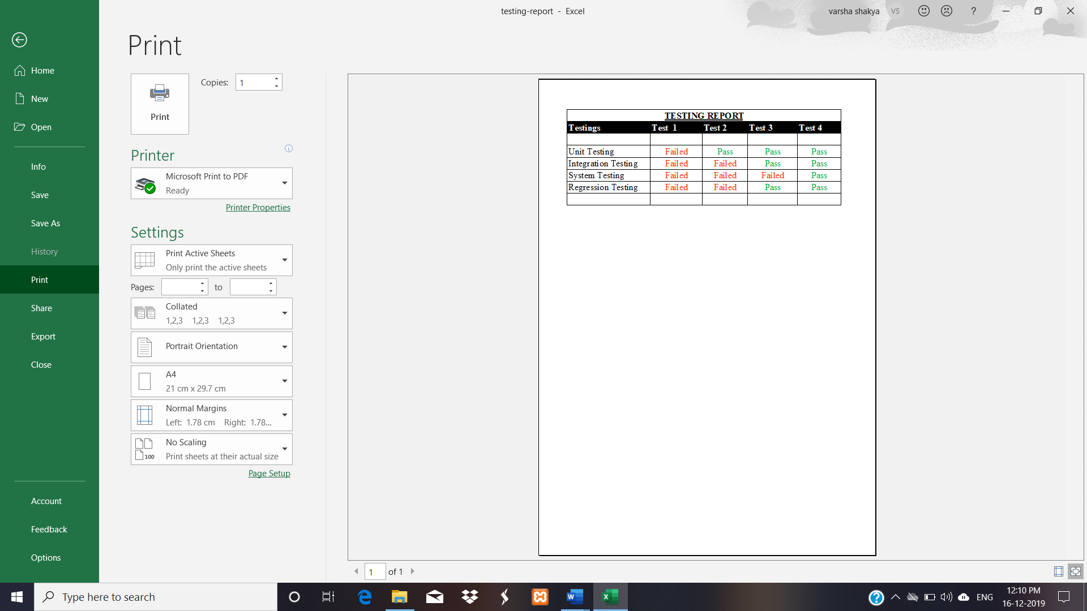

**Limitation Of Project:**

Every Project Work Has A Limitations Which Is Inspiring For The Betterment And Function Enhancement Of The Project.

* My Project “PhpMysqlChatApp” Could Not Handle Heavy Traffic Due To The Restrictions Of College Topic Project Should Only Use Mysql Database.
* The System require a few knowledgeable person to use this system.
* This system is not cover all the languages.
* This system does not cover to payment gateway but will initialized.
* This system is also a web based application so internet facility must be needed.

**Future Scope**

This Project Will Enhance The Connectivity To Peoples Each Others To Interact More Quickly And Efficiently. This Software Is Developed In Order To Computerize The Activities Which Take More Time, If Done Manually.

PhpMysqlChatApp Will Enable The Public To Make Things Faster Can Get Information Quickly. If We Want Any Information About Others. We Can Access It Quickly.

**Application Of Project:**

* **Improve Data Security**

The fact has been highlighted and reinforced by experts that other social media platform that rely on the continue other third party app are more vulnerable to data theft and leakage than automated ones. A full-fledged secure chatSystem keeps every bit of information secure from unauthorized access.

* **Avoid Errors And Track Every Single Detail**

As stated earlier, managing data is a credential thing where there is no scope for errors. A manual system can’t assure foolproof and 100% accurate processing. There are possibilities of errors and mistakes. Installing an automated secured system removes the chance of error completely, and you avoid compliance issues and lawsuits, the two biggest hassles.

* **Establish Your Chats Or Your Credential Data As Technically Advanced**

When your data is managed by new-age [security management system](https://www.knowarth.com/solutions/hospital-management-system/), it gets established as a techno-savvy and modern secure center. It is highly important in the fiercely competitive modern world that your platform has a good reputation. Today, people rely on computerized systems more than manual ones. It creates a high level of trust in the systems and processes. Also, it is possible to maintain connectivity with peoples and peripheral systems if the operations are managed using automated systems.