**Applicant Name: ALEXIS P. CLIMACO**

**PART I**

* **Description:**
  + Create a smoke suite for the **Listboxer** application
  + Provide reports on 3 defects found **SMOKE TESTING:**

**Setup & Configuration:**

**OS: Windows**

**Version: ListBoxer version 1.98 (see ListBox_readme_txt)**

**File/Data Repositories: C:\ManualTestFolder**

**SMOKE TEST:**

|  |  |  |  |  |  |
| --- | --- | --- | --- | --- | --- |
| **SCENARIO 01:** | **Opening ListBoxer application** | | | **Status** | **Comment** |
| **TEST 001:** | **Open List Boxer Application using Windows Taskbar** | | | **PASS** |  |
|  | **STEPS** | **Description** | **Expected** |  |  |
|  | 1 | Click Windows button at the taskbar. | Will show all application listed in Alphabetical order. |  |  |
|  | 2 | Select/Click ListBoxer application | ListBoxer application will open. |  |  |
| **TEST 002:** | **Open ListBoxer application using Command Line** | | | **PASS** |  |
|  | **STEPS** | **Description** | **Expected** |  |  |
|  | 1 | Go to commandline |  |  |  |
|  | 2 | Go to <installation_directory> |  |  |  |
|  | 3 | Type ListBoxer.exe | ListBoxer application will open. |  |  |

|  |  |  |  |  |  |
| --- | --- | --- | --- | --- | --- |
| **SCENARIO 02:** | **Verify Menu execution** | | | **Status** | **Comment** |
| **TEST 001:** | **Execute Open in File Menu.** | | | **PASS** |  |
|  | **STEPS** | **Description** | **Expected** |  |  |
|  | 1 | Launch ListBoxer application | ListBoxer application will show. |  |  |
|  | 2 | Click File Menu and Clcik Open or (Ctrl+O) | File directory screen will launch. |  |  |
|  | 3 | Change and Select Path to C:\ManualTestFolder | Path or Directory folder changed. |  |  |
|  | 4 | Select/Click TestFile1.lbx | TestFile1.lbx selected |  |  |
|  |  |  |  |  |  |
| **TEST 002:** | **Verify Save As in File Menu.** | | | **FAILED** | BUG#4 |
|  | **STEPS** | **Description** | **Expected** |  |  |
|  | 1 | Open ListBoxer application | ListBoxer application launched. |  |  |
|  | 2 | Add list 8 times (ex: aa, bb, cc, dd, ee, zz, xx,uu). | Lists added in the listbox screen. |  |  |
|  | 3 | Select File menu and Save (Filename: TestFile1.lbx) | TestFile1.lbx saved |  |  |
|  | 4 | Select Clear List button | List at the listbox screen is cleared. |  |  |
|  | 5 | Select File menu and Open the saved “.lbx” file (Filename: TestFile1.lbx) | All lists reflected in the listbox screen. | **FAILED** | Missing 1 field. |
| **TEST 003:** | **Verify Exit in File Menu.** | | | **PASS** |  |
|  | **STEPS** | **Description** | **Expected** |  |  |
|  | 1 | Open ListBoxer application | ListBoxer application launched. |  |  |
|  | 2 | Click File Menu and Click Exit or (Ctrl+Q) | LisxtBoxer Application will close. |  |  |
| **TEST 004:** | **Verify Undo (Ctrl-Z) in Edit Menu.** | | | **PASS** |  |
|  | **STEPS** | **Description** | **Expected** |  |  |
|  | 1 | Open ListBoxer application | ListBoxer application launched. |  |  |
|  | 2 | Add list 2 times (ex: aa, bb). | Lists added in the listbox screen. |  |  |
|  | 3 | Select Edit menu |  |  |  |
|  | 4 | Select Select Undo (Ctrl+Z) | Removing 1 list (bb) |  |  |
|  |  |  |  |  |  |
| **TEST 005:** | **Verify Cut (Ctrl-X) in Edit Menu.** | | |  | Not part of the Requirements? |
|  | **STEPS** | **Description** | **Expected** |  |  |
|  | 1 | Open ListBoxer application | ListBoxer application launched. |  |  |
|  | 2 | Add list 2 times (ex: aa, bb). | Lists added in the listbox screen. |  |  |
|  | 3 | Select Edit menu |  |  |  |
|  | 4 | Select Cut or (Ctrl+X) | Should be Disable |  |  |
| **TEST 006:** | **Verify Copy (Ctrl-C) in Edit Menu.** | | |  | Not part of the Requirements? |
|  | **STEPS** | **Description** | **Expected** |  |  |
|  | 1 | Open ListBoxer application | ListBoxer application launched. |  |  |
|  | 2 | Add list 2 times (ex: aa, bb). | Lists added in the listbox screen. |  |  |
|  | 3 | Select Edit menu |  |  |  |
|  | 4 | Select Copy or (Ctrl+C) | Should be Disable |  |  |
| **TEST 007:** | **Verify Paste (Ctrl-V) in Edit Menu.** | | |  | Not part of the Requirements? |
|  | **STEPS** | **Description** | **Expected** |  |  |
|  | 1 | Open ListBoxer application | ListBoxer application launched. |  |  |
|  | 2 | Add list 2 times (ex: aa, bb). | Lists added in the listbox screen. |  |  |
|  | 3 | Select Edit menu |  |  |  |
|  | 4 | Select Paste or (Ctrl+V) | Should be Disable |  |  |
| **TEST 008:** | **Verify “Contents…” in Help Menu** | | | **PASS** |  |
|  | **STEPS** | **Description** | **Expected** |  |  |
|  | 1 | Open ListBoxer application | ListBoxer application launched. |  |  |
|  | 2 | Select Help menu |  |  |  |
|  | 3 | Select Content.. sub menu | Should launch support URL |  | Not part of the Requirements? |
| **TEST 009:** | **Verify “About” ListBoxer in Help Menu** | | | **FAILED** | Bug #01 |
|  | **STEPS** | **Description** | **Expected** |  |  |
|  | 1 | Open ListBoxer application | ListBoxer application launched. |  |  |
|  | 2 | Select Help menu |  |  |  |
|  | 3 | Select About ListBoxer.. sub menu | Should launch About ListBoxer screen | **FAILED** | **Version is incorrect** |
| **TEST 010:** | **Verify All texts and Naming Conventions for the Menu and Sub-Menu.** | | | **FAILED** | Bug #03 |
|  | **STEPS** | **Description** | **Expected** |  |  |
|  | 1 | Open ListBoxer application | ListBoxer application launched. |  |  |
|  | 2 | Verify Menu names and Spelling | Menu spelled correctly. | **Failed** | Edjt word is incorect |

|  |  |  |  |  |  |
| --- | --- | --- | --- | --- | --- |
| **SCENARIO 03:** | **Verify Sort Order function** | | | **Status** | **Comment** |
| **TEST 001:** | **Verify Sort Order Ascending using Alphabetical symbol** | | | **FAILED** | BUG #5 |
|  | **STEPS** | **Description** | **Expected** |  |  |
|  | 1 | Open ListBoxer application | ListBoxer application launched. |  |  |
|  | 2 | Select Range All | All range selected. |  |  |
|  | 3 | Select Sort Order (Ascending) | Ascending Sort Order Selected. |  |  |
|  | 4 | Select Symbols (Aplhabetic) | Alphabetic symbol selected. |  |  |
|  | 5 | Add list 8 times (ex: aa, bb, cc, dd, ee, zz, xx,uu). | Lists added in the listbox screen in Ascending order. |  |  |
| **TEST 002:** | **Verify Sort Order Descending using Alphabetical symbol** | | | **FAILED** | BUG #5 |
|  | **STEPS** |  |  |  |  |
|  | 1 | Open ListBoxer application | ListBoxer application launched. |  |  |
|  | 2 | Select Range All | All range selected. |  |  |
|  | 3 | Select Sort Order (Descending) | Ascending Sort Order Selected. |  |  |
|  | 4 | Select Symbols (Aplhabetic) | Alphabetic symbol selected. |  |  |
|  | 5 | Add list 8 times (ex: aa, bb, cc, dd, ee, zz, xx,uu). | Lists added in the listbox screen in Descending order. |  |  |
| **TEST 003:** | **Verify Sort Order Ascending using Numeric Symbol.** | | | **FAILED** | BUG #5 |
|  | **STEPS** |  |  |  |  |
|  | 1 | Open ListBoxer application | ListBoxer application launched. |  |  |
|  | 2 | Select Range All | All range selected. |  |  |
|  | 3 | Select Sort Order (Ascending) | Ascending Sort Order Selected. |  |  |
|  | 4 | Select Symbols (Numeric) | Numeric symbol selected. |  |  |
|  | 5 | Add list 8 times (ex: 11, 88, 44, 33, 22, 77, 66,55). | Lists added in the listbox screen in Ascending order. |  |  |
| **TEST 004:** | **Verify Sort Order Descending using Numeric Symbol.** | | | **FAILED** | BUG #5 |
|  | **STEPS** |  |  |  |  |
|  | 1 | Open ListBoxer application | ListBoxer application launched. |  |  |
|  | 2 | Select Range All | All range selected. |  |  |
|  | 3 | Select Sort Order (Descending) | Descending Sort Order Selected. |  |  |
|  | 4 | Select Symbols (Numeric) | Numeric symbol selected. |  |  |
|  | 5 | Add list 8 times (ex: 11, 88, 44, 33, 22, 77, 66,55). | Lists added in the listbox screen in Descending order. |  |  |
| **TEST 005:** | **Verify Sort Order Ascending using Mixed Symbol.** | | | **FAILED** | BUG #5 |
|  | **STEPS** |  |  |  |  |
|  | 1 | Open ListBoxer application | ListBoxer application launched. |  |  |
|  | 2 | Select Range All | All range selected. |  |  |
|  | 3 | Select Sort Order (Ascending) | Ascending Sort Order Selected. |  |  |
|  | 4 | Select Symbols (Alphabetic) | Alphabetic symbol selected. |  |  |
|  | 5 | Select Symbols (Numeric) | Numeric symbol selected. |  |  |
|  | 6 | Add list 8 times (ex: 11, zz, 44, bb, 22, xx, 66, yy). | Lists added in the listbox screen in Ascending order. |  |  |
| **TEST 006:** | **Verify Sort Order Descending using Mixed Symbol.** | | | **FAILED** | BUG #5 |
|  | **STEPS** |  |  |  |  |
|  | 1 | Open ListBoxer application | ListBoxer application launched. |  |  |
|  | 2 | Select Range All | All range selected. |  |  |
|  | 3 | Select Sort Order (Descending) | Descending Sort Order Selected. |  |  |
|  | 4 | Select Symbols (Alphabetic) | Alphabetic symbol selected. |  |  |
|  | 5 | Select Symbols (Numeric) | Numeric symbol selected. |  |  |
|  | 6 | Add list 8 times (ex: 11, zz, 44, bb, 22, xx, 66, yy). | Lists added in the listbox screen in Descending order. |  |  |

|  |  |  |  |  |  |
| --- | --- | --- | --- | --- | --- |
| **SCENARIO 04:** | **Verify Symbols Function** | | | **Status** | **Comment** |
| **TEST 001:** | **Verify using “Alphabetic” symbol functions.** | | | **PASS** |  |
|  | **STEPS** | **Description** | **Expected** |  |  |
|  | 1 | Open ListBoxer application | ListBoxer application launched. |  |  |
|  | 2 | Select Symbols (Aplhabetic) | Alphabetic symbol selected. |  |  |
|  | 3 | Add list 8 times (ex: aa, bb, cc, dd, ee, zz, xx,uu). | Lists added in the listbox screen. |  |  |
|  | 4 | At Range Section Select “a-m” | Only list of “a-m” will show at the listbox |  |  |
|  | 5 | At Range Section Select “n-z” | Only list of “n-z” will show at the listbox |  |  |
|  | 6 | At Range Section Select “All” | All will show at the listbox |  |  |
|  | 7 | At Range Section Select “nonel” | None will show at the listbox |  |  |
| **TEST 002:** | **Verify using “Numeric” symbol functions.** | | | **FAILED** | BUG#2 |
|  | **STEPS** | **Description** | **Expected** |  |  |
|  | 1 | Open ListBoxer application | ListBoxer application launched. |  |  |
|  | 2 | Select Symbols (Numeric) | Numeric symbol selected. |  |  |
|  | 3 | Add list 8 times (ex: 11, 22, 200, 300, 301, 400, 101, 9999). | Lists added in the listbox screen. |  |  |
|  | 4 | At Range Section Select “1-100” | Only list of “1-100” will show at the listbox |  |  |
|  | 5 | At Range Section Select “101-200” | Only list of “101-200” will show at the listbox |  |  |
|  | 6 | At Range Section Select “201-300” | Only list of “201-300” will show at the listbox |  |  |
|  | 7 | At Range Section Select “301-9999” | Only list of “301-9999” will show at the listbox | **FAILED** | BUG#2 |
|  | 8 | At Range Section Select “All” | All will show at the listbox |  |  |
|  | 9 | At Range Section Select “nonel” | None will show at the listbox |  |  |
| **TEST 003:** | **Verify using “Mixed” symbol functions.** | | | **FAILED** | BUG#2 |
|  | **STEPS** | **Description** | **Expected** |  |  |
|  | 1 | Open ListBoxer application | ListBoxer application launched. |  |  |
|  | 2 | Select Symbols (Aplhabetic) | Alphabetic symbol selected. |  |  |
|  | 3 | Select Symbols (Numeric) | Numeric symbol selected. |  |  |
|  | 4 | Add list 8 times (ex: aa, bb, cc, dd, ee, zz, xx,uu). | Lists added in the listbox screen. |  |  |
|  | 5 | Add list 8 times (ex: 11, 22, 200, 300, 301, 400, 101, 9999). | Lists added in the listbox screen.. |  |  |
|  | 6 | At Range Section Select “a-m” | Only list of “a-m” will show at the listbox |  |  |
|  | 7 | At Range Section Select “n-z” | Only list of “n-z” will show at the listbox |  |  |
|  | 8 | At Range Section Select “1-100” | Only list of “1-100” will show at the listbox |  |  |
|  | 9 | At Range Section Select “101-200” | Only list of “101-200” will show at the listbox |  |  |
|  | 10 | At Range Section Select “201-300” | Only list of “201-300” will show at the listbox |  |  |
|  | 11 | At Range Section Select “301-9999” | Only list of “301-9999” will show at the listbox | **FAILED** | BUG#2 |
|  | 12 | At Range Section Select “All” | All will show at the listbox |  |  |
|  | 13 | At Range Section Select “nonel” | None will show at the listbox |  |  |

|  |  |  |  |  |  |
| --- | --- | --- | --- | --- | --- |
| **SCENARIO 05:** | **Verify Range Execution** | | | **Status** | **Comment** |
| **TEST 001:** | **Verify Range using “<none >” function for Alphabetic Symbol** | | | **PASS** |  |
|  | **STEPS** | **Description** | **Expected** |  |  |
|  | 1 | Open ListBoxer application | ListBoxer application launched. |  |  |
|  | 2 | At Range Section Select “none” | None is selected. |  |  |
|  | 3 | Select Symbols (Aplhabetic) | Alphabetic symbol selected. |  |  |
|  | 4 | Enter text (ex. AA, 11) at input field then click Add to List button. | Inputted text or number is not added in the listbox |  |  |
| **TEST 002:** | **Verify Range using “All” function for Alphabetic Symbol** | | | **PASS** |  |
|  | **STEPS** | **Description** | **Expected** |  |  |
|  | 1 | Open ListBoxer application | ListBoxer application launched. |  |  |
|  | 2 | At Range Section Select “All” | None is selected. |  |  |
|  | 3 | Select Symbols (Aplhabetic) | Alphabetic symbol selected. |  |  |
|  | 4 | Enter text (ex. AA, BB) at input field then click Add to List button. | Inputted text is added in the listbox |  |  |
| **TEST 003:** | **Verify Range for Alphabetic Symbol function** | | | **PASS** |  |
|  | **STEPS** | **Description** | **Expected** |  |  |
|  | 1 | Open ListBoxer application | ListBoxer application launched. |  |  |
|  | 2 | At Range Section Select “a-m” | Range “a-m” is selected. |  |  |
|  | 3 | Select Symbols (Aplhabetic) | Alphabetic symbol selected. |  |  |
|  | 4 | Enter (ex. AA, BB) at input field then click Add to List button. | Inputted text is added in the listbox |  |  |
|  | 5 | At Range Section Select “n-z” | Range “n-z” is selected. |  |  |
|  | 6 | Enter (ex. XX, YY) at input field for Add to List section., | Inputted text is added in the listbox |  |  |
| **TEST 004:** | **Verify Range using “<none>” function for Numeric Symbol** | | | **PASS** |  |
|  | **STEPS** | **Description** | **Expected** |  |  |
|  | 1 | Open ListBoxer application | ListBoxer application launched. |  |  |
|  | 2 | At Range Section Select “none” | None is selected. |  |  |
|  | 3 | Select Symbols (Numeric) | Numeric symbol selected. |  |  |
|  | 4 | Enter Number (ex. 11) at input field then click Add to List button. | Inputted text is added in the listbox |  |  |
| **TEST 005:** | **Verify Range using “All” function for Numeric Symbol** | | | **PASS** |  |
|  | **STEPS** | **Description** | **Expected** |  |  |
|  | 1 | Open ListBoxer application | ListBoxer application launched. |  |  |
|  | 2 | At Range Section Select “All” | None is selected. |  |  |
|  | 3 | Select Symbols (Numeric) | Numeric symbol selected. |  |  |
|  | 4 | Enter Number (ex. 11, 9999) at input field then click Add to List button. | Inputted Number is added in the listbox |  |  |
| **TEST 006:** | **Verify Range for Numeric Symbol function** | | | **PASS** |  |
|  | **STEPS** | **Description** | **Expected** |  |  |
|  | 1 | Open ListBoxer application | ListBoxer application launched. |  |  |
|  | 2 | Select Symbols (Numeric) | Numeric symbol selected. |  |  |
|  | 3 | Select Range 1-100 | Range selected |  |  |
|  | 4 | Enter Number (ex. 11, 100) at input field then click Add to List button. | Inputted number is added in the listbox |  |  |
|  | 5 | Select Range 101-200 | Range selected |  |  |
|  | 6 | Enter Number (ex. 101, 200) at input field then click Add to List button. | Inputted number is added in the listbox |  |  |
|  | 7 | Select Range 201-300 | Range selected |  |  |
|  | 8 | Enter Number (ex. 201, 300) at input field then click Add to List button. | Inputted number is added in the listbox |  |  |
|  | 9 | Select Range 301-9999 | Range selected |  |  |
|  | 10 | Enter Number (ex.301, 9999) at input field then click Add to List button. | Inputted number is added in the listbox |  |  |
| **TEST 011:** | **Verify Range using “<none>” for Mixed Symbols Functions** | | | **PASS** |  |
|  | **STEPS** | **Description** | **Expected** |  |  |
|  | 1 | Open ListBoxer application | ListBoxer application launched. |  |  |
|  | 2 | At Range Section Select “none” | None is selected. |  |  |
|  | 3 | Select Symbols (Aplhabetic) | Alphabetic symbol selected. |  |  |
|  | 4 | Select Symbols (Numeric) | Numeric symbol selected. |  |  |
|  | 5 | Enter text (ex. AA, BB) at input field then click Add to List button. | Inputted text is NOT added in the listbox |  |  |
|  | 6 | Enter Number (ex. 11) at input field then click Add to List button. | Inputted Nnmber is NOTadded in the listbox |  |  |
| **TEST 012:** | **Verify Range using “All” for Mixed Symbols Functions** | | | **PASS** |  |
|  | **STEPS** | **Description** | **Expected** |  |  |
|  | 1 | Open ListBoxer application | ListBoxer application launched. |  |  |
|  | 2 | At Range Section Select “none” | None is selected. |  |  |
|  | 3 | Select Symbols (Aplhabetic) | Alphabetic symbol selected. |  |  |
|  | 4 | Select Symbols (Numeric) | Numeric symbol selected. |  |  |
|  | 5 | Enter text (ex. AA, BB) at input field then click Add to List button. | Inputted text is added in the listbox |  |  |
|  | 6 | Enter Number (ex. 11) at input field then click Add to List button. | Inputted Nnmber is added in the listbox |  |  |
| **TEST 013:** | **Verify Range using Mixed Symbols Functions** | | | **PASS** |  |
|  | **STEPS** | **Description** | **Expected** |  |  |
|  | 1 | Open ListBoxer application | ListBoxer application launched. |  |  |
|  | 2 | Select Symbols (Numeric) | Numeric symbol selected. |  |  |
|  | 3 | Select Symbols (Aplhabetic) | Alphabetic symbol selected. |  |  |
|  | 4 | Select Range 1-100 | Range selected |  |  |
|  | 5 | Enter Number (ex. 11, 100) at input field then click Add to List button. | Inputted number is added in the listbox |  |  |
|  | 6 | Select Range 101-200 | Range selected |  |  |
|  | 7 | Enter Number (ex. 101, 200) at input field then click Add to List button. | Inputted number is added in the listbox |  |  |
|  | 8 | Select Range 201-300 | Range selected |  |  |
|  | 9 | Enter Number (ex. 201, 300) at input field then click Add to List button. | Inputted number is added in the listbox |  |  |
|  | 10 | Select Range 301-9999 | Range selected |  |  |
|  | 11 | Enter Number (ex.301, 9999) at input field then click Add to List button. | Inputted number is added in the listbox |  |  |
|  | 12 | At Range Section Select “a-m” | Range “a-m” is selected. |  |  |
|  | 13 | Enter (ex. AA, BB) at input field then click Add to List button. | Inputted text is added in the listbox |  |  |
|  | 14 | At Range Section Select “n-z” | Range “n-z” is selected. |  |  |
|  | 15 | Enter (ex. XX, YY) at input field for Add to List section., | Inputted text is added in the listbox |  |  |

**Bug #01:**

**Summary:** ListBoxer application version 1.89 is incorrect

**Description:** Incorrect application version between ListBoxer application and ListBox_readme.txt

**Setup: Latest build release version 1.98**

**Steps:**

1. Install latest build release of ListBoxer application
2. Open ListBoxer application
3. Go to help Menu

**Observation:** The ListBoxer_readme.txt file is using higher version of application (version 1.98), while in the latest build release installed version 1.89. It might be typo error or it needs replacement of the application in the repository.

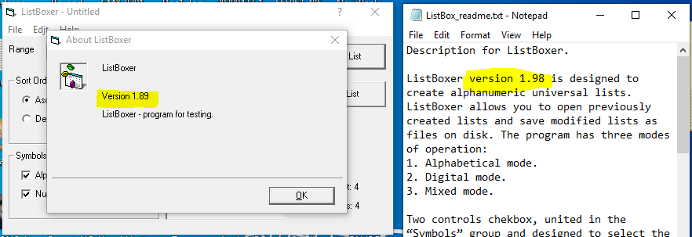

**Expected:** Both application and readme file should follow the correct versioning of application.

**Bug2:**

**Summary:** Incorrect range for “300 - 9999 ” instead of “301-9999”.

**Description:** The beginning range 300 for “300-9999” is overlapping to the ending range of “201-300”.

**Setup:**

Range: All

Sort Order: None

Symbols: Numeric

**Steps:**

1. Launch ListBoxer application.
2. At Symbols section check Numeric checkbox
3. Click Range dropdown button

**Observed:** The “300-9999” range doesn’t meet to the requirements document. (see screenshot)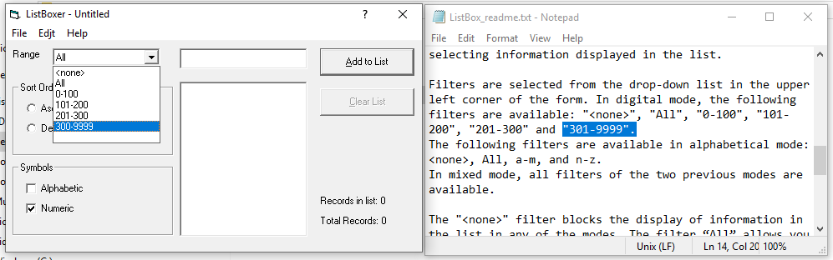

**Expected:** The range should be “301-9999”

**Bug3:**

**Summary:** Misspelled “Edit” word in Menu.

**Description:** When launching the ListBoxer application the misspelled “Edjt” word is visible. It should be “Edit” in the menu.

**Setup:**

Range: All

Sort Order: None

Symbols: Alphabetic

**Steps:**

1. Go to taskbar Windows button.
   1. 
2. Select the ListBoxer desktop app.

**Observation:** At the ListBoxer menu bar a misspelled word for “Edit” menu.

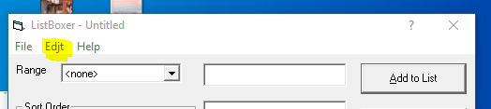

**Expected:** Need to change the string from “Edjt” to “Edit” menu.

**Additional Bug:**

**Bug 4:**

**Summary:** Missing 1 list when opening the newly saved .lbx file.

**Description:** When opening the newly saved .lbx file there is 1 missing list (first list).

**Setup:**

Range: All

Sort Order: none

Symbols: Alphabetic and Numeric

**Steps:**

1. Open ListBoxer application
2. Add list 8 times (ex: aa, bb, cc, dd, ee, zz, xx,uu). 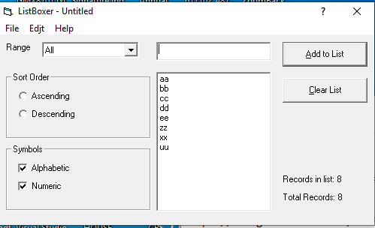
3. Select File menu and Save (Filename: TestFile1.lbx)
4. Select Clear List button
5. Select File menu and Open the saved “.lbx” file (Filename: TestFile1.lbx)

**Observation:** A missing list found in the listbox screen. (See Screenshot)

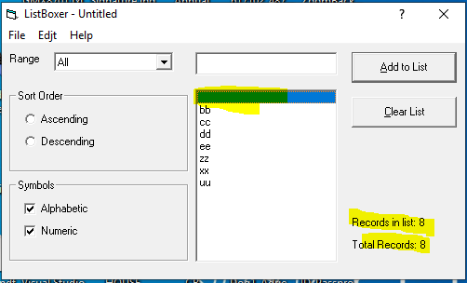

**Expected: A list “aa” should be present in the listbox because the Records is list is equal to 8.**

**Additional Bug:**

**Bug #5:**

**Summary:** Selected Sort Order (Ascending) doesn’t follow sort order after adding the list.

**Description:** When Sort Order is selected (Ascending), and adding the new list value should sort automatically. Currently, it needs to click the Descending radio button then back to Ascending button to populate the ascending effect.

**Setup:**

Range: All

Sort Order: Ascending

Symbols: Numeric

**Steps:**

1. Enter number 5432
2. Enter Number 4321

**Observation:** Step 1 still in the upper list of the field box. (See screenshot **“5432”**)

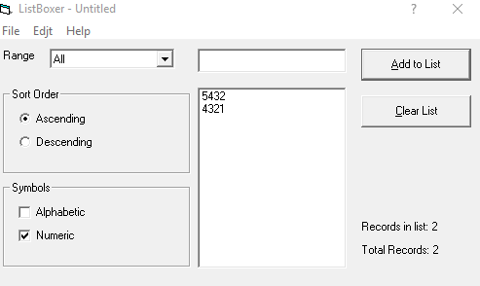

**Expected:** Step 2 (“**4321**”) should automatic in the upper list field placement since we selected already the (Ascending) Sort order.

As a user I don’t need to use the descending and back to ascending in order to sort the list that I have been selected by default.

**NOTE: This will happen also using Alphabetic and Mixed.**

**PART II**

**Description:**

Please review questions and provide answers for each of them as clear and

complete as possible. Please, fully describe not only your decisions, but also whole

logic chain that led to these decisions.

**1. What will be your guidance in case of assigning tasks through the team?**

**Answer 1:**

My experience about assigning task through the team are always follow what is written in the JIRA Dashboard priorities.

Being a leader in SW QA in previous company, I have to make sure that the JIRA dashboard is visible to the QA and also who are all involve in the project as well. During scrum (15 mins) meeting/stand-up meeting and assigning task to them, I often to use to speak their own intuition and abilities/expertise to get a specific task to test. Sometimes, within a meeting I do short discussion to talk to the team about task that are difficult to handle in testing.

After a scrum/stand-up meeting I have to collaborate for those tasks handled by QA that are really difficult for them to execute and give them some advises and key-person to contact for the features to be tested. After the SW QA discussion to the key-person of the features to test and if we do have a clear definition for the difficult issue to handle for testing and we both agrees, then we set a clear direction and goals about the task to test.

After all the discussion I have to set also the schedule/timeline for all testing to keep all QA focused and accountable for each issue they test. Since we set already our goals and schedule, as a QA Lead I use to follow-up occasionally about their work progress if they need support or any assistance. Also, In assigning tasks, I check the workload of the tester/developer if not overloaded and if he/she will be able to deliver within the sprint.

I also use Skype/Teams tools for a chat discussion channel if we need group discussion or provide a feedback that are needed for everybody. Through this channel also we can have valuable discussion or collaboration about topics or issues in the project.

Once SW QA/Tester did a god job about the testing task I use to give credits to say “great work!” or “good job!!” for accomplishing the task during scrum/stand-up meeting or in a group chat channel.

As an individual contributor also or as a SW QA/Tester, my guidance in taking the task/responsibilities is to check first the possible items/issues in JIRA Dashboard to deliver for the next/within sprint. Discuss with the team for the estimates and possible tasks in each stories (or issues), and breaking it down into smaller tasks.

As SW QA/Tester check if all requirements are available in the ticket/issue then you can proceed preparation and test planning execution. If not, you may exclude or do a communication and collaboration since it needs to be documented in the JIRA ticket. Do an estimation if all items are possible to deliver in the current sprint, if not, exclude some of the items based from the level of priority/urgency/during meeting discussion. Once there is a build release proceed your testing based on the test plan created and perform the testing. By rule, If Jira/tickets/issue is resolved then proceed in closing the Jira. If issue still exist then work with the developer and re-plan the testing.

**2. Two days remaining to release. PMs are adding five more stories to release**

**scope. What will you do?**

**Answer:** In my experiences regarding the additional more stories, I think this is the most common in every project delivery. I never heard that no one accepting nor discussing additional stories in release scope during sprint time. And I don’t agree also that we are breaking the process if we add another more stories in every release. We break because it is normal that our client or customer needs more info or additional requirements to be done in the current sprint. And I believe there is no such perfect process in this world but we do have smooth project delivery once we do have coordination between two parties. Because my point is, we value our customer/client if they need that certain stories to be covered in the current release then we have to do it.

But my intake with this kind of scenario is always discuss to the PM or the team about the additional stories. You can show data what will be the affect and effect if we add more stories. Showing your data will prove about the additional stories will be covered or not.

**3. Recently you’ve noticed that acceptance criteria in tickets is not respected too**

**often. What will you do for handling of this situation?**

**Answer:** In my current company we do follow process from picking the JIRA to test, down to documentation process. As a SW QA I create a mini test plan for every JIRA improvement that I work to elaborate all the testing scope and activities. Having this data documentation both BA/Dev/QA are able to check all the guidelines for an issue that we have been working/testing. Since I am the SW QA and responsible for all the testing I have to make sure that ANY testing in the documentation is properly executed and never skipped.

Also, during our retrospective we should put all our “what went well” and “What went wrong” to discuss all the processes that we missed to execute.

**4. How will you check the quality of your team member’s work?**

**Answer:** I am into data driven person, I have to make sure that everything that we tested both parties (BA/Dev/QA) is documented and agreed about all the outcome. I believe my answer in #3 is the best way to check and collect information for the quality.

**PART III**

Your objective is to create automation tests for the mobile application “Todoist”

Todoist allows users to interact and organize tasks with others.

**Please refer:** <https://github.com/lexustest2020/ToDoist/commits/master>