**1.**

Our Social Cataloging Application will be about movies. The idea is that you can create an account and an associated profile that can be viewed by other users. The movie database will include movies, their directors, date of release and the genre they belong to. The user can search for movies, directors and genres. A user can also like movies, this will add the movie to their profile and display it on a watchlist.

**2. & 3.**

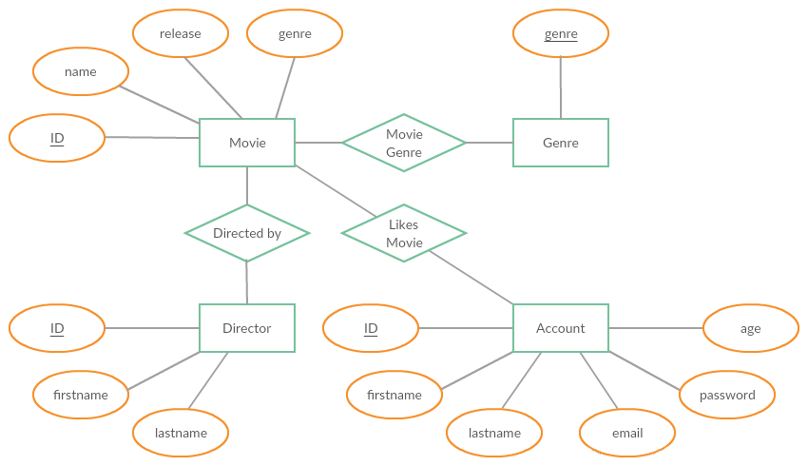

*Figure 1. ER-diagram of our database system.*

Our database system will look like the ER-diagram above. We will use four enities, which are Movie, Director, Genre and Account. The entities Movie, Director and Genre have a very obvious relationship with each other. Accounts can like movies and add them to their watchlist. That is the way the entities Movie and Account are connected.

Every entity has its own attributes, which are as followed: Movie has the attributes ‘ID’, ‘name’, ‘release date’ and ‘genre’, where ‘ID’ is the primary key. Director has the attributes ‘ID’, ‘firstname’ and ‘lastname’, where ‘ID’ is the primary key. Genre has the attribute and primary key ‘genre’. The entity Account has the attributes ‘ID’, ‘firstname’, ‘lastname’, ‘email’, ‘password’ and ‘age’, where ‘ID’ is the primary key.

**4.**

We think there will be at least two .php files. We will need one for the registration of accounts, and for logging into these accounts. This would also mean that we have to keep a session going while somebody is logged in, but we’re not sure whether that’s in the same file or in a different file. We will also need .php file to connect our tables in the database to the main website. We need this, to be able to search for movies and/or directors. Of course this is also needed to put the user information into a table. These are the main things we need to do using .php files. For the HTML part it will be quite straightforward. We will build a nice looking website which should be easy to use and should also be satisfying to use.

**5.**

We will split up the project in 3 parts. The database and MySql, the programming (php) and the html/CSS. The division of tasks will be as follows:

* Database design and MySql - Luuk
* Programming(php) - Kamil
* Interface, HTML/CSS - Leon

We think this would work out well, but some parts will be done together. For example the connection between the .php files and the database.