Proposal
In the module OCI_Transaction_Manager.c. when a transaction is started, the transaction name should be taken from the requestor where transaction required=yes. This Transaction_Name value could be anything, it is the business who fill this field. It could be for example Save Booking, make payment etc. This value should be applied to all operations in the request and should be displayed in the metrics output file metrics_Data_Manager.csv just like the unit test unit_test_tx

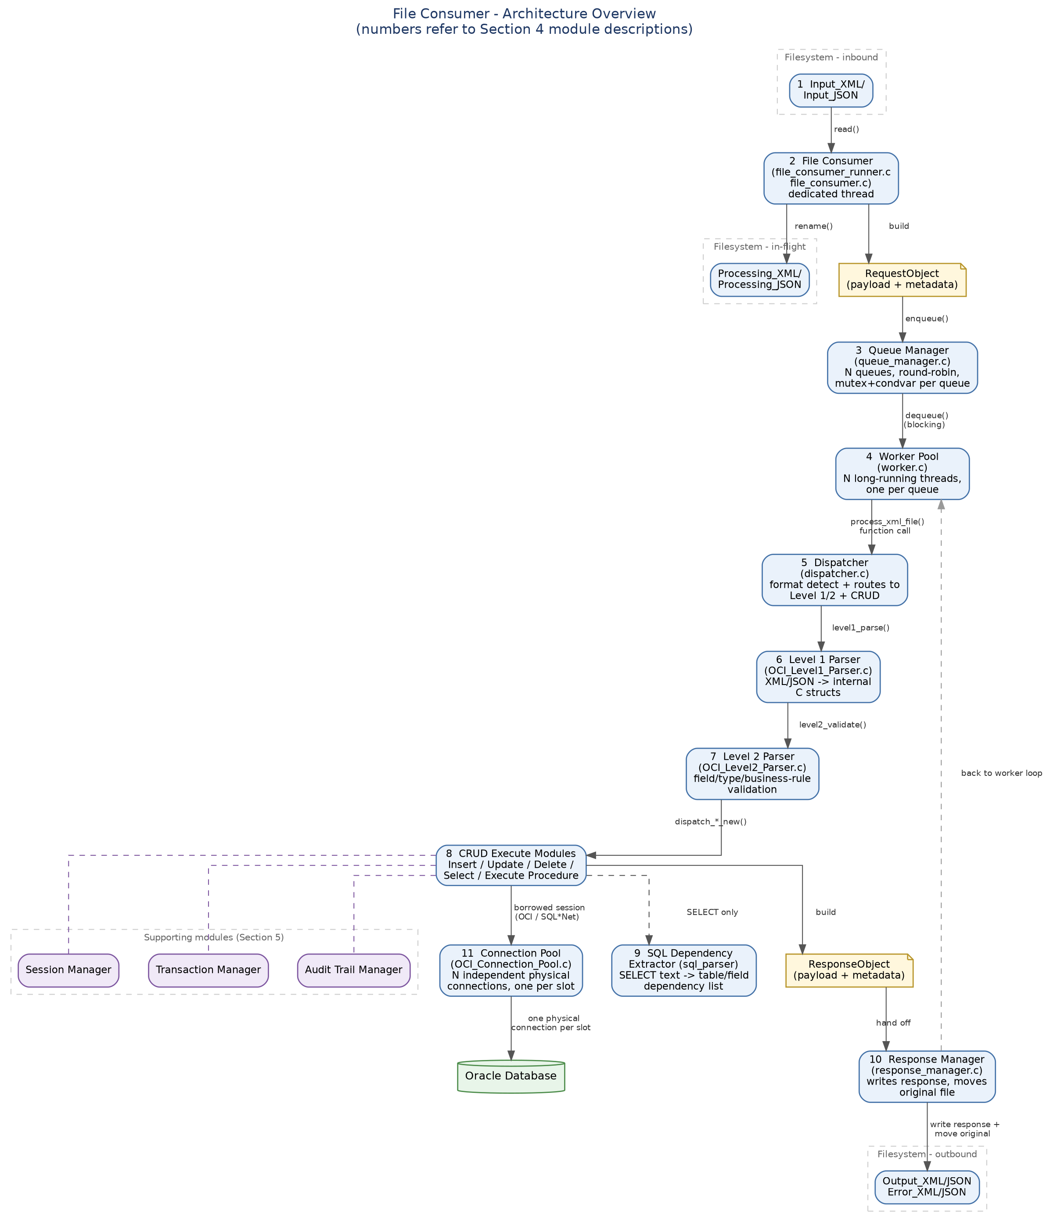

I propose the following adjusments in the below order.
1: Add the transaction names to the sample input and json files , uploaded to file consumer project. Please place random names in the xml and json scripts so we can confirm working.

2: Apply fix in the upper layers to consume the Transaction_Name

3: Carry Transaction Name through workflow. If you look at how Transaction_id is processed this is exactly the same.
4: Ensure the Tranaction_Name is printed in the relevant field in the csv metrics and in the database. Both the file writer and the database writer are reading the same metrics.

NB: You should not have to touch any of the CRUD modules for this as the value once set right at the upper layers should flow throug.

Please let me have you thoughts.

