Proposal
In the module metrics_writer.c, everythin works perfect. There is only 1 issue left to complete and that is as follows

The database writes go to the currently connected database. This is defined in config.ini in the following settings

dbname = localhost:1521/freepdb1
username = Data_Manager
# password removed - Oracle Wallet used instead (use_wallet = 1)
password = xxxxxxxxxxxxxxxxxxxxxxxxxxxxxxxxxxxxxxxxxxxxxxxxx Using wallet config xxxxxxxxxxxxxxxxxxxxxxxxxxxxxxxxxxxxxxxxxxxxxxxxxxxxxx
use_wallet = 1
wallet_location = /opt/oracle/wallets/OCI_Test

Now everuything is perfectly working to the current table in this database. The only issue is, in production the metrics will unlikely be stored in the production database and will likely be re-pointed to a collection database.
My proposal is to have a second database dedicated for metrics. For testing it will point at the same database, but can be changed in config.ini. So in order to get this working we need config.ini to contain the following
metrics_dbname = localhost:1521/freepdb1
metrics_username = Data_Manager
# password removed - Oracle Wallet used instead (use_wallet = 1)
metrics_password = xxxxxxxxxxxxxxxxxxxxxxxxxxxxxxxxxxxxxxxxxxxxxxxxx Using wallet config xxxxxxxxxxxxxxxxxxxxxxxxxxxxxxxxxxxxxxxxxxxxxxxxxxxxxx
metrics_use_wallet = 1
metrics_wallet_location = /opt/oracle/wallets/OCI_Test
The metrics module should inherit a connection to the metrics database, rather than the business database

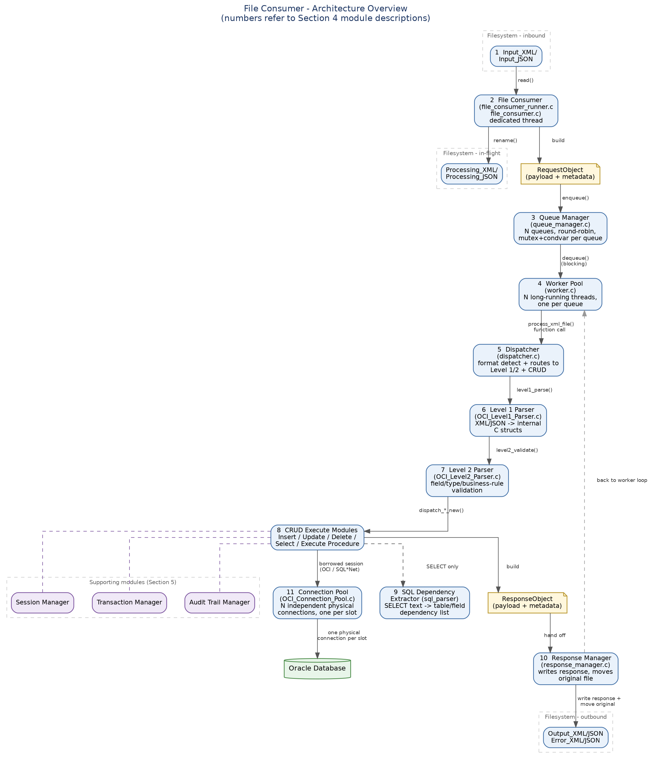

I have uploaded all source into Data Manager project. Please let me have you thoughts.

