Data Manager

Session Manager seperate thread proposal- Design Specification
Version 1.0
2026-08-08

Purpose and Scope
This document defines the remaing items left so the successful multi threaded consumer module and its components can be finished so the upcoming http module can get the features for free without having to re engineer them as they will be practicly identical.
Anything not described in this document is out of scope.
This document is written to stand on its own - a developer picking this up with no other context should be able toth start implementation directly from it.

Interested parties
1. Developers - running the suite locally during development, adding new tests as new functionality is built.
2. The request consumer (currently Test_XML_Runner.c's main(); in future, an HTTP consumer and/or an MQ consumer using the same dispatchers) - running the startup self-test automatically, and exposing on-demand testing via OP_UNIT_TEST for any consumer, including a future web-based one.

Proposal
The current consumber design is below as defined in section 3 in File_Consumer_Design_Specification.docx.
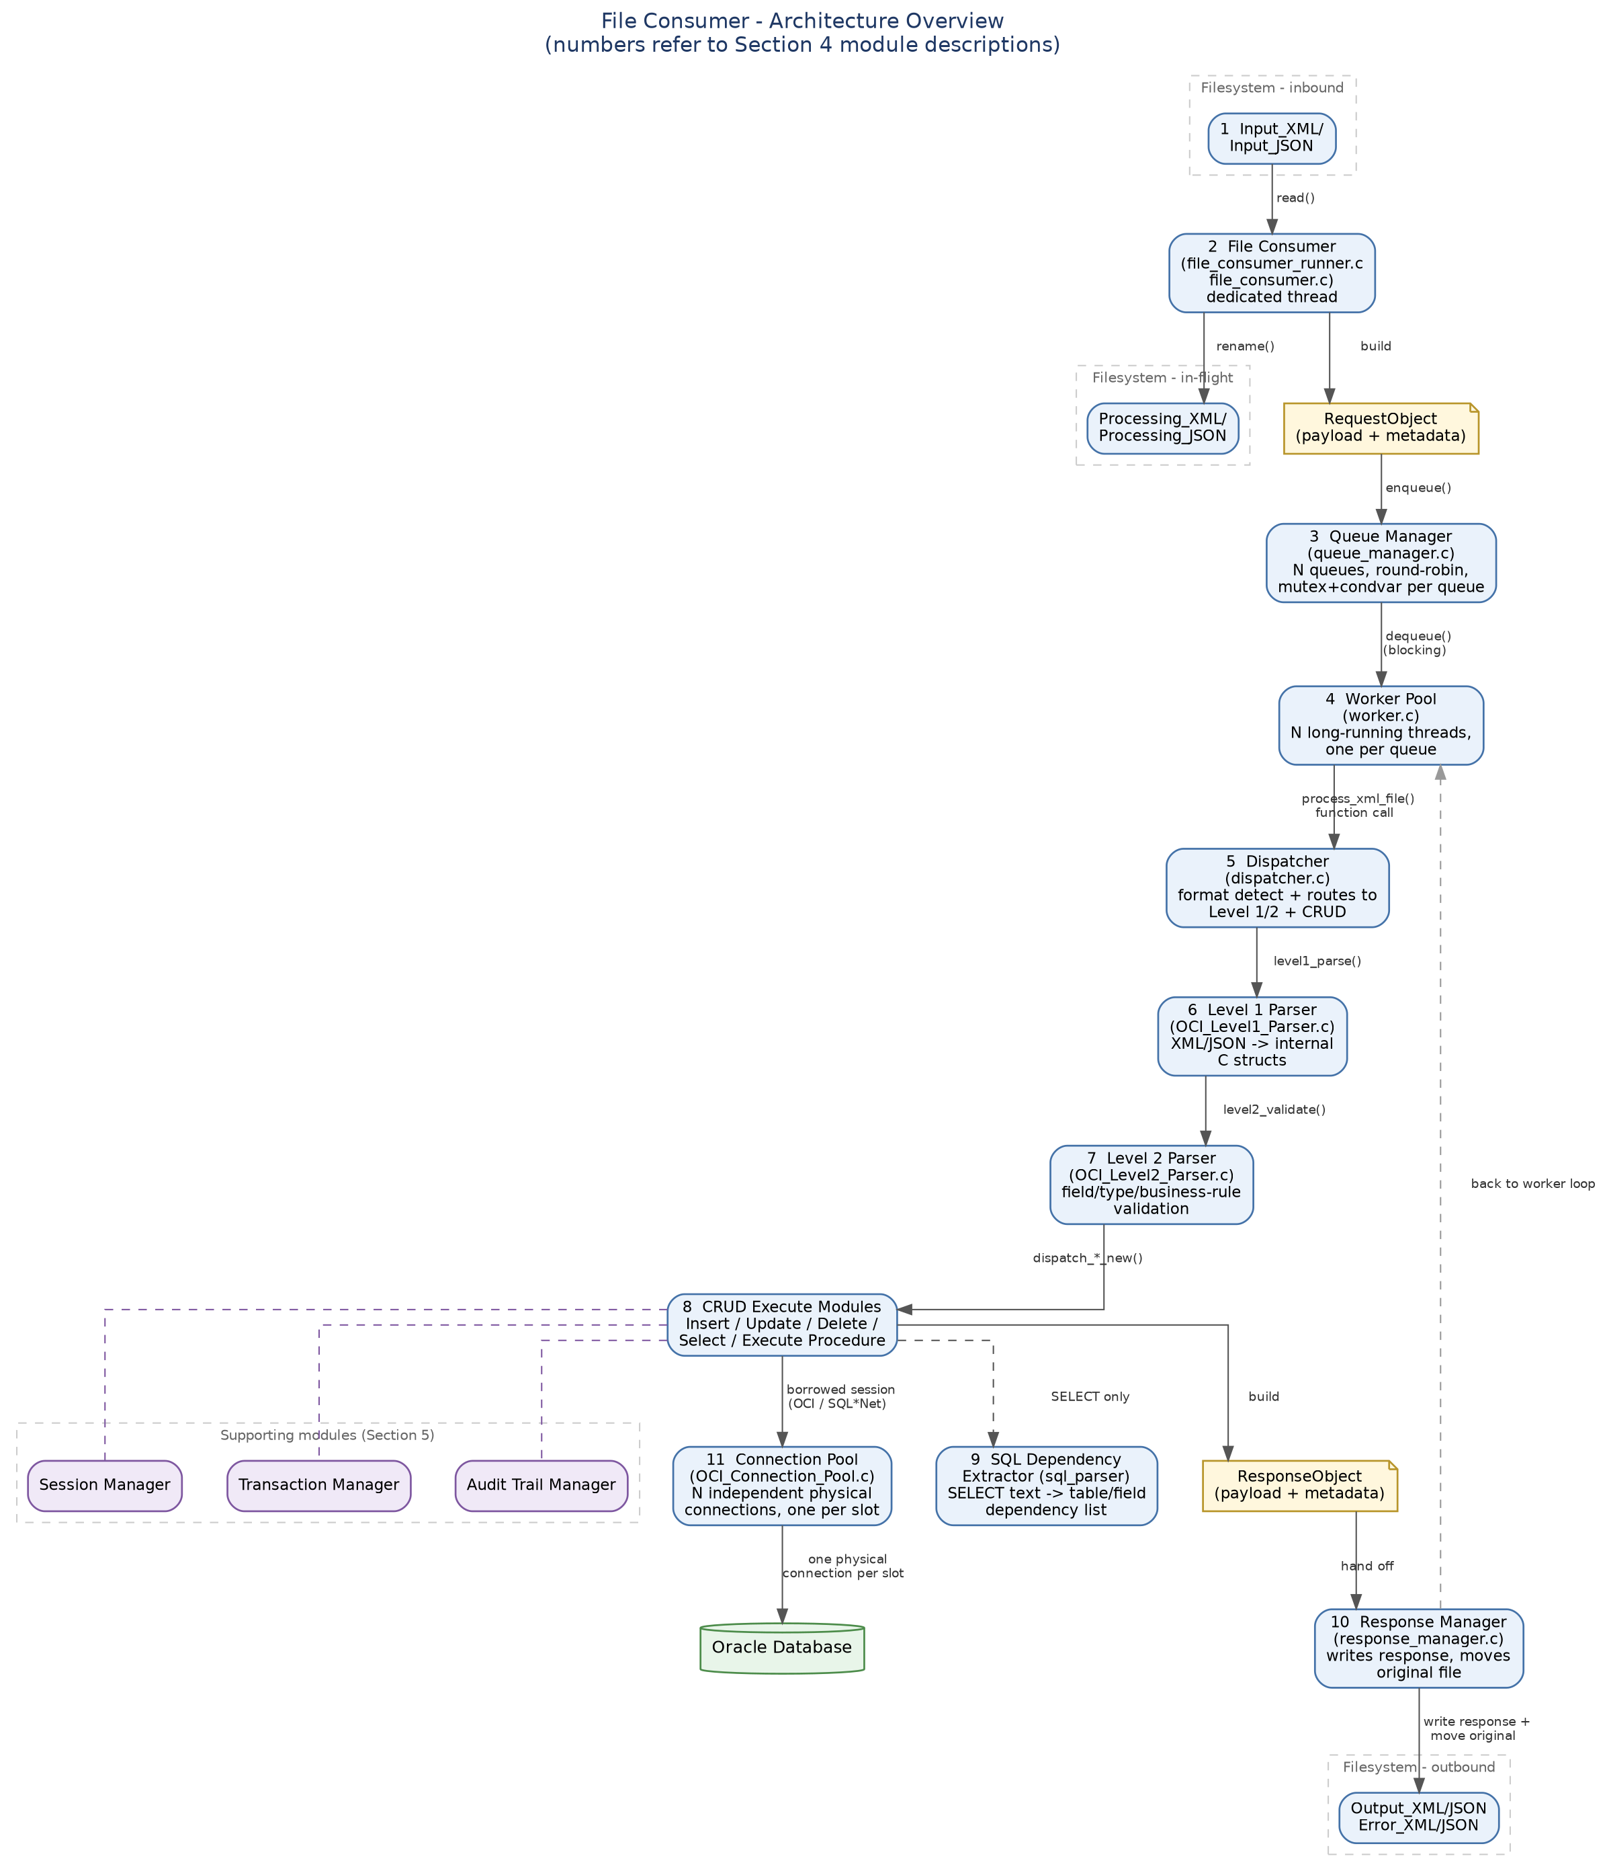

I propose the following adjusments in the below order.
1: Since we learnt and touched so many areas in the last week for mult-threading implementation and congestion I think it is the best time while the history if fresh to add all the event, troubleshooting methods, lessons learned, knowen errors and resolutions as well as contenton management process, especially in relation to the write worker and the general configuration concerning load tuning. I have made some changes to Oracle_Contention_Troubleshooting_Guide.docx but it needs to be fully revised.

2: A full revision of File_Consumer_Design_Specification.docx is now needed as this beast is in its final state almost.

3: Date Handling.
I noticed in the logs the below errors, they all look clearly correctly validated, which is good. However when working through contention issues last week I noticed hard coding in the Test_XML_Runner.c. This lead me to follow up a grep across all modules and I got the below grep results. The thing is that this value should only ever appear once in config.ins nls_date_format and that value replace everywhere required.
Results 1: Extract of grep with hard coding search,
leyden100@Terry-HP-Laptop-15-fd0xxx:~/eclipse-workspace/OCI_Wrapper/src$ grep -in "YYYY-MM-DD HH24:MI:SS" *.c
ini_reader.c:367: { "nls_date_format", CFG_STRING, offsetof(app_config_t, nls_date_format), "YYYY-MM-DD HH24:MI:SS", 0 },
OCI_Connection_Pool.c:522: COPY_NLS(pool->nls_date_format, ini->nls_date_format, "YYYY-MM-DD HH24:MI:SS");
OCI_Session_Manager.c:74:/* Internal: format a time_t as "YYYY-MM-DD HH24:MI:SS" - the base */
OCI_Table_Metadata_Module.c:897: * TO_CHAR(...,'YYYY-MM-DD HH24:MI:SS') for consistent formatting.
OCI_Table_Metadata_Module.c:909: " TO_CHAR(CREATED,'YYYY-MM-DD HH24:MI:SS'),"
OCI_Table_Metadata_Module.c:910: " TO_CHAR(LAST_DDL_TIME,'YYYY-MM-DD HH24:MI:SS'),"
OCI_Table_Metadata_Module.c:1582: " TO_CHAR(LAST_ANALYZED,'YYYY-MM-DD HH24:MI:SS'),"
OCI_Unit_Test_Module.c:1856: * shape (assumed 'YYYY-MM-DD HH24:MI:SS') - must be rejected. */
Test_XML_Runner.c:1139: ctx.NLS_DATE_FORMAT = "YYYY-MM-DD HH24:MI:SS";
leyden100@Terry-HP-Laptop-15-fd0xxx:~/eclipse-workspace/OCI_Wrapper/src$

Results: extract from error log
leyden100@Terry-HP-Laptop-15-fd0xxx:~/eclipse-workspace/OCI_Wrapper/logs$ grep "ORA-01861" *.log
error_Data_Manager.log:2026-08-08 17:20:05.497651 [ERROR] [T0] [normalize_client_date_value] Invalid date: value='19/08/2026' does not match nls_date_format='YYYY-MM-DD HH24:MI:SS' (ORA-01861: ORA-01861: literal does not match format string
error_Data_Manager.log:2026-08-08 17:20:05.497729 [ERROR] [T0] [level2_validate_update] Level 2: UPDATE validation failed - 1 failure(s), first: WHERE key 'DATE_COL': Invalid date: value='19/08/2026' does not match nls_date_format='YYYY-MM-DD HH24:MI:SS' (ORA-01861: ORA-01861: literal does not match format string
update_Data_Manager.log:2026-08-08 17:20:05.497651 [ERROR] [T0] [normalize_client_date_value] Invalid date: value='19/08/2026' does not match nls_date_format='YYYY-MM-DD HH24:MI:SS' (ORA-01861: ORA-01861: literal does not match format string
update_Data_Manager.log:2026-08-08 17:20:05.497729 [ERROR] [T0] [level2_validate_update] Level 2: UPDATE validation failed - 1 failure(s), first: WHERE key 'DATE_COL': Invalid date: value='19/08/2026' does not match nls_date_format='YYYY-MM-DD HH24:MI:SS' (ORA-01861: ORA-01861: literal does not match format string
leyden100@Terry-HP-Laptop-15-fd0xxx:~/eclipse-workspace/OCI_Wrapper/logs$

4: The select module.
An adjustment is required in the record count guard as follows

A. This needs to be refactored into two individual warnings rather than the ambiguos error currently in place.
B: The first check is for no rows found. If that is the case we need to report a warning “No Data” and goto cleanup.
C: If the row count exceeds the max_records, we should modify the query to return only the top max_records and log a warning.

This will give control over the max data size but will also allow users to continue to select what they are allowed without getting the ambiguos message and would probably log a help desk ticket. The user can then tune there query to be meet requirements allowed by max_record limit. Everyone is then happy.

5: Metrics.
I was thinking about metrics and thought it would be a good idea to perform a slight refactor and let me explain why.
1: Each crude module records metrics correctly and this all stays the same, no change.
2: One addition metic to be added, that is Thread number and this refers to the worker number, I.e [T0], [T1] etc. This could go beside the process id column. This will be really useful for debugging
3:In the finalize_metrics we could just add the metrics to a queue and then forget move on. This means every crude module is released from the final bottleneck.
4: A new module Metrics_writer consumes the queue data is posted on. Metics write has some workers, 1 for file writing and the second for database writing. The metric is moved to the correct queue. The workers then consume relevant queue and write the stats. The is one important thing about these metrics, they are not on critical path. I once saw a website where the database inserts in a logging module brought down the whole crm website because the partitioned table is was inserting into has some indexing issues and this blocked everything. The important point is database metrics logging and file metrics logging should have a switch in config.ini to power on or off.

5: What is really rich about logging directly to an oracle table is this is available immediately to the http website to instantly display how the system is performing. This will be one of the first pages I put on the front end site.

6: After completing 1-5, we need to do a re-check of unit testing and see what additions or amendments we need in to the new multithreaded world.

