Oracle Contention & Connection Troubleshooting Guide
Data Manager / File Consumer — companion to File_Consumer_proposal_03_Aug.docx
Compiled 2026-08-06, from a live investigation of a genuine cross-session lock hang hit during Stage 5 concurrency testing. Every command and query in this guide was actually run during that investigation, not written speculatively.

1. When to use this guide
Use this when a File Consumer run stops making progress and stays stopped: worker_Data_Manager.log stops advancing, no new PASS/FAIL lines appear, and the process does not exit on its own after a reasonable wait. This guide walks through confirming it's genuinely stuck (not just slow), finding out exactly where each thread is stuck, checking the database for the real cause, and fixing it.
Before you start
If you're about to kill a hung process, it's worth reading Section 4 first — killing it without checking for what it leaves behind on the database side is exactly how today's investigation got a second, unrelated red herring partway through.

2. Step 1 — Confirm it's genuinely stuck, not just slow
A few operations (large SELECTs, CLOB/BLOB handling, procedure calls with big result sets) can legitimately take a while. Before treating this as a hang, check two things:
- Is worker_Data_Manager.log still advancing at all, even slowly? Compare its last-modified time against the current time.
- Is CPU usage near-zero on the process, or is one core pegged at 100%? Use top or htop. Near-zero CPU with no log progress means every relevant thread is blocked waiting on something (a lock, a network read) — this is what Sections 3–5 are for. 100% CPU on one thread with no log progress means a tight loop, not a wait — that's a code bug, not an Oracle-side issue, and gdb (Section 3) will show you exactly which function is spinning.

3. Step 2 — Get a live thread backtrace (gdb)
This is the single most useful diagnostic step. It shows exactly which function every thread is parked inside at the moment of the hang — turning guesswork into a direct answer.

3.1 Find the real process ID
Don't assume the binary is named after the source file — check what your build actually produces:
find ~/eclipse-workspace/OCI_Wrapper -maxdepth 2 -type f -executable
Then find its PID (ignore the grep line matching itself):
ps -eLf | grep OCI_Wrapper
The first column repeated across multiple rows is the process ID (PID); the third column on each row is that thread's own LWP (lightweight process / OS thread) ID. Use the PID (not an LWP) to attach.

3.2 Attach and dump every thread's stack
sudo gdb -p <pid>
(gdb) thread apply all bt
sudo is often required — gdb needs ptrace permission on the target process.

3.3 How to read the output
- Multiple threads blocked inside pthread_mutex_lock / futex_wait on the exact same address, in otherwise unrelated functions — that's a client-side lock (inside the Oracle Client library itself, or your own code). Look for which thread does NOT show that pattern; it's very likely the one holding the lock.
- A thread inside a real blocking network read (frame names like nsprecv, nttrd, or similar deep in libclntsh.so, calling down into read()/recv()) is waiting for the database server to respond — a genuine round-trip wait, not a client-side deadlock.
- A thread inside pthread_cond_timedwait / pthread_join in your own application code (worker.c, file_consumer_runner.c, Test_XML_Runner.c) is working exactly as designed — it's a thread correctly waiting for other threads to finish, not evidence of a problem on its own.
Real example from 2026-08-06
Four threads were all blocked on the same mutex address inside libclntsh.so (kpuexec, kpufch, kpustmtrelease — all different OCI calls, same lock). A fifth thread was doing a genuine blocking network read inside OCIStmtExecute() for an UPDATE. That fifth thread was almost certainly holding the shared lock while it waited on the server — and the server, in turn, was blocked on a row lock held by a separate, unrelated session (see Section 4).

3.4 Detach without killing the process
If you want to keep investigating rather than kill it:
(gdb) detach
(gdb) quit

4. Step 3 — Check Oracle for blocking sessions
A hang with no client-side deadlock pattern in gdb, especially one thread doing a genuine network wait inside an INSERT/UPDATE/DELETE, usually means another Oracle session is holding a row lock this one needs.

4.1 Find blocking sessions
SELECT s.sid, s.serial#, s.username, s.status, s.last_call_et, s.program
FROM v$session s
JOIN v$lock l ON s.sid = l.sid
WHERE l.block = 1;
last_call_et is seconds since the session's last call — a large number on an INACTIVE session is a strong sign it's an orphan from an earlier run rather than something currently doing real work.

4.2 Find the SQL the blocking session is running (or last ran)
The query above tells you which session is blocking, but not what it's actually doing. This joins in the actual SQL text:
SELECT s.sid, s.serial#, s.username, s.status, s.last_call_et,
sq.sql_text
FROM v$session s
JOIN v$lock l ON s.sid = l.sid
LEFT JOIN v$sql sq ON s.sql_id = sq.sql_id
WHERE l.block = 1;
This will often point straight at the problem — e.g. confirming two fixtures are genuinely updating the same row, rather than having to infer it from filenames and timestamps.

4.3 Kill a blocking session — correct syntax
Common mix-up
ALTER SESSION only affects your own current session. To terminate a different session you need ALTER SYSTEM (requires the ALTER SYSTEM privilege).
ALTER SYSTEM KILL SESSION '<sid>,<serial#>' IMMEDIATE;
sid and serial# come straight from the sid and serial# columns of the query in 4.1 — no separate lookup needed. IMMEDIATE tells Oracle to clean up right away rather than waiting for the session's next call.

4.4 Get the PID/serial# the other way around (from an OS process ID)
If you instead have an OS-level PID (e.g. from ps, not from a v$session query) and want to find its Oracle session:
SELECT sid, serial# FROM v$session WHERE paddr = (
SELECT paddr FROM v$process WHERE spid = '<os_pid>'
);

5. Step 4 — Check for stale sessions left by previously killed runs
If you've killed a hung Test_XML_Runner process during debugging, its Oracle session doesn't always get cleaned up immediately — a killed client isn't the same as a client that cleanly disconnected. The next run can inherit locks from a session that, from the OS's point of view, no longer exists.
- Run the same query as 4.1 before starting a new run, not just after a new one hangs.
- A long last_call_et on an INACTIVE DATA_MANAGER session, with a program column showing OCI_Wrapper, is the signature of exactly this — kill it (4.3) before assuming the current code is at fault.
What this looked like in practice
During the 2026-08-05/06 investigation, two separate hangs on two separate runs turned out to be two different stale sessions left behind by two different earlier kills (SID 28 and SID 48) — not the same bug recurring, and not a defect in the concurrency implementation at all.

6. Step 5 — Database-level tracing (last resort)
Two genuinely different tools solve two different classes of problem here. Reach for the wrong one and you'll get a trace full of irrelevant detail.

6.1 SQL*Net / TNS-level tracing — for connection and network problems
Use this for symptoms like ORA-12609 (TNS receive timeout), connection refusals, or anything that looks like a networking/listener issue rather than a SQL problem. This traces the wire protocol between client and server, not the SQL itself.
Add to sqlnet.ora on the client (the machine running OCI_Wrapper), typically found via $TNS_ADMIN or alongside tnsnames.ora:
TRACE_LEVEL_CLIENT = 16
TRACE_DIRECTORY_CLIENT = /home/leyden100/oracle_trace
TRACE_FILE_CLIENT = ocic_trace
TRACE_UNIQUE_CLIENT = ON
TRACE_LEVEL_CLIENT: 4=user, 10=admin, 16=support (most detailed, largest files). Turn this off again once done — level 16 tracing is verbose and will grow quickly under real load.

6.2 SQL-level tracing — for identifying what a session is executing or waiting on
Use this for exactly the SID 28 / SID 48 class of problem: understanding what a specific session actually did, and what it's waiting on right now. This is DBMS_MONITOR (session-level) or the underlying 10046 event, not sqlnet.ora.
To trace a specific already-connected session, using the sid/serial# from Section 4.1:
EXEC DBMS_MONITOR.SESSION_TRACE_ENABLE(
session_id => <sid>, serial_num => <serial#>,
waits => TRUE, binds => FALSE);

-- ... reproduce the issue ...

EXEC DBMS_MONITOR.SESSION_TRACE_DISABLE(
session_id => <sid>, serial_num => <serial#>);
waits => TRUE is the important part for contention troubleshooting — it records exactly what the session was waiting on (e.g. "enq: TX - row lock contention") and for how long. The resulting trace file appears in the database server's own trace directory (query the DIAGNOSTIC_DEST parameter or user_dump_dest, depending on version, to find it) and is best read with tkprof rather than raw.
If you can't identify the session in advance, DBMS_MONITOR also supports enabling tracing for the next session matching a given service/module/action name — worth asking a DBA about if this comes up often enough to be worth the setup.

7. Known root causes hit so far (running log)
Keeping a record of what's actually caused a hang or apparent failure in this project, so the same investigation doesn't get repeated from scratch next time.

7.1 metrics.c unguarded header-check + row write (fixed)
metrics_write() had an unprotected ftell()-then-fprintf() sequence — two threads could both see an empty file and both write the CSV header, or interleave a header write with a row write. Fixed with a single mutex guarding the whole write as one critical section, matching logger.c's existing log_mutex pattern.

7.2 CLOB chunked-read loop silently treating a failed read as success (fixed)
handle_clob_column_batch()'s OCILobRead() failure was only logged (via CHECK_OCI, which never affects control flow), never actually detected — a failed read left 'amount' at its pre-call value rather than 0, so the loop advanced past the failure as if it had succeeded, producing corrupted/zero-filled CLOB content with no error ever surfacing. Fixed by capturing the real return code and breaking out on failure.

7.3 query_execution_timeout and network_read_write_timeout were dead configuration (fixed)
Both settings were read from config.ini, stored, and even printed in the pool startup summary — but never actually applied to any OCI call. Changing either had zero effect on a genuine hang. Fixed by wiring network_read_write_timeout into real OCI_ATTR_RECEIVE_TIMEOUT / OCI_ATTR_SEND_TIMEOUT attributes on the shared server handle (OCI_Connection_Pool.c, right after OCIServerAttach — this handle is shared by every pooled session, so setting it once there covers all of them). Requires Oracle Client 18c or later; this project is on 23.26.

7.4 Stale locks from previously killed test processes
Not a code bug — see Section 5. Repeatedly killing a hung process during debugging, without checking for what it leaves behind on the database side, can make a completely clean run look like it's hitting the same hang again.

7.5 Cold-start TNS receive timeout after a machine reboot (ORA-12609)
The very first connection after a full machine restart can legitimately be slower than OCI_ATTR_RECEIVE_TIMEOUT allows, even though the database is genuinely up (confirmed via a separate tool like SQL Developer, which has its own, unrelated timeout defaults and is a much lighter operation than the metadata query that timed out). Resolved on its own on the next run once the instance and OS network stack had fully settled. Not a bug — but worth recognising the pattern rather than re-diagnosing it: first run after reboot, ORA-12609, works fine on retry.

8. Tracing and comparing application side with Oracle Trace
This section demonstrates the procedure for comparing application test runs with Oracle traces to determin root cause of failures. We will start by looking at the failue
ORA-03114. ORA-03114
not connected to ORACLE

Cause
The connection between the Client and Server process did not exist. This is likely the result of an earlier ORA-03113 error. The cause may be that the database instance experienced a maintenance or unplanned outage, or that the Server process had a fatal error, or that the network connection was interrupted.

Action
Check the alert log of the database instance to see if a planned or unplanned outage occurred. Check the alert log to see if a process termination (ORA-07445, kill, or ORA-00600) occurred. Check for network problems and review the SQL*Net setup. After the problem is identified and resolved, retry the operation.

Risk
With this error, the Oracle error is raised by the client when he tries to retieve information about the error that occurred. This does not mean that the request reached the server, or what happened. This needs clear troubleshooting.

The process of trouble shooting comes in 4 stages, they are as follows

1: Clean and prepare client for a clean test.
2: Enable Oracle tracing on the server
3:Run clientside test on fresh server.
4: Submit a second test to append to first test results.
5:Disbable server side tracing
6:Locate the trc files
7: Run tkprof on trace files to produce txt files
8: Copy txt files to local host

Stage 1: Clean and prepare client for a clean test.
In this stage we need to run the following steps in order
step1: Run repare_Rerun.sh to prepare comsumer input files

cd ~/eclipse-workspace/OCI_Wrapper/scripts
./Prepare_Rerun.sh

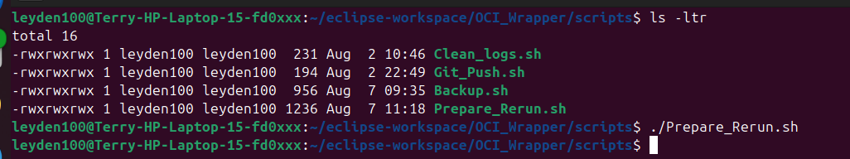
Step 2: Check consumer input files are correct by confirming below directories do or do not contain files as shown in examples.

The below folder should conatain test samples
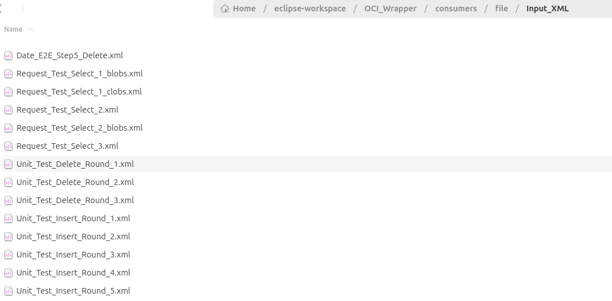
The below folder should conatain test samples
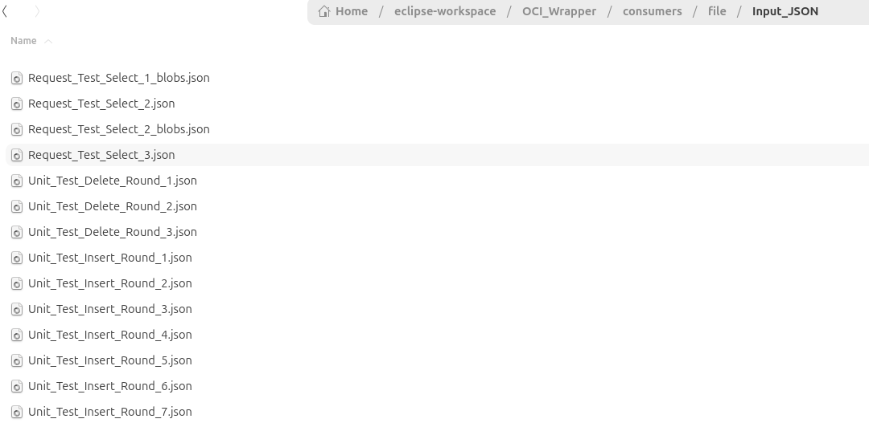
The folders starting with error, output or processing should all be blank with 0 files. The templates folder are only templates and are ok to contain data, however this is not processed and is not even considered.

Finally the logs folder below needs to be blanked to ensure no stale data is in the test run.
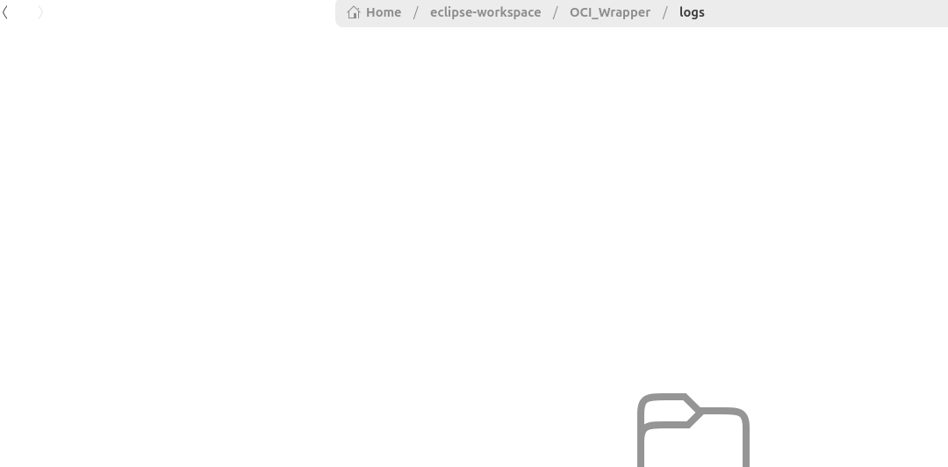
Step 3: Start OCI_Wrapper project so it opens connections with Oracle as shown from run menu in eclipse. The server will start and output will be in console window.

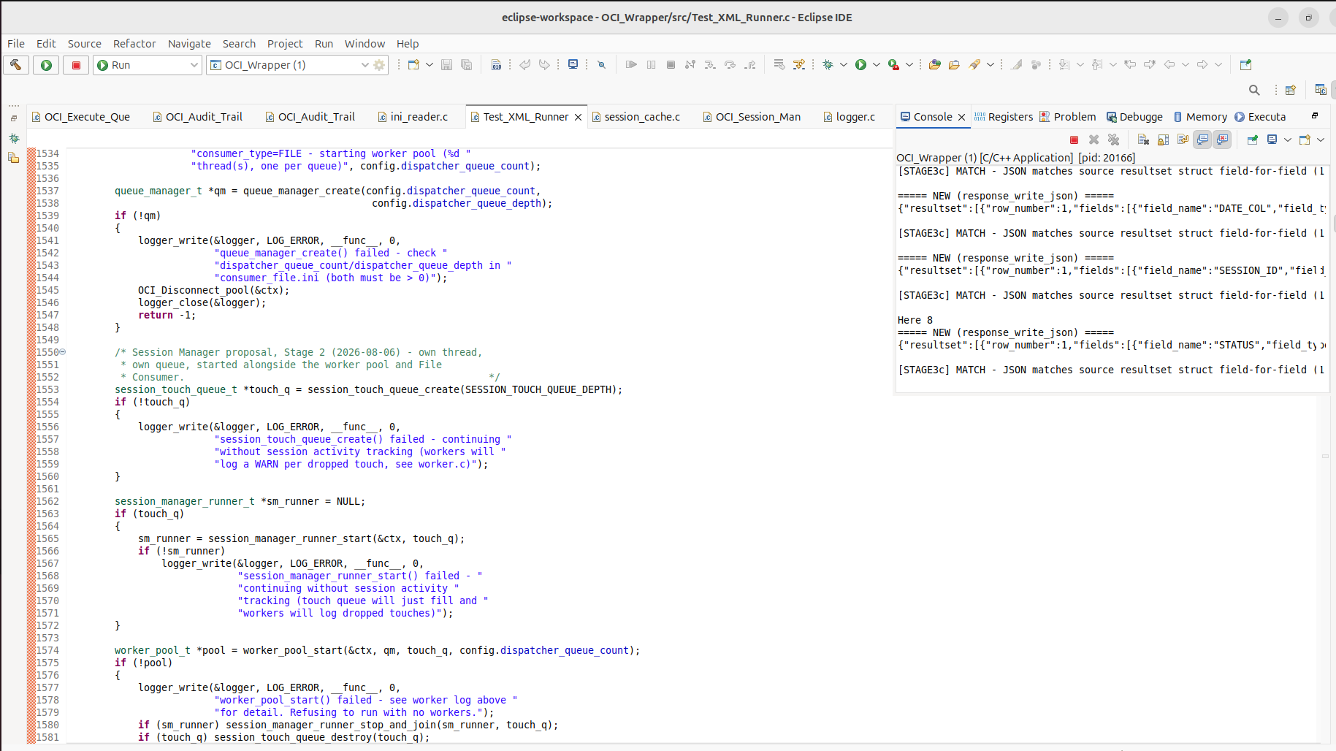

This completes stage 1.

Stage 2: Enable Oracle tracing on the server
Step 1 : Login to database with sqldeveloper. In this case the details it is OCI Test freepdb1 as shown in screenshot below

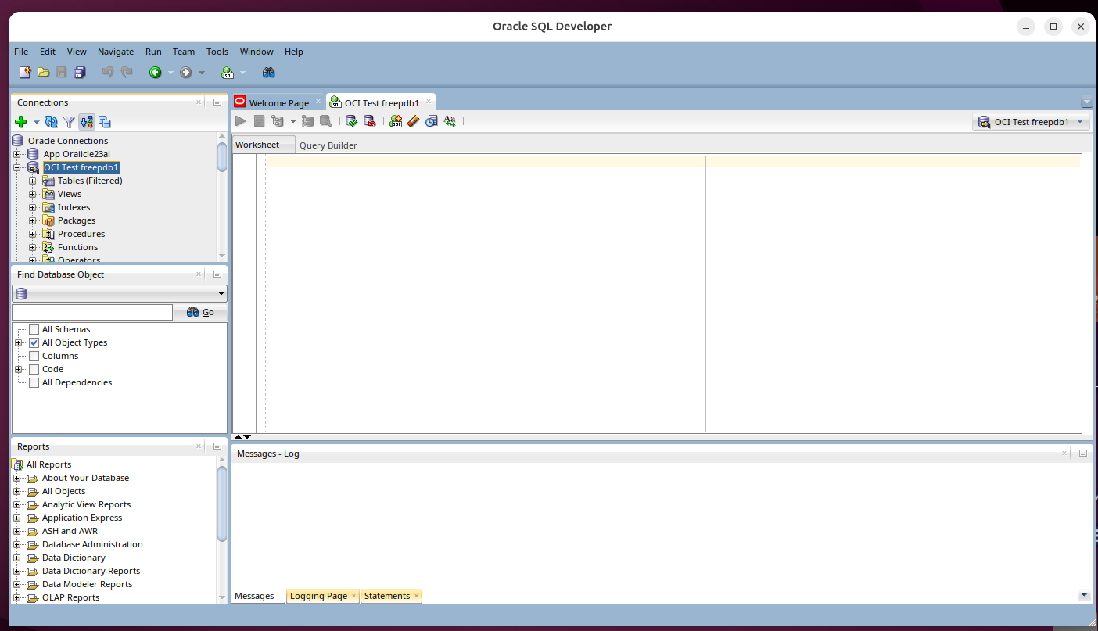
Step 2:Enable Oracle logging
-- Find your service name first
SELECT DISTINCT service_name, program
FROM v$session
WHERE program LIKE '%OCI_Wrapper%';

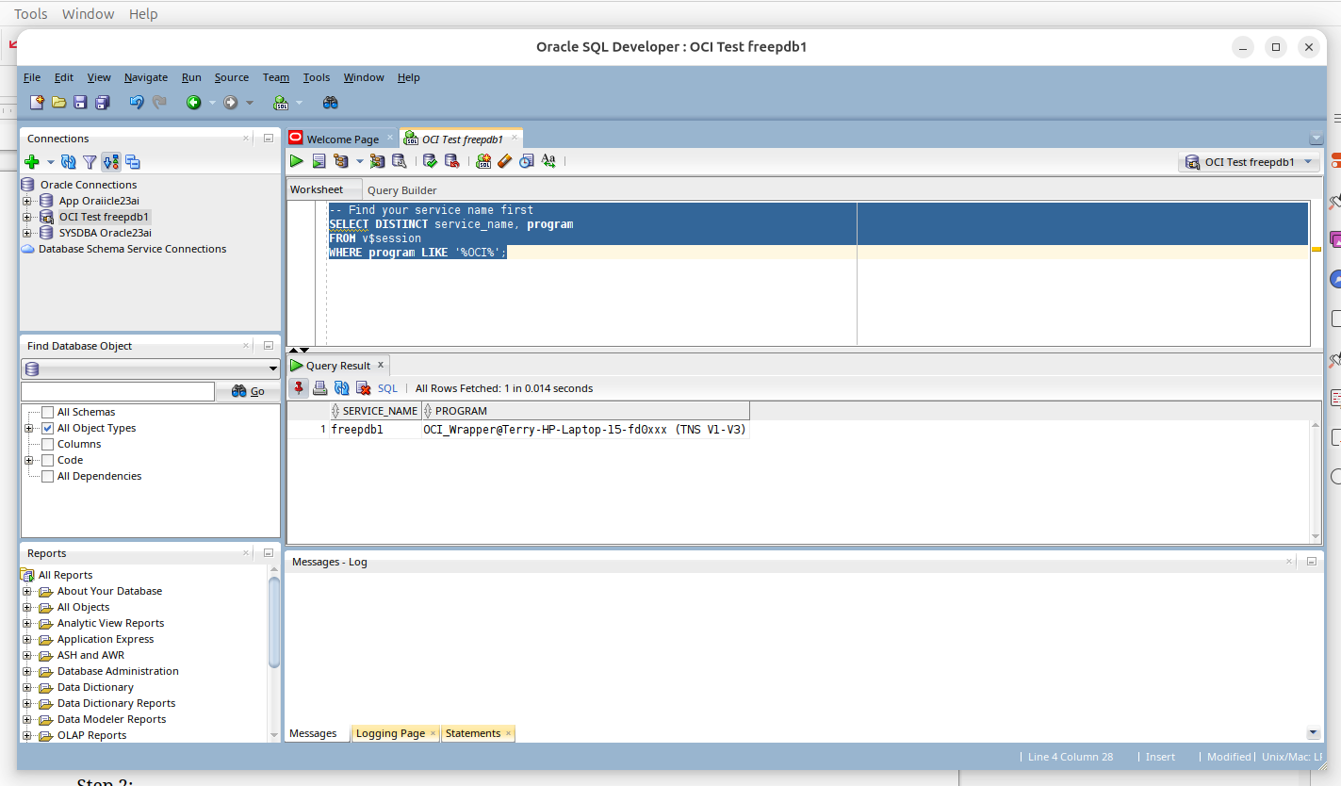
NB: The program must be running at this stage for the connection to show up it must be connected to the database. If it does not show up then you must go back to stage 1 and complete the last step.

Service_name = freepdb1 as shown in screenshot
Start Oracle logging

Step 3 Once service_name is known stop OCI_Wrapper project. Run stage 1 stage 1 again to prepare the run and delete existing logs. NB: the command nees to be all on 1 line.

ls -ld /opt/sqldeveloper
ls -lah /opt/sqldeveloper | head -30
find /opt/sqldeveloper -type f | wc -1
find /opt/sqldeveloper -type f | wc -l
ls -lah /opt/sqldeveloper/external | head
ls -lah /opt/sqldeveloper/ide/lib | head
ls -lah /opt/sqldeveloper/ide/extensions | head
ls -l /opt/sqldeveloper/external/*.jar

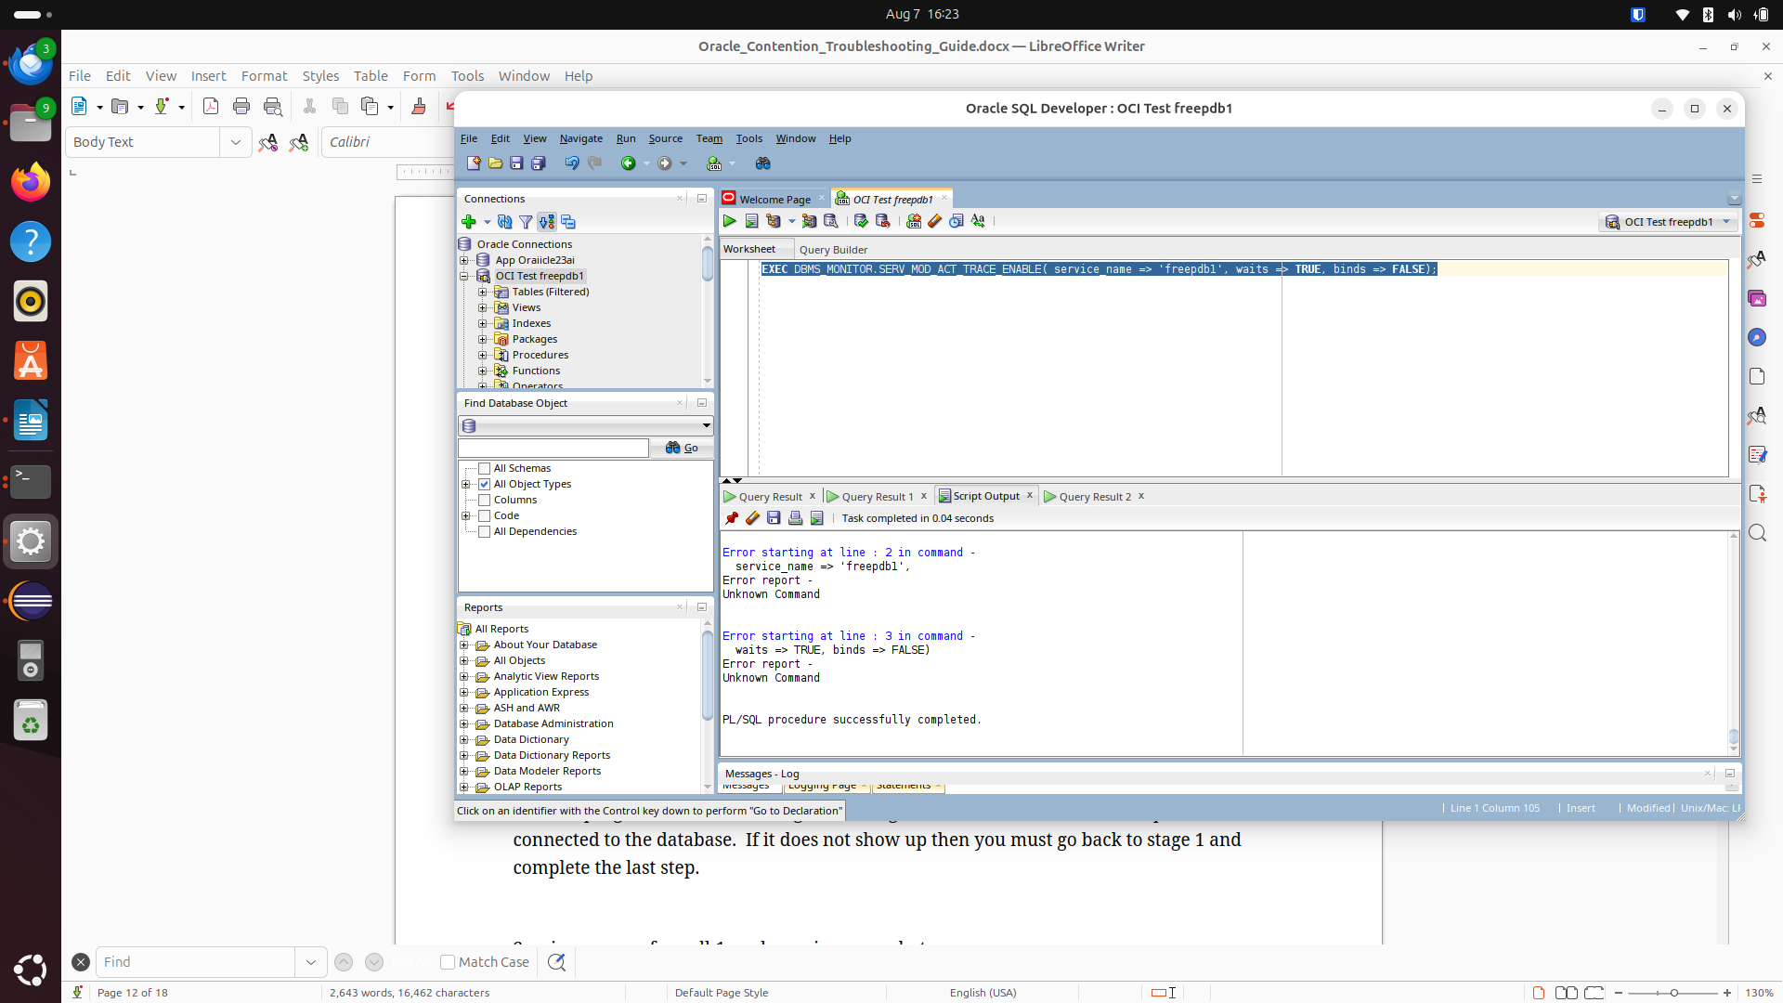

Step 3: Run a fresh test as shown by refreshing test data with Prepare_Rerun.sh

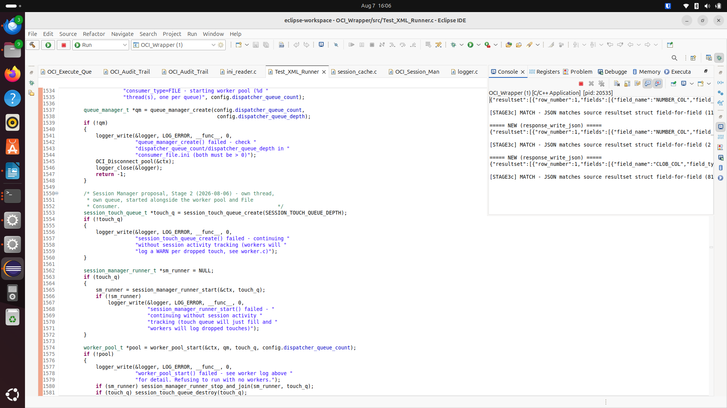

Get a count of failures in log as shown’

Prepare a fresh run as shown

Run or third run . There is no action needed here as the original run is still running and will pick up the new files immediately and process them.

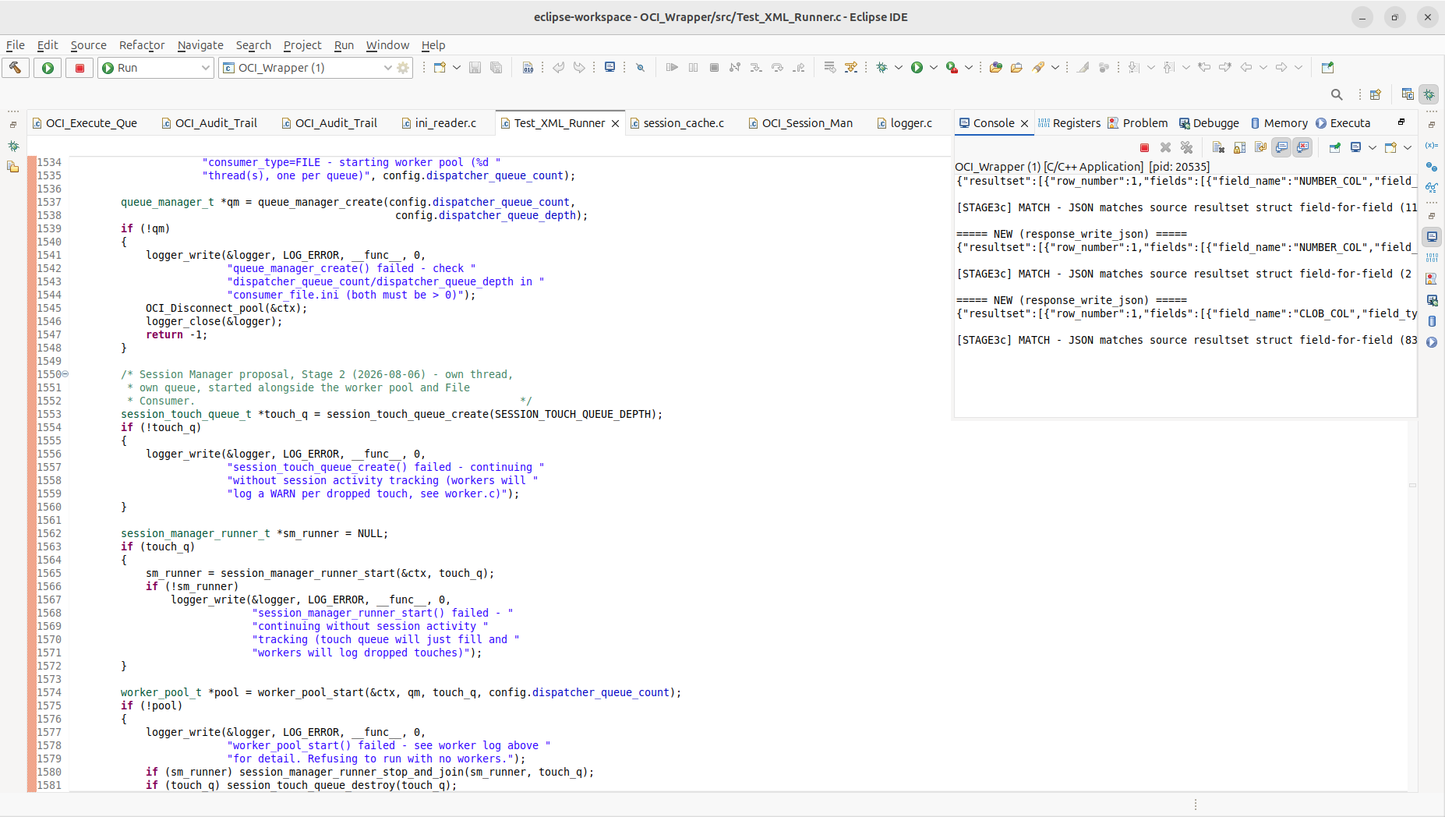
Get a fresh count of errors in log as shown

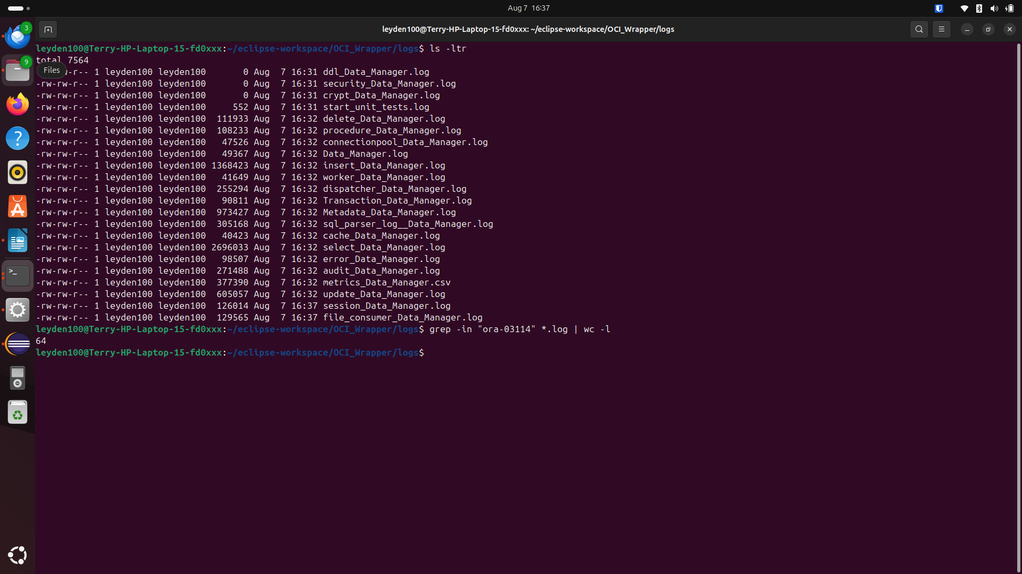

Now we see run 1 had 16 errors and run 2 had the original 16 plus it now has and additional 24 bringing the total to 40.

Finally stop OCI_Wrapper

Stage 5:Disbable server side tracing
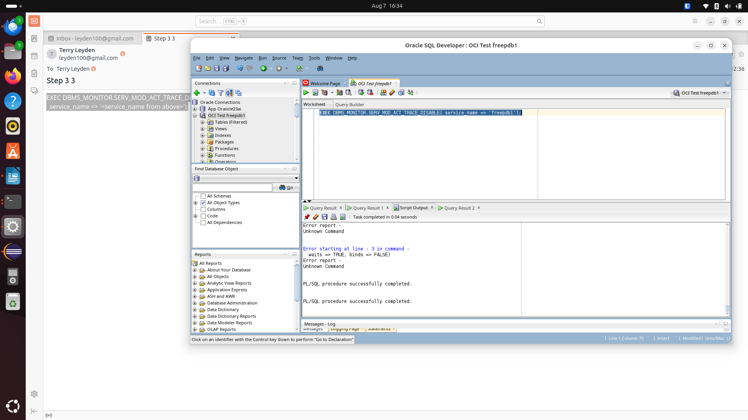

SELECT s.sid, s.serial#, s.username, s.status, s.last_call_et, s.program
FROM v$session s
JOIN v$lock l ON s.sid = l.sid
WHERE l.block = 1;

Run a stale query check using above. The below screenshot shows 0

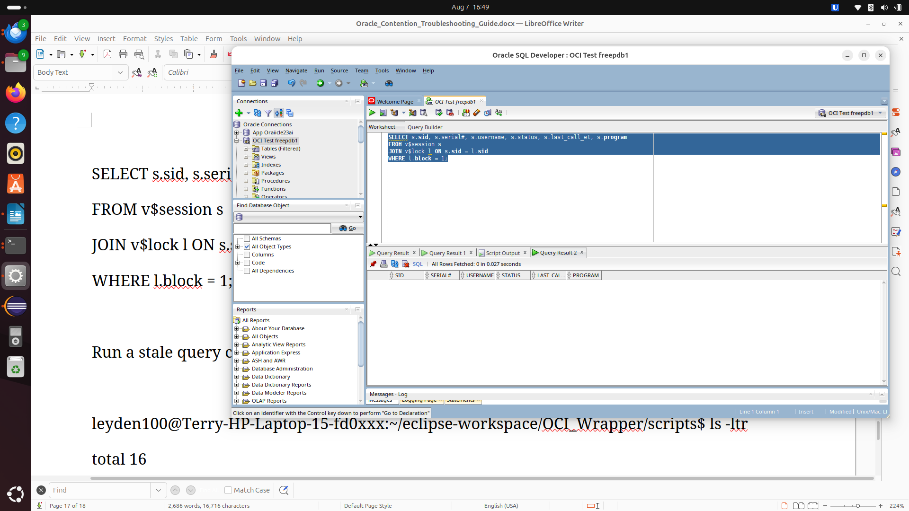

Get Trace files

Step 1: Get docker container

leyden100@Terry-HP-Laptop-15-fd0xxx:~/Desktop$ docker ps
CONTAINER ID IMAGE COMMAND CREATED STATUS PORTS NAMES
17604d0aa9d2 gvenzl/oracle-free:23-full "container-entrypoin…" 4 months ago Up 3 minutes 0.0.0.0:1521->1521/tcp, :::1521->1521/tcp, 0.0.0.0:5500->5500/tcp, :::5500->5500/tcp oracle23c
leyden100@Terry-HP-Laptop-15-fd0xxx:~/Desktop$

Connect to docker

docker exec -it 17604d0aa9d2 bash

9. Quick reference
# Find the process
find ~/eclipse-workspace/OCI_Wrapper -maxdepth 2 -type f -executable
ps -eLf | grep OCI_Wrapper

# Thread backtrace
sudo gdb -p <pid>
(gdb) thread apply all bt
(gdb) detach
(gdb) quit

# Find blocking sessions + their SQL
SELECT s.sid, s.serial#, s.username, s.status, s.last_call_et, sq.sql_text
FROM v$session s
JOIN v$lock l ON s.sid = l.sid
LEFT JOIN v$sql sq ON s.sql_id = sq.sql_id
WHERE l.block = 1;

# Kill a session (note: ALTER SYSTEM, not ALTER SESSION)
ALTER SYSTEM KILL SESSION '<sid>,<serial#>' IMMEDIATE;

