Oracle Contention & Connection Troubleshooting Guide
Data Manager - Consumer Layer
Version 2.0 - 2026-08-08 (supersedes v1.0, 2026-08-06)
Compiled from two live investigations: the original cross-session lock hang from Stage 5 concurrency testing (2026-08-06), and the follow-on ORA-03114 disconnect investigation that ran through the rest of that week (2026-08-06 to 2026-08-08), which traced the same underlying cause - row-lock contention between concurrent workers - all the way to a complete, verified fix. Every command, query, and screenshot in this guide was actually run during those investigations, not written speculatively.

1. When to use this guide
Use this when a File Consumer run stops making progress and stays stopped, or when it keeps completing but with occasional ORA-03114 ("not connected to ORACLE") errors in the logs. Both symptoms trace back to the same underlying cause covered in this guide: concurrent workers contending for the same database rows. Sections 2-6 cover the original hang-diagnosis procedure; Section 8 covers tracing a recurring, non-fatal ORA-03114 pattern to its root cause; Section 7 is the running log of everything actually found.
Before you start
If you're about to kill a hung process, it's worth reading Section 5 first - killing it without checking for what it leaves behind on the database side is exactly how the original investigation got a second, unrelated red herring partway through.

2. Step 1 - Confirm it's genuinely stuck, not just slow
A few operations (large SELECTs, CLOB/BLOB handling, procedure calls with big result sets) can legitimately take a while. Before treating this as a hang, check two things:
- Is worker_Data_Manager.log still advancing at all, even slowly? Compare its last-modified time against the current time.
- Is CPU usage near-zero on the process, or is one core pegged at 100%? Use top or htop. Near-zero CPU with no log progress means every relevant thread is blocked waiting on something (a lock, a network read) - this is what Sections 3-5 are for. 100% CPU on one thread with no log progress means a tight loop, not a wait - that's a code bug, not an Oracle-side issue, and gdb (Section 3) will show you exactly which function is spinning.

3. Step 2 - Get a live thread backtrace (gdb)
This is the single most useful diagnostic step for a genuine hang. It shows exactly which function every thread is parked inside at the moment of the hang - turning guesswork into a direct answer.

3.1 Find the real process ID
Don't assume the binary is named after the source file - check what your build actually produces:
find ~/eclipse-workspace/OCI_Wrapper -maxdepth 2 -type f -executable
Then find its PID (ignore the grep line matching itself):
ps -eLf | grep OCI_Wrapper
The first column repeated across multiple rows is the process ID (PID); the third column on each row is that thread's own LWP (lightweight process / OS thread) ID. Use the PID (not an LWP) to attach.

3.2 Attach and dump every thread's stack
sudo gdb -p <pid>
(gdb) thread apply all bt
sudo is often required - gdb needs ptrace permission on the target process.

3.3 How to read the output
- Multiple threads blocked inside pthread_mutex_lock / futex_wait on the exact same address, in otherwise unrelated functions - that's a client-side lock (inside the Oracle Client library itself, or your own code). Look for which thread does NOT show that pattern; it's very likely the one holding the lock.
- A thread inside a real blocking network read (frame names like nsprecv, nttrd, or similar deep in libclntsh.so, calling down into read()/recv()) is waiting for the database server to respond - a genuine round-trip wait, not a client-side deadlock.
- A thread inside pthread_cond_timedwait / pthread_join in your own application code (worker.c, file_consumer_runner.c, Test_XML_Runner.c) is working exactly as designed - it's a thread correctly waiting for other threads to finish, not evidence of a problem on its own.
Real example from 2026-08-06
Four threads were all blocked on the same mutex address inside libclntsh.so (kpuexec, kpufch, kpustmtrelease - all different OCI calls, same lock). A fifth thread was doing a genuine blocking network read inside OCIStmtExecute() for an UPDATE. That fifth thread was almost certainly holding the shared lock while it waited on the server - and the server, in turn, was blocked on a row lock held by a separate, unrelated session (see Section 4).
A hang isn't always what it looks like (2026-08-07)
A later gdb capture, taken during what looked like the same class of hang, showed every single thread genuinely idle - workers correctly blocked on their own queue's condition variable, File Consumer asleep between scan passes, main() correctly joined. The process had already recovered on its own before gdb attached. Worth checking this possibility before assuming every ORA-03114 report means a live hang - see Section 8 for the difference between a permanent hang and a transient, self-recovering disconnect.

3.4 Detach without killing the process
If you want to keep investigating rather than kill it:
(gdb) detach
(gdb) quit

4. Step 3 - Check Oracle for blocking sessions
A hang with no client-side deadlock pattern in gdb, especially one thread doing a genuine network wait inside an INSERT/UPDATE/DELETE, usually means another Oracle session is holding a row lock this one needs.

4.1 Find blocking sessions
SELECT s.sid, s.serial#, s.username, s.status, s.last_call_et, s.program
FROM v$session s
JOIN v$lock l ON s.sid = l.sid
WHERE l.block = 1;
last_call_et is seconds since the session's last call - a large number on an INACTIVE session is a strong sign it's an orphan from an earlier run rather than something currently doing real work.

4.2 Find the SQL the blocking session is running (or last ran)
The query above tells you which session is blocking, but not what it's actually doing. This joins in the actual SQL text:
SELECT s.sid, s.serial#, s.username, s.status, s.last_call_et,
sq.sql_text
FROM v$session s
JOIN v$lock l ON s.sid = l.sid
LEFT JOIN v$sql sq ON s.sql_id = sq.sql_id
WHERE l.block = 1;
This will often point straight at the problem - e.g. confirming two fixtures are genuinely updating the same row, rather than having to infer it from filenames and timestamps.

4.3 Kill a blocking session - correct syntax
Common mix-up
ALTER SESSION only affects your own current session. To terminate a different session you need ALTER SYSTEM (requires the ALTER SYSTEM privilege).
ALTER SYSTEM KILL SESSION '<sid>,<serial#>' IMMEDIATE;
sid and serial# come straight from the sid and serial# columns of the query in 4.1 - no separate lookup needed. IMMEDIATE tells Oracle to clean up right away rather than waiting for the session's next call.

4.4 Get the sid/serial# the other way around (from an OS process ID)
If you instead have an OS-level PID (e.g. from ps, not from a v$session query) and want to find its Oracle session:
SELECT sid, serial# FROM v$session WHERE paddr = (
SELECT paddr FROM v$process WHERE spid = '<os_pid>'
);

5. Step 4 - Check for stale sessions left by previously killed runs
If you've killed a hung Test_XML_Runner process during debugging, its Oracle session doesn't always get cleaned up immediately - a killed client isn't the same as a client that cleanly disconnected. The next run can inherit locks from a session that, from the OS's point of view, no longer exists.
- Run the same query as 4.1 before starting a new run, not just after a new one hangs.
- A long last_call_et on an INACTIVE DATA_MANAGER session, with a program column showing OCI_Wrapper, is the signature of exactly this - kill it (4.3) before assuming the current code is at fault.
What this looked like in practice
During the 2026-08-05/06 investigation, two separate hangs on two separate runs turned out to be two different stale sessions left behind by two different earlier kills (SID 28 and SID 48) - not the same bug recurring, and not a defect in the concurrency implementation at all.

6. Step 5 - Database-level tracing
Two genuinely different tools solve two different classes of problem here. Reach for the wrong one and you'll get a trace full of irrelevant detail.

6.1 SQL*Net / TNS-level tracing - for connection and network problems
Use this for symptoms like ORA-12609 (TNS receive timeout), connection refusals, or anything that looks like a networking/listener issue rather than a SQL problem. This traces the wire protocol between client and server, not the SQL itself.
Add to sqlnet.ora on the client (the machine running OCI_Wrapper), typically found via $TNS_ADMIN or alongside tnsnames.ora:
TRACE_LEVEL_CLIENT = 16
TRACE_DIRECTORY_CLIENT = /home/leyden100/oracle_trace
TRACE_FILE_CLIENT = ocic_trace
TRACE_UNIQUE_CLIENT = ON
TRACE_LEVEL_CLIENT: 4=user, 10=admin, 16=support (most detailed, largest files). Turn this off again once done - level 16 tracing is verbose and will grow quickly under real load.

6.2 SQL-level tracing, by session - for a known, already-connected session
Use this for exactly the SID 28 / SID 48 class of problem: understanding what one specific, already-identified session actually did, and what it's waiting on right now. This is DBMS_MONITOR (session-level) or the underlying 10046 event, not sqlnet.ora.
EXEC DBMS_MONITOR.SESSION_TRACE_ENABLE(
session_id => <sid>, serial_num => <serial#>,
waits => TRUE, binds => FALSE);

-- ... reproduce the issue ...

EXEC DBMS_MONITOR.SESSION_TRACE_DISABLE(
session_id => <sid>, serial_num => <serial#>);
waits => TRUE is the important part for contention troubleshooting - it records exactly what the session was waiting on (e.g. "enq: TX - row lock contention") and for how long.
Limitation, found the hard way (2026-08-07)
Session-level tracing needs a sid/serial# picked in advance - but a transient, unpredictable disconnect might not even be happening on the session you chose to trace, and by the time you've identified which session failed, it's too late to have already been tracing it. Section 8 covers the service-level alternative that solved this: enabling tracing for every session under a given service before the run even starts, so whichever session fails, its trace is already capturing.

7. Known root causes (running log)
Keeping a record of what's actually caused a hang, a crash, or an apparent failure in this project, so the same investigation doesn't get repeated from scratch next time.

7.1 metrics.c unguarded header-check + row write (fixed)
metrics_write() had an unprotected ftell()-then-fprintf() sequence - two threads could both see an empty file and both write the CSV header, or interleave a header write with a row write. Fixed with a single mutex guarding the whole write as one critical section, matching logger.c's existing log_mutex pattern.

7.2 CLOB chunked-read loop silently treating a failed read as success (fixed)
handle_clob_column_batch()'s OCILobRead() failure was only logged (via CHECK_OCI, which never affects control flow), never actually detected - a failed read left 'amount' at its pre-call value rather than 0, so the loop advanced past the failure as if it had succeeded, producing corrupted/zero-filled CLOB content with no error ever surfacing. Fixed by capturing the real return code and breaking out on failure.

7.3 query_execution_timeout and network_read_write_timeout were dead configuration (fixed, then superseded - see 7.9)
Both settings were read from config.ini, stored, and even printed in the pool startup summary - but never actually applied to any OCI call. First fixed by wiring network_read_write_timeout into OCI_ATTR_RECEIVE_TIMEOUT/SEND_TIMEOUT on the one shared server handle every pooled session used - this later turned out to be an unsafe design in its own right (see 7.6... actually 7.9's own note); superseded by per-slot connections (7.9 below), where the same attributes are applied per-slot instead and are genuinely safe.

7.4 Stale locks from previously killed test processes
Not a code bug - see Section 5. Repeatedly killing a hung process during debugging, without checking for what it leaves behind on the database side, can make a completely clean run look like it's hitting the same hang again.

7.5 Cold-start TNS receive timeout after a machine reboot (ORA-12609)
The very first connection after a full machine restart can legitimately be slower than the receive-timeout allows, even though the database is genuinely up. Resolved on its own on the next run once the instance and OS network stack had fully settled. Not a bug - but worth recognising the pattern rather than re-diagnosing it: first run after reboot, ORA-12609, works fine on retry.

7.6 Shared server connection was genuinely unsafe under real concurrent load (fixed)
Every pool slot originally shared one server attachment (one physical connection) - fine when only one thread ever used the pool, but once real concurrent worker threads existed, multiple sessions genuinely reading/writing over that one shared connection at the same time caused a full ORA-03114 cascade across every session simultaneously. Confirmed via a live gdb thread-backtrace: four threads blocked on the same internal OCI mutex, a fifth doing a genuine blocking network read - the shared connection itself was the single point of failure. Fixed by giving each pool slot its own independent OCIServerAttach() - a genuine separate physical connection per slot. This is also what made the OCI_ATTR_RECEIVE_TIMEOUT/SEND_TIMEOUT fix (7.3) safe to keep - applied per-slot afterward, not on one connection shared by every slot.

7.7 Cross-thread session cache use-after-free (fixed)
A worker calling session_validate() (checking out a cache entry, in_use=1) and the Session Manager thread calling session_touch() on the same session_id at the same moment could race: cache_insert()'s "replace an existing entry" path unconditionally freed the old entry with no check on whether another thread still had it checked out. Confirmed via a live ASan crash - a worker's own cache_release() wrote to memory the Session Manager thread had already freed moments earlier. Never exercised before the Session Manager's async activity-tracking thread and the dispatcher's session validation both existed and could run concurrently against the same session_id. Fixed by checking the in_use flag before freeing, inside the same lock that already governs both the check and the flag's own clear - race-free by construction. If the entry is genuinely checked out, the update is skipped for that cycle rather than freeing something still referenced - a slightly stale cache value for one cycle instead of a crashed process.

7.8 Worker connections do not self-heal after a disconnect (fixed)
Confirmed by direct testing: a worker whose session hit a connection-level failure did not reliably recover on its own - one worker showed zero successful executes for the rest of a run, another showed an unstable mix of passes and failures. Nothing previously detected or repaired this; a worker just kept using a known-bad handle until the whole process restarted. Fixed with two new functions - OCI_Pool_session_is_alive() (checks Oracle's own OCI_ATTR_SERVER_STATUS, not a specific error-code match) and OCI_Pool_reconnect_session() (release + reborrow + re-copy shared context fields, the same sequence a worker already runs once at startup, reused as a mid-loop repair step). Checked only after a failed dispatch, never on the healthy path. The item that triggered detection stays a FAIL and is not automatically retried - see 7.11's own note on why.

7.9 The actual root cause: row-lock contention from repeated re-processing of a fixed key set (root-caused, then fixed - see 7.10)
The real trigger behind the recurring ORA-03114, found via DBMS_MONITOR service-level tracing (Section 8): multiple worker threads genuinely contending for the same rows, with waits up to 24.54 seconds on enq: TX - row lock contention, confirmed directly in a tkprof trace. The mechanism: the same fixed batch of test files gets re-enqueued on every File Consumer scan pass (every 5 seconds by default), so INSERT/UPDATE/DELETE fixtures from consecutive passes - and even within one pass - can genuinely collide on the same key. This is not a bug in File Consumer, the connection pool, or the cache; it's what real concurrent access to shared rows looks like, faithfully reproduced by test fixtures that intentionally reuse a small, fixed key set faster than some operations can fully settle.

7.10 Contention Manager - single dedicated writer queue (the actual fix, confirmed eliminating ORA-03114 entirely)
Given 7.9's root cause, the fix isn't a bigger timeout or a smarter retry - it's not colliding in the first place. Contention Manager routes every request containing at least one INSERT/UPDATE/DELETE operation to one fixed, dedicated queue (contention_manager.mode=single_write_queue in consumer_file.ini), keeping all write traffic on one connection; SELECT and EXECUTE_PROCEDURE continue round-robin across the remaining workers unaffected. EXECUTE_PROCEDURE is deliberately not treated as a write - there's no visibility into what a procedure's own body does, and isolating it would need a different, larger design. Classification is a lightweight raw-payload peek (a string search for the operation-type marker) at enqueue time, before Level 1 parsing - not a full parse. Confirmed via two independent, clean test runs: zero ORA-03114 occurrences, and every INSERT/UPDATE/DELETE landing on the dedicated worker with zero leakage onto any other worker, even at volumes exceeding 50 write operations in a single run.
Config value type mismatch - silent failure (2026-08-08)
contention_manager.mode is a string setting ("off" | "single_write_queue"), following dispatcher.algorithm's pattern - but every other recently-added toggle in this project is a plain 0/1 boolean, and it's an easy, reasonable mistake to set contention_manager.mode=1 by the same habit. That value is never equal to "single_write_queue", so the feature silently never activates - no error, no warning, just plain round-robin continuing unchanged. Caught by checking the exact string value in consumer_file.ini directly. Worth double-checking the literal value, not just that the key exists, for any string-typed setting.

7.11 [T%d] thread-ID mislabeling in shared logs (fixed)
logger_write()'s thread_id parameter had been hardcoded to a literal 0 at nearly every call site across the whole codebase since the project began - only worker.c's own direct log lines ever passed a real value. Every downstream log line (dispatcher.c, every CRUD execute module) showed [T0] regardless of which actual worker thread was running it. This directly caused a false lead during this same investigation - a burst of ORA-03114 errors all tagged [T0] looked like it was happening outside the worker threads entirely, when it was actually workers 2-4, just mislabeled. Fixed the same way as the session_id/txid trace context: a __thread variable (g_worker_id) set once by worker.c at thread start, read automatically by logger_write() - zero signature changes needed anywhere else.

7.12 Recurring pattern - a delivered fix not actually landing in the build
Worth checking every time, not just once
This exact pattern recurred multiple times across this project: ini_reader.c missing a ctx_map entry, the CLOB read-loop fix, and (very nearly) the per-slot connection fix - each time, code delivered and confirmed correct on review simply hadn't made it into the actual build being tested. The fastest way to rule this out is always the same: grep the live source file for a specific, unique symbol from the fix (a function name, a constant, a log message) before spending any more time investigating the symptom itself. This became the default first move for every "the fix didn't work" report from partway through this project onward, and it was the actual answer more often than a genuine remaining code bug was.

8. Tracing and comparing application-side logs with an Oracle trace
This section walks through the full procedure for capturing a genuine Oracle-side trace of a File Consumer run and comparing it against the application's own logs to find the real root cause of a recurring, non-fatal issue - as opposed to Sections 3-5, which are for a genuine, ongoing hang. The two symptoms look similar from the application side (an ORA-03114 in the logs) but need different tools: a live hang needs gdb; a recurring, self-recovering disconnect needs a trace of what Oracle itself was doing at the moment it happened. This procedure - and the actual root cause it found - is documented step by step below, using the same commands, screenshots, and (initially) the same mistakes made working through it live.

8.1 Overview - five stages
- Stage 1: Clean and prepare the client for a clean test.
- Stage 2: Enable Oracle-side tracing for every session under the app's service - before the run starts, not after.
- Stage 3: Run the test (and, if useful, a second run appended to the first).
- Stage 4: Disable tracing and check for stale sessions.
- Stage 5: Retrieve and process the trace files with tkprof, then compare against the application logs.

8.2 Stage 1 - Clean and prepare the client
Run the project's own cleanup script to reset consumer input/processing/output/error folders and clear stale logs, so a fresh run isn't polluted by leftovers from a previous one:
cd ~/eclipse-workspace/OCI_Wrapper/scripts
./Prepare_Rerun.sh
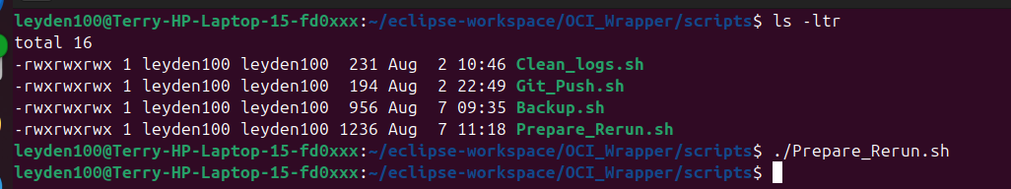
Prepare_Rerun.sh alongside the project's other maintenance scripts (Clean_logs.sh, Git_Push.sh, Backup.sh).
Confirm the input directories contain the expected test fixtures, and that every Processing_*/Output_*/Error_* directory is genuinely empty before starting - a leftover file in any of these means the previous run's state is bleeding into this one.
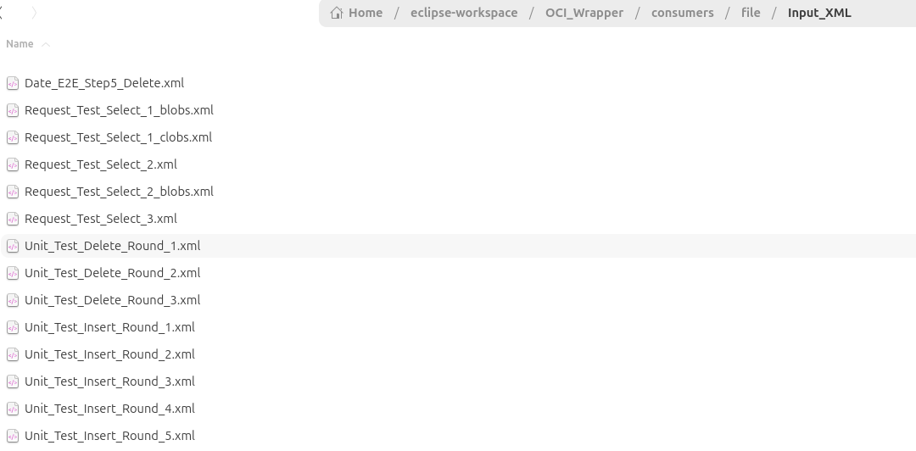
Input_XML - populated with the expected fixture set.
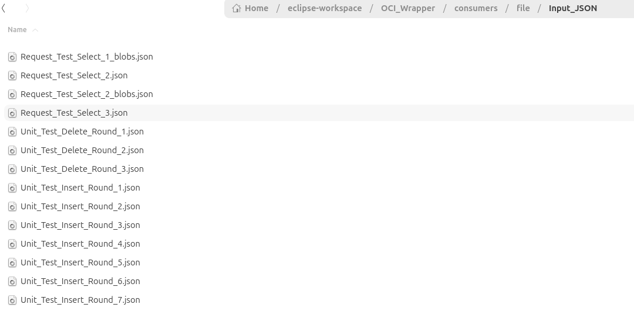
Input_JSON - populated with the expected fixture set.
The logs folder needs to be completely empty too, to ensure no stale data survives into the new run's log files:
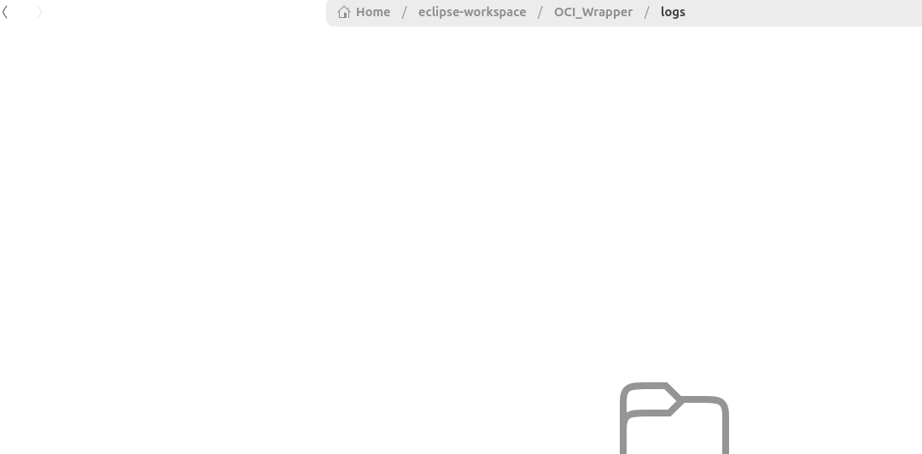
logs/ - empty, confirmed before starting.
Start OCI_Wrapper from Eclipse's Run menu so it opens its connections to Oracle - this needs to be running before Stage 2's service-name lookup will find anything:
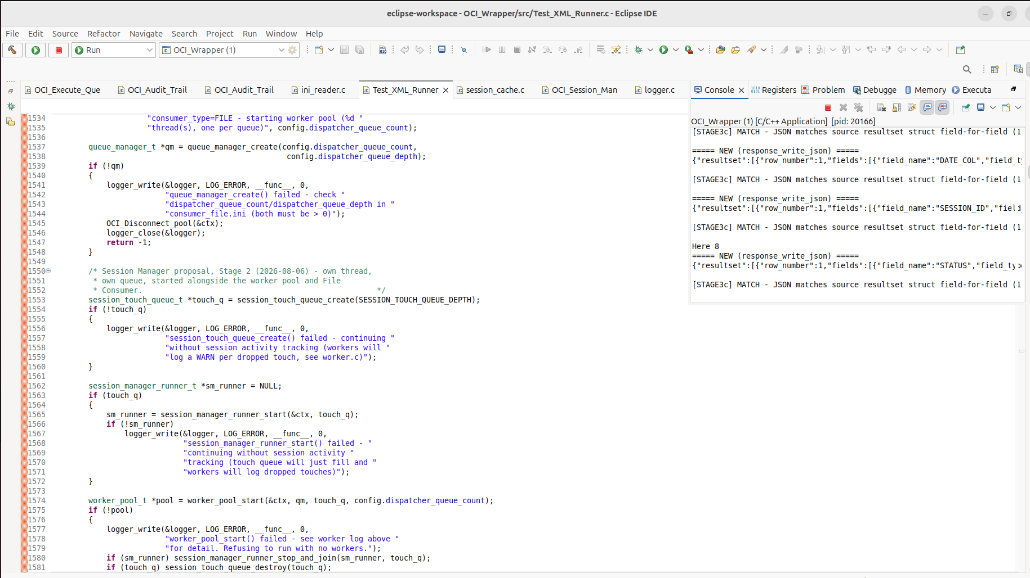
OCI_Wrapper starting up - console output confirms the process is live and connected.

8.3 Stage 2 - Enable Oracle-side tracing
Connect to the database with SQL Developer (or sqlplus):
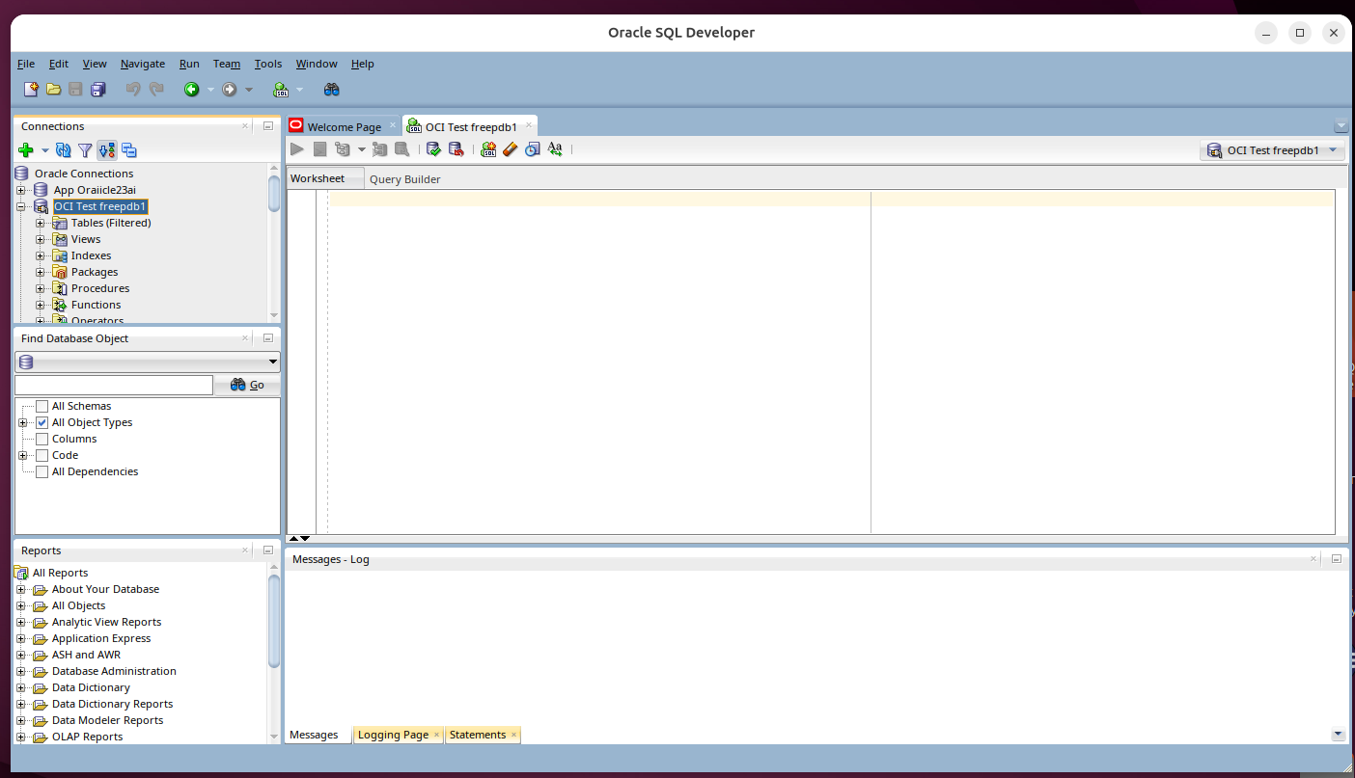
SQL Developer connected to the target schema.
Find the app's actual service name - don't assume it matches the PDB name in the connect string exactly:
-- Find your service name first
SELECT DISTINCT service_name, program
FROM v$session
WHERE program LIKE '%OCI_Wrapper%';
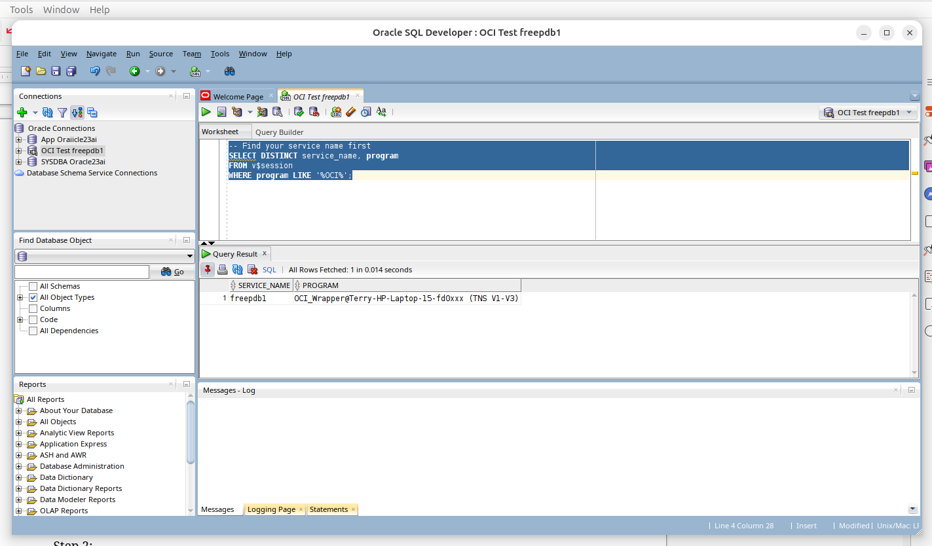
Confirmed: service_name = freepdb1.
The program must already be running for this to find anything
If this query returns no rows, OCI_Wrapper isn't connected yet - go back and complete Stage 1's last step before continuing.
Enable tracing for every session under that service:
EXEC DBMS_MONITOR.SERV_MOD_ACT_TRACE_ENABLE(service_name => 'freepdb1', waits => TRUE, binds => FALSE);
SQL*Plus/SQL Developer EXEC must be a single line
The multi-line form below looks natural but fails - SQL*Plus's EXEC shorthand only captures the first line as the command, then tries to execute each remaining line as its own separate statement:
EXEC DBMS_MONITOR.SERV_MOD_ACT_TRACE_ENABLE(
service_name => 'freepdb1',
waits => TRUE, binds => FALSE);
Either put the whole call on one line (as shown above), or use a proper BEGIN...END; block ending with / on its own line. The screenshot below is exactly this mistake being made live - note it still says "PL/SQL procedure successfully completed" at the bottom, from the corrected one-line version run afterward; the two "Unknown Command" errors above it are the multi-line attempt's leftover fragments.
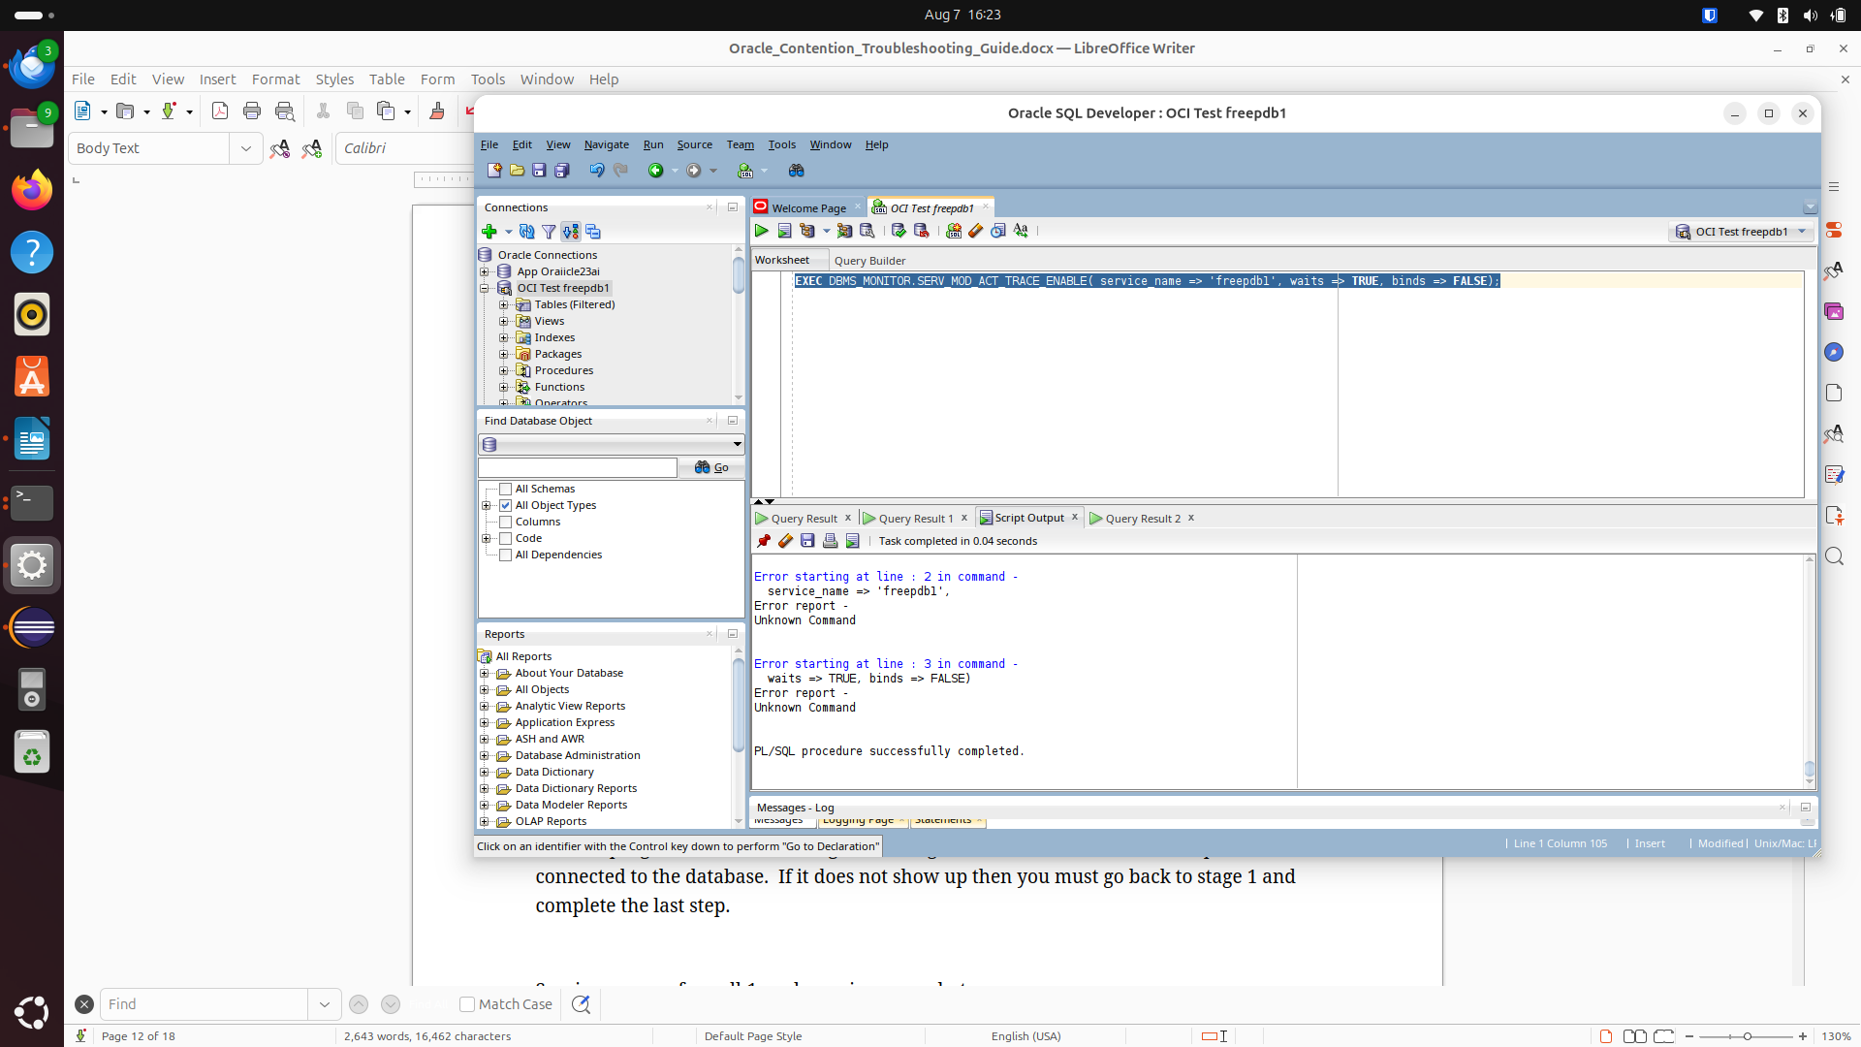
The multi-line EXEC mistake, caught live - two "Unknown Command" errors from the fragmented attempt, followed by a successful one-line retry.

8.4 Stage 3 - Run the test
Stop OCI_Wrapper, re-run Prepare_Rerun.sh (Stage 1) to reset for a genuinely clean run, then start it again with tracing already active from Stage 2:
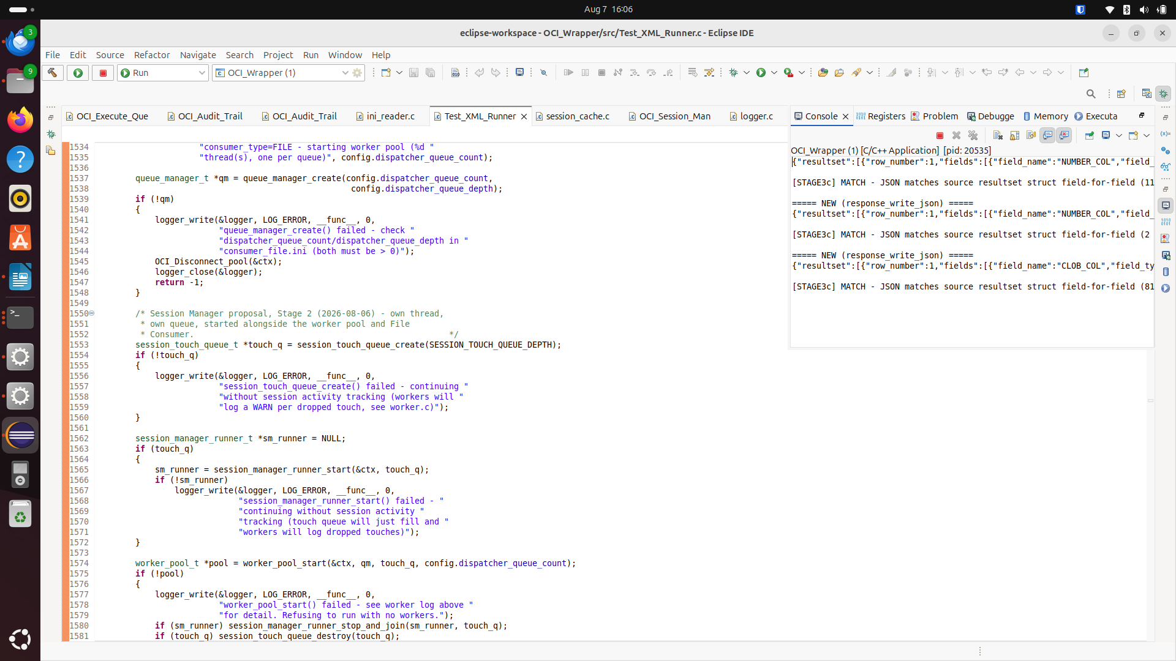
First run starting, with tracing already enabled.
A second batch of files can be dropped into Input_XML/Input_JSON while the same process is still running - File Consumer picks them up on its next scan pass automatically, no restart needed:
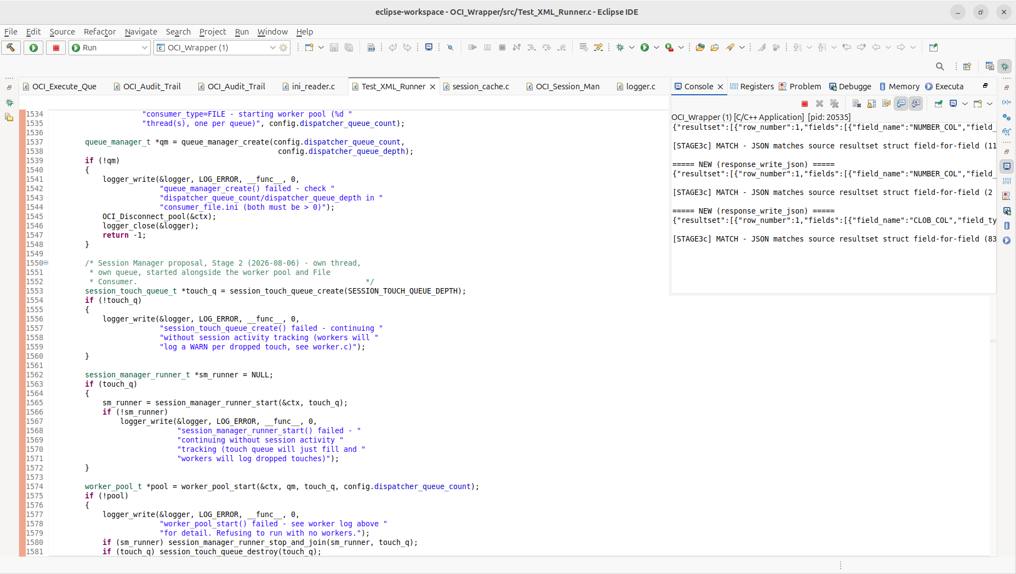
Second batch enqueued and being processed by the same already-running instance.
Grep case-sensitivity - a real gotcha, caught mid-investigation (2026-08-07)
grep -i "ora-03114" counts every ORA-03114 error line AND its own accompanying help-URL line (https://docs.oracle.com/error-help/db/ora-03114/, lowercase) as two separate hits for one real error - silently doubling every count. The screenshot below shows exactly this: grep -in reporting 64, which is really 32 genuine occurrences. Always compare case-sensitively against the real error text - grep "ORA-03114" *.log | wc -l - not case-insensitively against a pattern that also matches the help URL.
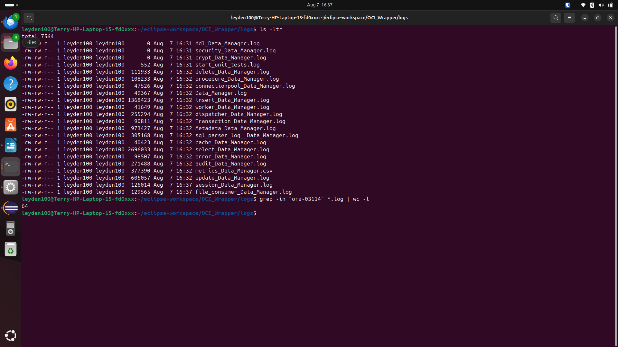
The double-counted result in practice - 64 raw matches from a case-insensitive grep, really 32 genuine occurrences once corrected.

8.5 Stage 4 - Disable tracing and check for stale sessions
EXEC DBMS_MONITOR.SERV_MOD_ACT_TRACE_DISABLE(service_name => 'freepdb1');
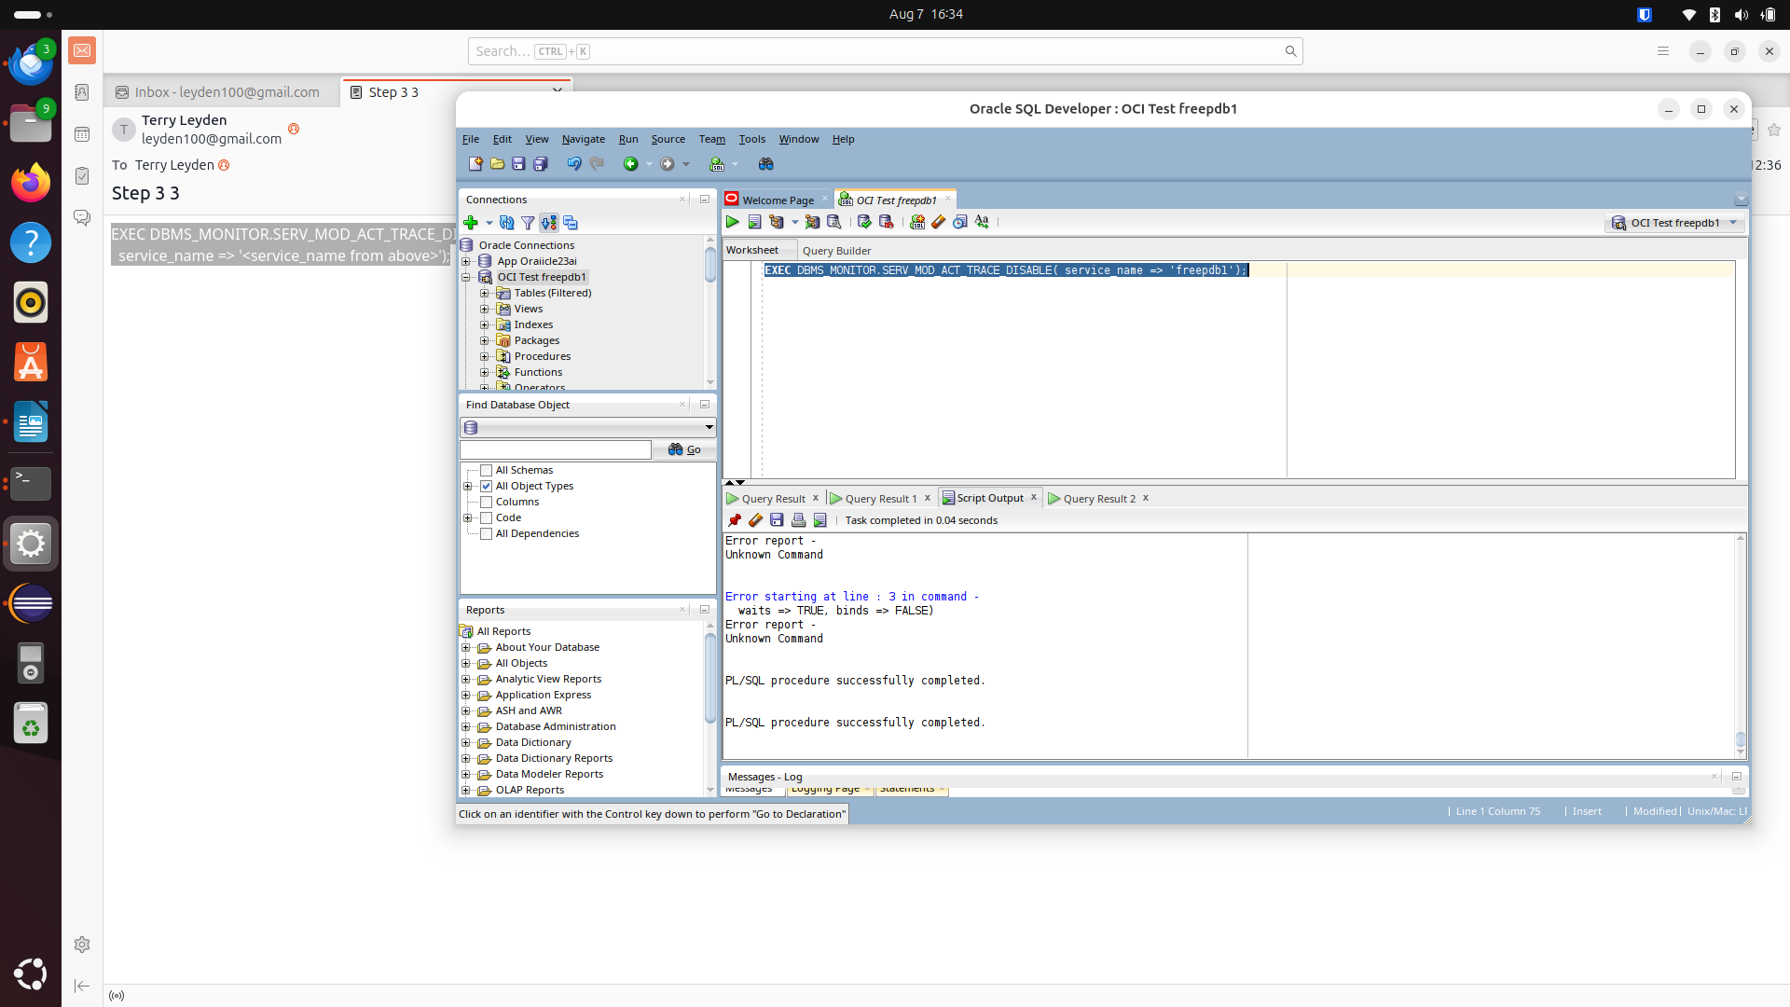
Tracing disabled cleanly ("PL/SQL procedure successfully completed" x2, from both the original correction and this disable call).
Always re-run the same blocking-session check from Section 4.1 before assuming the disconnects were the only issue - this run showed a clean 0 rows, ruling out orphaned sessions as a contributing factor for this specific investigation:
SELECT s.sid, s.serial#, s.username, s.status, s.last_call_et, s.program
FROM v$session s
JOIN v$lock l ON s.sid = l.sid
WHERE l.block = 1;
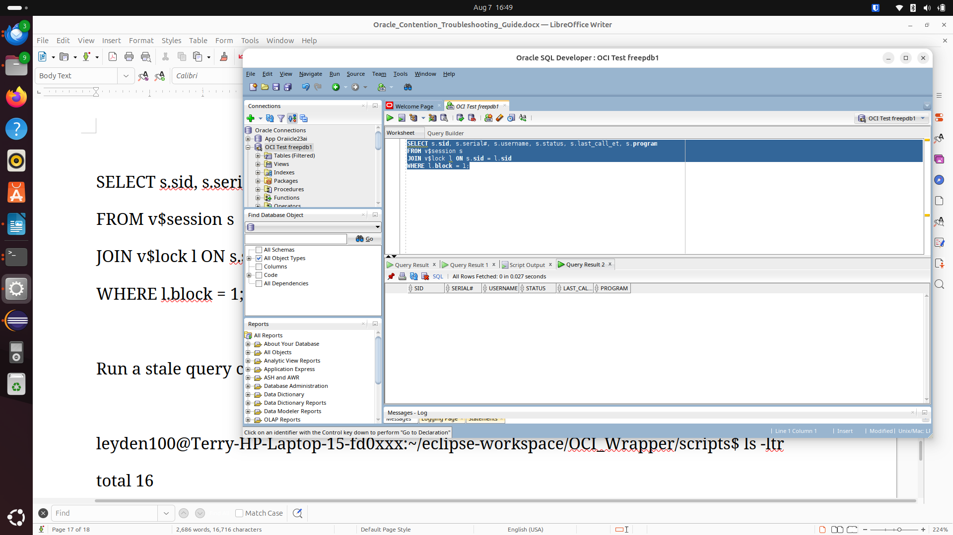
0 rows - no stale blocking sessions for this run.
Stop OCI_Wrapper once the test run(s) are complete.

8.6 Stage 5 - Retrieve and process the trace files
Trace files land inside the database's own filesystem - if Oracle is running in Docker (as here), you need to go into the container to reach them:
docker ps
docker exec -it <container_name> bash
Inside the container, the trace directory can be found from Oracle's own diagnostics view:
SELECT value FROM v$diag_info WHERE name = 'Diag Trace';
Foreground/user session traces follow an ora_<pid>.trc naming pattern - background process traces (dia0, lgwr, pmon, dbw0, ckpt, mmon, vktm, etc.) aren't useful for this and are safe to ignore.
Use a script, not manual tkprof calls, once there's more than one trace file
A real run produces one trace file per worker session (five workers = five files, plus File Consumer and Session Manager's own sessions if they touch the database directly). tkprof_batch.sh (delivered separately) processes every foreground trace file in a given time window in one pass - critically, in place, without moving or renaming the originals, so their timestamps stay exactly as Oracle wrote them:
/tmp/tkprof_batch.sh "2026-08-07 23:39" "2026-08-07 23:50"
Do not pass explain=n to tkprof
tkprof's explain= parameter expects a database username/password (explain=username/password), used only if you also want it to connect and generate execution plans - it is not a yes/no flag. Passing explain=n gets read as "connect as username n", and tkprof will sit there prompting password= forever, silently blocking the rest of a batch script. Simply omit the explain= parameter entirely - the wait-event and timing breakdown that actually matters for contention troubleshooting comes straight from the trace file itself, no database connection required.
Once processed, copy the readable .txt output back out to the host:
docker cp <container_name>:/opt/oracle/diag/rdbms/free/FREE/trace/tkprof_output ./oracle_tkprof_output
Compare the resulting wait-event breakdown against the application's own dispatcher_Data_Manager.log/worker_Data_Manager.log for the same time window - the trace shows what Oracle itself was doing (e.g. enq: TX - row lock contention, and for how long); the application logs show which specific files/operations were involved. Together they identify the actual root cause far faster than either source alone - this is exactly how 7.9's row-lock contention finding was confirmed, tying a 24.54-second wait in the trace directly to a specific UPDATE on a specific row.

8.7 What this investigation actually found
See Section 7.9 for the full root-cause finding and Section 7.10 for the fix - not repeated here. In short: genuine row-lock contention between concurrent workers, caused by a fixed test dataset being re-processed faster than some operations could settle, resolved completely by routing all write traffic through one dedicated connection rather than by any timeout, retry, or tracing change on its own.

9. Quick reference
# Find the process
find ~/eclipse-workspace/OCI_Wrapper -maxdepth 2 -type f -executable
ps -eLf | grep OCI_Wrapper

# Thread backtrace (genuine hang)
sudo gdb -p <pid>
(gdb) thread apply all bt
(gdb) detach
(gdb) quit

# Find blocking sessions + their SQL
SELECT s.sid, s.serial#, s.username, s.status, s.last_call_et, sq.sql_text
FROM v$session s
JOIN v$lock l ON s.sid = l.sid
LEFT JOIN v$sql sq ON s.sql_id = sq.sql_id
WHERE l.block = 1;

# Kill a session (note: ALTER SYSTEM, not ALTER SESSION)
ALTER SYSTEM KILL SESSION '<sid>,<serial#>' IMMEDIATE;

# Enable/disable service-wide tracing (put on one line each)
EXEC DBMS_MONITOR.SERV_MOD_ACT_TRACE_ENABLE(service_name => 'freepdb1', waits => TRUE, binds => FALSE);
EXEC DBMS_MONITOR.SERV_MOD_ACT_TRACE_DISABLE(service_name => 'freepdb1');

# Correct, case-sensitive ORA-03114 count (not -i - see 8.4)
grep "ORA-03114" *.log | wc -l

# Confirm self-healing reconnect is firing and succeeding (7.8)
grep -c "WARNING - connection lost" worker_Data_Manager.log
grep -c "reconnected successfully" worker_Data_Manager.log
grep -c "reconnect attempt itself failed" worker_Data_Manager.log

# Confirm Contention Manager write isolation is holding (7.10)
grep -oP '\[T\d\] \[dispatch_(insert|update|delete)_new\]' dispatcher_Data_Manager.log | sort | uniq -c

# Before assuming a fix isn't working, confirm it's actually in the build (7.12)
grep -n "<unique symbol from the fix>" <the file it should be in>

