File Consumer

Configuration & Design Specification
Data Manager - Consumer Layer
Version 1.0 - 2026-08-05
Covers the File Consumer end to end: architecture, every module in the request path, request/response formats, configuration surface, and file lifecycle. Written so a reader unfamiliar with the implementation history can understand the whole path in one read, without needing to re-derive it from source.

1. Introduction / Purpose
File Consumer is an automated, unattended request processor for the Data Manager platform. It watches designated input folders for XML or JSON request files, validates and queues them, dispatches each one through the same Level 1/Level 2/CRUD pipeline used throughout Data Manager, and writes a real response file back out - all without a human operator submitting requests interactively.
It is the first of what is intended to be several consumer types sitting in front of the same shared core (Level 1/2 parsing, CRUD execute modules, session/transaction/audit). A future HTTP consumer, for example, would replace only the folder-watching front end - everything from Level 1 parsing onward is already consumer-agnostic and reusable as-is.
This document exists so that architecture and design intent don't have to be re-derived from source code or reconstructed from a long implementation history every time someone - a new engineer, an auditor, or this document's own author in a future session - needs to understand how the system fits together.

2. Scope / Out of Scope

In scope
- File Consumer's own components: folder scanning, payload reading, queueing, the worker thread pool, and response writing/file lifecycle.
- The shared core pipeline File Consumer drives: Level 1/Level 2 parsing, CRUD execute modules, session/transaction/audit modules - described here at architectural depth (purpose, responsibilities, how they connect), not field-by-field.
- The File-Consumer-relevant portions of configuration (config.ini, consumer_file.ini).

Out of scope (see References, Section 10, for where each of these actually lives)
- Full field-by-field request/response schemas for every operation type - see Data_Manager_Request_Definitions.docx.
- The startup self-test module's internal design and test catalog - see Unit_Test_Module_Design_Specification.docx.
- Oracle-side contention diagnosis and troubleshooting procedure - see Oracle_Contention_Troubleshooting_Guide.docx.
- HTTP and MQ consumers - not yet built. This document's module descriptions (Sections 5-6) are written to be reusable by them, but no HTTP/MQ-specific design exists yet.
- Authentication - deliberately deferred; see Data_Manager_Request_Definitions.docx's own Authentication section.
- The full config.ini reference - Section 8 here covers only what File Consumer itself depends on.
- The least_busy dispatch algorithm - present as a named option in consumer_file.ini but not implemented; round_robin is the only working algorithm today.

3. Architecture Diagram
Numbers on each component below correspond to its subsection in Section 4. Solid arrows are labelled with the actual function call, filesystem operation, or protocol used at that interface; dashed arrows indicate a supporting/optional relationship rather than the main request path.

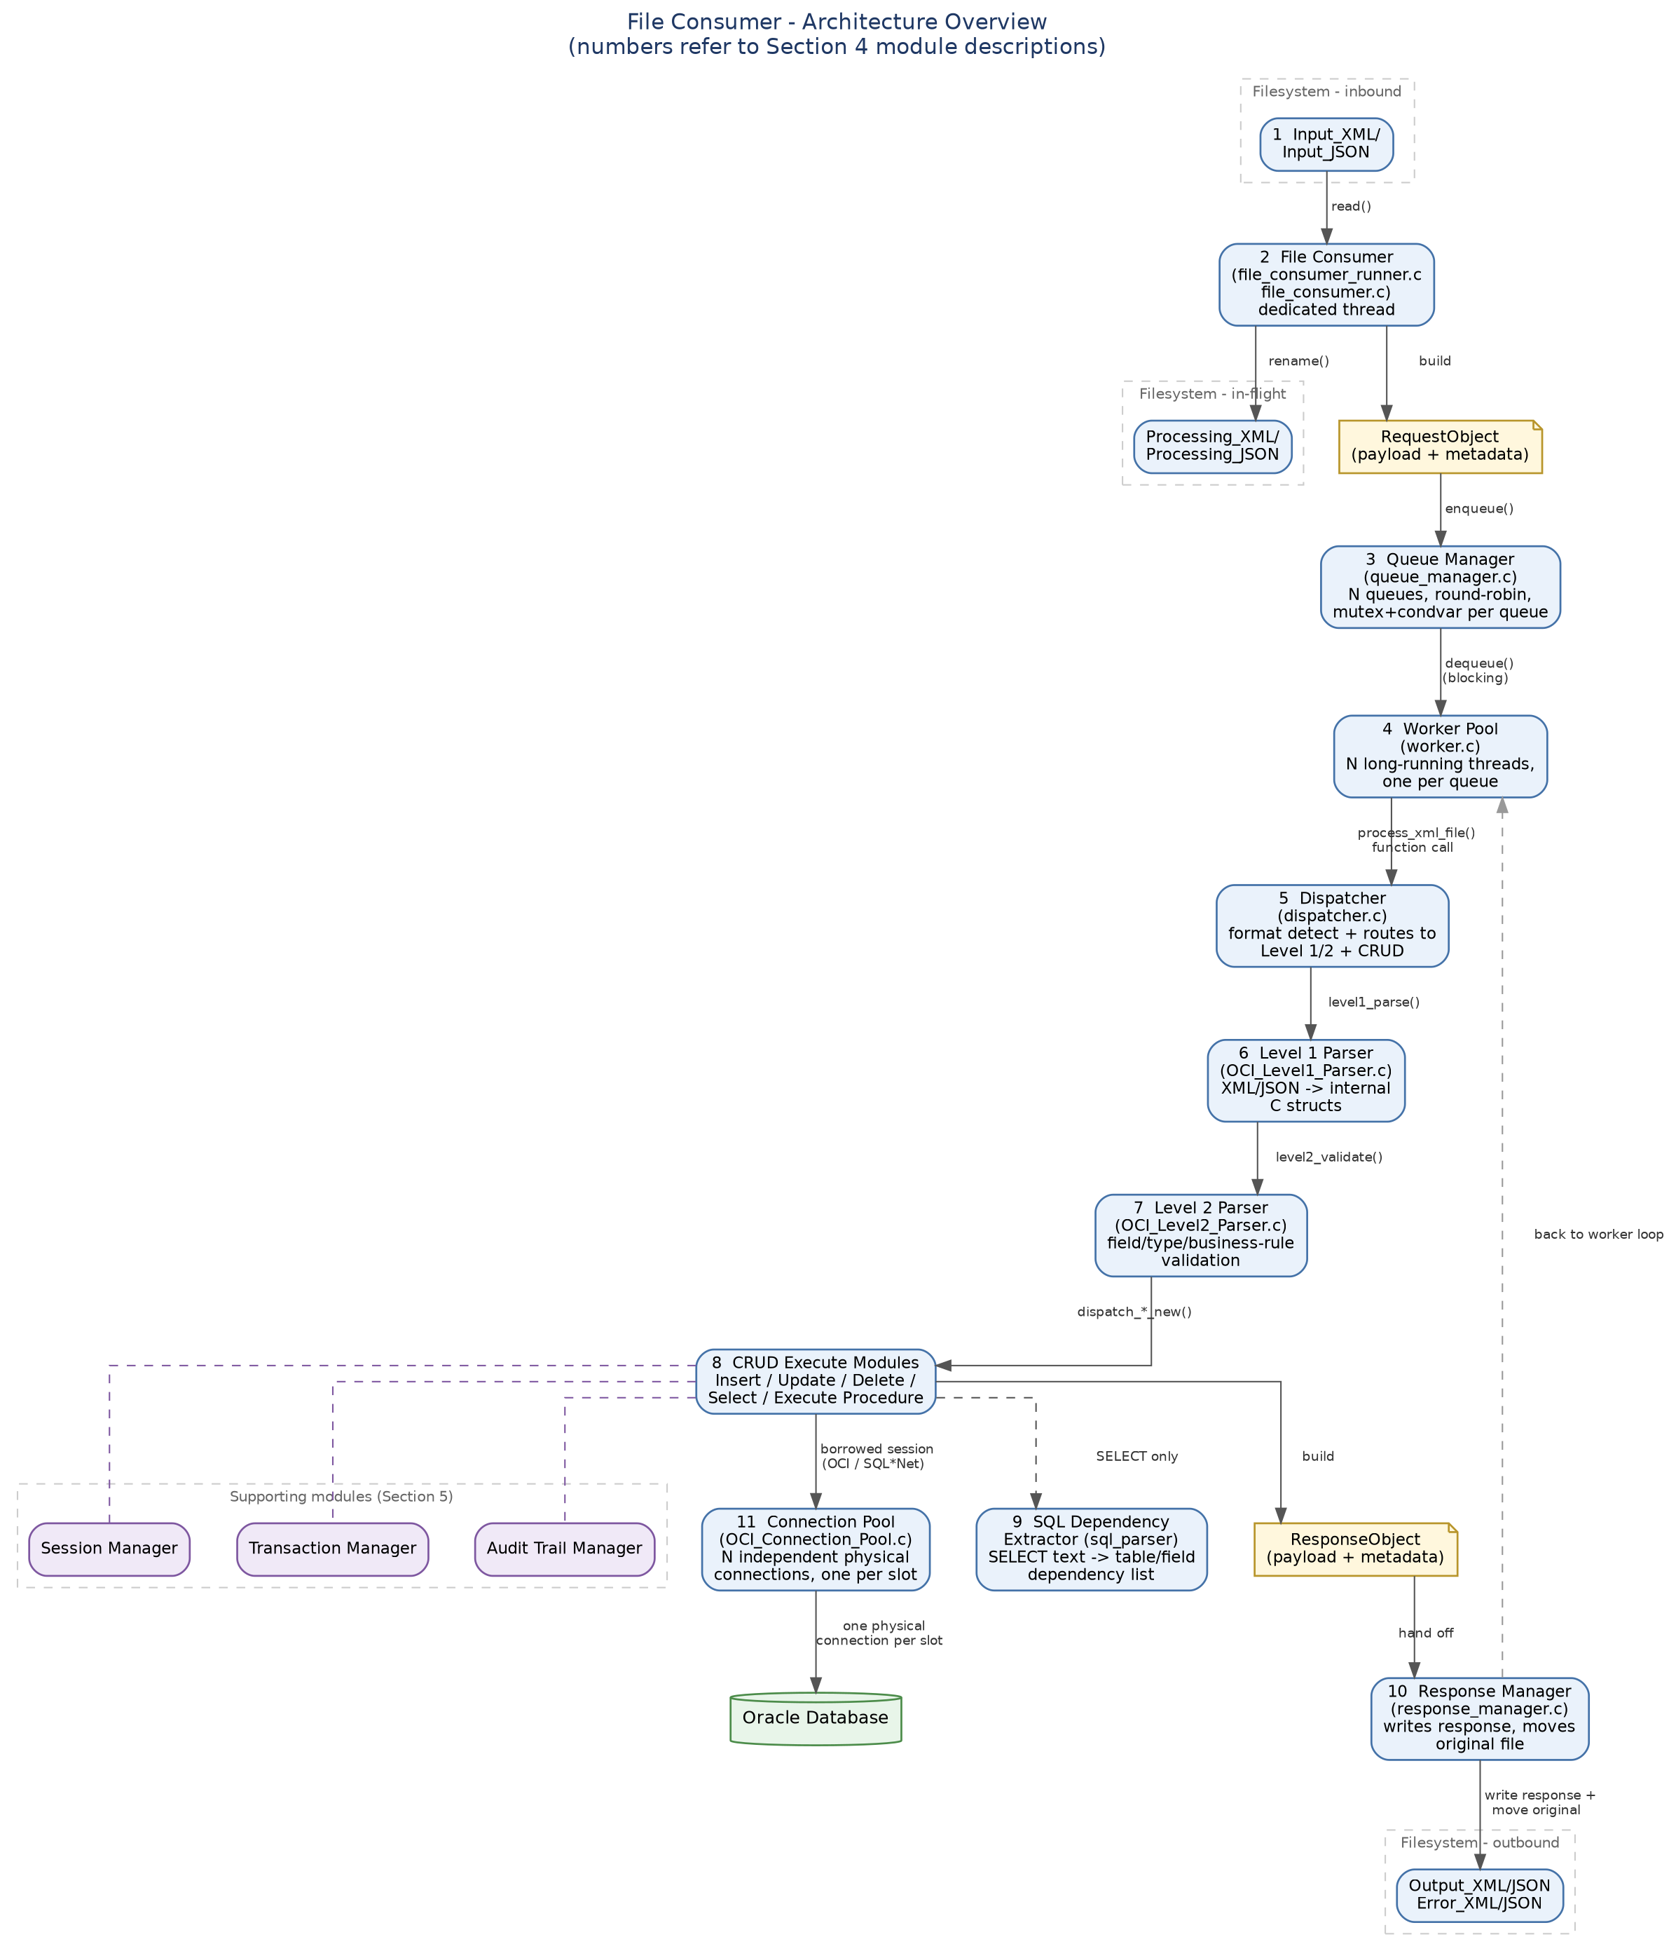

4. Modules on the Request Path

4.1 File Consumer (file_consumer_runner.c, file_consumer.c)
Owns exactly one long-running thread, started once at process startup and kept alive for the life of the process (thread creation is expensive enough that spinning one up per scan pass was rejected early on). On a configurable interval (dispatcher.poll_interval_seconds), it scans Input_XML and Input_JSON, and for each file found: validates it (regular file, non-zero size), reads its full payload into memory itself, and round-robin enqueues a RequestObject via the Queue Manager. Payload Ownership is a deliberate design rule: File Consumer is the only component that ever touches the filesystem for input files - everything downstream works only with the in-memory payload it was handed.
Two rejection paths skip the normal flow entirely and go straight from Input_* to Error_* without ever visiting Processing_*: a file that fails to read, and a file rejected because every dispatch queue is genuinely full (see 4.3). Both produce a real error response, not just a relocated file with no explanation.

4.2 RequestObject / ResponseObject
Two small, deliberately dumb carrier structs, not modules in their own right - included here because they're the interfaces every other module actually passes across. RequestObject carries a file's payload, length, filename, its current filesystem location, and its destination Output_*/Error_* directories from File Consumer through the queue to a worker. ResponseObject carries the outcome back: status (pass/fail), the real result body on success, and a synthesised error envelope (with a real error_code/error_text) on failure - always populated, never left null, so the Response Manager always has something concrete to write.

4.3 Queue Manager (queue_manager.c)
N fixed-depth queues (dispatcher_queue_count / dispatcher_queue_depth), each with its own mutex and condition variable - a queue is a single-producer (File Consumer), single-consumer (its one dedicated worker) structure, so per-queue locking avoids unrelated queues contending with each other. Enqueue is round-robin: the assigned queue is tried first, and the call overflows to the next queue with room rather than rejecting immediately if that one happens to be full - true rejection only happens when every queue is genuinely at capacity, matching an HTTP-503-style "no blocking, no retry" backpressure model. A rejected file's fate is the immediate Input_*-to-Error_* path described in 4.1.

4.4 Worker Pool (worker.c)
N long-running threads, one per queue, started once alongside File Consumer's own thread and kept alive for the process lifetime. Each thread borrows its own independent session from the Connection Pool (4.11) at startup and holds it for its entire lifetime - not re-borrowed per request, since each request already commits or rolls back atomically on its own (no explicit transaction wrapping needed at this layer; see 4.9's own atomicity note). A worker blocks on its queue's condition variable when there's nothing to do, wakes when File Consumer enqueues something, runs it through the Dispatcher (4.5) end to end, hands the result to the Response Manager (4.10), and loops.

4.5 Dispatcher (dispatcher.c)
Not to be confused with the Queue Manager, which the wider project's own design documents also sometimes call "the Dispatcher" (the architecture proposal's round-robin routing component) - this Dispatcher is a different, older piece: SQL-operation-level routing. It sniffs whether a payload is XML or JSON and whether it matches the new structured request format at all (falling back to a legacy flat-XML path, retained for backward compatibility, for old-format SELECT only), runs it through Level 1 (4.6) then Level 2 (4.7), and routes each validated operation to the correct CRUD execute module (4.8) by operation type.

4.6 Level 1 Parser (OCI_Level1_Parser.c)
Format detection and parsing into the project's internal, format-agnostic C structures (input_c_request_t and friends) - the point where an XML or a JSON request stops being two different things and becomes one thing everything downstream can treat identically. Detects malformed input and reports a specific error_code/error_text rather than a generic parse failure.

4.7 Level 2 Parser (OCI_Level2_Parser.c)
Field-level and business-rule validation of an already-structurally-parsed request: required fields present, types consistent, date/timestamp values genuinely valid (checked against a live Oracle round-trip, not just pattern-matched - see Data_Manager_Request_Definitions.docx's Date Handling section), row/parameter counts within configured limits. A request that fails here never reaches a CRUD module at all - the failure is reported with the same error_code/error_text shape used everywhere else in the response envelope.

4.8 CRUD Execute Modules
One module per operation type, each ultimately built around Oracle OCI array-bind batch calls rather than row-by-row execution:
- Insert / Update / Delete - bulk, array-bind batch operations: many rows in one round trip to Oracle rather than one call per row.
- Select - batch query execution with a configurable fetch array size (query_fetch_batch_size) that controls rows-per-round-trip; automatically forced to 1 whenever a CLOB column is present, since chunked LOB streaming and multi-row array fetch don't mix.
- Execute Procedure - IN/OUT/IN_OUT scalar parameters plus optional CURSOR OUT parameters, each producing its own resultset.
- LOB chunking - both directions. Extracting a BLOB/CLOB from a resultset streams it to a local file in bounded chunks (chunk_read_size) rather than materialising the whole LOB in memory; populating a BLOB/CLOB on insert/update reads a local source file the same way. A chunked-read defect found and fixed during Stage 5 testing (a failed OCILobRead() was previously being silently treated as a successful one) is documented in Oracle_Contention_Troubleshooting_Guide.docx, Section 7.2.
- Query safeguards - query_max_record_count bounds how many rows a SELECT may return; today the query is aborted if exceeded (a truncate-with-explicit-flag alternative has been proposed and is on the backlog, not yet implemented).
Every execute module shares the same atomicity model: when no managed transaction is active on the session (ctx->active_tx is NULL, which is the case for every File Consumer request), Oracle's OCITransCommit fires automatically at the end of a successful call. That's what makes per-request atomicity work correctly without the Dispatcher or Worker needing to wrap anything in explicit tx_begin()/tx_commit() calls.

4.9 SQL Dependency Extractor (sql_parser, sql_dependency_extractor.c)
Used only on the SELECT path. Parses the SQL text itself and extracts every table and field reference it contains into a dependency list - used for the table/field-level metadata lookups that back column-type resolution and result formatting. Deliberately restrictive about what it accepts: subqueries, UNION/INTERSECT/EXCEPT, and functions in the SELECT list are rejected outright rather than partially supported, and unqualified fields/SELECT * are only accepted where the source table is unambiguous or can be safely expanded from the OCI result descriptor after the query executes.

4.10 Response Manager (response_manager.c)
The last stop in the pipeline. Takes a populated ResponseObject and writes its body to Output_*/Error_* (matching status), then moves the original input file there alongside it - Processing_* is deliberately transient, not a permanent archive. Response filename convention is <original_filename>.response.xml (or .json): the moved original keeps its own name, the response sits right next to it under a related but distinguishable name.

4.11 Connection Pool (OCI_Connection_Pool.c)
Owns and hands out the OCI sessions every worker uses. Each pool slot has its own independent physical connection - its own OCIServerAttach() - rather than a session multiplexed onto one connection shared by every slot. That per-slot isolation is a deliberate fix, not the original design: a genuine ORA-03114 "not connected" cascade under real concurrent worker load was traced directly to the earlier shared-connection design, where multiple sessions doing concurrent I/O over one physical socket corrupted the connection for all of them simultaneously. Per-slot connections also made it safe to bound how long a call will wait for a response (OCI_ATTR_RECEIVE_TIMEOUT/SEND_TIMEOUT, set once per slot right after that slot's own OCIServerAttach()) - setting the same bound on a shared connection was what caused the cascade in the first place. Full investigation trail, including the live gdb thread-backtrace evidence that identified the shared connection as the cause, is in Oracle_Contention_Troubleshooting_Guide.docx.

5. Supporting Modules
Used by the CRUD execute modules (4.8), not part of the main request-routing path itself - shown as a supporting cluster in the architecture diagram rather than inline in the main flow.

5.1 Session Manager (OCI_Session_Manager.c)
Manages a client's logical application-level session - distinct from both an Oracle DB session/OCI connection and a Transaction Manager transaction; one session can span many transactions over its life. session_validate()/session_touch() are cache-only fast paths that don't hit the database on every call. session_reconcile_orphans() runs once at startup, before any request traffic is served, and closes out any session left ACTIVE with an elapsed TTL - the signature of a process that crashed or was killed without a clean session_end().

5.2 Transaction Manager (OCI_Transaction_Manager.c)
Gives a client explicit control over transaction boundaries spanning multiple DML calls, on top of Oracle's manual-commit-by-default OCI behaviour. Because the same OCI session is reused for every call within one logical session, work issued between tx_begin() and tx_commit()/tx_rollback() belongs to the same Oracle transaction automatically - the Transaction Manager doesn't need to intercept individual DML calls to make that true, it only needs to mark the boundaries and hand the client a transaction ID to reference.

5.3 Audit Trail Manager (OCI_Audit_Trail_Manager.c)
Records one audit row per field for every INSERT, UPDATE, or DELETE the application layer performs, using the same bulk-insert engine as ordinary business DML - which means audit rows share the caller's session and active transaction and commit or roll back atomically together with the business data they describe, with no separate commit step. A thread-local cycle-guard flag prevents the obvious infinite-recursion trap (an audit insert triggering its own audit insert).
Full audit trail
Between the Audit Trail Manager and the Response Envelope's own error_code/error_text detail preserved at both the per-operation and per-request level (see Data_Manager_Request_Definitions.docx), the system supports a full audit trail: every field change is recorded per-row, and every response - success or failure - carries enough detail to reconstruct what was attempted and what happened, not just whether it worked.

6. Request & Response Formats
Both XML and JSON are fully supported, symmetrically, for every operation type - not a primary format with a secondary one bolted on. A request's format is detected from its content by Level 1 (4.6), not from its filename or source directory; File Consumer's own Input_XML/Input_JSON split exists for operator/filesystem convenience; nothing downstream of Level 1 cares which folder a request actually arrived from.
The transform point - where an XML or JSON request stops being format-specific and becomes one thing - is Level 1 parsing itself. Level 1 produces the same internal C structures (input_c_request_t and its operation payloads) regardless of source format; every module from Level 2 onward, including all five CRUD execute modules, works exclusively with those structures and has no format-specific code at all.
Response format is independent of request format and is driven by the source_format recorded on the request: a JSON request gets a JSON response, an XML request gets an XML response. Both are produced from the same internal result data by the response-writing layer - there is no format conversion step, just two output serialisers over the same underlying result.
Reference - not repeated here
Full field-by-field request and response definitions for every operation type (GET_TEMPLATE, SELECT, INSERT, UPDATE, DELETE, EXECUTE_PROCEDURE, CREATE_SESSION, END_SESSION), including worked XML examples, exact struct field lists, and the response envelope's own precise shape, are in Data_Manager_Request_Definitions.docx. Not repeated here.

7. Configuration Overview
Two files. config.ini is the general Data Manager configuration - database credentials, logging (one section per subsystem logger, following an identical pattern each time), XML/BLOB/CLOB I/O behaviour, query execution limits, insert/update template defaults, and Connection Pool sizing/timeouts/NLS settings. consumer_file.ini is File-Consumer-specific and is only loaded when config.ini's consumer_type=FILE - it holds the dispatcher settings (queue_count, queue_depth, algorithm, poll_interval_seconds, lifetime_seconds) and the eight Input/Processing/Output/Error directory paths (four for XML, four for JSON).
Both are validated the same way: every key either file expects is checked at startup, and the process refuses to start with a clear, itemised list of anything missing - deliberately fail-closed rather than silently falling back to defaults for anything actually required.

config.ini - sections relevant to File Consumer
- Database credentials and Connection Pool sizing/timeouts - directly determines how many independent physical connections (4.11) are available to the worker pool.
- Logging - each subsystem (file_consumer, dispatcher, worker, and every CRUD module) has its own dedicated log file, same four-key pattern each time (log_file_name, log_file_max_size, log_file_rotation_number, log_level).
- Query execution / LOB chunking - query_max_record_count, query_fetch_batch_size, chunk_read_size (see 4.8's Query safeguards / LOB chunking notes).

consumer_file.ini - sections
- Dispatcher settings - dispatcher.queue_count (also the worker thread count - one thread per queue), dispatcher.queue_depth, dispatcher.algorithm (round_robin only, today), dispatcher.poll_interval_seconds, dispatcher.lifetime_seconds (0 = run until stopped).
- File Consumer directories - file_consumer.input_xml_dir / processing_xml_dir / output_xml_dir / error_xml_dir, and the matching four *_json_dir keys.
Connection Pool architecture note
See Section 4.11 for the per-slot-connection design and the concurrency issue it fixes - not repeated here.

8. File Processing Lifecycle
A file's journey through four possible directories per format (XML and JSON each have their own complete set):
Input_XML/ <- request file dropped here
|
| File Consumer reads payload, round-robin enqueues
v
Processing_XML/ <- moves here ONLY if enqueue succeeded
| (queue-full/read-failure: straight
| to Error_XML/ instead - see 4.1, 4.3)
| worker dispatches, gets a real PASS or FAIL result
v
Output_XML/ (PASS) Error_XML/ (FAIL)
<name> <name> <- original file
<name>.response.xml <name>.response.xml
<- real response/error body
Processing_* is deliberately transient - by design, a clean run ends with it empty. Every file that starts in Input_* ends up in exactly one of Output_*/Error_*, alongside a response file that always contains real content: a genuine result body on success, or a synthesised but specific error envelope (real error_code/error_text, not a generic failure) when something goes wrong before a real response could be produced - a read failure, a queue-full rejection, a Level 1/2 validation failure, or an execution failure all produce a distinct, identifiable error rather than a silent or generic one.
The two rejection paths that skip Processing_* entirely - read failure and queue-full - are described in 4.1 and 4.3.

9. Current Status
File Consumer has been load-tested at 200 concurrent requests end-to-end in under a few seconds, faster than the original 44-request single-threaded baseline, with no orphaned Oracle sessions or locks left behind afterward (confirmed against the blocking-session query in Oracle_Contention_Troubleshooting_Guide.docx, Section 4.2). All 200 requests reached a definitive Output_*/Error_* outcome; Processing_* was empty at completion.
Known, deliberately deferred items: authentication (Data_Manager_Request_Definitions.docx), the least_busy dispatch algorithm, and audit-log correlation via session_id/transaction_id on every log line (a thread-local logger context, proposed but not yet built).

10. References
- Data_Manager_Request_Definitions.docx - authoritative source for every request/response type, field-level shapes, the response envelope, and error reporting conventions.
- Unit_Test_Module_Design_Specification.docx - startup self-test module architecture, test tiers, and the full test catalog.
- Oracle_Contention_Troubleshooting_Guide.docx - live-incident-derived procedure for diagnosing Oracle-side contention/connection issues, plus a running log of every root cause found to date (including the per-slot connection fix referenced in Section 4.11).
- File_Consumer_proposal_03_Aug.docx - the original architecture proposal and staged implementation plan this design was built from, including the Payload Ownership and Queue-Full Behavior addenda referenced throughout Sections 4 and 8.

