Data Manager

Session Manager seperate thread proposal- Design Specification
Version 1.0
2026-08-06

Purpose and Scope
This document defines the requirements and design for a independent session manager worker process.
Anything not described in this document is out of scope.
This document is written to stand on its own - a developer picking this up with no other context should be able to start implementation directly from it.

Interested parties
1. Developers - running the suite locally during development, adding new tests as new functionality is built.
2. The request consumer (currently Test_XML_Runner.c's main(); in future, an HTTP consumer and/or an MQ consumer using the same dispatchers) - running the startup self-test automatically, and exposing on-demand testing via OP_UNIT_TEST for any consumer, including a future web-based one.

Proposal
The current consumber design is below as defined in section 3 in File_Consumer_Design_Specification.docx.
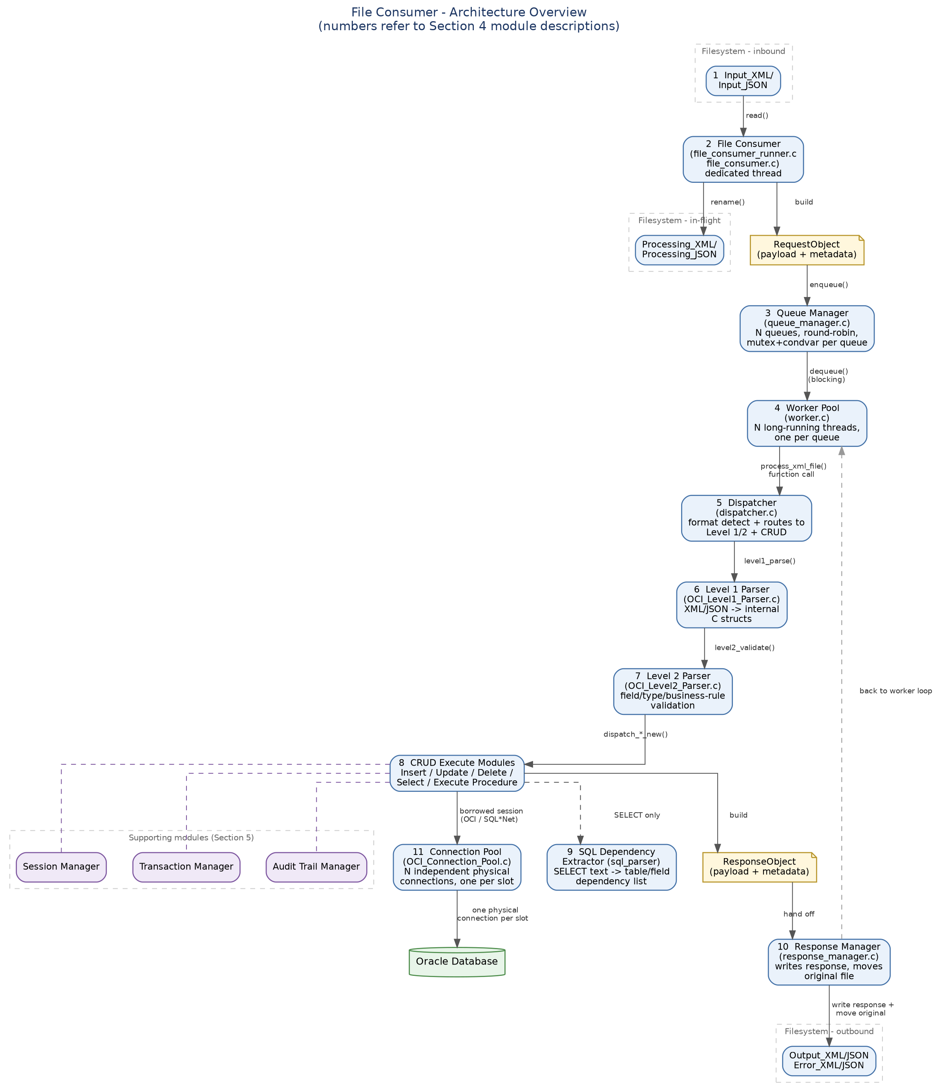

Now we know before step 4 of session_id or transaction_id is set, we set it in logger.c. What is clear is the session last activity time is not maintained. This needs to be maintained, regardless of where the consumer is consuming, e.g files, http or MQ for the following reasons.

1: A session will just automaticly idle time out and be inactivated if it is not updated with the last activity.
2: This will be heavily depended on in the future for http.
3: In the case of the file consumer he must create a session if he doesn’t have one. The reason being lets say its 10am and her runs a batch of records taking 10 minutes. This is fine and the session will timeout and be destroyed after ttl expires. Now lets say he runs another batch at 20:00. A new session id is the clear way to show that this is not using the same session from 10:00, so he will create a new session and continue.

4: For audit and security this is the clear way I see of managing this.

5: One of the last modules in this will be the security manager who will also fit in here for authentication and authorizationm, but lets leave that out of this loop for this session.

Proposal
My proposal is as follows
1: For every consumer, we will create a session before doing anything. This is already supported by 8 session manager. Once its created it is cached in the session cache as is.

2: Before each request is dispatched the last activity on the session is updated in the session table and cache. This has a direct impact on ttl timing across all consumers be it file, http or mq.
3: I think the session managed can be run in a threaded process, the reason being as once the response object is built, he can put a message onto the session manager queue to update the last_activity time. The session manager can consume this queue and update the table and cache with the response time.

This will definitly be needed for the http consumer so I think it is really worth implementing now and testing. Please let me have you inputs or concerns, or alternative considerations or solutions. Thank you.

