Iran is recognized for being one of the world's most seismically active countries, as it is traversed by numerous major faults and has been hit by plenty of devastating earthquakes in recent decades, resulting in numerous fatalities and huge financial losses. Fig. 1 depicts the earthquakes with a magnitude greater than four that occurred in Iran from 1900 to 2020 (IIEES, www.iiees.ac.ir). The city of Mashhad, with a population of over 3 million people is Iran's second most populous city. This city is Iran's most important religious tourism hub, with over 20 million tourists visiting each year, resulting in increased population density. The city is also one of the most important and fundamental cities due to the existence of some critical factories and industries, as well as its vital and key role in the development and expansion of the country's eastern provinces. The existence of unfavorable urban conditions, such as lack of strength in buildings, and old and worn textures in different areas of the city, which have little stability against earthquakes, has intensified the vulnerability of its different areas (see Fig. 2 (Hafezi–Moghaddas, 2007[1])). Therefore, it can be stated that an earthquake in this metropolis may result in tremendous and irreversible human and financial losses. Hence, earthquake disaster management in Mashhad is of particular importance.

The possibility of a high–intensity earthquake in Mashhad is considered in this case study. The data and information is gathered from reliable sources provided based on Mashhad's real conditions and via interviews with some disaster management experts. The considered hypotheses and data are as follows:

* Mashhad is divided into 13 districts, which are referred to as *affected areas*. In order to locate the warehouses, one location is nominated in each district according to criteria such as *seismic hazard*, *distance from active faults*, and *vulnerability of the network of passages*. Affected areas and candidate locations for warehouses are shown in Fig. 3.

|  |  |
| --- | --- |
| seismicity-map-of-iran1-822x1030**Fig. 1. Seismicity map of Iran from 1900 to 2020 (IIEES,** [**www.iiees.ac.ir**](http://www.iiees.ac.ir)**).** | C:\Users\NP\Desktop\Untitled.png**Fig. 2.** **Seismic hazard level map of different areas of Mashhad (Hafezi–Moghaddas, 2007).** |

* Three types of relief commodities, namely, canned tuna, canned beans, and drinking water, are needed to be stored in available warehouses. Three liters of drinking water, one can of tuna, and one can of beans are a person's daily requirements for drinking water and food (Sphere, 2018). Therefore, each affected person will require nine liters of drinking water, three cans of tuna, and three cans of beans for the first 72 hours immediate aftermath.
* For each commodity type, five reliable suppliers are recognized to provide the demand for which the locations are provided in Fig. 3. It is worth noting that canned tuna and canned beans are both supplied by the same suppliers.
* Commodities are kept in warehouses in favorable circumstances and the return time of each commodity to its corresponding supplier is agreed upon at 1.5 years.
* The pre-disaster PTH is three years, which is divided into 6 time periods of 6 months.

The number of affected people in each area is estimated by multiplying the *population size* by the *predicted damage percentage*. Predicted damage percentage is calculated by utilizing the *common set of weights* and *data envelopment analysis* techniques (DEA–CSW) for which sixteen criteria are considered. In particular, considered criteria are as follows: 1) health per capita, 2) green space per capita, 3) network of passages per capita, 4) number of fire stations, 5) development stage, 6) percentage of low–durability buildings, 7) age of buildings, 8) population density, 9) horizontal acceleration of faults, 10) soil erosion, 11) slope, 12) proximity to faults, 13) soil liquefaction, 14) area of hazardous applications, 15) traffic service level, and 16) percentage of buildings with more than three floors. 40% of the inefficiency score obtained from DEA–CSW method is considered as the predicted damage percentage. Accordingly, the quantity of demand for each commodity type is reported Table 1.

* Table 2 displays the storage capacity of three commodity types which are, respectively, 21, 21, and 42 percent of the population size of the corresponding district and adjacent districts.
* In order to estimate the construction cost per square meter, the seismic resistance of each district is first evaluated using *step–wise weight assessment ratio analysis* (SWARA) and *simple additive weighting* (SAW) methods. In particular, horizontal acceleration of faults, soil erosion, slope, proximity to faults, and soil liquefaction are considered as effective criteria of the proposed method. It is worth noting that the lower the land's seismic resistance, the stronger the building is required, which leads to the higher construction cost. Finally, the establishment cost of each warehouse is estimated by considering its seismic resistance and capacity and construction cost per square meter in Mashhad, which is shown in Table 2.

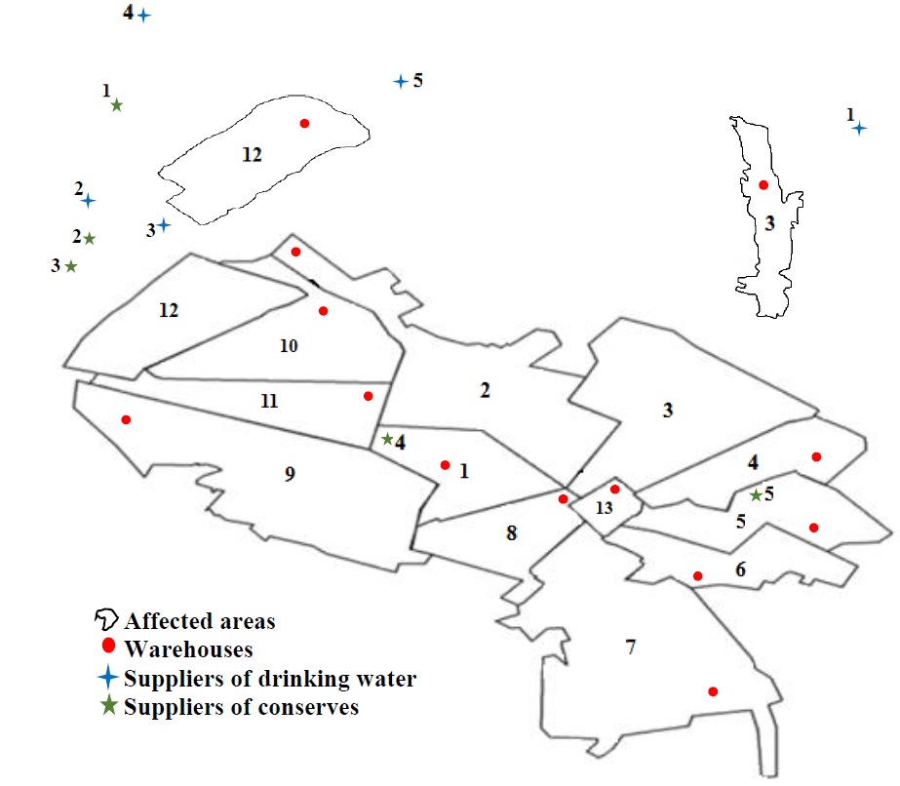

**Fig. 3. Locations of affected areas, candidate warehouses, and suppliers.**

* The percentage of possible earthquake damage to each warehouse is estimated using DEA–CSW method for which eight criteria are considered as follows: 1) the network of passages per capita, 2) number of fire stations, 3) horizontal acceleration of faults, 4) soil erosion, 5) slope, 6) proximity to faults, 7) soil liquefaction, and 8) traffic service level. It is worth mentioning that the possible damage percentage accounts for 15% of the inefficiency score obtained from the DEA–CSW technique. Finally, the estimated damage percentage is considered as the percentage of stockpiled conserves that are unusable following the disaster. In addition, this percentage for drinking water is taken into account 3% more than the conserves (see Table 2).
* The unit selling price offered by each supplier and its production capacity are extracted from its website, and the rest of the contract parameters are generated at random while considering their practical and real–world situations. Results are reported in Table 3.
* For each time period, Table 4 shows the required budget for the establishment and procurement of relief supplies.
* Following an earthquake, there may be disruptions in the transportation network due to damage to routes and traffic congestion; as a result, travel time may rise compared to normal conditions. Hence, post–disaster travel time is calculated by multiplying *normal travel time* by *the coefficient of disruption in the transport route*. The measurement tool on Google maps is used to determine normal travel time from the suppliers and warehouses to the centers of the affected areas. Also, the coefficient of disruption in the transport route is estimated based on the vulnerability of its network of passages and districts[2].Complete results are provided in Tables 5–9.
* The 6–month general inflation rate is set at 21% (average 6–month general inflation rates of 2018–2021).
* Throughout the pre–disaster PTH, the budgets are deposited in a bank that calculates profit every day under a nominal annual interest rate of 10%. As a result, the effective daily interest rate is 0.0274%.
* The establishment cost of each warehouse is paid in three installments, namely, 1) 45% of the cost at the beginning of the period, 2) 35% of the cost at 30 days after the beginning of the period, and 3) 20% of the cost at 60 days after the beginning of the period.
* $β_{1}, β_{2}$ are set to 0.5.

1. . Hafezi–Moghaddas, N. (2007). Seismic microzonation of the Mashhad city. Technical report. Khorasan–Razavi Housing and Urban Development Organization, Washington, DC.
2. . The vulnerability of the network of passages of the transport route is estimated using the vulnerability rating of Mashhad's network of passages, created by specialists. Also, the vulnerability of each district is calculated as the second column of Table 1.