**Designing a Mobile Shopping List App: A Prototype Approach**

Leyla McFarland

February 9, 2025

CSC505: Principles of Software Development

Dr. Steven Evans

**Introduction**

Mobile apps have revolutionized how people manage day-to-day tasks, particularly in areas like grocery shopping. As users demand greater convenience, shopping list apps have become an essential tool for organizing and tracking grocery needs. While many options exist in the market, developing a user-friendly and functional prototype is crucial to enhancing the shopping experience. This paper explores the early-stage design of a mobile shopping list app, focusing on its architecture, the key screens involved, and the app's user flow.

**Preliminary Architectural Design**

A successful mobile app design must balance both functionality and usability. The architecture of the shopping list app proposed here consists of a simple front-end interface for user interactions and a backend structure for data storage. The app's **frontend** would feature an easy-to-use interface with screens for creating, editing, and viewing shopping lists. These screens include:

1. **Splash Screen**: A brief introduction to the app, providing users with an initial loading experience.
2. **Home Screen**: The main dashboard where users can see all their created shopping lists and access options to add or view individual lists.
3. **Add Item Screen**: A screen to input new items, allowing users to specify item names, quantities, and categories.
4. **View List Screen**: This screen displays the shopping list, with the ability to check off items as they are bought.
5. **Settings Screen**: Allows users to manage preferences, such as syncing their lists across devices or adjusting notifications.

The app's **backend** would store the user's shopping lists and preferences locally (using databases like SQLite or Firebase for cloud storage), enabling offline functionality and seamless syncing across devices.

**User Flow and Paper Prototype**

The app's user flow is designed to be as intuitive as possible. Upon launching the app, users are greeted with a **Splash Screen** before being directed to the **Home Screen**, where they can choose to create a new list or view existing ones. If they choose to create a new list, they are taken to the **Add Item Screen**, where items can be added. Once added, the list appears on the **View List Screen**, where items can be checked off as they are bought. The **Settings Screen** provides an option to manage app preferences and synchronize lists.

A Python script is used to visualize the page sequence and flow, helping to outline the app’s basic navigation structure.

**UML Diagram**

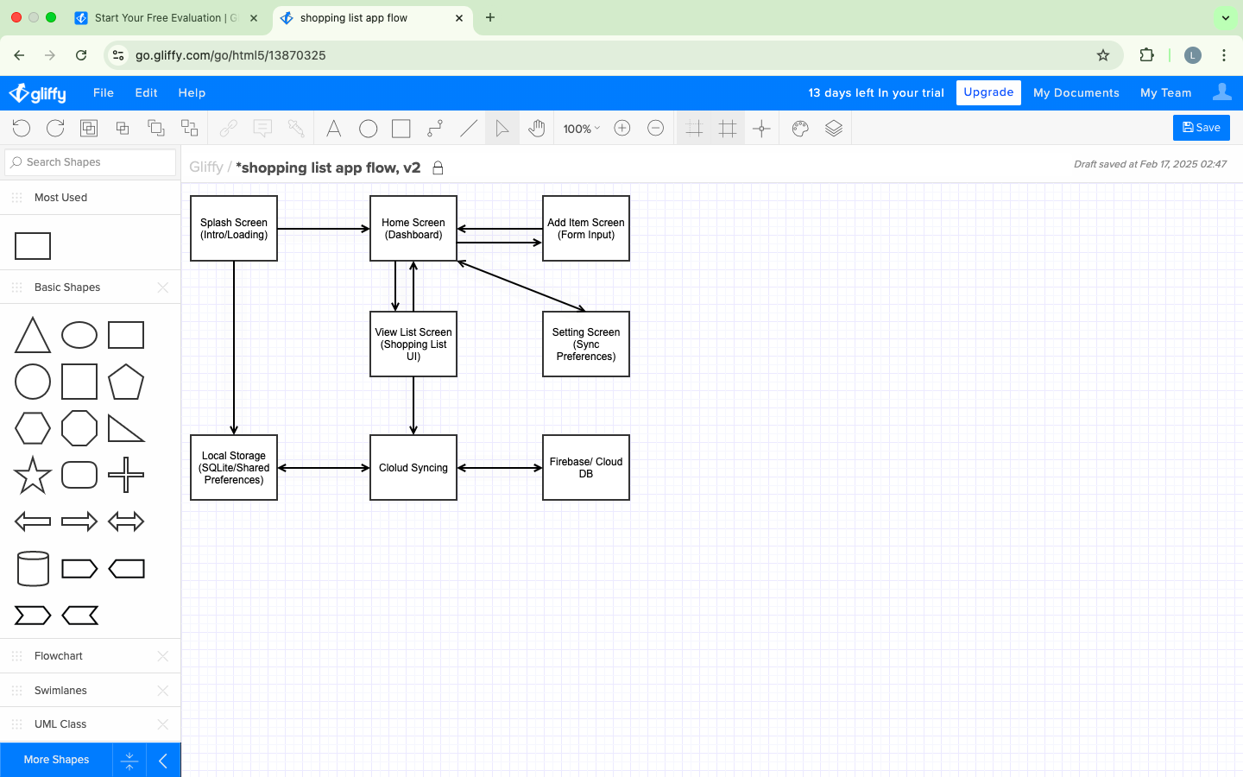

**Research on User-Centered Design**

User-centered design (UCD) principles are key to ensuring that the app meets the needs of its users. UCD emphasizes designing the app based on real user feedback, focusing on their pain points, and ensuring ease of use (Norman, 2013). In the case of a shopping list app, simplicity and efficiency are paramount. As noted by Nielsen (2012), ease of navigation and minimal steps to complete tasks are essential components of a successful mobile app interface. This paper draws on these principles, ensuring that the shopping list app is straightforward and convenient, which is crucial for meeting the demands of modern consumers.

**Conclusion**

This paper outlines the design of a mobile shopping list app, focusing on creating an intuitive and user-friendly interface through careful architectural planning and user flow. By adhering to user-centered design principles and leveraging established mobile app development frameworks, the prototype aims to offer a solution that simplifies grocery shopping. As the app progresses from prototype to full development, continuous user feedback will be vital to refining its features and usability. The research emphasizes the importance of simplicity and usability in app design, principles that will continue to guide the development of this app.

**References**

Nielsen, J. (2012). *Usability Engineering*. Morgan Kaufmann.

Norman, D. A. (2013). *The Design of Everyday Things: Revised and Expanded Edition*. Basic

Books.