SOG Glass and Aluminum Services
Appointment Booking and Management System
Capstone Technical Background, Resources, Scope, Context Flow Diagram, and Data Flow Diagram
Prepared for: College Capstone Documentation

1. Technical Background
SOG Glass and Aluminum Services requires a reliable digital system for handling customer appointment requests, product quotations, work scheduling, payment records, and job progress monitoring. In a traditional manual process, booking requests, quotation details, customer contacts, measurements, payment follow-ups, and worker assignments can become scattered across messages, paper notes, and informal reminders. This creates risks such as missed appointments, inconsistent quotation records, delayed updates, and limited visibility for customers and staff.
The proposed system is a web-based appointment booking and management platform designed to centralize the company workflow. It supports online appointment booking, product quotation preparation, customer tracking, staff scheduling, work job monitoring, payment recording, audit logs, and real-time notifications. It also includes a separate augmented reality measurement tool that uses WebXR and Three.js to help customers or staff visualize and capture approximate product dimensions using supported mobile devices.
The system follows a client-server architecture. The frontend provides user interfaces for customers, administrators, and workers. The backend exposes secure API endpoints, handles validation and business rules, stores system records, and triggers notifications. The database stores users, products, appointments, quotations, work jobs, payments, audits, and related records.

2. Technologies to be Used

2.1 Frontend Technologies
Technology | Use in the System
Next.js 16 | Main customer, admin, and worker web application with routed pages and server/client rendering support.
React 19 | Reusable component-based user interface for dashboards, forms, modals, quotations, and customer pages.
TypeScript | Static typing for frontend models, API payloads, form data, and reusable components.
Tailwind CSS 4 | Utility-based styling system for responsive and consistent layouts.
shadcn UI / Radix UI | Accessible UI primitives such as dialogs, drawers, select controls, buttons, tabs, and form components.
Lucide React | Consistent icon library for navigation, actions, status indicators, and dashboard cards.
Zod | Client-side schema validation for forms and safer typed data handling.
FullCalendar | Appointment and worker schedule calendar views.
Recharts | Dashboard and sales chart visualizations.
Google Maps | Customer location display, route reference, and address-based map views.
@google/model-viewer | Admin preview of uploaded GLB product 3D models.
PayPal React SDK | Customer payment buttons for PayPal sandbox and card-supported checkout flows.
Laravel Echo and Pusher JS | Realtime notification and page refresh events from Laravel Reverb broadcasting.
Playwright | Frontend end-to-end testing for major user flows.

2.2 Backend Technologies
Technology | Use in the System
Laravel 13 | Main backend API framework for routing, validation, services, events, listeners, notifications, and data resources.
PHP 8.3 | Backend programming language used by Laravel.
Laravel Sanctum | API authentication for logged-in customer and staff requests.
Laravel Fortify | Staff profile, password, and two-factor authentication features.
Spatie Laravel Permission | Role and permission management for admin, sub-admin, worker, and customer access.
Laravel Reverb | Self-hosted realtime broadcasting for notifications and live status updates.
Laravel Notifications | Database notifications for appointment, quotation, work job, payment, and status changes.
Laravel Auditing | Audit trail for important create, update, and delete actions.
Maatwebsite Laravel Excel | Excel and CSV exports for reports such as sales records.
Spatie Laravel PDF / Browsershot | Quotation and report PDF generation.
PayPal REST API | Payment order creation, capture, and payment record synchronization.
Relational Database | Persistent storage for users, products, appointments, quotations, work jobs, payments, notifications, audits, and supporting records.

2.3 Augmented Reality and 3D Technologies
Technology | Use in the System
Vite + React | Separate lightweight AR frontend application for faster mobile testing and deployment.
Three.js | 3D rendering engine for GLB models, anchor points, measurement lines, labels, and object placement.
WebXR Hit Testing | Detects real-world surfaces and places points or models in AR space on supported Android/Chrome devices.
GLB 3D Models | Product models uploaded and linked to catalog items for AR visualization.
Blender | Creation and preparation of 3D product models before upload.

3. System Resources

3.1 Hardware Resources
Hardware | Specification / Purpose
Development Laptop | MacBook Air M1 with 24 GB unified memory and 512 GB storage.
Mobile Test Device | AR-capable Android smartphone with Chrome/WebXR support for AR hit testing.
Internet Connection | Required for API access, PayPal sandbox testing, maps, notifications, and deployment testing.
Optional External Display | Helpful for development, debugging, documentation, and browser testing.

3.2 Software Resources
Software | Purpose
Visual Studio Code | Primary code editor for frontend, backend, AR, and documentation work.
Laravel Herd | Local PHP/Laravel development environment.
Node.js and npm | Frontend, AR application, and testing dependency management.
Composer | Laravel package and dependency management.
Google Chrome / Chrome DevTools | Browser testing, WebXR testing, network inspection, and UI debugging.
Blender | Creation, optimization, and export of product 3D models in GLB format.
Microsoft Word | Capstone document preparation and formatting.
Git | Version control for source code and documentation changes.
PayPal Developer Sandbox | Safe testing of PayPal checkout without using real money.

4. Scope of the Study
The study covers the design and development of a web-based appointment booking and business management system for SOG Glass and Aluminum Services. The system scope includes:
- Customer appointment booking with or without quotation items.
- Customer OTP login using email or phone and customer dashboard access.
- Product catalog management, including product images, variants, option groups, options, categories, and uploaded 3D product models.
- Quotation creation, item status management, digital customer review, e-signature, approved-item PDF generation, and re-signing when approved items are changed.
- Admin appointment management, including confirmation, rescheduling, cancellation, reopening, no-show handling, and calendar viewing.
- Worker assignment, worker dashboard, assigned appointment/work job views, status updates, remarks, and before/after photo visibility.
- Work job and back job management, including jobs created from appointments and warranty or unfinished-work scenarios.
- Payment lifecycle support, including PayPal payments, down payments, full payments, manual/cash records, additional charges, payment status tracking, and sales reports.
- Realtime notification updates using Laravel Reverb and database notifications.
- Audit logging for security and accountability.
- AR measurement and product model visualization using a separate React/Vite WebXR application.
- Dashboard analytics, sales reporting, calendar monitoring, PDF exports, Excel/CSV exports, and frontend E2E testing.

5. Limitations of the Study
- The AR measurement tool provides approximate measurements and does not replace professional on-site measurement by company personnel.
- WebXR hit testing depends on supported devices, supported browsers, camera permission, lighting, surface texture, and browser security requirements such as HTTPS.
- The system requires an internet connection for online booking, notifications, maps, PayPal checkout, and real-time updates.
- PayPal integration is tested through sandbox mode; live payment processing requires correct live credentials and PayPal account approval.
- SMS and email delivery depend on configured third-party providers and network availability.
- The system does not cover payroll, supplier purchasing, full inventory accounting, or manufacturing automation.
- 3D model accuracy depends on the quality and scale of uploaded GLB files prepared in Blender or other modeling software.
- Real-time updates require the Laravel Reverb server and frontend Echo connection to be running properly.
- Final quotation prices and job completion still require staff validation because actual site conditions may change after booking.

6. Context Flow Diagram
The context flow diagram shows the system as one central process and identifies how external actors and services exchange information with it.
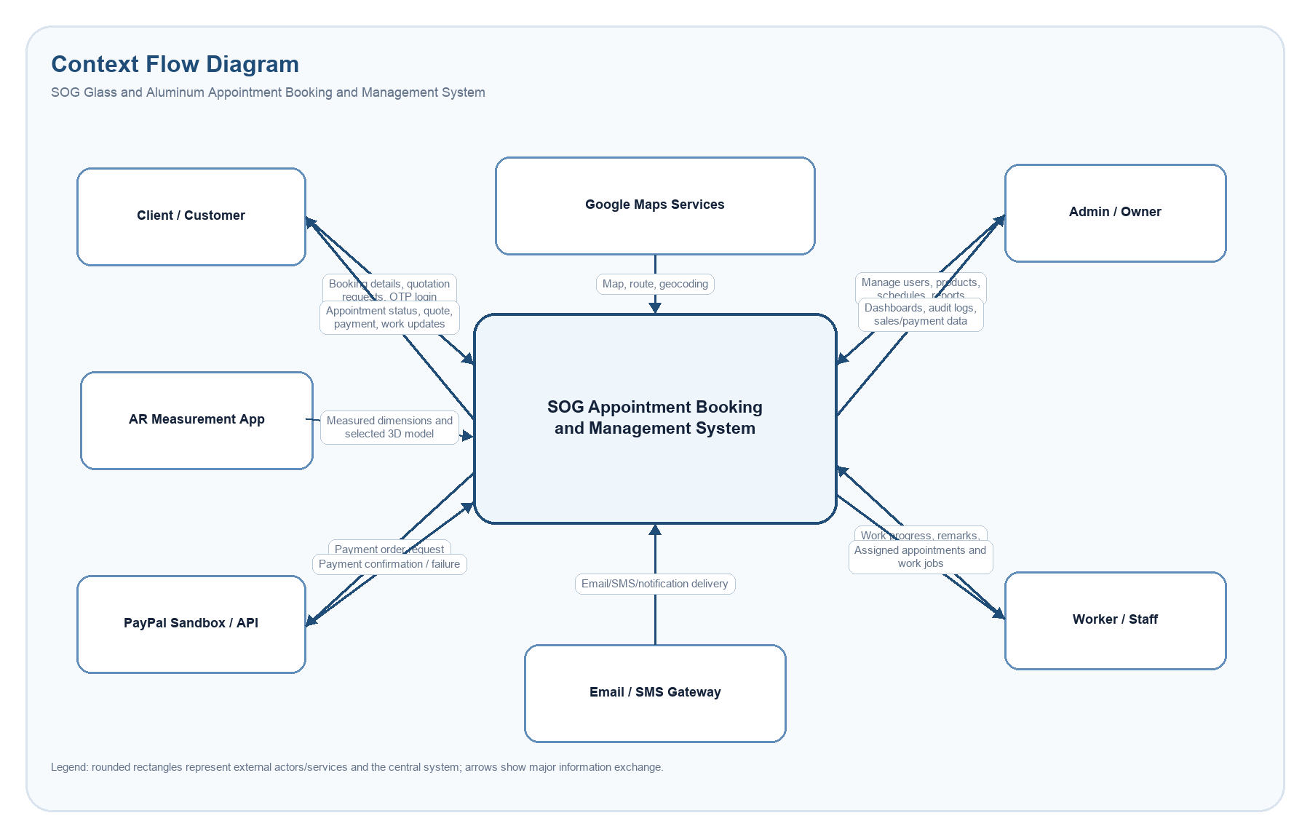
Figure 1. Context Flow Diagram of the SOG Appointment Booking and Management System.

7. Data Flow Diagram
The Level 1 DFD decomposes the system into major processes and shows how data moves between customers, staff, external services, and internal data stores.
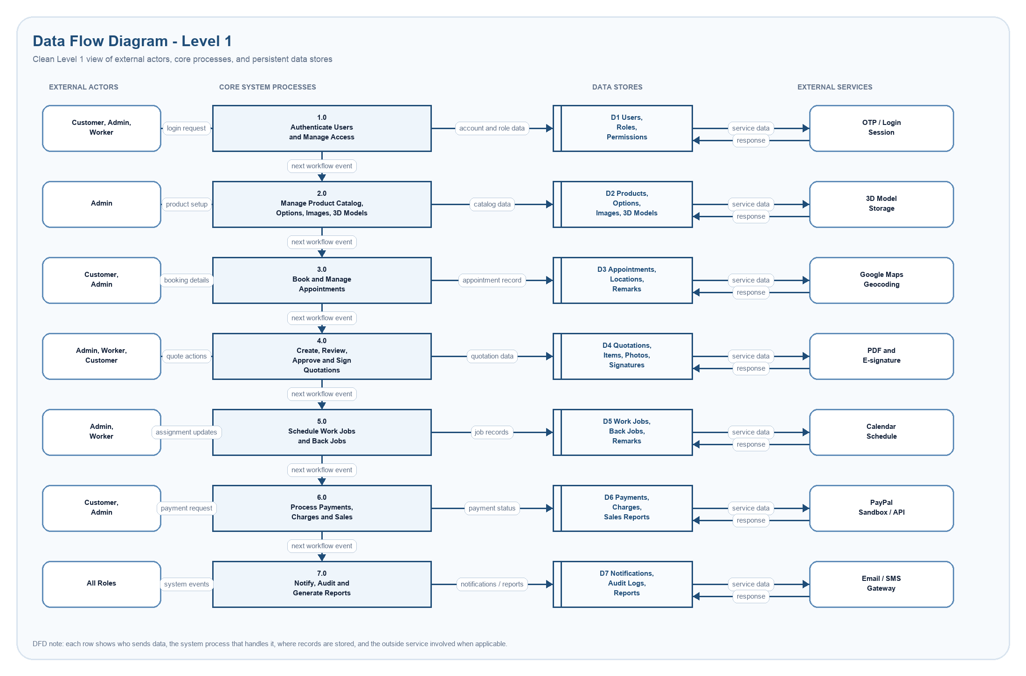
Figure 2. Level 1 Data Flow Diagram of the SOG System.

7.1 DFD Process Descriptions
Process | Description
1.0 Authenticate Users and Manage Access | Handles customer OTP login, staff login, two-factor authentication, roles, permissions, and session access.
2.0 Manage Product Catalog | Stores product information, categories, variants, option groups, images, and 3D model files.
3.0 Book and Manage Appointments | Receives booking requests, stores preferred or confirmed schedules, and supports status changes.
4.0 Create, Review, and Sign Quotations | Creates quotation items, applies product/options snapshots, manages approval statuses, and stores digital signatures.
5.0 Schedule Work Jobs and Back Jobs | Creates work jobs from appointments, assigns workers, tracks progress, and supports back jobs for warranty or unfinished work.
6.0 Process Payments, Charges, and Sales | Creates PayPal payment records, tracks manual/cash payments, handles additional charges, and supports sales reports.
7.0 Notify, Audit, and Generate Reports | Creates notifications, broadcasts real-time events, stores audit records, and produces operational reports.

8. Summary
The proposed system supports the full operational cycle of SOG Glass and Aluminum Services from customer inquiry to appointment booking, quotation preparation, worker scheduling, payment tracking, job completion, and reporting. By combining Laravel, Next.js, WebXR, PayPal, real-time notifications, audit logs, and role-based access control, the system provides a modern platform that improves transparency, traceability, and customer service while still allowing staff to validate final measurements and pricing.

