Comp306 Sec.005 Yoonseop Lee 301037418 Lab2

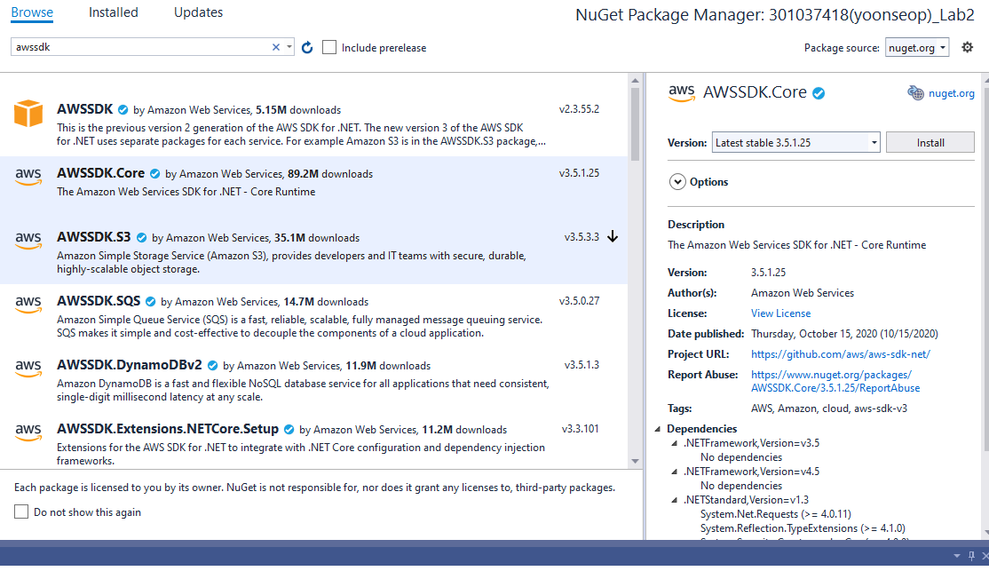

Installed nugget package beforehand.

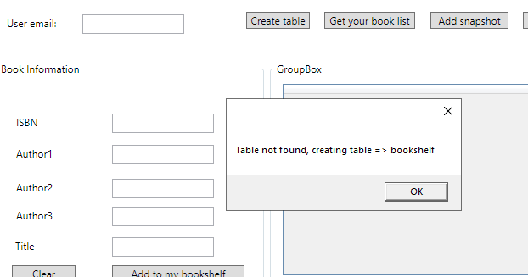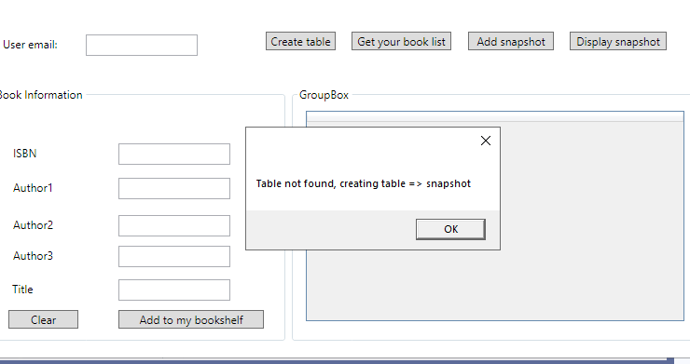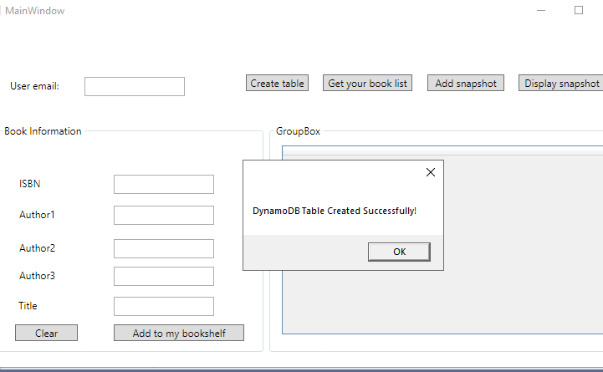

“Create table” creates dynamoDb table accordingly

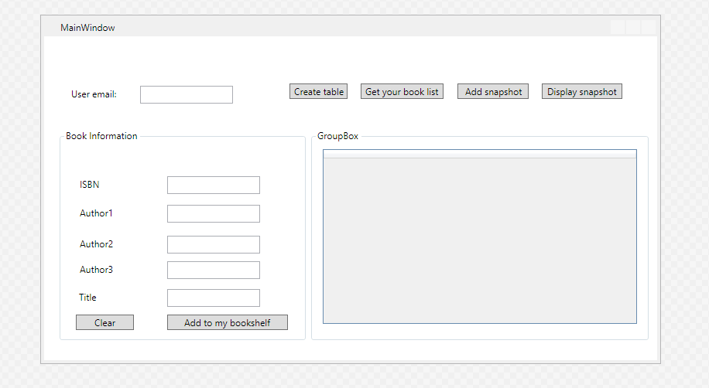

Also, I made WPF GUI.

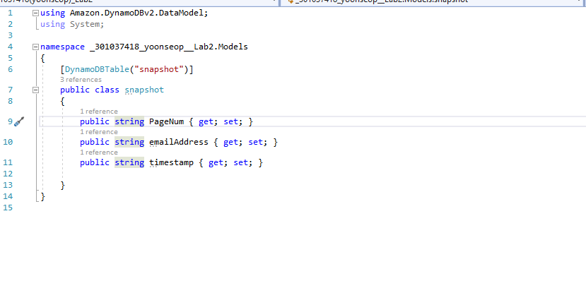

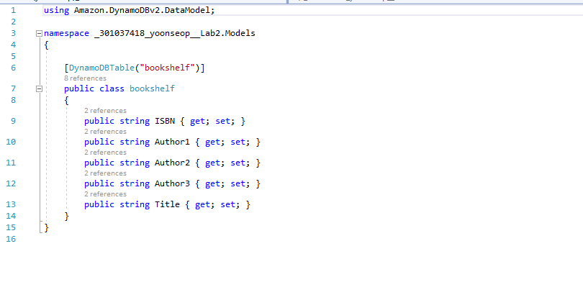

Classes made for the table data (bookshelf, snapshot)

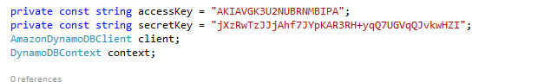

Connected amazon API successfully

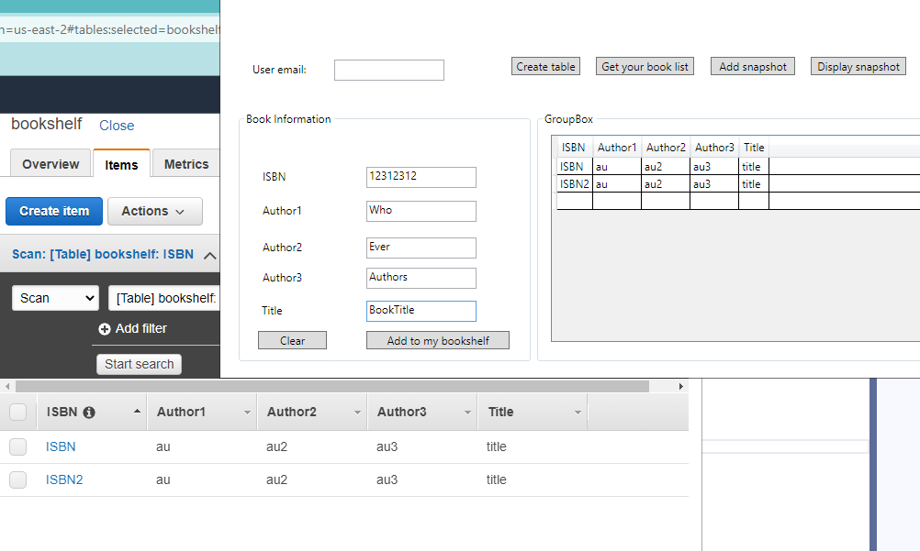

I will get bookshelf table from DynamoDB by clicking the “Get your book list” button

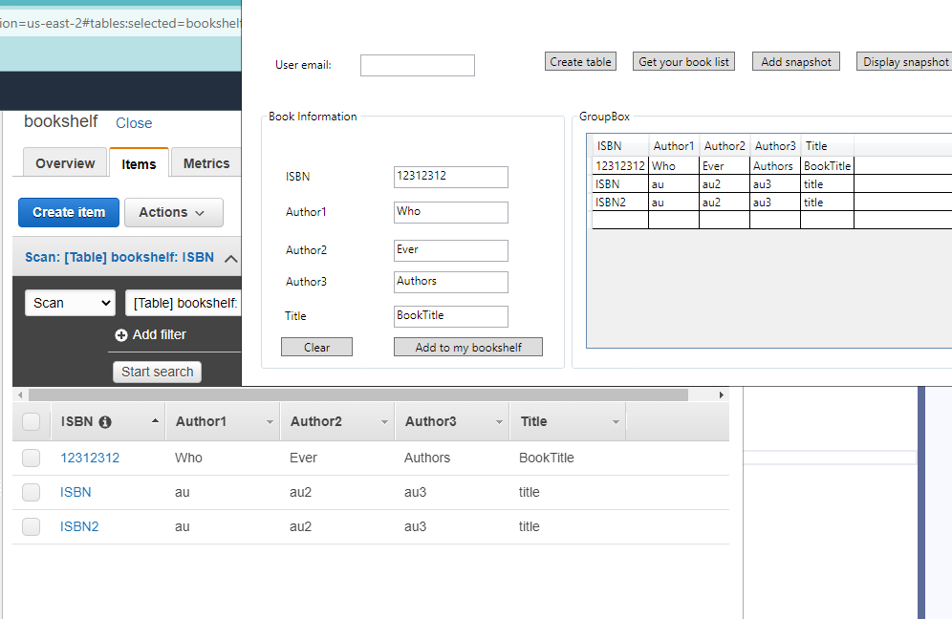

Also, I can add new my bookshelf by clicking “Add to my bookshelf button”

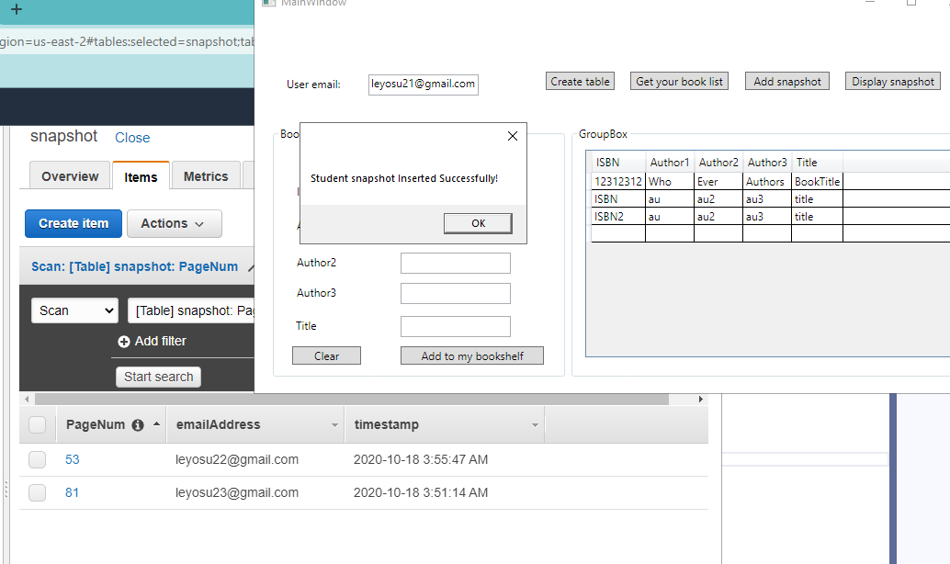

I will add a new snapshot

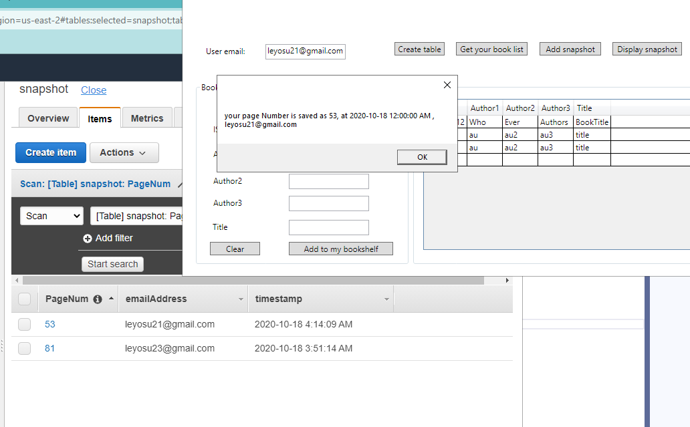

DynamoDB updated accordingly

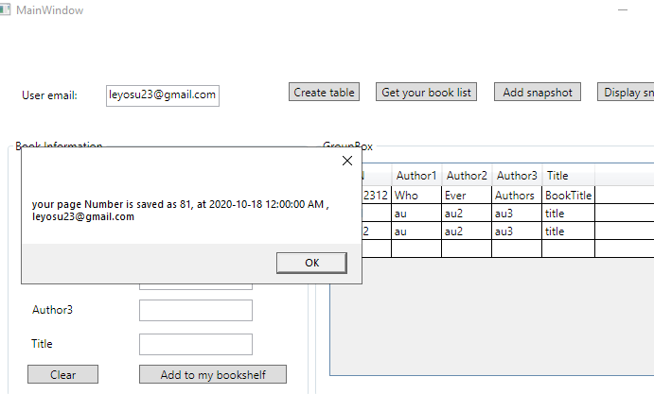

Also, different user information works well.