Yoonseop Lee 301037418

Question1[5marks]

Implement a C# app to create a bucket in S3 and upload an object to this bucket.

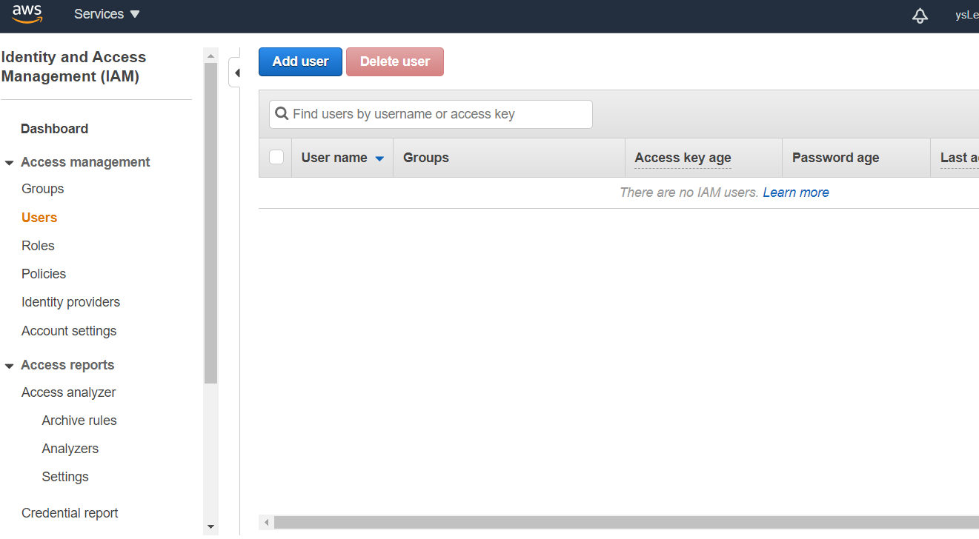Added new user in IAM.

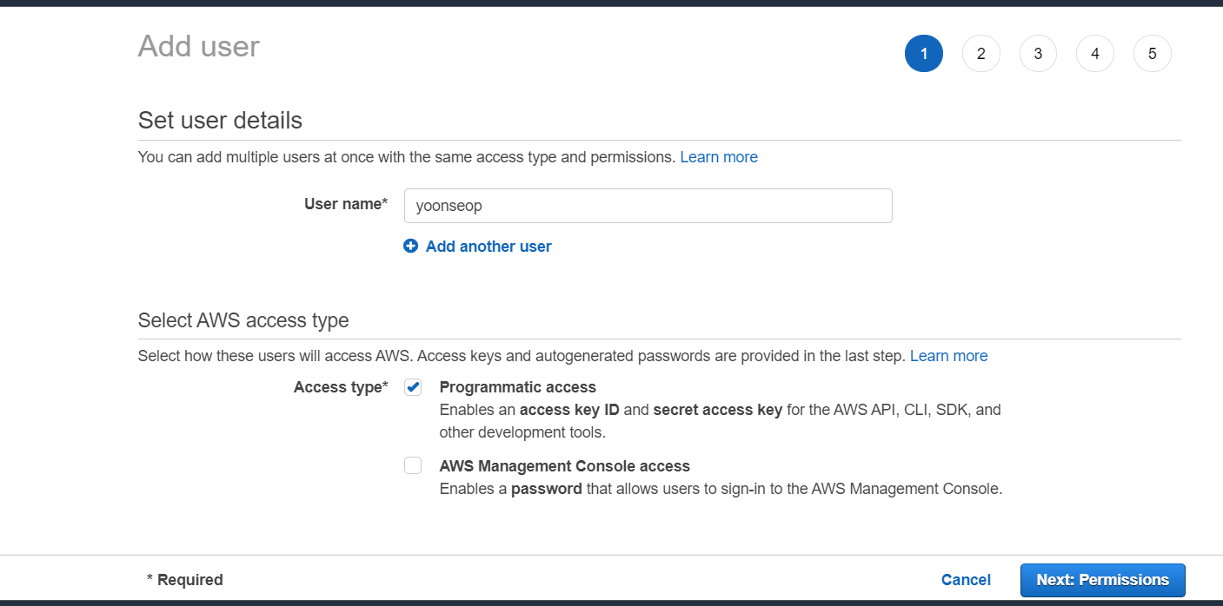

Defined user detail and check programmatic access

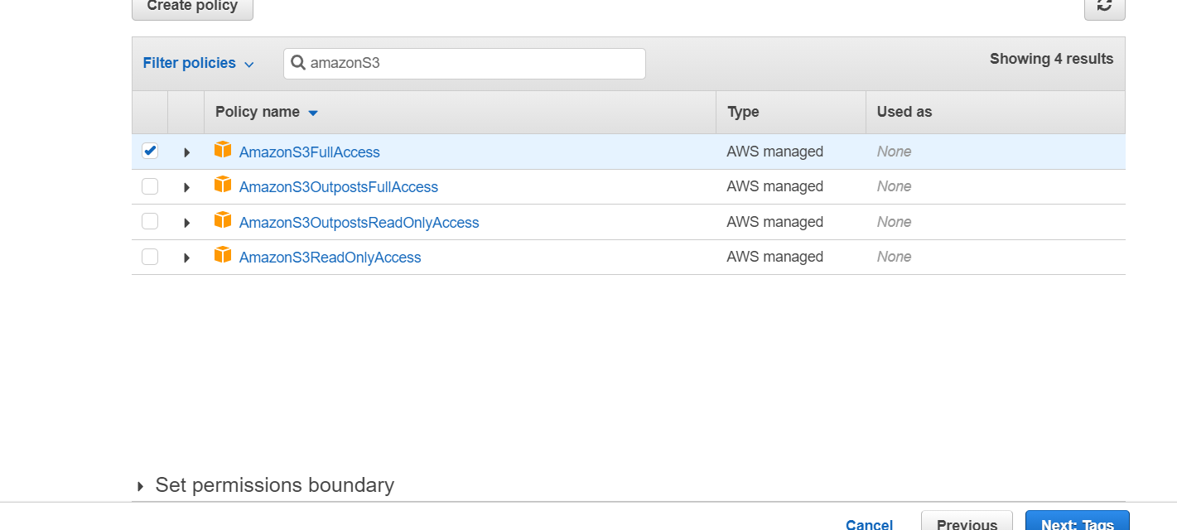

Checked AmazonS3FullAccess.

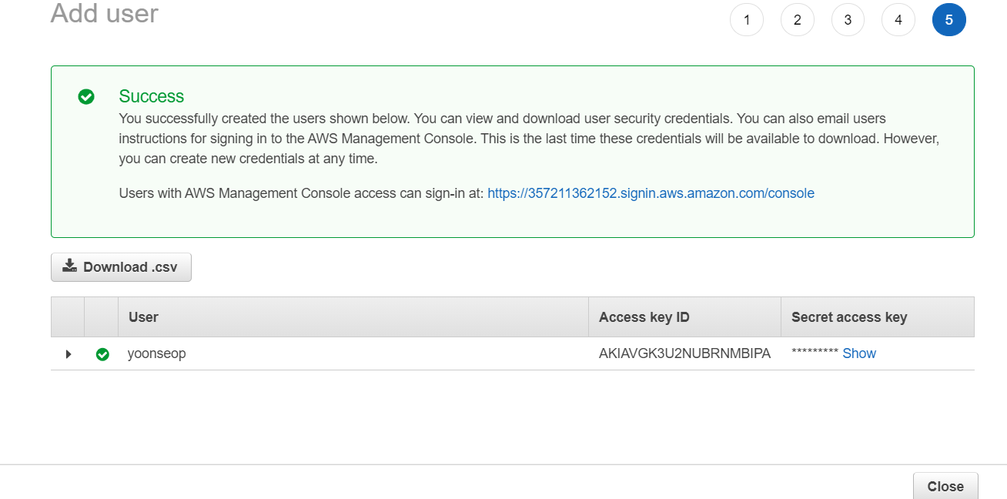

Verified success user and download csv file.

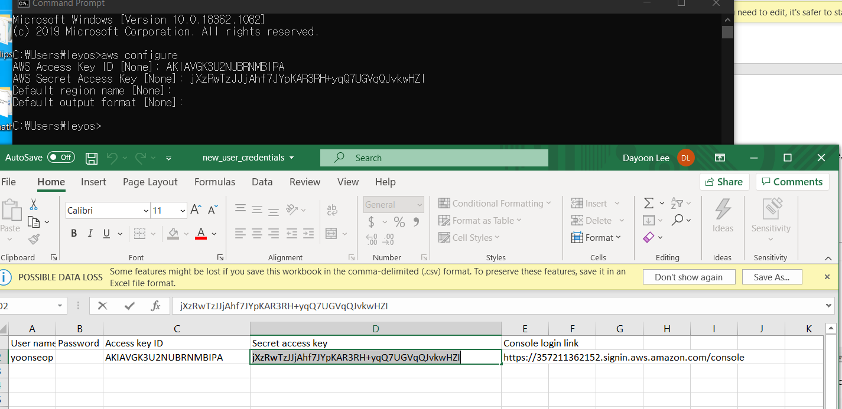

Put proper Access Key Id and Secret Access key.

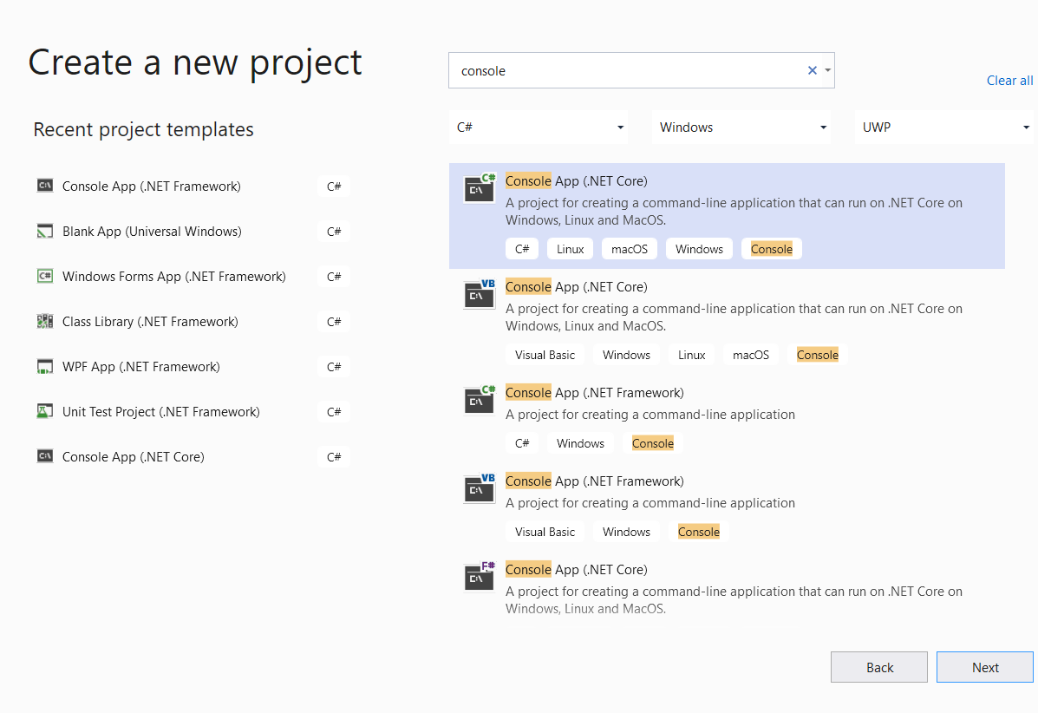

Created a new console App.

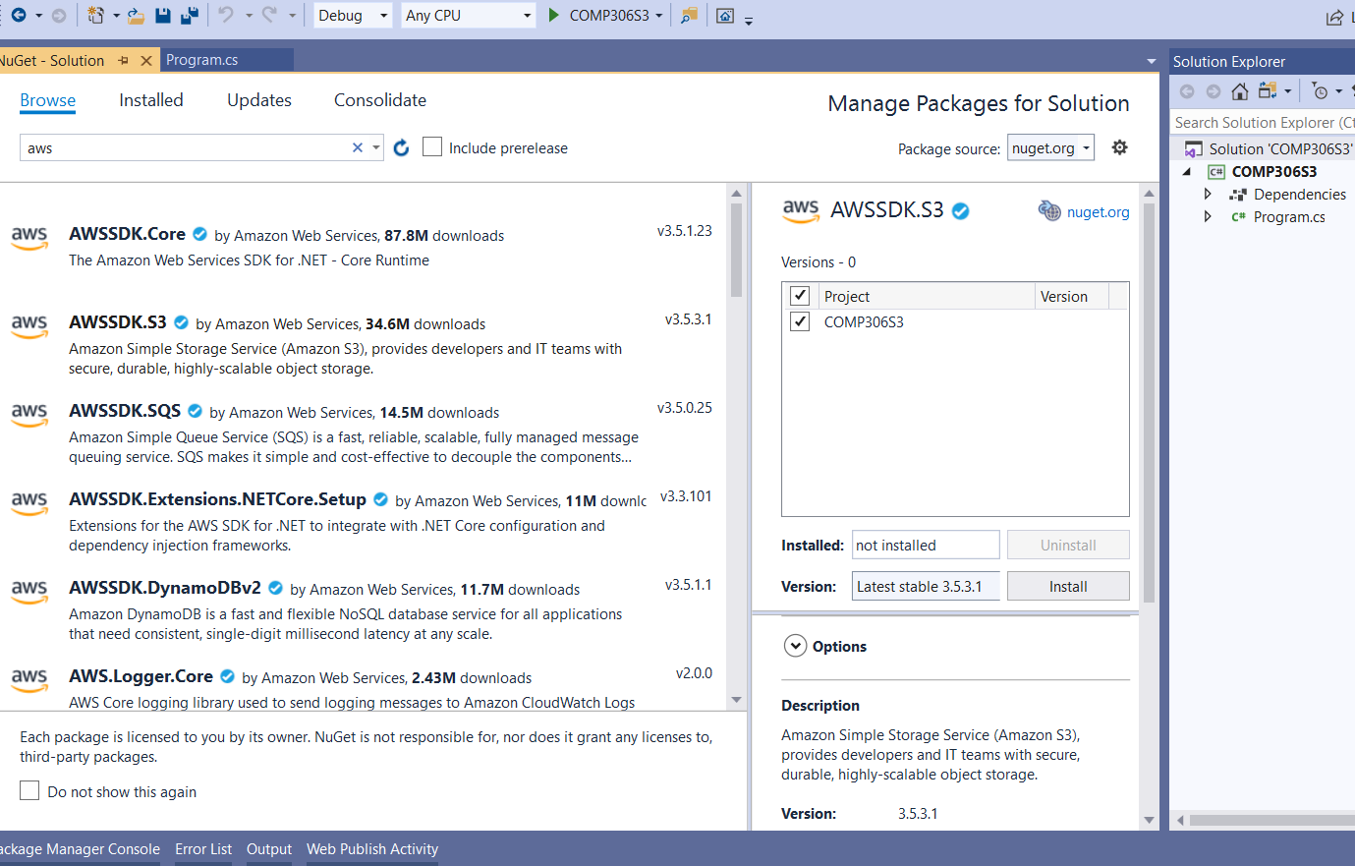

Installed AWKSDK.S3 in the NuGet packages.

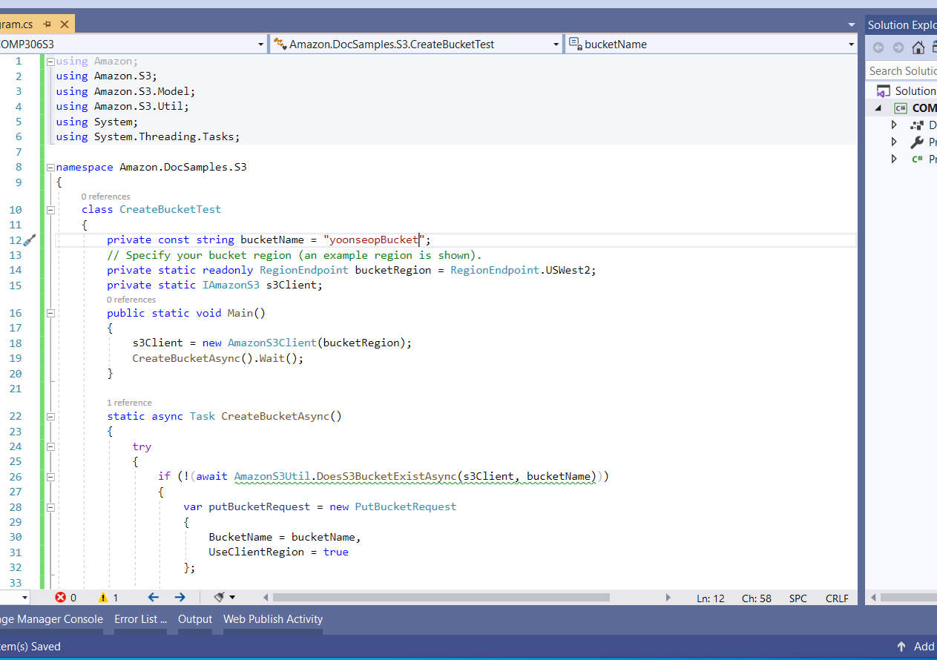

Changed bucket name and bucket Region appropriately.

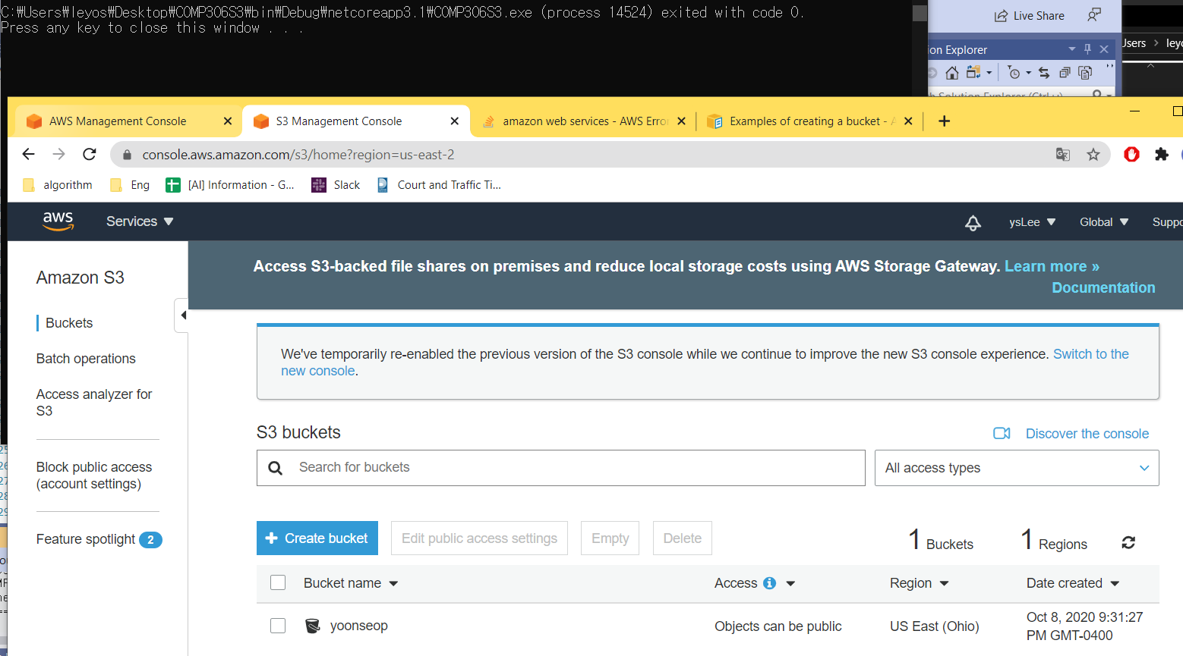

Created a new bucket successfully.

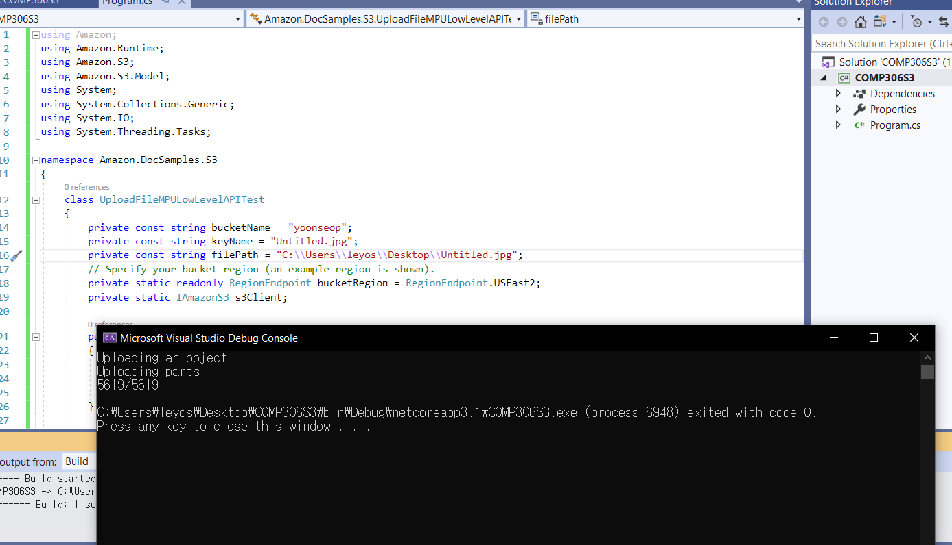

Changed fields appropriately.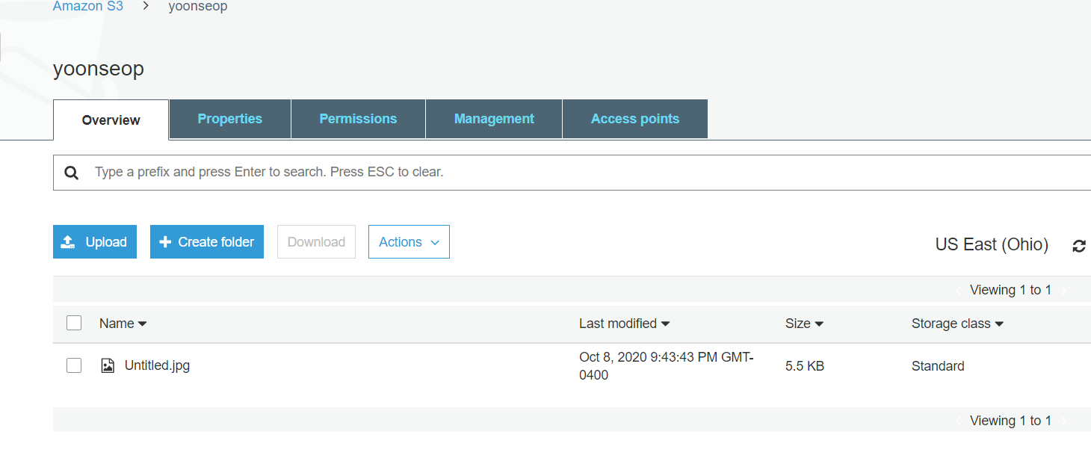

Verified a new jpg file is into the bucket.

Question2[5marks]

Log into your AWS account by using AWS management console, then finish following two tasks:

2.1 Use AWS RDS service to create a MySQL database engine, create a table called Student to hold all information about student such as ID, first name, last name, email address, contact number; insert your own information into table Student[2marks]

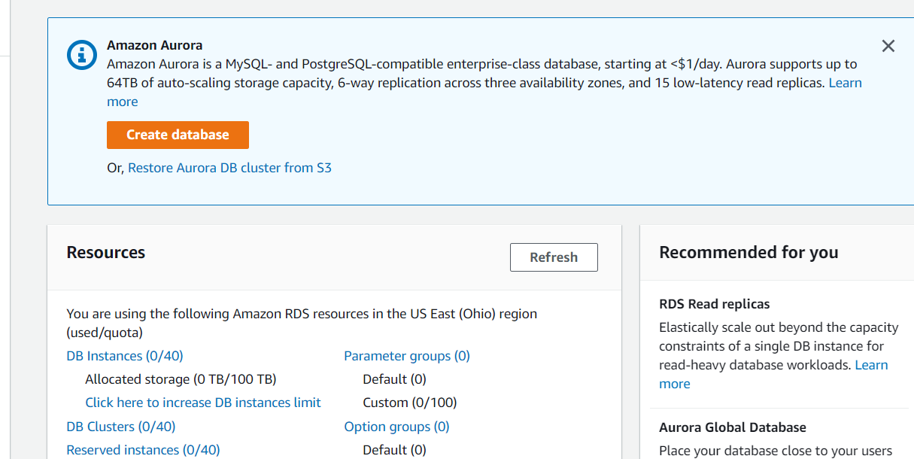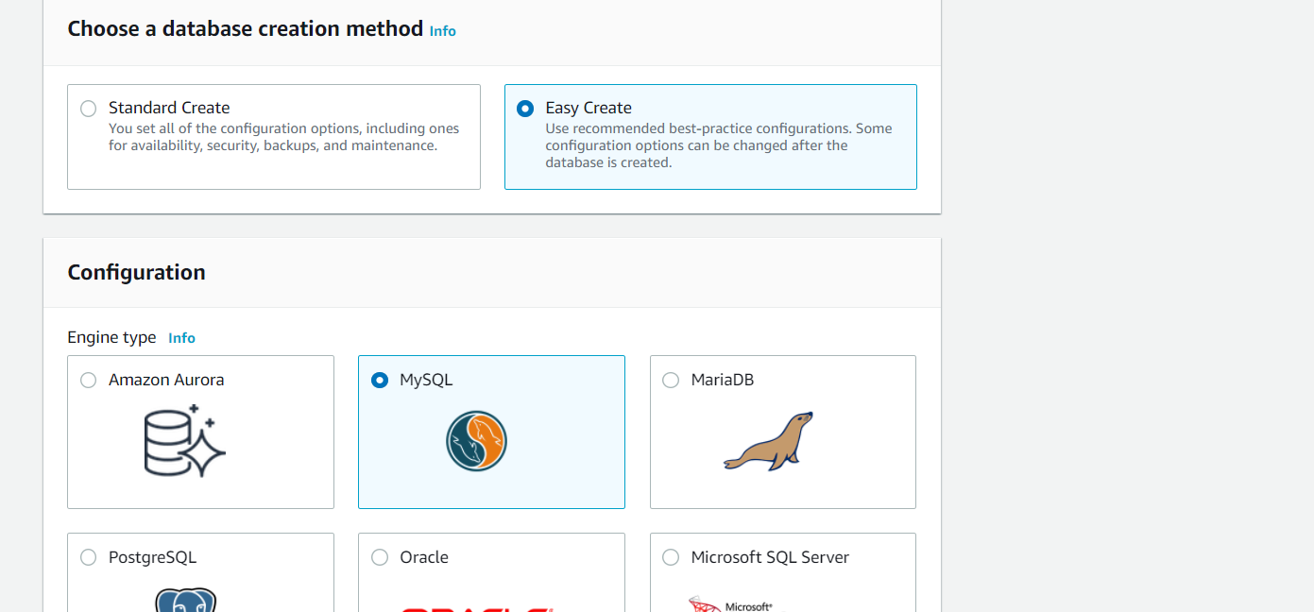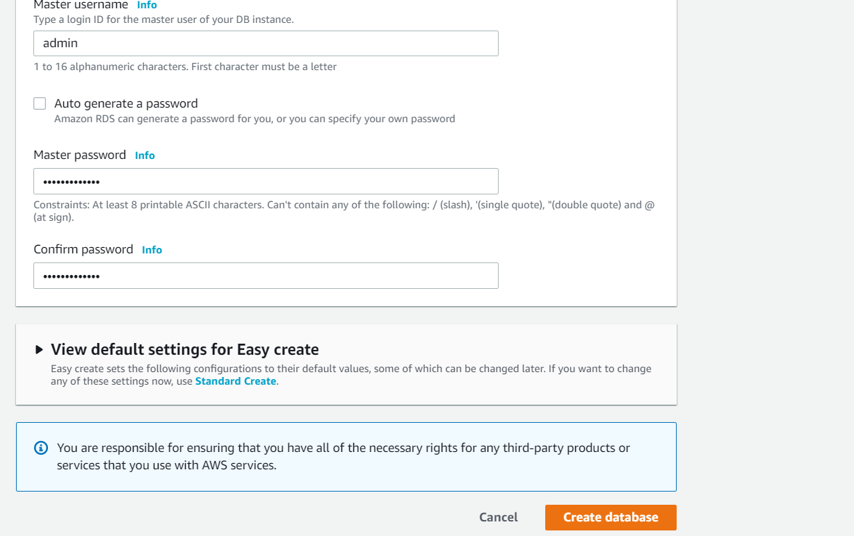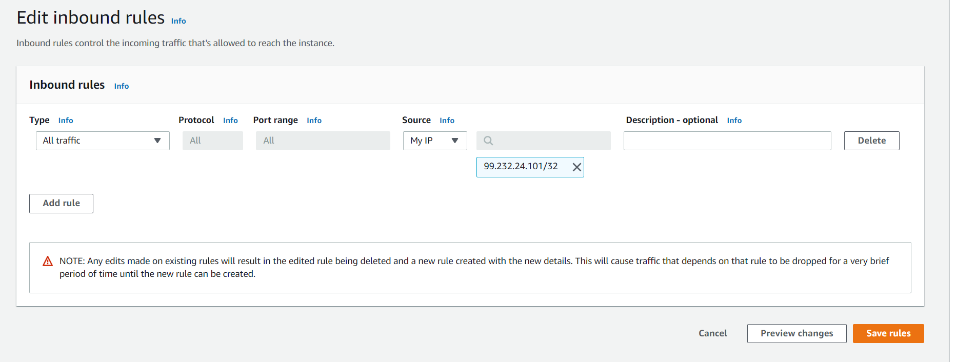

Created a new databased and configured security accordingly.

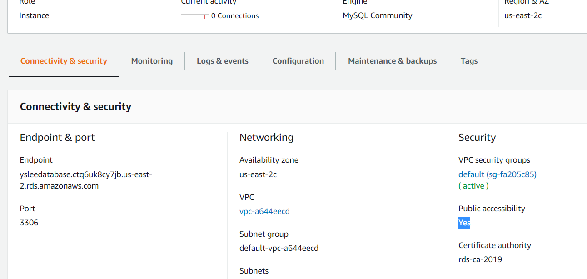

Set public accessibility to Yes.

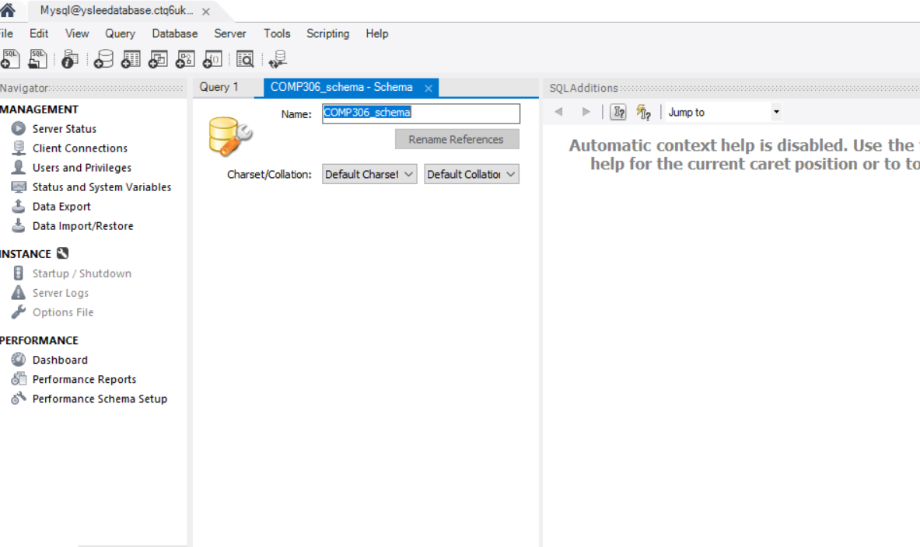

Created a new schema.

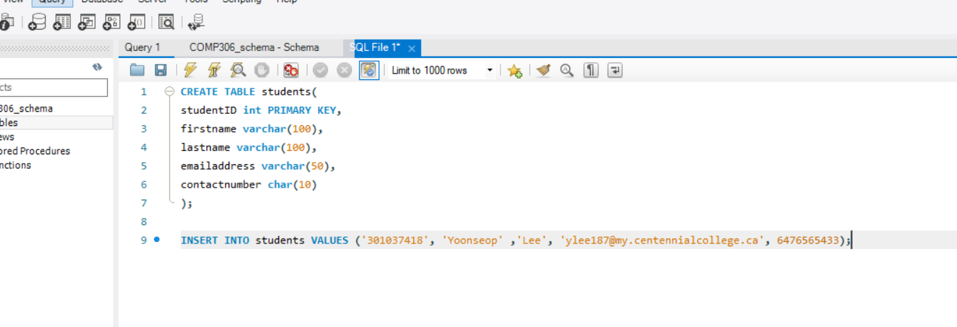

Created a new record.

2.1Create a DynamoDB table to record emails for a mail server, the table should include sending date, sender, recipient, subject, message, etc. Explain the rationale of your design [3marks]

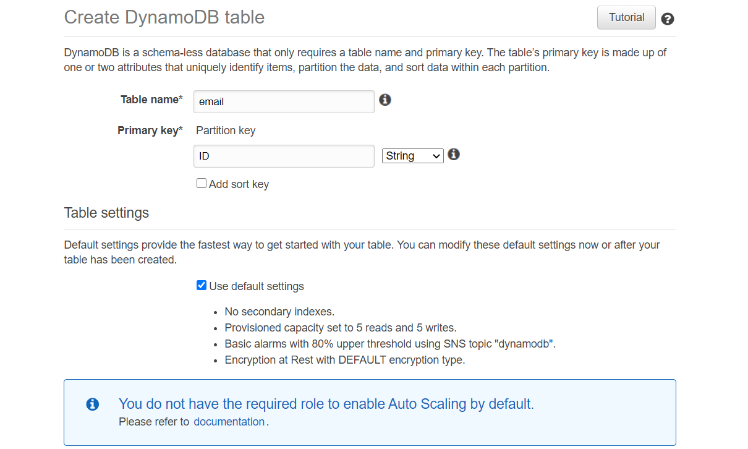

Created a new DynamoDB Table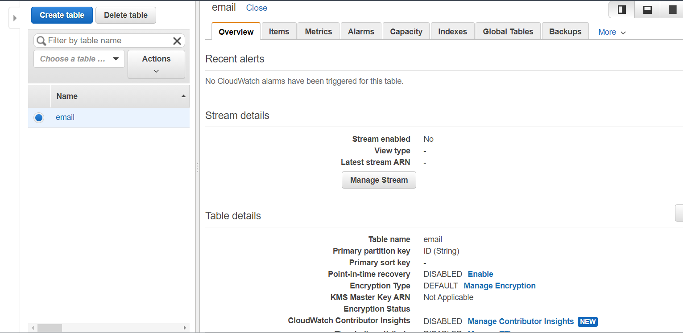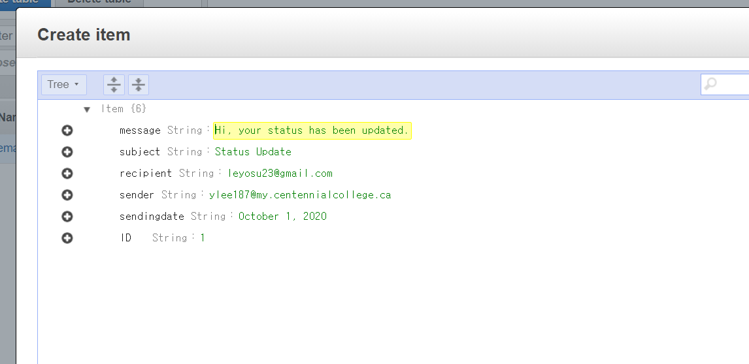

Created Items in the table accordingly.

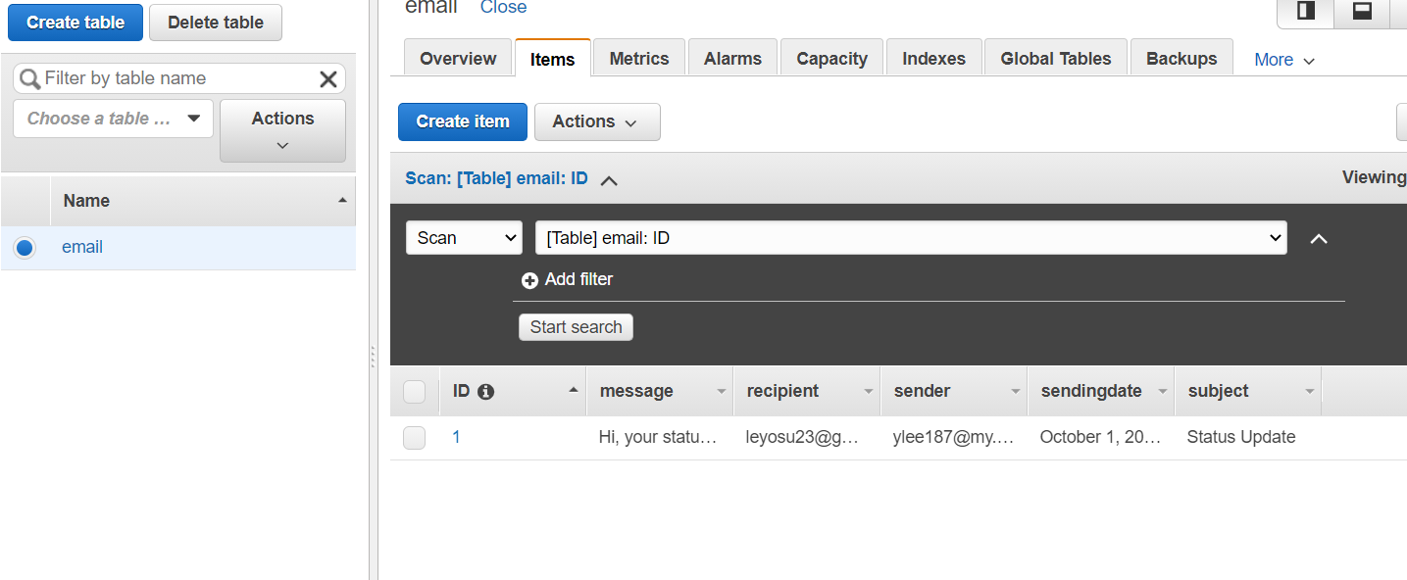

Verified a new item is in the table appropriately.