**Beykoz University**

**Department of “Computer Engineering”**

**“Database Systems”**

**Project Phase 1 Report**

**- Restaurant Management System -**

**Lecturer: Selçuk Kıran**

***Leyla Abdullayeva - 1904010038***

**1.Brief Description of the System**

This study includes a new database application that will help the restaurant manager to manage the restaurant more effectively and efficiently by computerizing meal ordering, billing and inventory control. This is the main purpose of this Project.

The database infrastructure of the program is MSSql.

The goals of our system are:

1. To manage chaotic systems in an easy & most effective way.

2. To promote online ordering & management software systems on the internet.

3. To provide an “anytime anyplace service” for the customer.

4. To obstruct wasting time while managing a restaurant manually.

**1.1 Scope Definition**

This system is to automate day to day activity of a restaurant.

Scope of project in building a computerized system for silk route to handle billing restaurant records was to include the employees who are involved in the process of billing of a customer to storage of restaurant records and enable them to view the records as desired. The employees are given limited access in order to safeguard the privacy and security of the records. Also, the application that will be created in the project will help managers and other employees to run the restaurant properly and will save a big amount of time, make the system work correctly. The database is maintained in the whole project.

**1.2. Determining System Requirements**

1. Users (both restaurant managers, waiters, chefs) can login to the system and will be able to do different operations.
2. Restaurant manager (owner) can modify (change) its own data.
3. The system can verify the data before a transaction.
4. Restaurant manager should be able to update information about his/her restaurant.
5. Restaurant manager should be able to view weekly sales for his/her (own) outlet.
6. All the users including (restaurant manager, chef, waiter, customer) can check menu / food data by clicking on a certain menu's main page in a web application (or just page).

**1.3 Potential Users of the System**

After the database design, user screen designs with different authorizations to use the system were made. Database tables were created to meet the needs of three different types of users.

* ***Restaurant Manager*** – Restaurant manager will receive statistical reports and will be able to follow business operations
* ***Customer*** – Customers can order the food by using this software from computers & also mobile smartphones.
* ***Employees (Waiter,Chef, Supplier)*** - Some of the sales department employees are authorized to use the system to define new campaigns and prepare reports for management.

**2. Design of Database System**

**2.1 Database Design**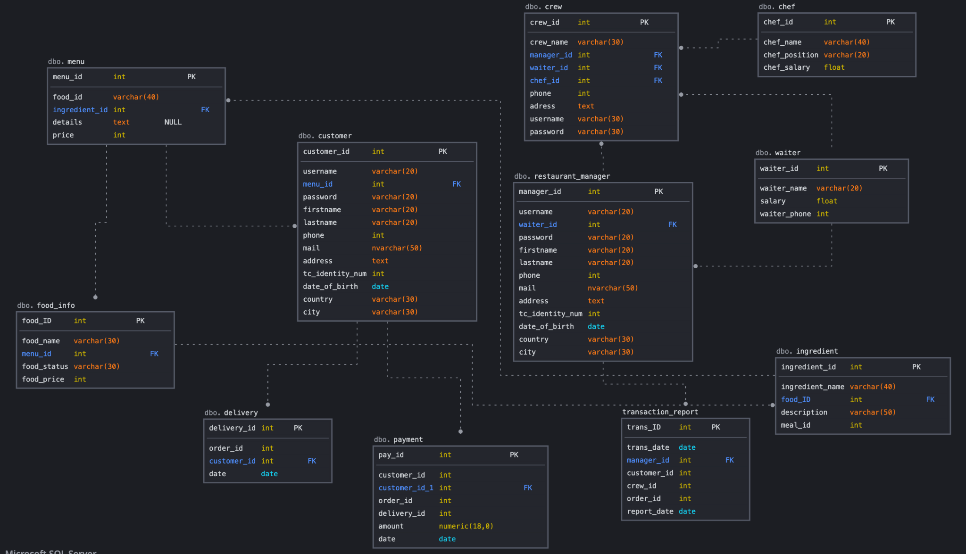

**2.2 Data Dictionary**