Website Marrolo.ca

1. Brand Identity & Visual Language
The website must reflect a blend of high-fashion sophistication and raw street style.
- Logo Usage: The "Marrolo" heart logo is the central element. It should be black on light backgrounds and white on dark backgrounds.
- Color Palette:
  - Primary: White and Black for a minimalist and classic look.
  - Secondary: Vibrant Red, Pink, Blue, yellow
  - Accents: Shines and glitters, reflecting the brand's bold essence.
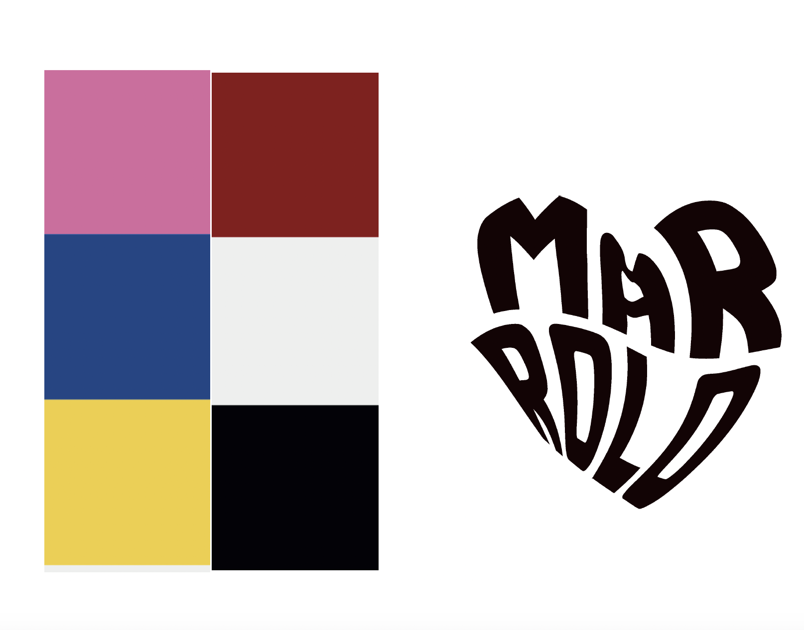
- Typography:
  - Titles: Modern and refined Serif fonts (e.g., Playfair Display, Cormorant Garamond).
  - Body: Clean and timeless Sans Serif fonts (e.g., Helvetica, Futura)

2. Technical Foundations
- Currency: Canadian Dollar (CAD).
- Language: English.
- Logistics: Delivery and Local Pickup option for the Vancouver area at checkout.
- Production Model: items are produced "on-demand" to minimize waste.

3. Website Structure & Content

I. Home Page (Impact & Emotion)
- Hero Element: High-quality full-screen video loop capturing the brand's vibe and Vancouver’s urban art scene.
Inspiration: https://nude-project.com/es?country=CA
https://dailypaperclothing.com/
https://www.eckhauslatta.com/
- Main Button (CTA): SHOP NOW o EXPLORE THE COLLECTION.
- Sub-Button: OUR STORY.

II. Shop
- Product Organization: Categorized by item type T-shirts, Hoodies, Pants and caps.
- Product Buttons: ADD TO BAG, SELECT SIZE.
- Checkout Button: PROCEED TO CHECKOUT.
- Delivery Option Button: LOCAL PICKUP (VANCOUVER ONLY).

III. Archive / Community
- Behind the Scenes: A section dedicated to the "Amor por el Proceso," showing the dedication from design to delivery.
- Community Gallery: A visual space for "Marrolovers" showing diverse people wearing Marrolo.
- Buttons: VIEW GALLERY, BEHIND THE SCENES, COLLABORATIONS.

IV. Collaborations Section
- Header: MARROLO COLLABS.
- Description: "A dedicated space for our partnerships with local Vancouver artists and creators, celebrating collective creativity and the diversity of our city."

V. About Us (Mission & Vision)
- Mission: To create versatile garments that transmit emotions and security while minimizing environmental impact.
- Vision: To change the concept of fashion through sustainable practices and community collaboration.
- Values (The Amores):
  - Amor por la Creatividad: Each garment is a unique expression.
  - Amor por la Comunidad: A space for urban style and self-expression.
  - Amor por el Planeta: Sustainability through on-demand production.
  - Amor por la Diversidad: Inclusion where everyone feels represented.
  - Amor por el Proceso: Dedication in every step from design to delivery.

VI. Contact & Newsletter
- Goal: To keep the community united through direct, friendly, and inclusive communication.

VII.

A. Production & Shipping Policy (The "On-Demand" Model)
- Key Message: "Each Marrolo piece is created uniquely for you."
- Details: "Because we are committed to Love for the Planet, we produce everything on-demand to minimize waste. Please allow 7 to 15 business days for your order to be crafted and ready for shipping or pickup, depending on current demand."

B. Refunds & Returns Policy
- Header: REFUND POLICY.
- Text: "At Marrolo, we value Love for the Process and transparency. Since our items are made-to-order to avoid environmental waste, we offer refunds or exchanges only in the following cases:
  - Manufacturing defects or damaged items upon arrival.
  - Incorrect item received.
- Process: "Please contact us within 14 days of receiving your order to initiate a return. For local customers, exchanges can be coordinated via our Vancouver Pickup point."

